**Captions for Funk and Mullen, “The Spine of American Law.”**

Figure 1. States often borrowed their codes of civil procedure from nearby jurisdictions, which had ultimately derived theirs from New York’s. In this bill passed by Nevada in 1861, the legislature marked up a printed copy of California’s procedure code, making amendments in pen and renumbering the sections. Detail from Council Bill 21, First Territorial Legislative Session (1861), courtesy of the Nevada State Library, Archives and Public Records.

Figure 2. This map shows which states adopted codes of civil procedure based on the New York Field reforms. The date shown is the date of the first enactment of a procedure code; most states subsequently revised their codes. Many southern states and western states came to adopt the Field Code during the Civil War and Reconstruction. By the end of the nineteenth century, thirty-one jurisdictions (those displayed on the map, plus Alaska) had adopted a version of the Field Code. Data adapted from Charles McGuffey Hepburn, *The Historical Development of Code Pleading in America and England* (Cincinnati, 1897).

Figure 3. These two sections of New York’s 1850 code of civil procedure abolished prior forms of practice and established a new form of civil action between a plaintiff and a defendant. These sections were borrowed by nearly all states which adopted the Field Code. Final Report of the Commissioners on Practice and Pleadings (New York, 1850), 225–25, §§ 554–555.

Figure 4. California’s 1851 procedure code adopted the civil action between a plaintiff and a defendant from New York’s 1850 code. California made minor changes (and introduced a typographical error) to the wording from New York, and because it was a new state it did not need the language abolishing equity courts. 1851 California Laws 51 §§ 1–2.

Table 1. This subset of the section-to-section similarity matrix shows strong Jaccard similarities between sections in the New York and California procedure codes, indicating that California borrowed those sections from New York.

Equation 1.

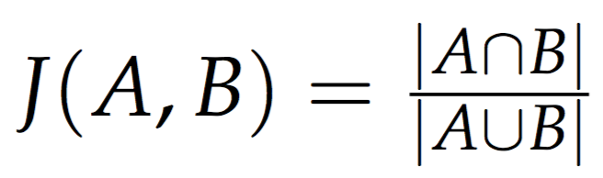

Figure 5. This network graph shows the structure of borrowings among nineteenth-century codes of civil procedure. Each node on the network is a statute or code of civil procedure, and an edge indicates a borrowing. For clarity, only the most significant borrowings for each code are shown. Several versions of New York’s Field Code were at the center of the network, while other states such as California and Ohio became centers of regional variations on the Field Code. States that adopted any of the variations on the Field Code became part of a network centered on New York.

Figure 6. This chart shows how individual sections of California’s 1850 procedure code (each box) were borrowed from earlier codes (each color). The bulk of the code was borrowed from New York, with several sections on new trials borrowed from Louisiana. Some parts of California’s code, such as its court and county structures, were unique to California (white boxes).

Figure 7. When California revised its code of civil procedure in 1851, it borrowed primarily from the 1850 New York code and not its own earlier 1850 code.

Figure 8. Washington’s 1855 code of civil procedure borrowed long contiguous sections from Indiana’s 1852 code and Oregon’s 1854 code. Washington’s code commissioners had previously been judges in those jurisdictions, which also borrowed their procedure codes from New York’s Field Code.

Figure 9. Washington’s 1873 code mostly revised its earlier 1855 code, though a large section on probate was taken from California’s 1872 code.