# OOAD

## Java



### Compilation Process

javac

→ class file → loaded into Classloader → check for bytecode → interpreter

→ execute

→ send it to the

CPU/hardware

class file = bytecode

### terminologies

JVM

JDK

software kit

JRE

Java Runtime Environment

JVM

### program I/O

System.out.println()

Scanner(System.in )

nextInt()

nextLong()

…

nextLine() string

## IDEs

IntelliJ

VScode

Eclipse

Visual Studio

### Online env:

replit

### Java as a language

Statically typed Language

Strongly Typed Language

### keywords

boolean byte char

false true

int short long

float double

## Data types

### Primitive Data Types

int 4

short 2

long 8

float 4

double 8

char 2

boolean 1 bit

byte 1 byte

float

12.36

1236 x 10-2

### Non Primitive Data Types

Reference Types

Arrays

Strings

Class

Objects

Interfaces

## Operators

### arithmetic

+

-

*

/

% modulo

### assignment

=

compound

+= a += b

a = a + b

-= a = a -b

…..

### relational

<

>

<=

>=

==

!=

### logical

&& and

|| or

! not

### unary

-

a = -100

++

post

pre

### bitwise

& and

| or

^ ex-or

### shift

<<

>>

>>>

<<

0011 1100 x

0111 1000 y

0001 1110 z

0011 1100 x

1111 0000 x << 2

0000 1111

+1

0001 0000

1010 0000

1010 0000 0000 0001

0001 1111 31

0000 0011 3

0000 0100 -4

### terniray

## Flow control

### if else

if

else if

else

### switch

switch

case

break

default

### while

while

do while

break

continue

### for

for

break

continue

### for-each

loops automatically

assigns too

features:

no index

can not be effectively used to change contents of the array

moves only forward

moves only in single steps

## Arrays

* dynamically allocated
* continuous memory allocation
* objects
* [ ]

int [ ] arr = {10, 20, 30}; //length is 3

arr.length → data

String stra = “atlas” // length is 5

stra = “amazon” // length is 6

stra.length() → function

## Strings

### String

* objects
* immutable

String literal

* String Constant pool
* JVM optimize

new operator

* dynamically allocated
* heap

### String methods

str.length()

str.toUpperCase()

str.toLowerCase()

str.indexOf(“”) the index of that particular sub-string

str.charAt() the character the specified index

str.isEmpty()

### StringBuffer

a t l a s t

01 23 4

### StringBuilder

faster than StringBuffer

not thread-safe

## Recursion

-- function/method calling itself

public static int add(int num){

if (num > 0){

return num + add (num -1);

}

else {

return 0;

}

4 + *add(3)*

4 + *3 +* ***add(2)***

4 + 3 + **2 + add(1)**

4 + 3 + 2 + 1 + add(0)

4 + 3 + 2 + 1 + 0

10



## OOPs

### general concepts

Object class is a superclass

DRY

Do not repeat yourself

#### vocabulary

state

(values)

properties

behaviour

methods

identity

class (memory) division

class has:

* account number
* deposit amount
* type of account
* display()
* static data (interest rate)

objw objx objy



#### class declarations, in general:

modifiers

public

private

constructor

methods

#### declaring member variables

various kinds:

within a class → fields

within a method (or block of code) → local data

in method declaration → parameters

#### method name (conventions)

speak

speakLoudly

getData

runFast

changeRoomTemperature

#### objects

Bank objy = new Bank(234682, 3000, "savings");

Bank objy → declaration

new → instantiate

Bank(xxx, yy) → initialisation

#### garbage collection

JRE deletes objects when it feels that those objects are no longer being used

runs automatically

an object can be deleted, when:

-- no references to that object

#### Features

Encapsulation

Inheritance

Polymorphism

function/methods overloading

C++ Java

operator

C++ Python

Abstraction

## static

### static variable

only one memory location

shared among all objects

if changed for one object, gets changed for another object too

### static methods

can access only static methods & static variables

can not use non static data/method

no this keyword

no super keyword

can be accessed without creating an object

## Polymorphism

4 + 6

“hello” + varx

Static

compile time

go_for_dinner(Saturday)

Runtime

Run time

### Function/Method Overloading (points to remember)

* num of parameters
* data types of parameters
* order of type of parameters
* not on the return type
* static method can be overloaded

### Function Overriding (points to remember)

* different (or specific) implementation in a child/subclass
* static methods can not be overridden
  + unless inherited class also makes it static (hides the parent’s implementation)
* method name in parent & child should be same
* parameter list & order should be same in parent & child

## Encapsulation

capsule

hide the data

## Inheritance

parent class or super class

child class or subclass

Unix()

Linux()

IS-A

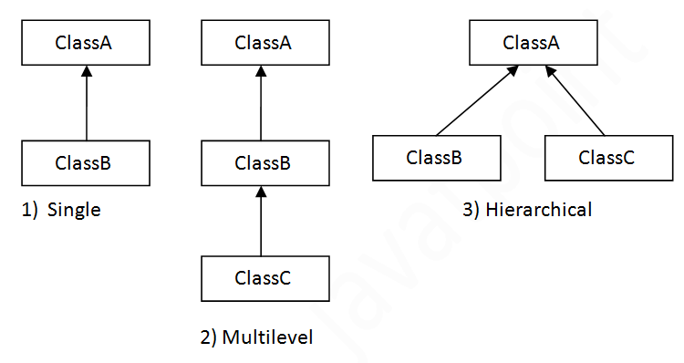

### inheritance (points to remember)

private attributes are not inherited

multiple inheritance not supported through class

### super

* used to invoke parent class constructor
* use to invoke parent class method

super.method()

* used to refer parent class data variable

### final

* final variables (data) can not change their value
* final methods can not be overridden
* final class can not be inherited
* final methods can be overloaded

## Object & Class Relationships

Association

Composition

Aggregation

### Association



association manages:

one-to-one

one-to-many

many-to-many

two forms of association:

composition

aggregation

## Example

flight_one

Seat:

| [empty]  [food] | [empty]  [food] | [empty]  [food] | [empty]  [food] |
| --- | --- | --- | --- |
| [empty]  [food] | [empty]  [food] | [empty]  [food] | [empty]  [food] |
| [empty]  [food] | [empty]  [food] | [empty]  [food] | [empty]  [food] |
| [empty]  [food] | [empty]  [food] | [empty]  [food] | [empty]  [food] |

flight_number =

single object

Seat obja = new Seat();

Seat(){

// constructor

}

multiple objects (array form)

Seat[] arr = new Seat[2];

arr[0] = new Seat();

arr[1] = new Seat();

Seat(){

// constructor

}

## constructor

same name as that of the class

no return type

can not be called explicitly

gets called implicitly (automatically) when an object is created

if not defined, then JVM will provide a default (empty) constructor

can not be static

can not be abstract

can not overridden

can be overloaded (parameterised)

can not be final

invoked when a new object is created

can have all access modifiers

# abstraction

hiding the details

* abstract
* interfaces (100% abstraction)



### abstract classes

#### points to remember

* abstract keyword for class (mandate)
* abstract & non-abstract methods
* even one abstract method means, class should be abstract
* no instantiation (no objects can be created)
* can have final methods
* can have constructors
* can have static methods

### interfaces

#### points to remember

* it's not a class, its an interface
* interface keyword (mandate)
* all methods have to be abstract & public, unless static
* data variables
  + public
  + static
  + final
* no instantiation (no objects can be created)
* multiple inheritance
  + interface can extend one or more interface
  + interface can extend only another interface
  + class can implement more than one interface
    - abstract
    - non-abstract
* non-abstract class implementing an interface
  + concrete implementation of all abstract methods
  + maintain exact signature of a method
* can have private methods (java 9 onwards)
* can have static methods (java 8 onwards)
* can have overloaded methods
* can not have constructors in interfaces

## inner classes and nested classes

nested classes

inner classes

* inner class
* within method (local classes)
* anonymous inner class

static nested classes

terminology/vocabulary

nested class

outer class

### points to remember

* need outer class for instantiating inner class object
* local inner classes can not be invoked from outside the method
* nested interfaces (static)
  + will not be private
* object of static nested class can be created without outer class object
* anonymous class
  + can be abstract too

## packages

collection of classes, interfaces & sub packages

helps organise classes into a folder structure

easy to find them

reusability

namespace

access specifiers

public

can be accessed from outside/within the package/within the class

private

can be accessed from within the class

protected

can be accessed from within the package/within the class

## Exception Handling

Object

-- Throwable

-- Error

-- stack overflow

-- no memory

-- OS send a signal

-- JRE/JVM error

-- Exceptions

-- Checked Exceptions

discovered during compile time

-- Unchecked Exceptions

-- user defined Exceptions

Throwable

Exception

RuntimeException

NullPointerException

IOException

java.lang

### keywords

try

catch

finally

### finally

1. exception occurs, is handled

catch block executes

finally block executes

code continues

1. exception occurs, is not handled

finally block executes

code crashes

1. exception does not occur

finally block executes

code continues

### throw

can explicitly raise exceptions

while throwing unchecked exceptions

can either catch it

or let system display the exception & stop the code

while throwing checked exceptions

mandatory to catch the exceptions

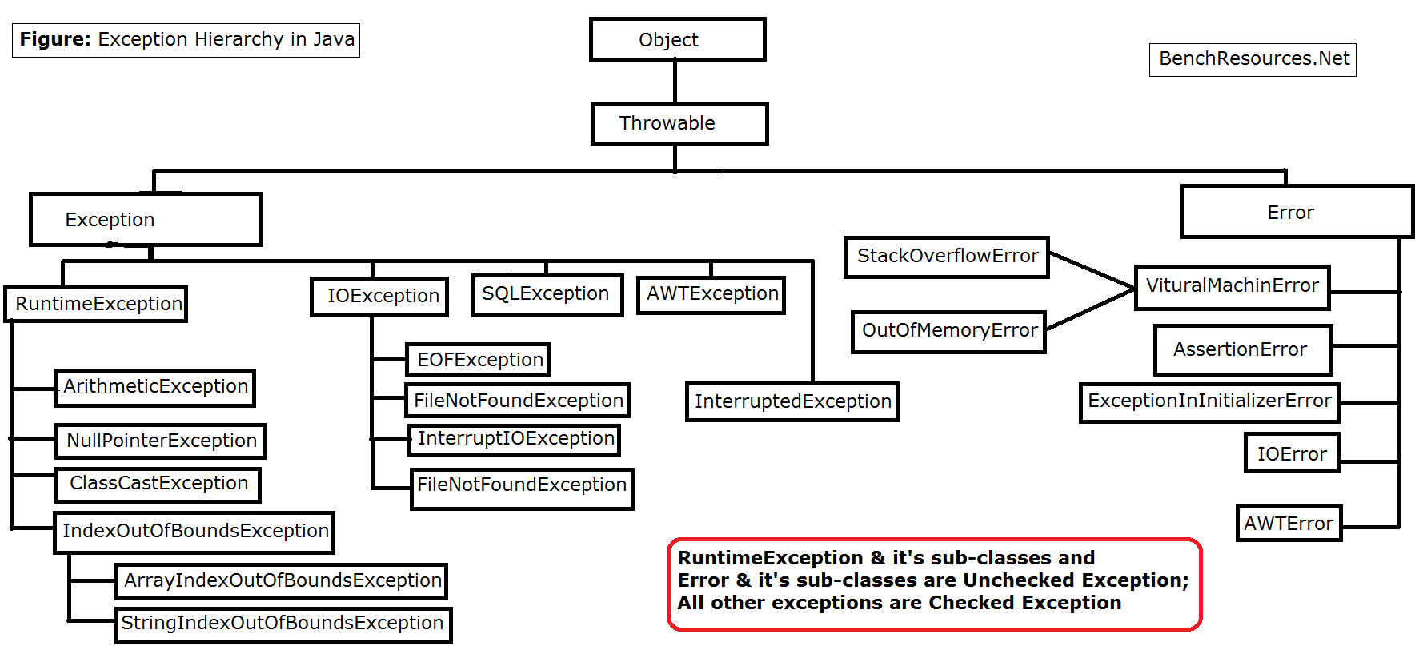

## Math

Math.min(x,y)

Math.max(100, 200)

Math.pow()

Math.sqrt()

x = 23 x = -12

y = Math.abs(x)

intervals = [[3,4],[2,3],[1,2], [5,6], [4536789012, 5]

i = 0

intervals[0] = [3, 4]

j = ? (0, 1, 2, 3)

res = [-1, 0, 1]

i = 1

intervals[1] = [2, 3]

j = 0, 3

[3, 4] or [5, 6]

i = 2

intervals[2] = [1, 2]

j = ? (0, 1, 2, 3)

0, 1, 3

i = 3

intervals[3] = [5,6]

j = ? (0, 1, 2, 3)

## Collections

interfaces

List

Set

Deque

Map

Implementations

ArrayList

HashSet

TreeMap

Algorithms

sort()

search()

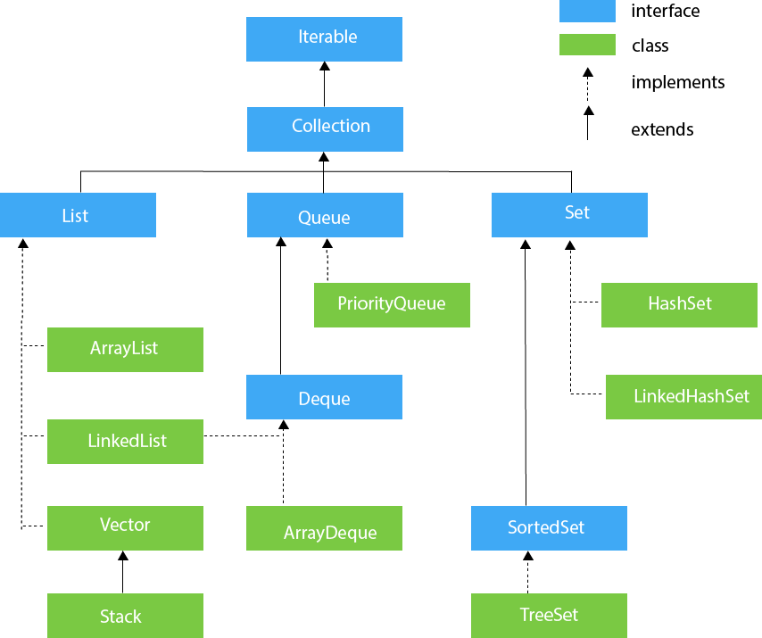

### Collection interface methods

Modification methods

Add

add()

addAll()

Remove

clear()

remove()

removeAll()

retainAll()

Query methods

contains()

equals()

size()

isEmpty()

other methods

iterator()

toArray()

### List

Modification methods

Add

add(Element el)

add(int index, Element el)

addAll(Collection cl )

addAll(int index, Collection cl )

Remove

clear()

remove(int index)

remove(Object obj)

removeAll(Collection cl)

retainAll(Collection cl)

modify elements

set(int index, Element )

Query methods

contains(Object obj)

equals(Object obj)

get(int index)

indexOf(Object obj)

lastIndexOf(Object obj)

size()

isEmpty()

subList(int from, int to)

other methods

iterator()

listIterator()

listIterator(int index)

toArray()

List

ArrayList

LinkedList (also implements Deque)

### ArrayList

default size = 10

.add()

.add(index)

.set()

.get()

.get(.size() -1 )

.size()

.indexOf()

.lastIndexOf()

.contains()

* re-sizeable
* starts with size 10
* internally uses array to store the elements
* can retrieve elements by index
* allows duplicate values
* allows null values
* ordered collection
* not synchronised

### Set

* unordered
* no duplicate values

### HashSet

* unordered
* unique
* uses hashing for storing the values
* allows null value
* 16 default size
* not synchronised

### LinkedHashSet

* ordered (maintains insertion order)
* unique elements
* null values allowed
* not synchronised

### TreeSet

* ordered (maintains ascending order)
* unique elements
* null values not allowed
* not synchronised

### HashMap

key:value

* unordered
* no duplicate keys
* allows null
* allows null key
* not thread-safe

# Data Structures (Java)

## types of DS

primitive

byte, short, int ….

non primitive

1. Linear Data Structure
   1. Array
   2. Linked List
   3. Stack
   4. Queue

…..

1. Non-Linear Data Structure
   1. Tree
   2. Graph

## Array

linear data structure

collection of data/variables/objects

int, float

Strings

objects

referenced by a common name

contiguous memory location

data type = base type

Arrays are considered as objects

heap area (dynamic memory)

new

size of array = int

length

public final length

Object class is a superclass of array

Linear Data Structure

advantages:

random access of elements (using index)

access is faster

sorting, iteration is easier

modification (of values )

disadvantages:

size is fixed

modification (insertion, deletion) cumbersome

time taking

capacity is huge, used section is less, then memory is wasted

always needs contiguous memory locations

for(int val : arr)

{

// body of the loop

}

### clone

#### while passing to a function:

arr

| 10 | 20 | 30 | 40 | 50 | 60 |
| --- | --- | --- | --- | --- | --- |

brr = arr

brr was referencing back to arr

crr = arr

crr was referencing back to arr

any changes done to crr, effects arr too

#### while passing to a function by clone, or by equating using cloning:

arr

| 10 | 20 | 30 | 40 | 50 | 60 |
| --- | --- | --- | --- | --- | --- |

brr = arr.clone()

brr is a new copied version of arr

separate area in the memory is created

crr = arr.clone()

crr is a new copied version of arr

any changes done to crr, does not effect arr

crr

| 6 | 16 | 26 | 36 | 46 | 56 |
| --- | --- | --- | --- | --- | --- |

### multi dimensional arrays

arr[m][n]

m rows

n columns

m number of n arrays

arr [6][4]

6 one-dimensional arrays

each one dimensional array is of the size 4

ways of creating multi dimensional array:

int arr [ ] [ ] = new int [6] [4]

int [ ] [ ] arr = new int [6] [4]

## Linked List

tiffin box mould

start = 7000

| 8055 |
| --- |
| chole bhature |
| 7054 |

7000

| 7000 |
| --- |
| momos |
| 8000 |

7054

| 7054 |
| --- |
| pasta (red sauce) |
| 9011 |

8000

| 9011 |
| --- |
| shawarma |
| 8055 |

8020

| 8020 |
| --- |
| biryani |
| 7000 |

8055

| 8000 |
| --- |
| chicken masala |
| 8020 |

9011



## Stack

* LIFO
* top

insertion & deletion

### major operations

push

insert element at the top

pop

removes the top element

-------

isEmpty()

return True if it is empty

look() peek()

take the value from the top, but do not delete it

## Queue

* FIFO
* Q

## Hashing

key value (pairs)

### 

319540

→ 42605

→ 665

A

B

C

D

XYZ

-- one-directional process

-- deterministic

-- uniformity

-- fixed size output

-- avoid collision

-- Message Digest

SHA-256

Secure Hash Algorithm

-- large amount of data

smaller table

### Hash Functions

-- Message Digest Functions

340: ironman:suit

341: captain: hammer_shield

357: thor: hammer_thunder

### Hash table

Hash Map

0 to n

division method

remainder

| Data | Hash Function | Hash Value |
| --- | --- | --- |
| 23 | 23 % 10 = 3 | 3 |
| 37 |  | 7 |
| 29 |  | 9 |
| 48 |  | 8 |
| 54 |  | 4 |
| 35 |  | 5 |
|  |  |  |

| 0 | 1 | 2 | 3 | 4 | 5 | 6 | 7 | 8 | 9 |
| --- | --- | --- | --- | --- | --- | --- | --- | --- | --- |
|  |  |  | 23 | 54 | 35 |  | 37 | 48 | 29 |

table size = 10

load factor = num of items/ table size

6/10

H(77) = 7

i 105

d 100

l 108

e 101

“abcf” “bcfw” “cvrh” “guio”

396 418

“idle” 414

“idel” 414

“deli” 414

“lied” 414

“idle” (105*10 + 100*20 + 108*30 + 101*40)%599 =

“idel” 414

“deli” 414

“lied” 414

Collision / Clash

Linear Probing

## Sorting Algorithms

rearrange the positions

### Bubble Sort

{88, 14, 32, 25, 79}

**88 14** 32 25 79

14 **88 32** 25 79

14 32 **88 25** 79

14 32 25 **88 79**

-------------------------------------------

**14 32** 25 79 88

14 **32 25** 79 88

14 25 **32 79** 88

14 25 32 **79 88**

* two loops (inner & outer)
* keep swapping in the inner loop
  + if current element is smaller than the adjacent element (then swap)
* repeat till the outer loop exhausts

### Insertion Sort

13 15 17 18 14 12 11 19 16

**13 15 17 18** 14 12 11 19 16

**13 15 17 14** **18** 12 11 19 16

**13 15 14 17** **18** 12 11 19 16

**13 14 15 17** **18** 12 11 19 16

13 14 15 17 18 12 11 19 16

1. pick a key (an index actually)
2. repeat steps 2 to 4 till the end of array is reached
3. compare the element at current index with the left values, if it is smaller then repeat step 3
4. keep shifting elements from the “sorted” section of the array till the correct location of the key is found
5. increment the loop variable (i)

### Selection Sort

### Merge Sort

divided & conquer algorithm

8 3 1 6 17 14

8 3 1 6 17 14

8 3 1 6 17 14

3 8 1 6 17 14

1 3 8 6 14 17

1 3 6 8 14 17

a b c d e

a b c d e

a b c

mergeSort()

merge()

### Quick Sort

{ 88, 14, 32, 25, 79 }

25

14 25 88 32 79

32 88 79

79 88

14 25 32 79 88

## Graphs

-- Finite Graph

-- Infinite Graph

complete graph

(every node is adjacent to every other node)

vertices = n

each vertex’s degree = n-1

number of edges = (n * (n-1) )/2

max cut vertex n-2





Digraph

Connected Graph

edge connections

vertex node

degree

out-degree

in-degree

source vertex (in degree = zero)

path

strongly connected

(or has a path, in terms of directed graphs)

Adjacency matrix

adjacency list

cut vertex

### BFS



Visited → A,

Queue → B, C, D

Visited → A, B

Queue → C, D

Visited → A, B , C

Queue → D, E

Visited → A, B , C, D

Queue → E

Visited → A, B , C, D, E

Queue →

O (ver + ed)

### DFS



Visited → A,

Stack → B, C, D

Visited → A, B

Stack → C, D

Visited → A, B, C

Stack → E, D

Visited → A, B, C, E,

Stack → D

Visited → A, B, C, E, D

Stack →



S.visited = true

A.visited = true

D.visited = true

B.visited = true

C.visited = true

stack → S

S A

S A D

S A D B

S A D C

S A D

S A

S

(empty)

Display:

S A D B C

### Colouring

