

**A report on**

**PCB Designing of closed loop buck converter**

**[Self-project]**

**AKESH KOTNNA  
224102102**

**Aim**: To design a printed circuit board (PCB) for controlling the output voltage of a given buck converter. An analogue type PI controller is considered.

Converter Requirements:

Input Voltage = 300V   
Output Voltage = 120V  
Switching frequency = 25KHz

Current ripple = 10%  
Voltage ripple = 5%  
Power rating = 300W

**Calculations:**

Duty Ration $D=\frac{V_{O}}{V_{in}}=\frac{120}{300}=0.4$

Output Current $=\frac{300}{120}=2.5A$, Load Resistance R= $\frac{120}{2.5}=48Ω$

Inductor $L=\frac{\left(1-D\right)V_{0}}{f_{s}∆I_{L}}=\frac{\left(1-0.4\right)x 120}{25K*\left(0.1*2.5\right)}=0.115mH$

Capacitor $C=\frac{\left(1-D\right)}{f_{s}^{2}8LC∆V_{0}}=\frac{1-0.4}{{\left(25k\right)}^{2}*8*4.8e^{-3}*(0.05*120)}=0.2μF$  
  
**Transfer function of non-ideal Buck Converter:**

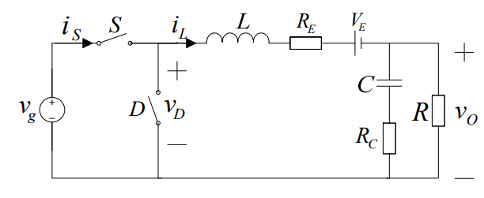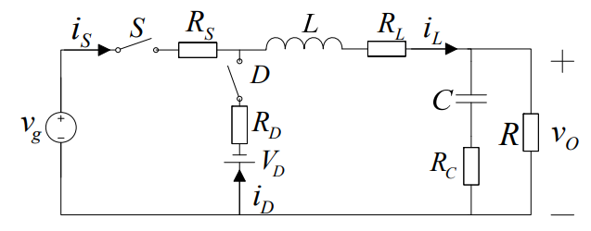Where $R_{E}=\left[R_{L}+DR_{S}+\left(1-D\right)R_{D}\right]\left[1+\frac{∆i_{L}^{2}}{3I_{L}^{2}}\right]$ and $V_{E}=\left(1-D\right)V_{D}$

Figure 1:Non-ideal Buck converter after equivalent conversion

Figure 2:Non-ideal Buck converter considered parasitic parameters

transfer function for the above converter can be written as:

$$G_{vd}\left(s\right)={\left.\frac{{\hat{v}}_{0}\left(s\right)}{\hat{d}\left(s\right)}\right|}_{\hat{d}\left(s\right)=0}=\frac{V_{g}R}{R+R_{E}}.\frac{1+\frac{s}{ω_{z1}}}{1+\frac{s}{Qω_{0}}+{\left(\frac{s}{ω_{0}}\right)}^{2}}$$

Where

Quality factor $Q=\frac{\sqrt{\left(R+R_{E}\right)\left(R+R_{C}\right)LC}}{RR_{E}C+RR_{C}C+R_{E}R_{C}C+L}$   
Zero point $ω_{z1}=\frac{1}{R_{C}C}$  
Resonance frequency $ω_{0}=\sqrt{\frac{R+R_{E}}{\left(R+R_{C}\right)LC}}$

**Controller Design:***Design Requirements*: Phase Margin = 120 $°$ and Gain Crossover frequency $ω_{gc}$ =2000 rad/sec

Let, Controller transfer function $G_{c}\left(s\right)=K_{p}+\frac{K_{i}}{s}$  
And plant (buck) transfer function $G_{p}\left(s\right)=G_{vd}\left(s\right)$  
now, overall transfer function $G\left(s\right)=G_{C}\left(s\right)G_{P}\left(s\right)$

Now we have two unknowns to find, those are $K_{p}$ and $K_{i}$.We need two equations to solve these two unknowns. Phase margin and Gain relations give these two equations.  
we know that

Phase margin $PM=180°+{\left.∠G\left(s\right)\right|}_{ω_{gc}}$ $$120°=180+\left[∠\left(K_{p}+\frac{K_{i}}{s}\right)+∠{ G}_{p}\left(s\right)\right]$$

$$120=180+\left[\tan^{-1}\left(\frac{ωK_{p}}{K_{i}}\right)-90°-31.9077°\right]$$ $\frac{K_{p}}{K_{i}}=\frac{1.873}{ω_{gc}}$-------- (1)

Another equation can be obtained from gain relation

$$1=\left|K_{p}+\frac{K_{i}}{s}\right| .\left|{ G}_{p}\left(s\right)\right|$$ ${\left(\frac{ω_{gc}}{330.3362}\right)}^{2}={\left(\frac{1.873}{ω_{gc}}K_{i}\right)}^{2}{ω_{gc}}^{2}$------------- (2)

By solving above two equations we can get $K_{p}$ and $K_{i}$ values [ $K_{p}=2.851$ and $K_{i}=0.0027]$.

**Bode plot:**



**Power Circuit components:**

|  |  |
| --- | --- |
| **Component** | **Specifications** |
| MOSFET | IRF440-500V,8A,0.85 $Ω$ Power MOSFET |
| Diode | 400V/600V ,8A, Trr<135ns fast switching soft recovery diode |
| Inductor | SC-07-50J 250V/5mH/7.3A/27 m $Ω$ |
| Capacitor | B58043, SMD 2220 series 400V/0.25 $μF$/ESR-0.004 $Ω$ |

**Block diagram:**

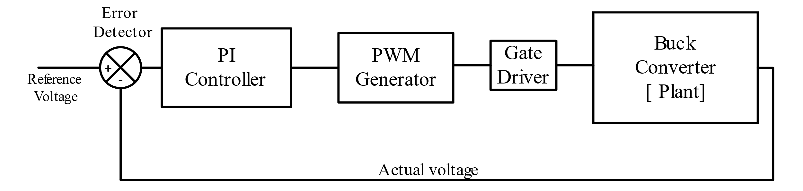

Figure 3:Block diagram of closed loop buck converter

Output voltage from the buck converter is given to the error detector. This actual output voltage is fed to the error detector to get the error with respect to reference voltage. Error detector is realised by subtractor using OP-AMP. This is error signal will go to the PI controller. PI controller can be implemented by a series RC circuit in the OP-AMP feedback. Output from the PI controller is given to the comparator, another input for the comparator is sawtooth signal having frequency same as switching frequency. These two signals are compared to get the duty signal for the MOSFET. As we cannot give duty signal to the power MOSFET directly, a driver IC is used to give this duty signal to the MOSFET. Gate driver IR2117 is used for this operation.

**Gate Driver:** The IR2117 is a high voltage, high speed power MOSFET and IGBT driver. The logic input is compatible with standard CMOS outputs. This driver is tolerant to negative transient voltage and dv/dt immune. The output driver features a high pulse current buffer stage designed for minimum cross-conduction.

**MATlab & LTspice Simulations:**  
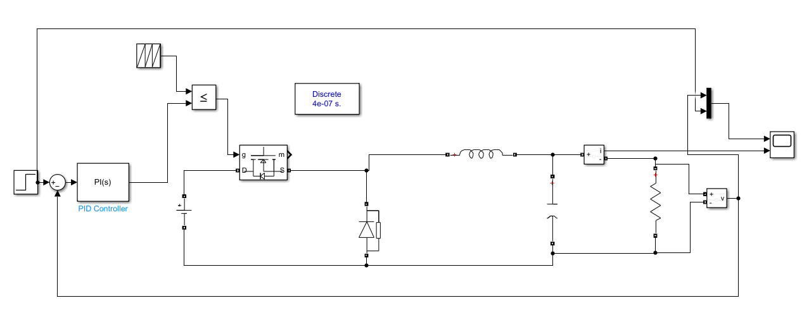

Figure 4:MATlab simulation of PI controlled buck converter

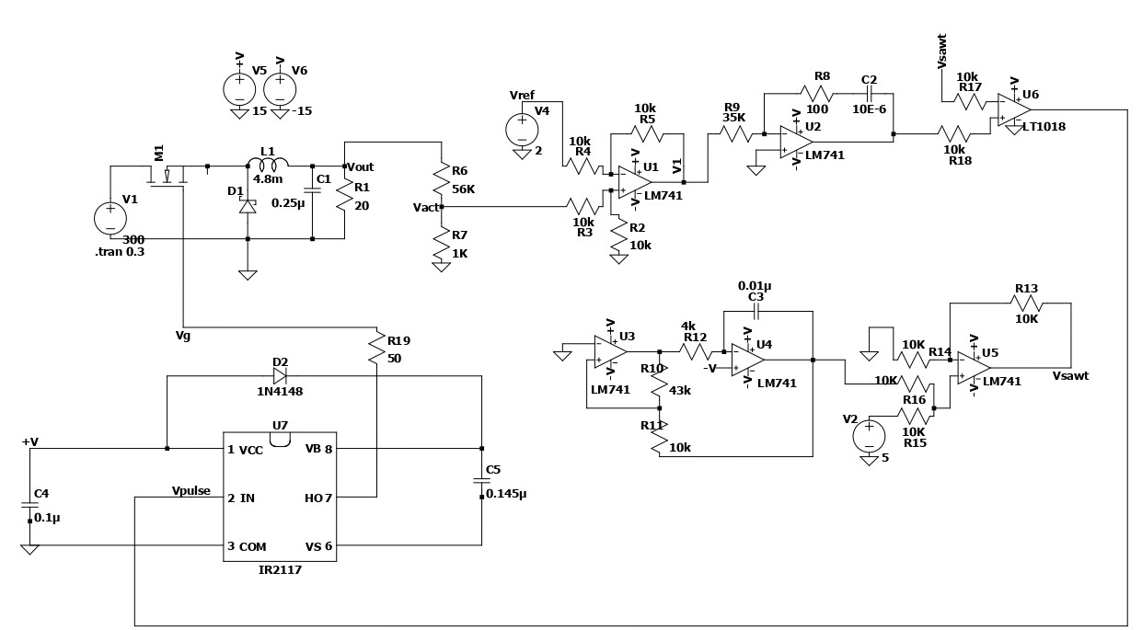

Figure 5:LTspice model of closed loop buck converter

Results:

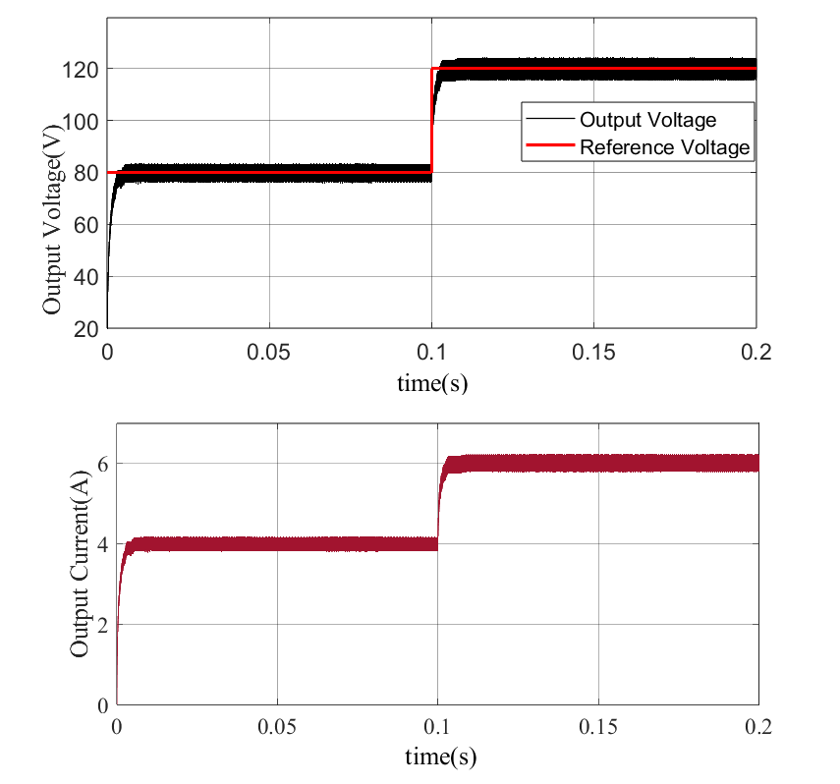

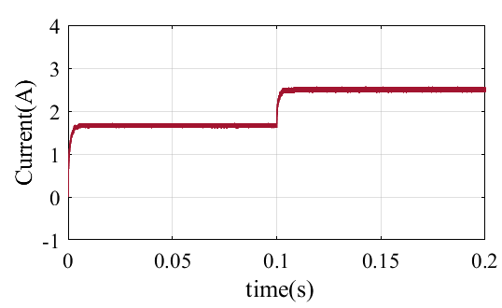

**Signal Circuit Components used:**

|  |  |
| --- | --- |
| **Component** | **Specifications** |
| LM741 | 8-DIP general purpose operational amplifier |
| IR2117 | 600V/(10V-20V), 125 ns delay, designed for bootstrap operation |
| LT1018 | Micropower, High frequency Comparator |
| 1N4118 | 0.2A, Ultra-high speed, fast reverse recovery time |
| Resistors | 1k,4k,10k,35k,43k, |
| Capacitors | 0.145uF,0.1uF,10uF |

**Designed PCB:**

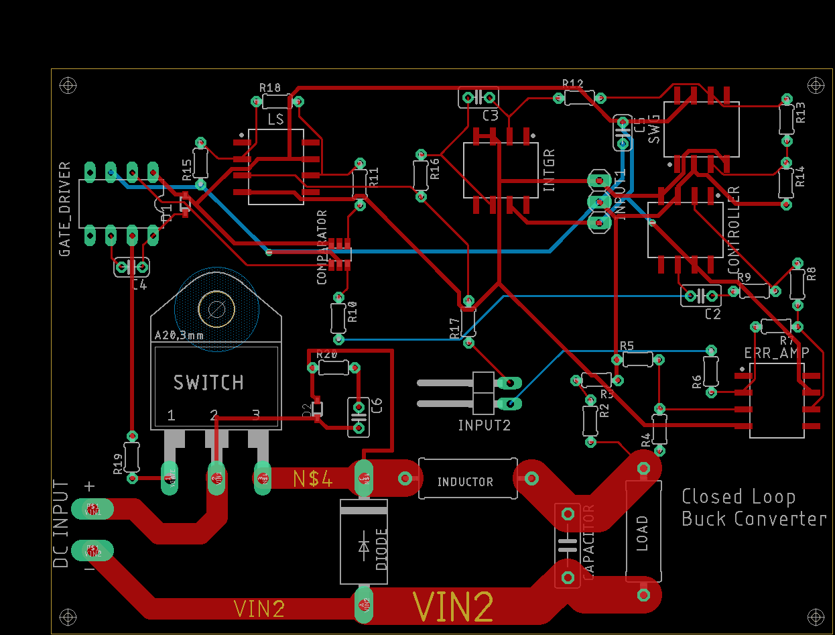

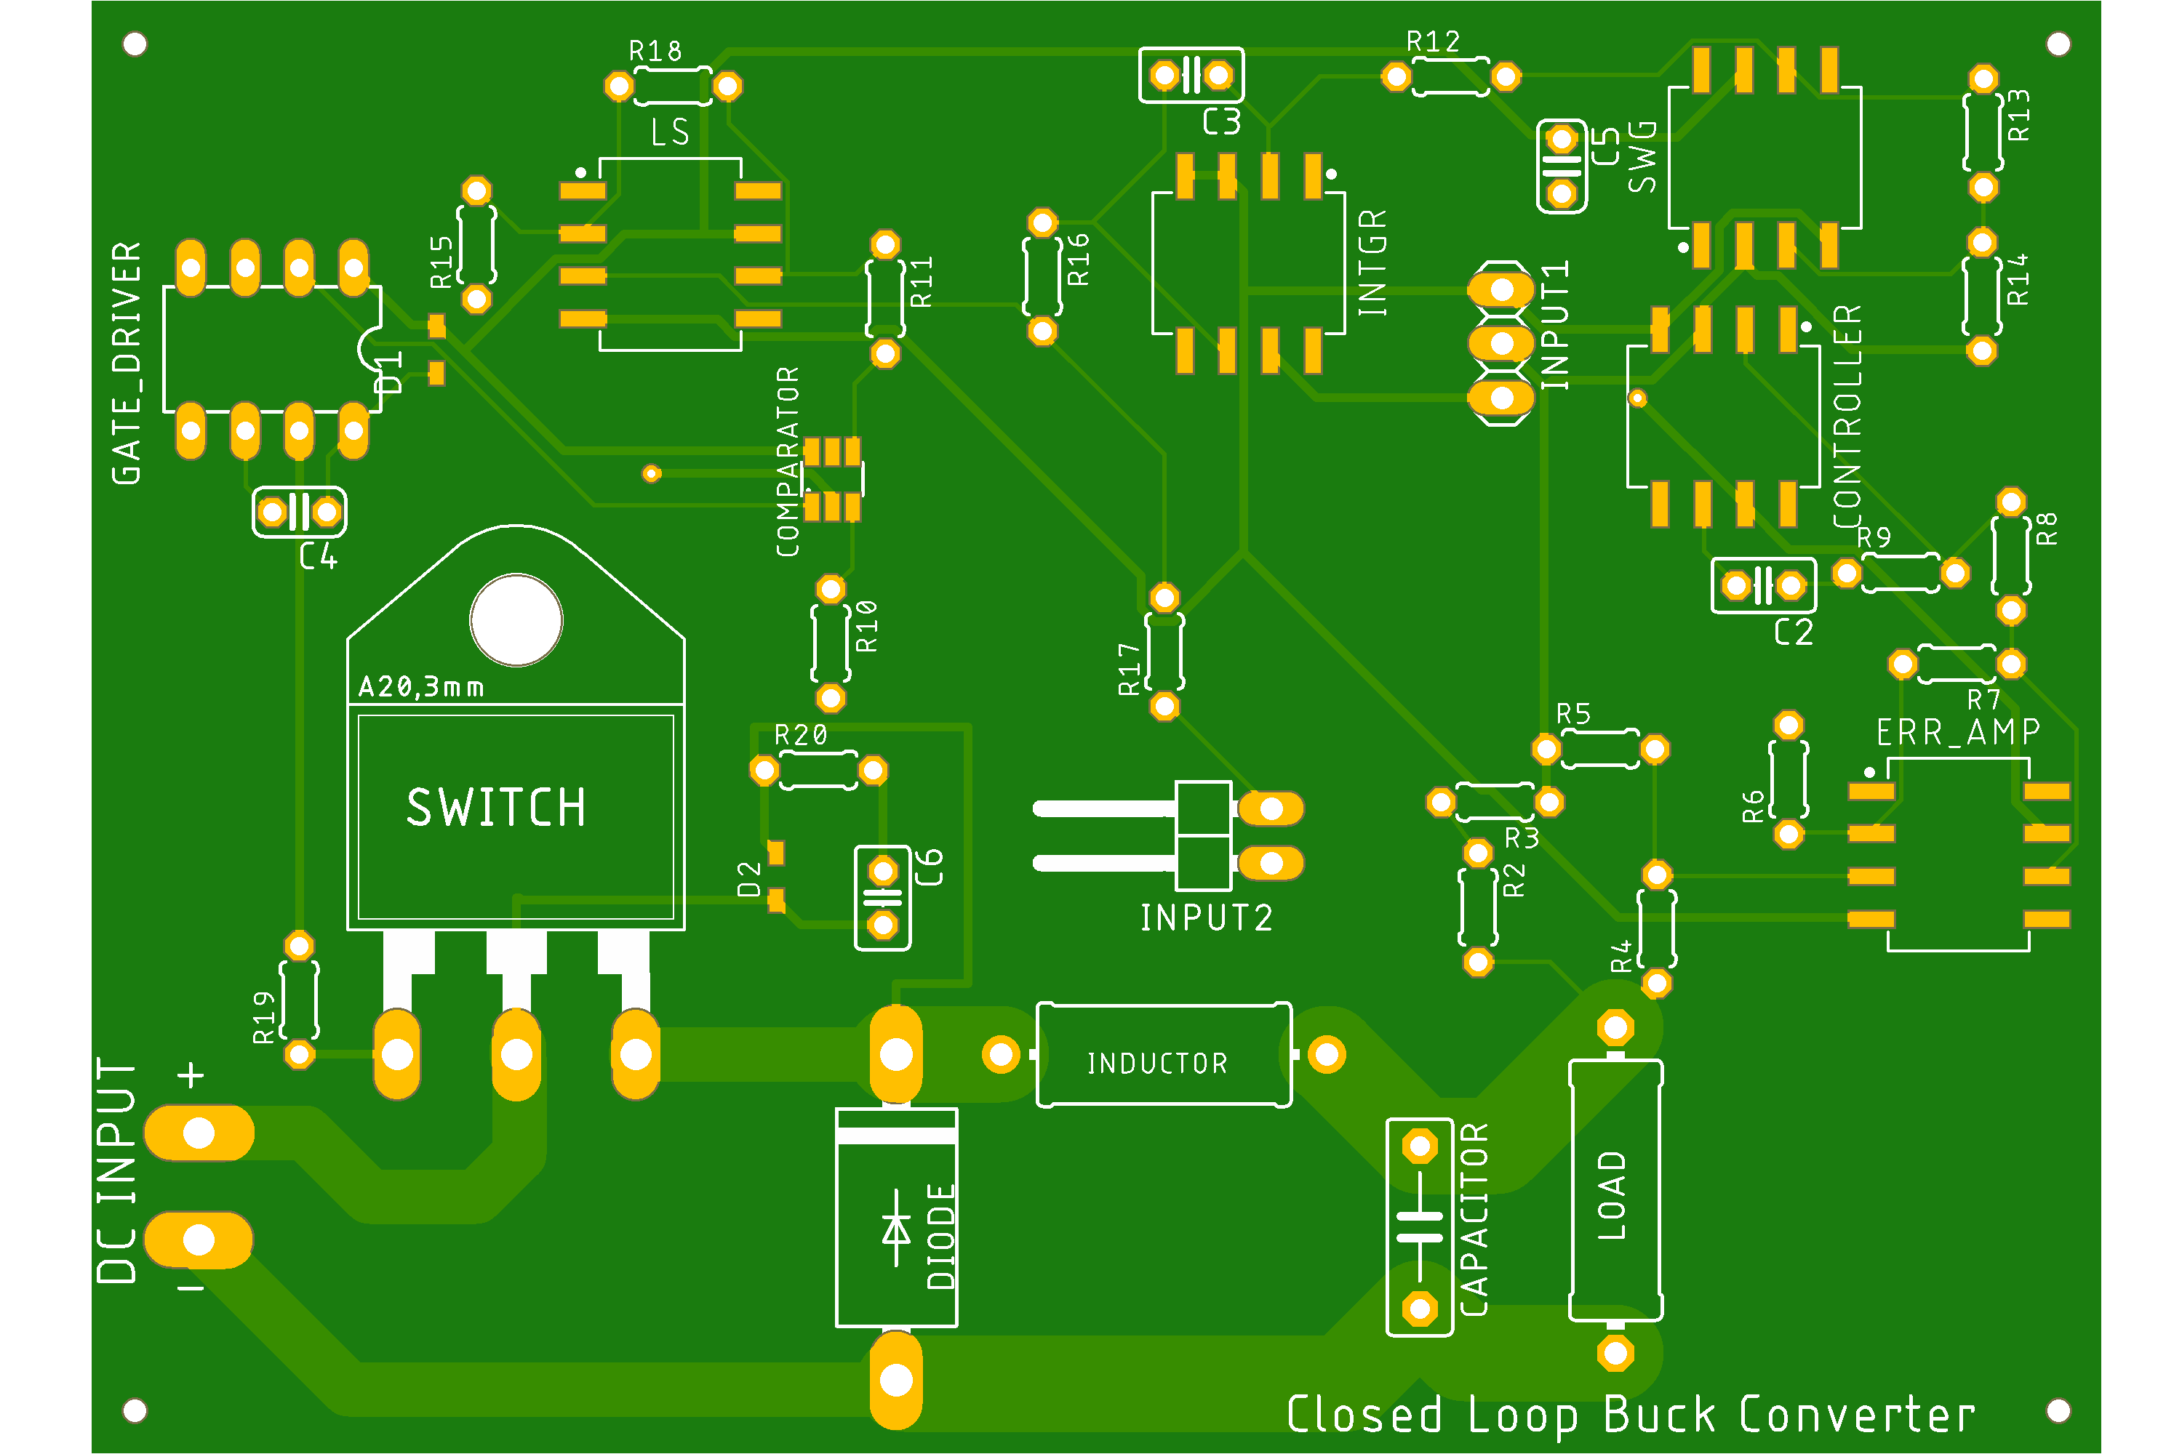

Figure 6: PCB top view

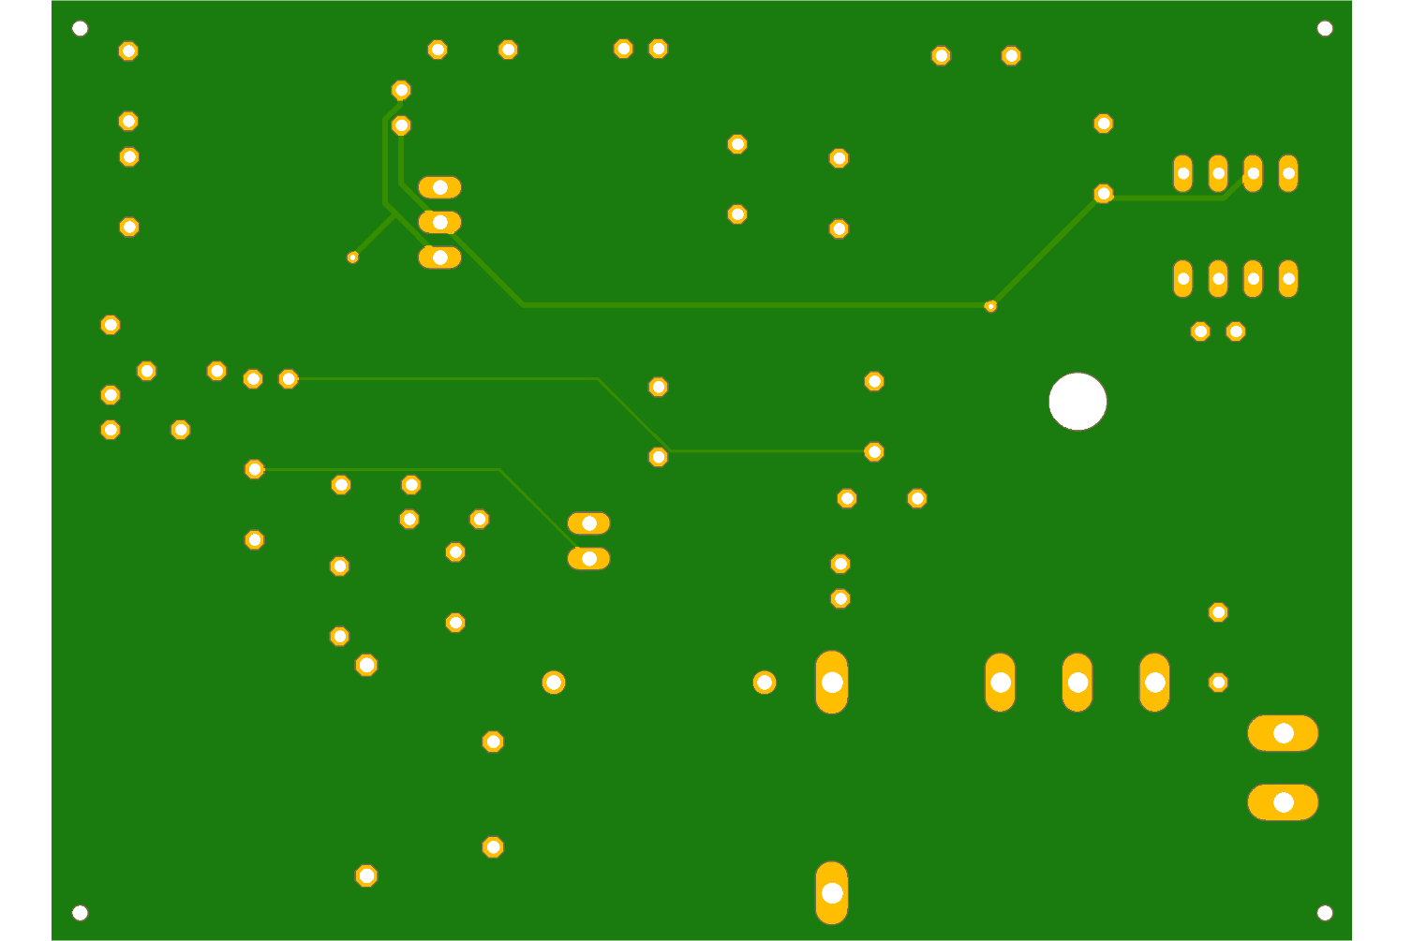

Figure 7:PCB bottom view

**Gerber** **files**:

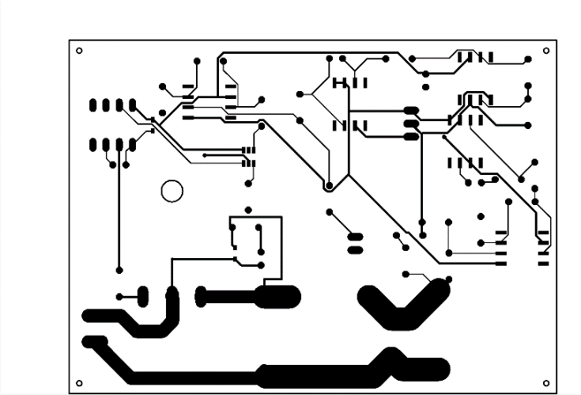

Figure 8: Top copper layer

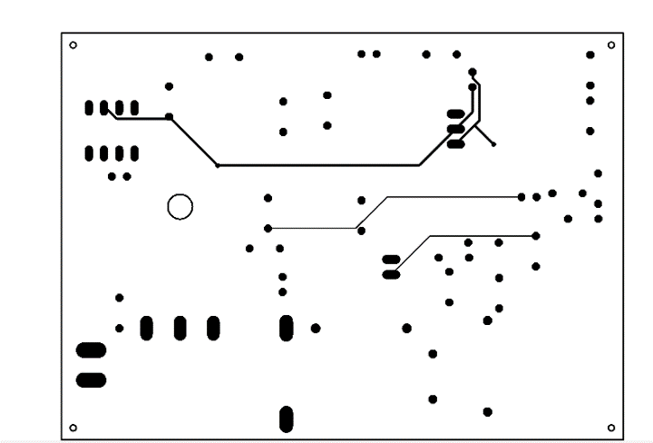

Figure 9: Bottom copper layer