**Wind Energy Visualization in Europe (2015–2024)**

# **Final Documentation**

# Author: Akezhan Yergali 57320 Date: July 2025 Course: Information Visualization

## **0. Abstract**

This project explores the development of wind energy in European countries from 2015 to 2024 through an interactive web-based visualization. The aim is to present complex, multivariate, and time-based data in a clear and engaging format using modern web technologies. The project addresses three core hypotheses related to country-level progress, historical trends, and future investments in wind power. By integrating geospatial maps, interactive charts, and forecast diagrams, the project demonstrates how information visualization can make renewable energy data more accessible for analysis, education, and policy evaluation. The final prototype is structured as a one-page responsive web application, developed independently and backed by reliable data from trusted energy reports and international databases.

## **1. Introduction and Motivation**

Wind energy has become one of the most crucial components in Europe’s transition to renewable energy. As climate change continues to pose significant threats, European countries are intensifying their investment in sustainable power sources. Wind energy, in particular, has shown consistent growth and innovation across both onshore and offshore sectors.  
  
 This project focuses on visualizing the development of wind power across Europe between 2015 and 2024, aiming to uncover patterns, progress, and investment strategies.  
  
 Several factors inspired the selection of this topic:  
 - Environmental Urgency: Wind energy directly contributes to reducing carbon emissions and dependence on fossil fuels.  
 - Relevance to Policy and Society: Governments and organizations need tools to assess the real impact of energy policies. Visualization can provide quick insights into national performance and progress.  
 - Data Richness and Complexity: Wind energy data includes multiple variables (e.g., turbine count, energy output, revenue), enabling advanced multivariate visual analysis.  
 - Public Communication: A clear and interactive presentation helps inform not only experts but also the general public and students.  
  
 Main Question:  
 How effectively has wind energy developed in European countries over the last 10 years?  
  
 To answer this question, the project explores three hypotheses:  
 1. Leadership & Distribution: Which countries lead in wind turbine numbers, energy production, and financial returns?  
 2. Trends Over Time: How has wind energy infrastructure and output evolved between 2015 and 2024?  
 3. Future Outlook: What are the investment prospects and strategic plans for wind energy up to 2030?

## **2. Data Sources and Preparation**

The data for this project was gathered from a variety of reputable international energy organizations, scientific reports, and public statistical databases. The primary sources include:  
  
 - WindEurope Statistics 2024  
 - IEA – Global Energy Review 2025  
 - Ember – Global Electricity Review 2024  
 - EUROSTAT – statistical data on energy and environment  
 - IRENA – International Renewable Energy Agency  
 - JRC EMHIRES – European wind resource datasets  
 - Wikipedia (cross-checked for consistency and used for general attributes)  
 - See the attached document Used References.pdf for full source list and links.  
  
 Data Types:  
 The dataset consists of both quantitative and qualitative attributes:  
 - Quantitative:  
 - Total number of wind turbines  
 - Energy production in TWh  
 - Installed capacity in MW  
 - Wind energy revenue in €  
 - Energy exports (GWh)  
 - Average wind speed (m/s)  
 - Qualitative:  
 - Country  
 - Zone classification (Baltic, North Sea, Atlantic, Mediterranean)  
 - Turbine type (onshore/offshore)  
 - Year (2015–2024)

Data Preparation Process:  
 The raw data came from PDFs, online reports, and CSV/Excel files. The following steps were taken to ensure consistency and usability:  
 - Extraction: Data was manually extracted or converted to tabular formats.  
 - Cleaning: Incomplete or inconsistent entries were corrected or removed.  
 - Transformation: Data was restructured into JavaScript arrays.  
 - Alignment: Time-series values were manually synchronized year by year.  
 - Enrichment: Each dataset was enhanced with multiple metrics per country.  
  
 Usage in the Application:  
 The structured data supports:  
 - Geospatial visualization (Leaflet.js)  
 - Time-series trends (Plotly.js)  
 - Multivariate comparisons (parallel coordinates)  
 - Investment projections (Chart.js and pyramid diagram)

## **3. Concept**

The main goal of this project was to build an interactive one-page web application that clearly communicates the development of wind energy across Europe from multiple perspectives. The design is structured around three research hypotheses and aims to deliver meaningful insights to both experts and the general public.

Visualization Types (based on InfoVis taxonomy):

- Geospatial visualization: Leaflet map with clickable regions.

- Temporal visualization: Time-series showing wind energy growth from 2015 to 2024.

- Multivariate visualization: Parallel coordinates for comparing multiple metrics.

- Categorical visualization: Pie/Bar charts for investment and revenue.

- Forecast visualization: Investment pyramid for 2030 projections.

Visual Style & Moodboard:

- Colors: green, blue, yellow (eco and energy-inspired)

- Typography: simple and readable

- Icons: minimalist and intuitive

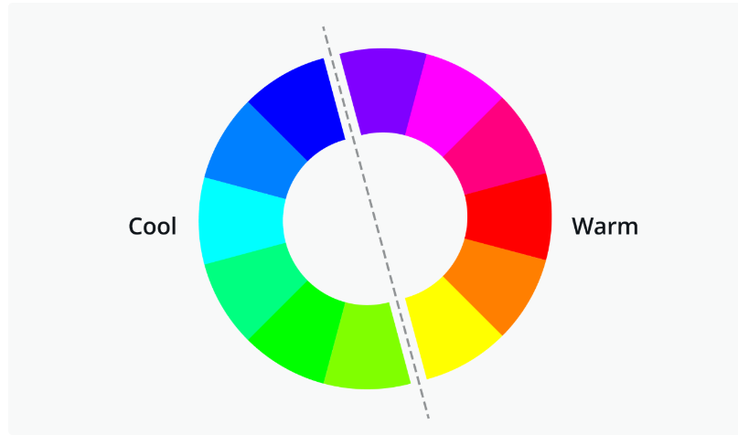

Storyboard:

The one-page app includes:

1. Header

2. Map section

3. Statistics section

4. Investment section

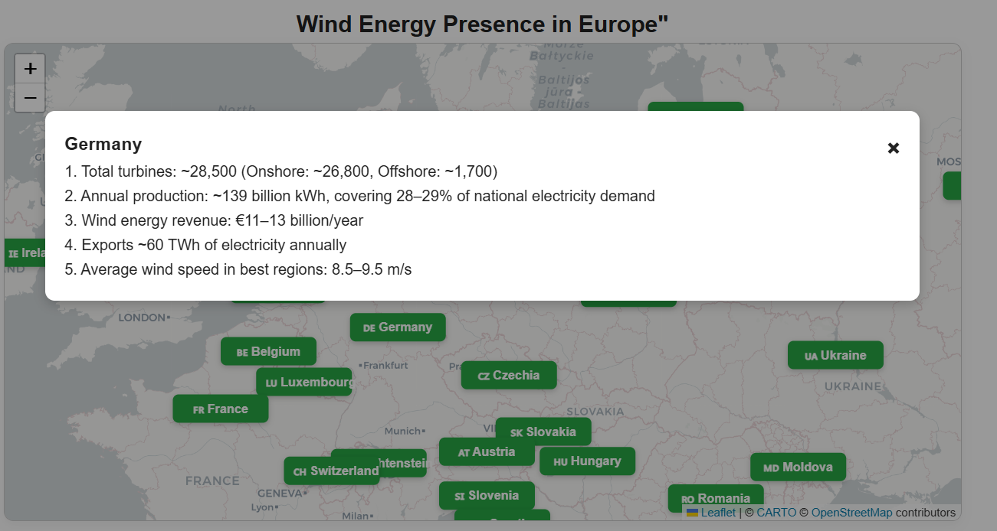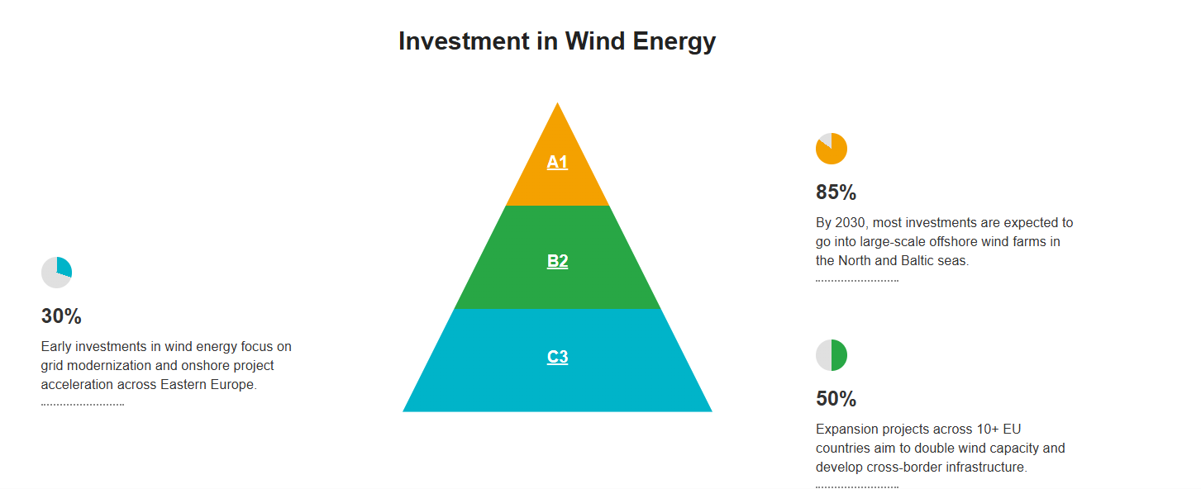

## **4. Implementation**

The web application was developed using modern front-end technologies:

- HTML5 and CSS3: for structure, layout, and responsive styling

- JavaScript : for dynamic behavior, event handling, and data manipulation

- Leaflet.js: for interactive geospatial visualization of Europe with clickable zones

- Plotly.js: for advanced charts, including time-series and parallel coordinates

- Chart.js: for categorical data like investment and revenue share (pie/bar charts)

- Netlify: for deployment and versioned web hosting

Each library was chosen for its performance, flexibility, and open-source accessibility.

Application Structure:

The application is structured as a single-page responsive website, divided into logical sections:

1. Interactive Map (Leaflet): displays European wind zones and modal pop-ups with data

2. Country Statistics: time-based charts and metric filters

3. Multivariate Analysis (Plotly): parallel coordinates for complex comparisons

4. Investment Section: pie chart and pyramid for forecasting

Features:

- Clickable zones on the map

- Modals with per-country energy statistics

- Filterable and dynamic charts

- Year slider for data range selection

- Investment pyramid for 2030 goals

Code Organization:

- JavaScript modules handle separate visualizations

- Arrays hold structured data

- Functions manage DOM updates and transitions

- Codebase deployed via Netlify and packaged in a zip archive

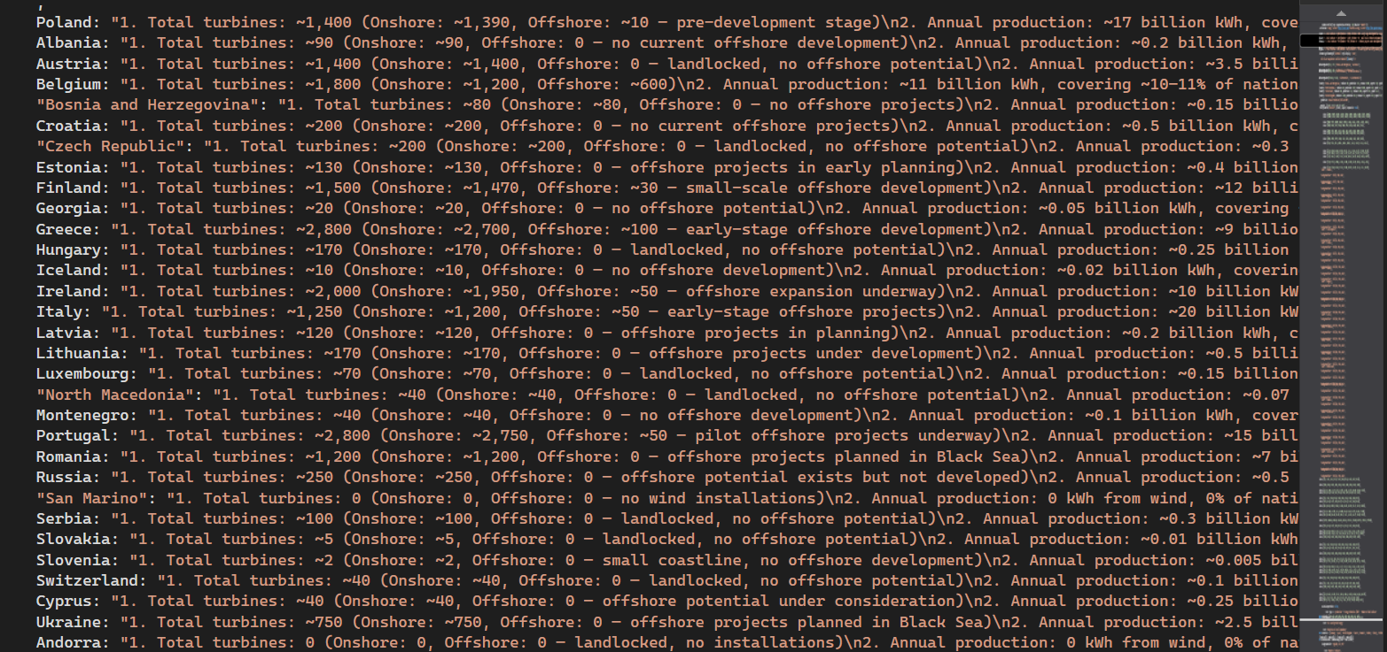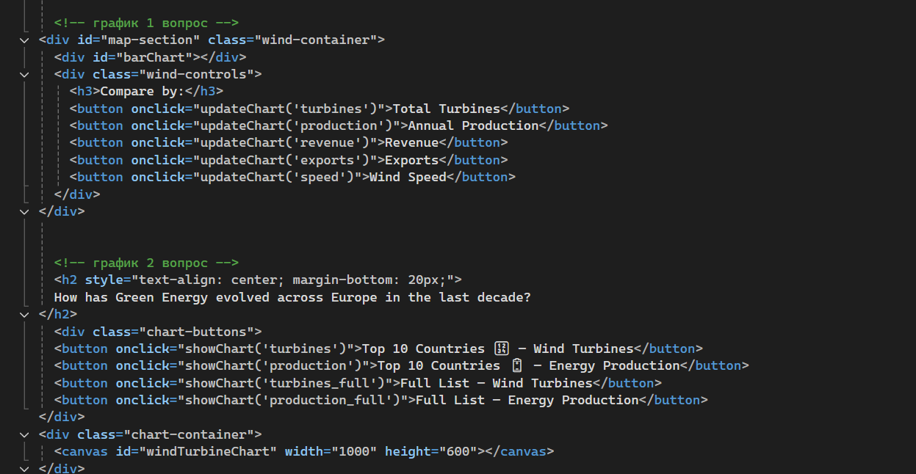

## **5. Conclusion and Future Work**

This project successfully visualized the development of wind energy across Europe from 2015 to 2024. It enabled users to explore trends, compare country-level performance, and understand regional strategies.  
  
 The three hypotheses were clearly addressed:  
 1. Countries like Germany, the UK, and Spain lead the wind energy transition.  
 2. Time-series showed growth trajectories and shifts in national energy portfolios.  
 3. Visual forecasts highlight development goals and financial trends toward 2030.  
  
 Future Work:  
 - Live data via API integration  
 - Regional (subnational) layers  
 - Forecast models using machine learning  
 - Accessibility improvements and multilingual support  
 - Overlay policy datasets and climate goals  
  
 This visualization lays the foundation for broader public engagement and research into renewable energy.

## **6. Personal Reflections**

This project was a rewarding and challenging experience. I worked independently on every stage: data collection, design, implementation, and documentation.  
  
 What I Learned:  
 - Technical: Improved JavaScript, responsive design, and library integration  
 - Analytical: Enhanced data handling and visualization thinking  
 - Design: Practiced user-focused design with accessibility in mind  
 - Project Management: Learned to plan, prioritize, and deliver independently

Final Thoughts:  
 This project combined my interests in data, sustainability, and web development. It showed me the importance of effective storytelling through data visualization. I am proud of the final result and hope to build on this foundation in future academic and personal projects.

**References (APA Style)**  
  
Reports and Statistical Sources:

International Energy Agency. (2025). *Global Energy Review 2025*.<https://www.iea.org/reports/global-energy-review-2025> (Accessed: July, 2025)

Ember Climate. (2024). *Global Electricity Review 2024*. https://ember-climate.org/insights/research/global-electricity-review-2024/ (Accessed: July, 2025)

WindEurope. (2024). *Wind energy in Europe: 2023 Statistics and 2024–2030 Outlook*. https://windeurope.org/intelligence-platform/statistics/ (Accessed: July, 2025)

European Wind Energy Association. (2015). *Wind in power: 2015 European statistics*. https://www.ewea.org/fileadmin/files/library/publications/statistics/EWEA-Annual-Statistics-2015.pdf (Accessed: July, 2025)

Clean Energy Wire. (2023). *German Onshore Wind Power – Output, Business, and Perspectives*. https://www.cleanenergywire.org/factsheets/german-onshore-wind-power-output-business-and-perspectives (Accessed: July, 2025)

ETIPWind. (2022). *Strategic Research and Innovation Agenda: Clean energy transition*. https://etipwind.eu/publications/ (Accessed: July, 2025)

EUROSTAT. (2024). *Energy statistics*. https://ec.europa.eu/eurostat/web/energy/data/database (Accessed: July, 2025)

IRENA – International Renewable Energy Agency. (2023). *Renewable capacity statistics*. https://www.irena.org/Statistics (Accessed: July, 2025)

JRC EMHIRES. (2023). *Wind and Solar Energy Resource Dataset*. https://data.jrc.ec.europa.eu/collection/id-0023 (Accessed: July, 2025)

Additional Sources Referenced in Data Preparation folder.