**Wind Energy Visualization in Europe (2015–2024)**

# **Interactive Website Overview**

Author**:** Akezhan Yergali 57320

Date**:** July 2025

Course: Information Visualization

**0**. **Introduction Section**

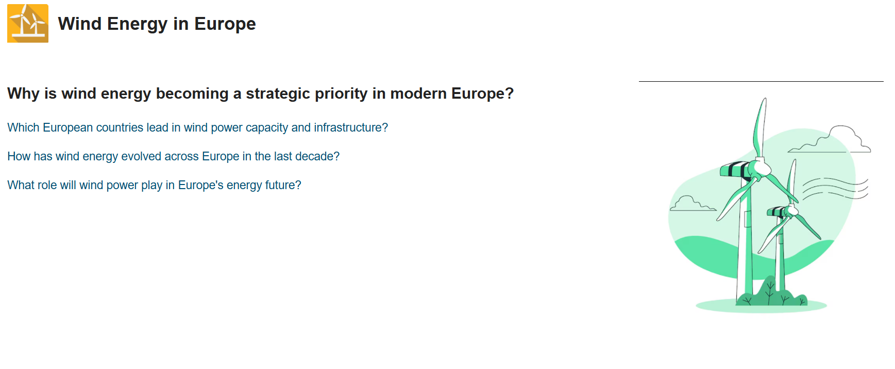

**Description:** This is the opening section of the website. It introduces the key questions the project aims to explore, such as:

* Which European countries lead in wind power capacity and infrastructure?
* How has wind energy evolved across Europe in the last decade?
* What role will wind power play in Europe's energy future?

**Purpose:**

This section sets the stage for the entire application. It frames the motivation and invites the user to explore the interactive elements below. It aligns directly with the project’s hypotheses and narrative structure.

1. **Interactive Map: Wind Energy Presence in Europe**

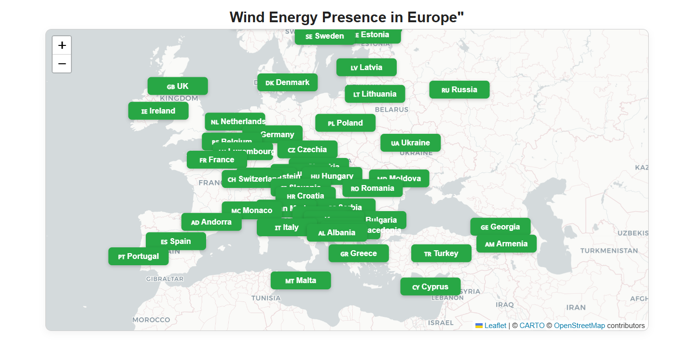

**Description:** This map visualizes the presence of wind energy infrastructure across European countries. Each country is represented with a clickable label that opens a modal window containing key data:

* Total number of wind turbines
* Onshore and offshore capacity
* Annual production and revenue
* Export volume and average wind speed

**Technology:** Implemented using Leaflet.js, which enables fast, interactive and mobile-friendly geospatial rendering.

**Purpose:** This serves as the core navigation interface for the entire visualization. It gives users a bird’s-eye view of Europe’s wind power landscape and allows for focused exploration of each country. The layout reflects both political borders and regional clustering

2. **Comparative Bar Chart: Wind Energy Metrics**

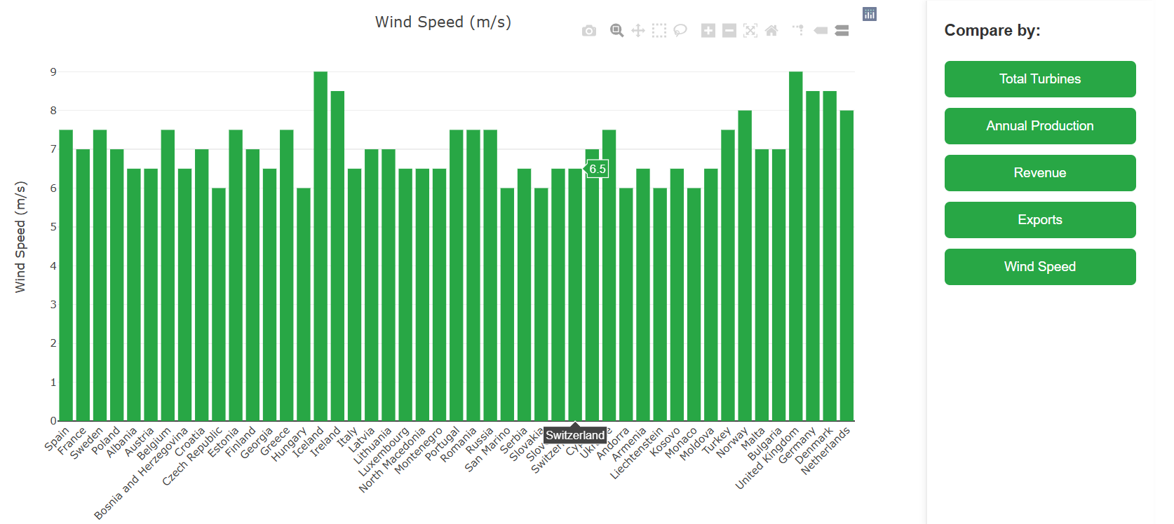

**Description:** This interactive bar chart allows users to compare wind energy indicators across more than 40 European countries.  
 The following parameters can be selected via buttons on the right side:

* Total Turbines
* Annual Production
* Revenue
* Exports
* Average Wind Speed

All data is dynamically sourced from the map modal pop-ups, ensuring consistency across sections. Hovering shows exact values, and users can download the chart as an image directly from the toolbar.

**Technology:**

Built with Plotly.js, this chart supports responsive design, animations, and export functionality.

**Purpose:** This section allows direct country-by-country comparison based on user-selected criteria. It helps identify leaders and outliers in the European wind energy landscape with a clean and visual overview.

**3.Parallel coordinates chart: How has green energy evolved across Europe in the last decade?**

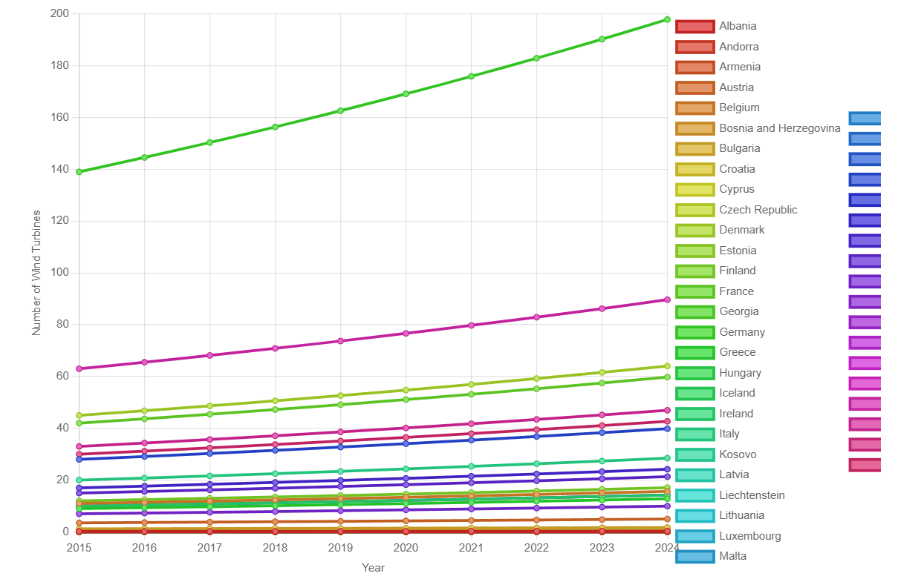

**Description:** This section visualizes the growth of wind energy across Europe from 2015 to 2024. Two interactive line charts display:

* Number of Wind Turbines
* Annual Energy Production

Users can switch views between:

* Top 10 Countries for each metric
* Full list of 47 European countries for comprehensive comparison

The dynamic color-coded legend on the right allows easy identification of each country. Charts can be downloaded directly for use in reports and presentations.

**Technology:** Built with Plotly.js, featuring smooth animations, responsive layout, and timeline control.

**Purpose:** This visualization answers the key question:  
 “How has green energy evolved across Europe in the last decade?”

It helps users:

* Analyze growth trends across regions
* Identify consistent leaders (e.g., Germany, Denmark, Spain)
* Monitor progress in emerging markets
* Understand the effectiveness of policies and investments in renewable energy

**4. Comparative Bar Chart: CO₂ Savings and Fossil Dependency Reduction**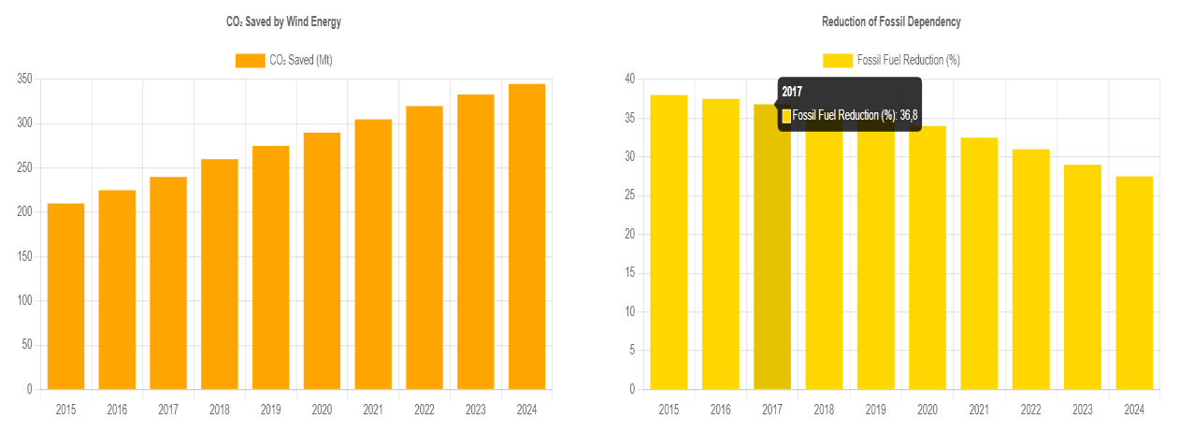

**Description:** This section presents two key environmental indicators that highlight the impact of wind energy expansion in Europe:

* CO₂ Saved by Wind Energy (in Megatonnes)  
   Year-over-year increase in carbon dioxide emissions avoided due to wind energy replacing fossil fuels.
* Reduction of Fossil Fuel Dependency (%)
* The decline in the share of coal, oil, and gas in the energy mix, thanks to the rise of wind power.

**Insight:** Wind energy plays a crucial role in Europe's climate strategy by:

* Preventing over 330 million tons of CO₂ emissions in 2024 alone
* Gradually lowering fossil fuel usage from ~38% in 2015 to under 28% in 2024
* Supporting national and EU-wide decarbonization goals and energy security

**Technology:**  
 Built with Chart.js, both bar charts are fully responsive, styled for clarity, and provide tooltips on hover for precise values.

**Purpose:** This section demonstrates the long-term environmental benefits of investing in wind energy — not only for economic growth but also for climate responsibility. It underlines the importance of scaling up renewables to meet the European Green Deal and net-zero targets.

**5.Dual Bar Chart: Wind Energy Growth in Europe by 2030**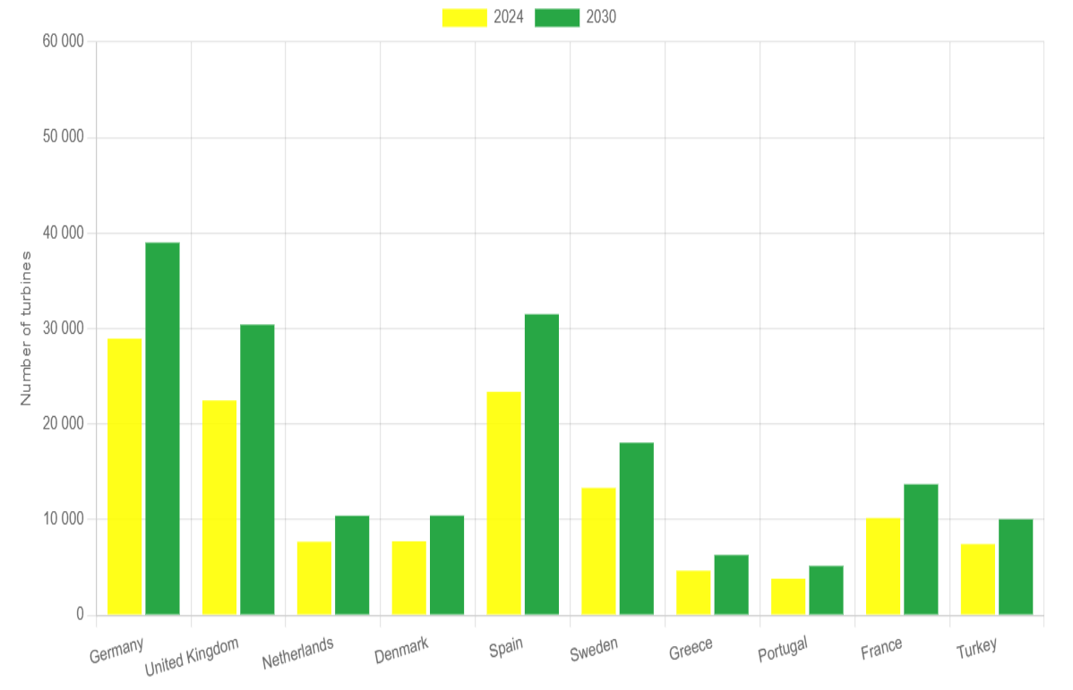

**Description:** This animated bar chart forecasts the growth of wind turbines in the top 10 European countries by 2030. The chart transitions dynamically, rotating through country rankings like a carousel to emphasize evolving leadership in turbine installation.

* Yellow bars: Current number of wind turbines in 2024
* Green bars: Projected number of turbines by 2030

**Key Highlights:**

* Germany and Spain are projected to remain top leaders in turbine count
* United Kingdom and Netherlands will see significant expansion
* Sweden and France are catching up, reflecting growing investment

**Technology:** Built using Chart.js with animation plugins, the chart supports smooth transitions and visually communicates growth trends.

**Purpose:** This section illustrates the ambitious national goals for scaling up wind infrastructure by 2030, in alignment with the EU's renewable energy targets. It allows stakeholders to anticipate regional changes and prioritize investments.

**5. Investment Pyramid: Investment in Wind Energy**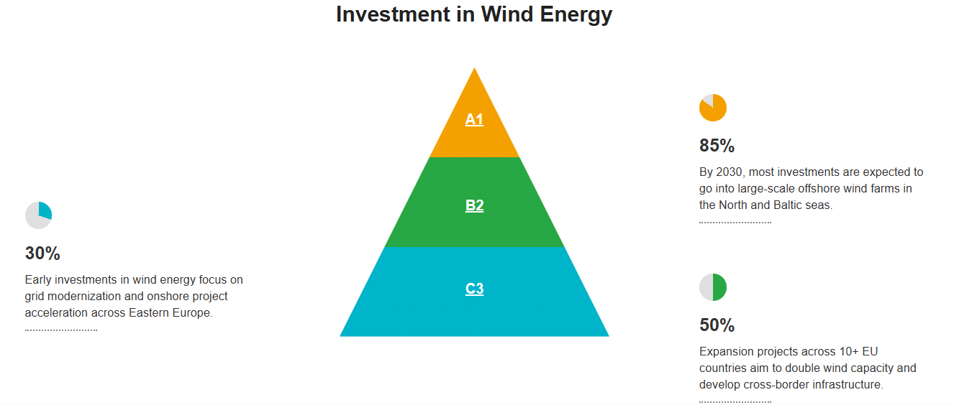

**Description:** This pyramid chart presents the projected distribution of wind energy investments in Europe toward 2030. It is divided into three tiers — A1, B2, and C3 — each highlighting a specific funding priority. Each tier is interactive: clicking on it opens a relevant external resource that provides deeper context and insights into the corresponding investment strategy.

**Tiers Overview:**

* A1 (85%) — Future investments primarily directed to large-scale offshore wind farms in the North and Baltic seas.
* B2 (50%) — Mid-term investments targeting cross-border expansion projects and doubling wind capacity across 10+ EU countries.
* C3 (30%) — Initial investments focus on grid modernization and onshore wind project acceleration in Eastern Europe.

**Technology:** Custom-built static pyramid with linked tier elements. Designed using HTML, CSS, and JavaScript, with clickable navigation to detailed content.

**Purpose:** The pyramid helps illustrate investment priorities in a clear hierarchical format. It enables users to explore Europe’s phased financial approach to wind energy development by decade.