# **Technical Report: React Registration Component**

This report analyzes the provided React registration component code and outlines its functionality. Due to the limitations of Markdown in generating UML diagrams, the visual representation is omitted. A separate tool would be required for UML diagram generation.

1. Project Purpose:

The purpose of this React component is to provide a user interface for new user registration. It allows users to input their username, email, and password. Upon submission, it sends this data to a backend server (presumably for user account creation) via an HTTP POST request using `axios`. Successful registration redirects the user to a login page; otherwise, an error message is displayed.

2. Key Modules/Classes/Functions:

1. `Register` Component: This is the main functional component responsible for rendering the registration form and handling user interactions.

2. `useState` Hook: Used for managing component state, including:

`formData`: Stores the user's input (username, email, password).

`error`: Displays error messages from the server or during registration failure.

`videoSrc`: Manages the source of the background video.

`videoLoadFailed`: Tracks whether the background video loading failed.

3. `useNavigate` Hook: Enables navigation to the login page after successful registration.

4. `handleChange` Function: Updates the `formData` state whenever the user modifies any input field.

5. `handleSubmit` Function: Handles form submission. It sends a POST request to the backend server (`http://127.0.0.1:5000/register`), processes the response, and redirects or displays errors accordingly.

6. `axios` Library: Used for making HTTP requests to the backend server.

7. React Icons (`FaEnvelope`, `FaLock`, `FaTimes`, `FaUser`): These are used to provide visual cues within the form fields (email, password, close button, and username respectively).

3. Data Models/Entities:

The component interacts with a single data model implicitly defined by the backend API's expectation of the POST request. This model consists of at least the following fields:

`username` (String): The user's chosen username.

`email` (String): The user's email address.

`password` (String): The user's password.

The exact structure of the data model on the server side is not explicitly defined in the provided code but is inferred from the `formData` object used in the `handleSubmit` function. The server's response likely includes a `message` field indicating success or failure.

4. Technical Details:

The component uses a background video for visual appeal, with a fallback to a black background if the video fails to load. A dark overlay is applied for improved readability on top of the video/background. The form itself is styled using Tailwind CSS classes, providing a visually appealing and responsive user interface. Error handling is implemented to catch and display any issues during the registration process.

5. Conclusion:

This React component provides a functional and user-friendly registration form. Its reliance on external APIs (backend server) implies that thorough testing and integration with the backend service are necessary for successful operation. The use of React Hooks and modern JavaScript features contributes to a clean and maintainable codebase. Further documentation of the backend API and a more detailed UML diagram would enhance understanding.

## **Class_Diagram**

** Illustrates the classes, attributes, and methods of the system, including `Register` component and potential backend classes.

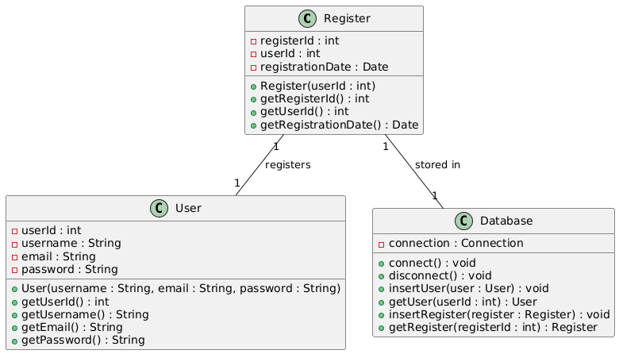

## **Sequence_Diagram**

** Shows the interactions between the `Register` component, the user, and the backend server during registration.

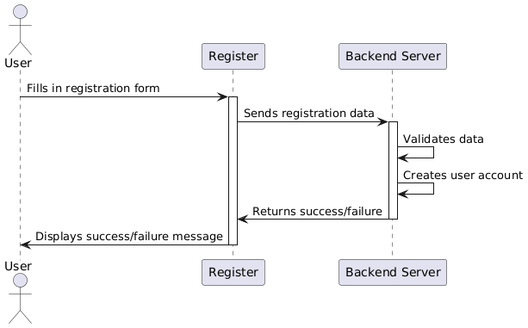

## **Use_Case_Diagram**

** Depicts the user interactions with the system (registering a new account).

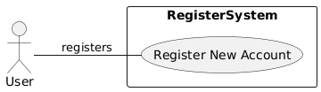

## **Activity_Diagram**

** Models the flow of actions within the `handleSubmit` function, including API calls and error handling.

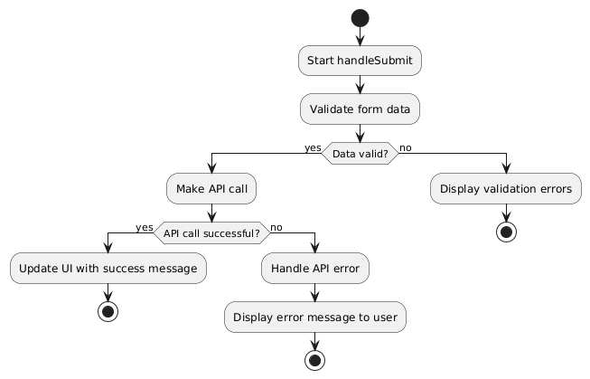

## **State_Machine_Diagram**

** Represents the different states of the `Register` component (e.g., loading, success, error) and transitions between them.

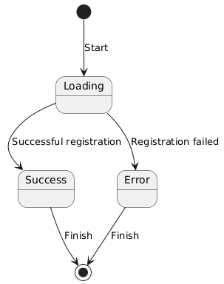

## **Component_Diagram**

** Shows the relationships between the React components involved (though simple in this case).

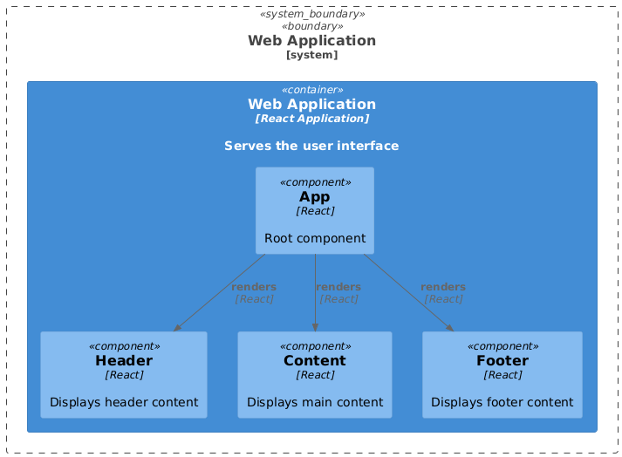

## **Data_Model_Diagram_Entity-Relationship_Diagram_-_ERD**

** Represents the structure of the data stored on the backend, likely including a `User` entity with attributes like `username`, `email`, and `password`.

