# **Technical Report: User Registration Component**

This report documents the React-based user registration component, including its purpose, key components, and data model. The component facilitates user registration by submitting data to a backend server.

1. Project Purpose:

The primary purpose of this component is to provide a user-friendly interface for new users to register on a platform. It handles user input validation, submission to a backend API endpoint (`http://127.0.0.1:5000/register`), and provides visual feedback to the user regarding the registration process (success or failure). It leverages React for the front-end and Axios for making API calls.

2. Key Modules, Classes, and Functions:

`Register` Component: This is the main React functional component responsible for rendering the registration form and handling user interactions.

`useState` Hook: Used to manage component state, including:

`formData`: An object storing the user's entered username, email, and password.

`error`: A string to display error messages from the server or during registration.

`videoSrc`: The URL of the background video.

`videoLoadFailed`: A boolean to manage fallback if the video fails to load.

`useNavigate` Hook: Used for redirecting the user to the login page after successful registration.

`handleChange` Function: Updates the `formData` state whenever the user modifies input fields.

`handleSubmit` Function (async): Handles form submission, sends registration data to the backend via an Axios POST request, and manages error handling. The function redirects to the `/login` route upon successful registration.

`axios` library: Handles HTTP requests to the backend server.

React Icons (`FaEnvelope`, `FaLock`, `FaTimes`, `FaUser`): Provides visual icons for enhanced user interface.

3. Data Models/Entities:

The component interacts with a single data model implicitly defined by the backend API:

User Registration Data: This data is represented by the `formData` object within the React component. It consists of the following fields:

`username` (String): User's chosen username.

`email` (String): User's email address.

`password` (String): User's password.

4. Technical Details and Considerations:

Error Handling: The component includes robust error handling using a `try...catch` block within the `handleSubmit` function. Error messages are displayed to the user, improving the user experience.

Background Video: The component uses a background video for an enhanced visual appeal, with a fallback to a black background if the video fails to load.

Styling: The component uses Tailwind CSS for styling, resulting in a visually appealing and responsive user interface.

Backend Integration: The component interacts with a backend API located at `http://127.0.0.1:5000/register`. This URL should be updated to reflect the production server address in a deployed environment.

5. Future Improvements:

Implement client-side input validation before submitting the data to the server.

Add password strength indicators and confirmation.

Integrate with a more robust authentication system, potentially using JWT for secure token management.

Improve accessibility by adding appropriate ARIA attributes.

This report provides a comprehensive overview of the React user registration component's architecture and functionality. Further details can be gleaned from examining the source code directly. UML diagrams would further enhance this documentation but are beyond the scope of this markdown report.

## **Class_Diagram**

** Shows the classes (e.g., `Register` component, User entity), their attributes, and methods.

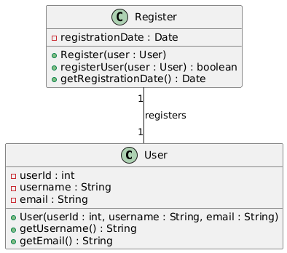

## **Component_Diagram**

** Illustrates the components of the React application and their relationships.

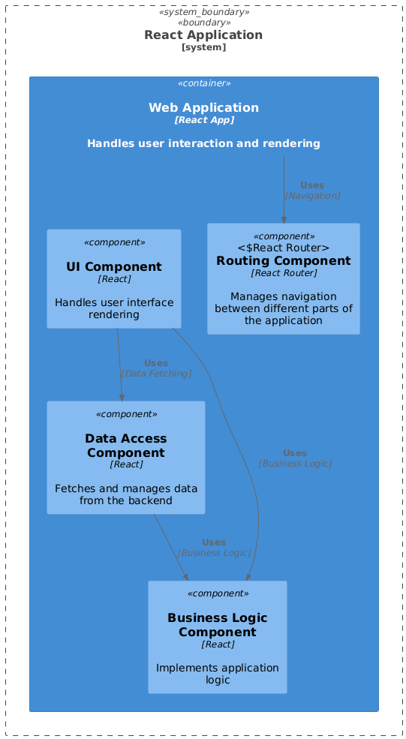

## **Sequence_Diagram**

** Depicts the interactions between the React component, the backend service, and the database during registration.

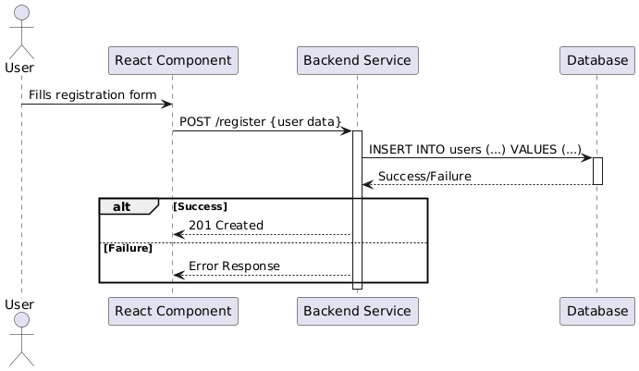

## **Activity_Diagram**

** Models the workflow of the registration process, including user interactions and system responses.

