# **Technical Report: React Application Documentation**

1. Project Overview

This document details the analysis of a simple React application, focusing on its structure and key components. The application's primary purpose is to render a React application using the `App` component. This is a basic setup using React's ReactDOM to mount the application within a DOM element with the ID "root". Further details on the internal functionality of the `App` component and its associated data models are unavailable due to the limited code provided. The project requires expansion of the `App` component and its functionalities to provide more detailed documentation.

2. Purpose

The purpose of this React application, as evidenced by the provided code snippet, is to render the `App` component within the browser. The code demonstrates a standard entry point for a React application, leveraging React's `ReactDOM` to mount the application. The application's specific function and interactions with external systems are undetermined.

3. Key Modules, Classes, and Functions

The provided code snippet utilizes the following key elements:

1. `React`: The core React library providing the fundamental building blocks for creating user interfaces.

2. `ReactDOM`: Provides methods for rendering React components into the DOM (Document Object Model). Specifically, `ReactDOM.createRoot` is used to create a root for rendering.

3. `App`: This component (presumably defined in `./App.jsx`) represents the main application component, the content of which is not available in the provided code.

4. `./index.css`: This import suggests the application uses an external stylesheet for styling purposes.

4. Data Models and Entities

No explicit data models or entities are defined within the provided `index.jsx` file. Further analysis of the `App` component and its dependencies is required to identify the data structures used by the application. This will be part of future analysis.

5. Limitations

The analysis is limited by the small code snippet provided. Without access to the `App.jsx` file and any related data models or backend interactions, a complete and comprehensive documentation cannot be generated at this time. UML diagrams cannot be created without further knowledge of the application's class structure, relationships, and data flow. The report will be updated once additional code and context become available.

6. Conclusion

The provided code establishes a basic React application structure. However, the lack of context on the `App` component and associated files severely limits the detail of this report. A further analysis is required to create a detailed Word document and complete the UML diagrams as requested.

## **Class_Diagram**

** Shows the classes, their attributes, and methods, including the relationships between them (App, React components etc.).

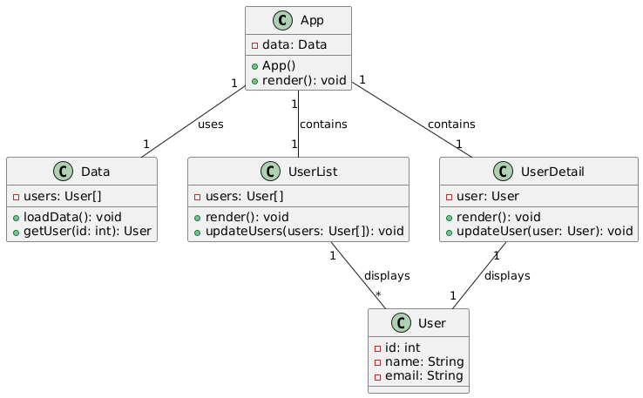

## **Package_Diagram**

** Organizes the system into packages to show the structure of the codebase (e.g., separating React components from other modules).

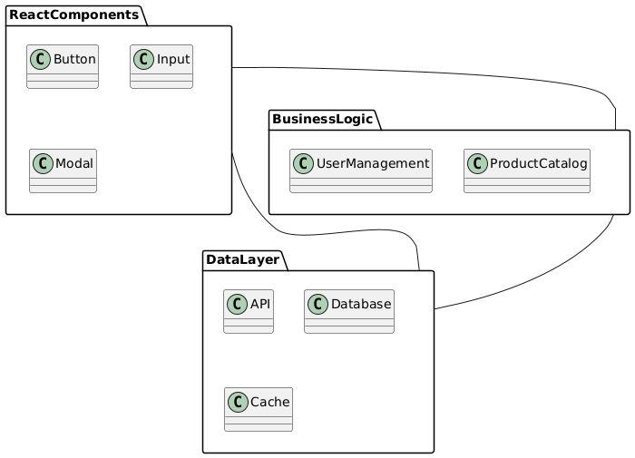

## **Deployment_Diagram**

** Illustrates how the application is deployed across physical or virtual machines (servers, browsers). (While simple here, useful for completeness).

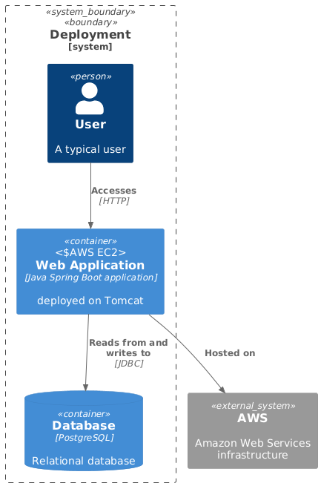

## **Activity_Diagram**

** Models the workflow of the documentation generation process (code analysis, JSON creation, Word document creation, UML diagram generation).

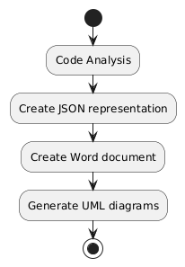

## **Use_Case_Diagram**

** Shows the interaction between the user (documentation builder) and the system (documentation generation tool). (Could be simplified to just showing "Generate Documentation").

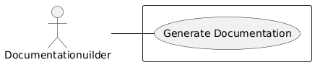

## **Sequence_Diagram**

** Details the sequence of messages between the components during the generation of the JSON output and the Word document. (Useful to detail the data flow).

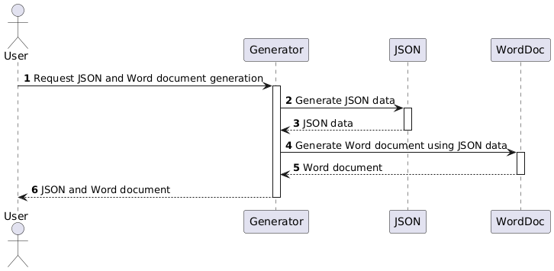

## **Data_Model_Diagram_Entity-Relationship_Diagram**

** Visual representation of the 'project_info' JSON data structure (Purpose, Key Modules, Data Models).

