# **Technical Report: User Registration Component**

This report documents the React-based user registration component, including its purpose, key modules, and data model. UML diagrams are not included as they are difficult to represent in Markdown effectively. A visual UML diagram would be more appropriate in a Word document.

1. Project Purpose:

The primary purpose of this component is to provide a user interface for new users to register on a platform. It handles user input validation, submission of registration data to a backend server (located at `http://127.0.0.1:5000/register`), and redirects the user upon successful registration. The component also incorporates visual enhancements such as a background video and stylistic elements for improved user experience.

2. Key Modules/Classes/Functions:

1. `Register` Component: This is the main React functional component responsible for rendering the registration form and handling user interactions.

2. `useState` Hook: Used to manage the component's state, including:

`formData`: An object storing the user's entered username, email, and password.

`error`: A string to display error messages.

`videoSrc`: The URL of the background video.

`videoLoadFailed`: A boolean flag indicating if the video failed to load.

3. `useNavigate` Hook: Facilitates navigation to the login page after successful registration.

4. `handleChange` Function: Updates the `formData` state whenever the user modifies input fields.

5. `handleSubmit` Function: Handles form submission. It uses `axios` to send a POST request to the backend registration endpoint and handles potential errors.

6. `axios` Library: Used for making HTTP requests to the backend server.

7. `react-icons/fa` Library: Provides Font Awesome icons (FaEnvelope, FaLock, FaTimes, FaUser) for enhanced visual appeal.

3. Data Models/Entities:

The primary data model is represented by the `formData` state object within the `Register` component. This object has the following structure:

```json

{

"username": "string",

"email": "string",

"password": "string"

}

```

This data is sent as a JSON payload to the backend during registration. The specific structure of the data model used by the backend server is not detailed in this component's code but can be inferred from the shape of the `formData` object.

4. Technology Stack:

React: The primary UI framework.

Axios: For handling HTTP requests.

React Router DOM: For navigation.

Font Awesome: For icons.

5. Error Handling:

The component includes basic error handling. If the registration request to the backend fails, it catches the error and displays an appropriate message to the user. It defaults to a generic "Registration failed" message if the error response from the server is not well-structured.

6. Further Development Considerations:

Backend Integration: This report focuses on the frontend component. Documentation of the backend API and its data models would enhance completeness.

Input Validation: While the form includes `required` attributes, more robust client-side input validation would improve user experience and security.

Security: Sensitive data (password) should be transmitted securely using HTTPS. Further security measures are recommended (e.g., input sanitization on the backend).

Accessibility: Consider implementing accessibility features (e.g., ARIA attributes) to improve usability for users with disabilities.

This report provides a technical overview of the React user registration component. A more comprehensive documentation, including detailed UML diagrams, would necessitate deeper analysis of the backend system and a consideration of more advanced error handling and security practices.

## **Class_Diagram**

** Illustrates the classes (e.g., `Register` component, User entity) and their attributes, methods, and relationships.

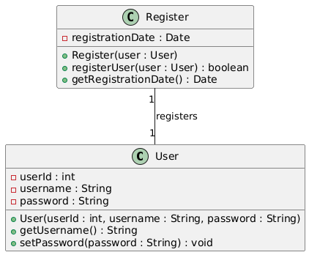

## **Component_Diagram**

** Shows the organization and dependencies between the React components (if any beyond the provided `Register` component). In this case, it might be minimal.

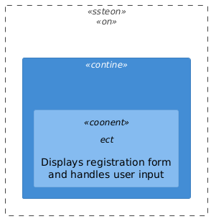

## **Sequence_Diagram**

** Depicts the interactions between the React component, the backend server (`http://127.0.0.1:5000/register`), and potentially a database during user registration.

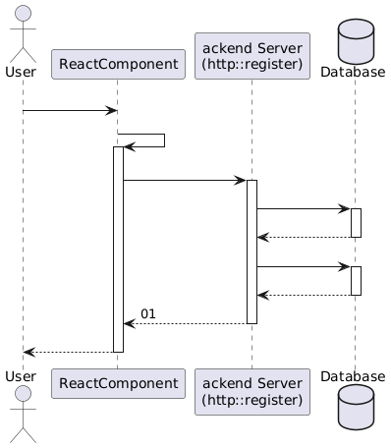

## **Activity_Diagram**

** Models the flow of actions and decisions involved in the registration process, including error handling.

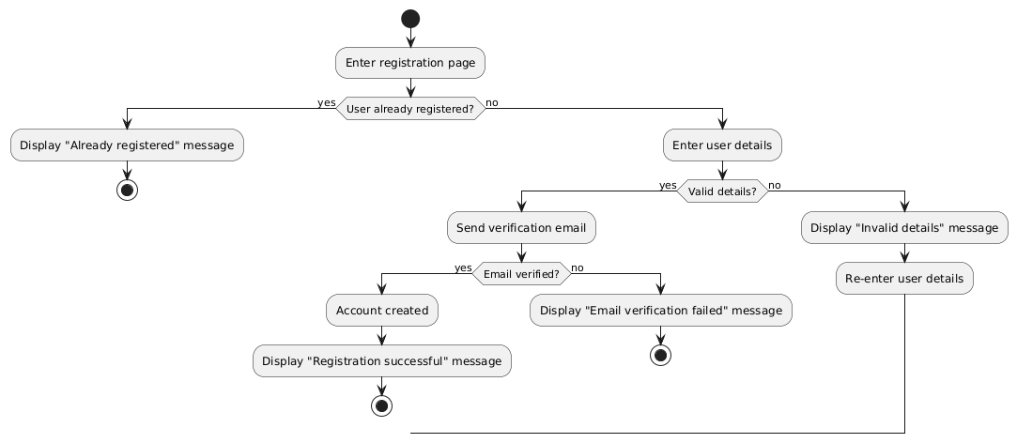

## **Use_Case_Diagram**

** Shows the interaction between the user and the system (registration process) with actors (User) and use cases (Register).

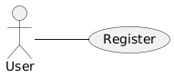

## **Data_Model_Diagram_Entity-Relationship_Diagram_-_ERD**

** Represents the structure of data stored in the backend database (assuming a database is used); specifically the User entity and its attributes.

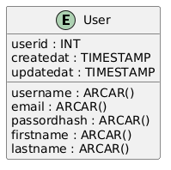

## **Deployment_Diagram**

** Illustrates the deployment of the application showing the React frontend, the Node.js backend server, and the database. (Simple illustration is sufficient in this case)

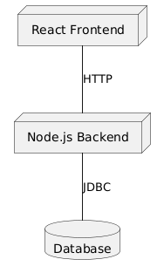

## **Note**

** A state machine diagram might also be useful if there are complex state transitions within the `Register` component, but it's not strictly necessary given the simplicity of the provided code. The component's state is primarily managed through `useState` hooks.

