# **Technical Report: React Application Documentation**

This report details the analysis of a simple React application and outlines a plan for generating comprehensive documentation, including a Word document and UML diagrams.

## **1. Project Overview**

1.1 Purpose: The primary purpose of this project is to build a React application. The provided `index.jsx` file serves as the application's entry point, rendering the main application component (`App`) within a React StrictMode. The application's specific functionality is not explicitly defined in the provided code snippet but inferred from the standard React application structure. Further analysis of the `App.jsx` component and associated files would be necessary to detail its functionality completely.

1.2 Key Modules/Classes/Functions:

1. `React`: The core React library, providing the fundamental building blocks for creating user interfaces.

2. `ReactDOM`: The React library module responsible for rendering React components into the DOM. Specifically, `ReactDOM.createRoot` is used to create a root for the application.

3. `App`: This is the main application component, imported from `./App.jsx`. Its internal structure and functionality are unknown without access to its source code.

4. `index.css`: This file likely contains the CSS styles for the application.

1.3 Data Models or Entities: No explicit data models or entities are defined in the provided `index.jsx` file. The data structures used within the application will depend entirely on the implementation within the `App` component and its sub-components. Further code analysis is required to identify these.

## **2. Documentation Plan**

The documentation will consist of two main parts:

2.1 Word Document: This document will provide a comprehensive overview of the application, including:

A description of the application's purpose and functionality.

Details on the key components, their interactions, and data flow.

Instructions for running and using the application.

Explanations of any significant design choices or considerations.

A description of the technologies used.

2.2 UML Diagrams: The following UML diagrams will be generated:

Class Diagram: This diagram will illustrate the classes (components) within the application, their attributes, and methods. This will require a deeper dive into the `App.jsx` and any child components.

Component Diagram: This will visually represent the composition of components within the React application, showcasing how different parts interact to achieve overall functionality. This is crucial for understanding the application's architecture.

Sequence Diagram(s): These will depict the interaction flow between components and show how data is exchanged. This diagram will depend heavily on the specific logic inside the components.

## **3. Next Steps**

To complete the documentation, the following actions are necessary:

1. Obtain the source code for `App.jsx` and any associated files.

2. Analyze the code to identify data models, key functions, and component interactions.

3. Develop the Word document based on the analysis and project requirements.

4. Create the UML diagrams using a suitable modeling tool, based on the identified classes and component interactions.

This report provides a preliminary analysis based on the limited code available. A more detailed and complete documentation will be generated once the additional information is obtained.

## **Class_Diagram**

** Shows the classes, their attributes, methods, and relationships (like inheritance and association) within the application.

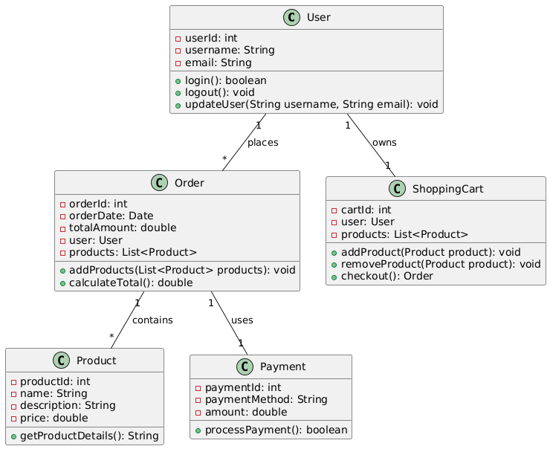

## **Component_Diagram**

** Illustrates the high-level components of the React application (e.g., App, individual components) and their dependencies.

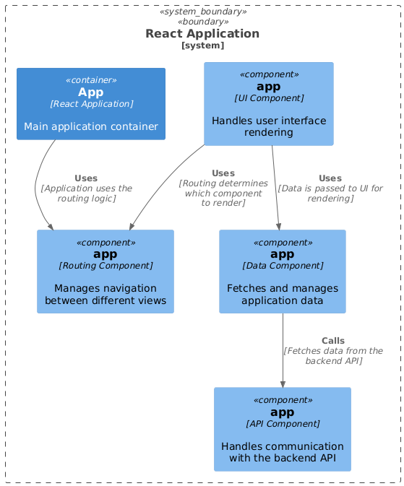

## **Package_Diagram**

** Organizes the system into packages to show structural relationships between different parts of the codebase (e.g., separating UI components from business logic).

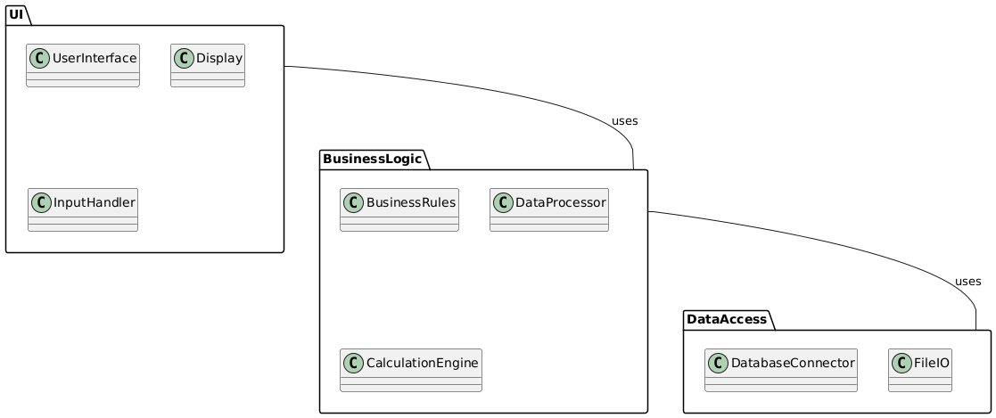

## **Deployment_Diagram**

** (Potentially useful, depending on scope) Depicts the physical deployment of the application (servers, databases, etc.). Less critical for a small React app.

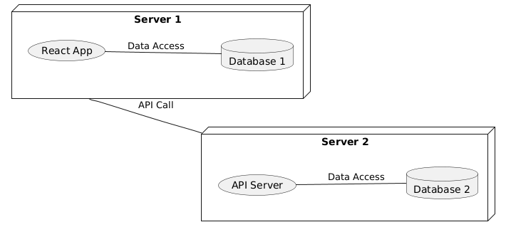

## **Sequence_Diagram**

** (Potentially useful, for specific interactions) Shows the sequence of interactions between objects/components during a specific use case. This would mostly apply to analyzing user interactions within the application.

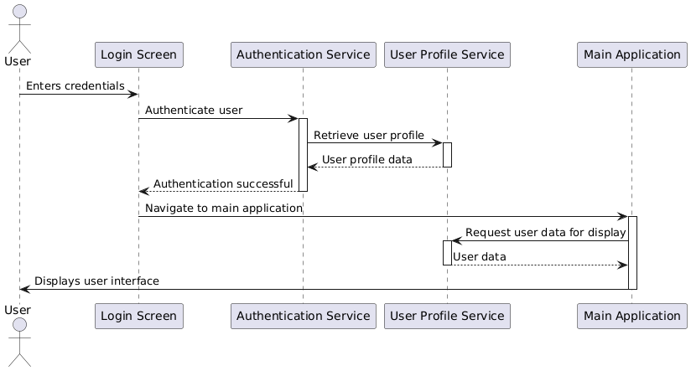

## **Activity_Diagram**

** (Potentially useful, for specific workflows) Visualizes the flow of control within a specific function or process, such as the documentation generation process itself.

