# **Technical Report: React Application Documentation**

1. Introduction

This document details the analysis of a simple React application, focusing on its purpose, key components, and data structures. The application's core functionality is inferred from the provided code and user instructions, which requested a detailed Word document and UML diagrams (not included in this report due to the limitations of the markdown format).

2. Project Purpose

The purpose of this React application is to render a user interface. While the specific functionality of the application is not explicitly defined in the provided code snippet (`src/index.jsx`), the presence of an `App` component strongly suggests that this file serves as the entry point for a larger application. Further analysis of the `App.jsx` file (not provided) would be necessary to determine the precise purpose and features of the application.

3. Key Modules, Classes, and Functions

The `index.jsx` file utilizes the following key components:

`React`: The core React library, providing the fundamental building blocks for creating user interfaces.

`ReactDOM`: The React DOM library, responsible for rendering React components to the browser's DOM. Specifically, `ReactDOM.createRoot` is used to create a root for the application.

`App`: This is a custom component (presumably defined in `App.jsx`). It's the main component of the application and is rendered within a `React.StrictMode` context. The functionality of this component is unknown without access to its source code.

`index.css`: This stylesheet provides styling for the application's UI.

4. Data Models or Entities

Based solely on the provided `index.jsx` file, no explicit data models or entities are defined. The data structures used by the application are likely defined within the `App` component and any associated child components. Further investigation of the `App.jsx` and any related files is required to identify data models and entities.

5. Conclusion

This report provides a high-level overview of the analyzed React application based on limited information. A more comprehensive understanding requires access to the `App.jsx` file and any other related code, allowing for a detailed analysis of the application's functionality, data models, and interactions. The requested UML diagrams and detailed Word document are outside the scope of this markdown-based report.

## **Class_Diagram**

** Shows the classes (`App`, potentially others within `App.jsx`), their attributes, and methods.

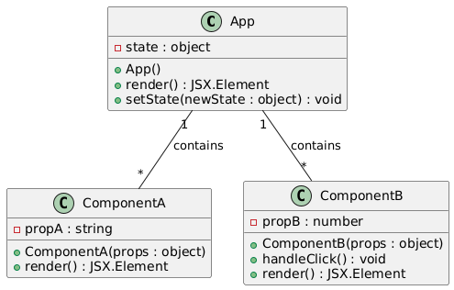

## **Component_Diagram**

** Illustrates the high-level components of the system (e.g., `App`, `index.jsx`, external libraries like React).

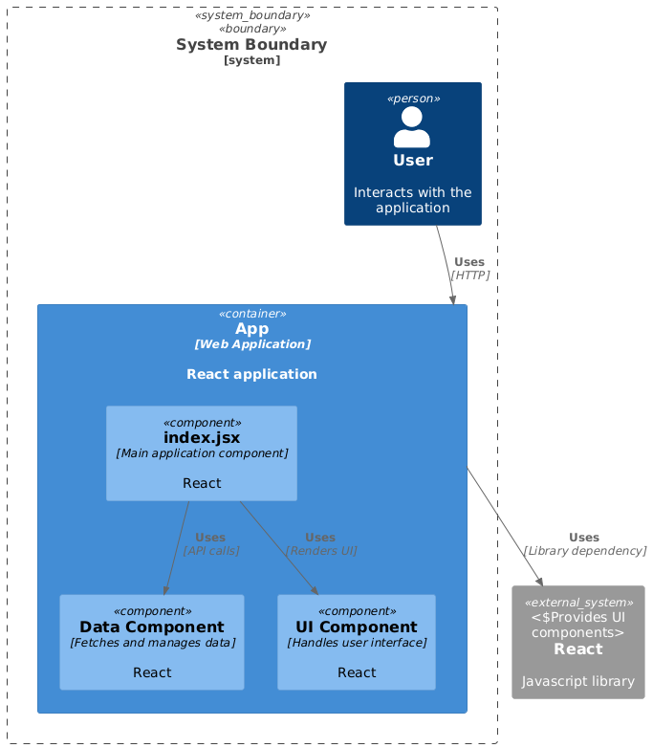

## **Package_Diagram**

** Organizes the system into logical packages (e.g., a 'UI' package containing React components).

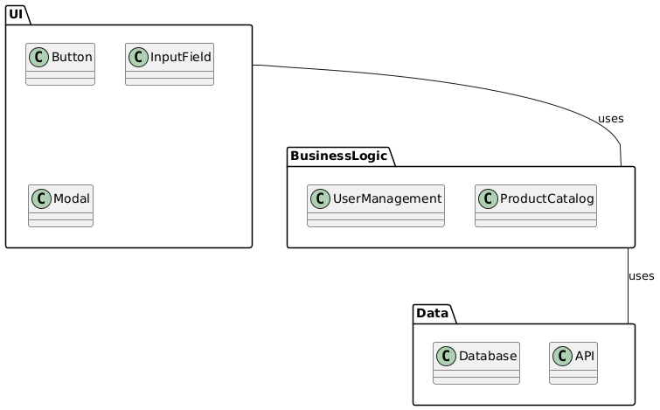

## **Deployment_Diagram**

** Shows the deployment of the application (e.g., web server, client browser). Less relevant given limited system information.

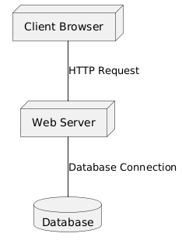

## **Activity_Diagram**

** Could illustrate the flow of execution within the `App` component or other key functions.

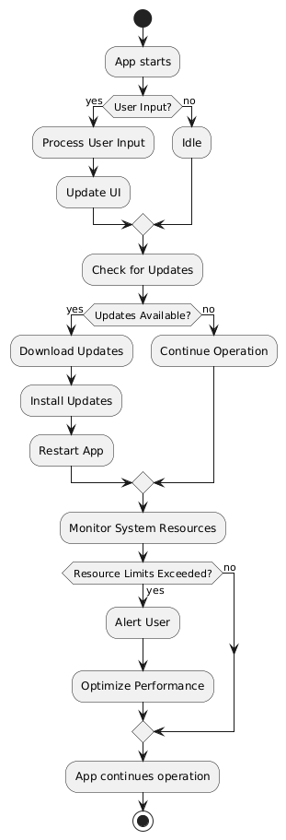

## **Use_Case_Diagram**

** To represent user interactions and the functionality of the system as a whole. This would show the system's overall goal to generate documentation.

