Technical Report

**Generate a detailed Word document and UML diagrams for this component**

Generated on: June 15, 2025

# Technical Report: React Application Documentation

1. Project Overview

This document details the analysis of a simple React application, focusing on its purpose, key components, and data models. The application's source code utilizes React's component model for rendering, and leverages standard React libraries for DOM manipulation and rendering. The project's primary purpose is to render a main application component, `App`, within a React Strict Mode environment. Further details regarding the `App` component's internal structure and functionality are not available within the provided code snippet. The lack of extensive code prevents a thorough UML diagram generation, but a high-level diagram is provided.

2. Purpose

The primary purpose of this React application is to render the `App` component, the contents of which are currently undefined in this analysis. This suggests a foundational structure for a larger application, or a minimal example demonstrating React's basic rendering capabilities.

3. Key Modules/Classes/Functions

The following key modules and functions are identified within the provided `index.jsx` source code:

`React`: The core React library, providing fundamental components and functionalities for building user interfaces.

`ReactDOM`: The library responsible for rendering React components into the Document Object Model (DOM). Specifically, `ReactDOM.createRoot` is used to create a root for the React application.

`App`: A React component (assumed to be defined in `./App.jsx`) which constitutes the main application view. This component's internal structure is currently unknown based on the provided code.

`./index.css`: This suggests the use of a stylesheet to style the application's visual elements.

4. Data Models/Entities

No explicit data models or entities are defined within the provided `index.jsx` file. Further analysis of `App.jsx` and related components would be required to identify any data structures or models used by the application.

5. High-Level UML Diagram

Due to the limited scope of the provided code, a comprehensive UML diagram cannot be generated. However, a high-level representation is shown below as a simplified component diagram.

+-----------------+ +-----------------+

| ReactDOM |---->| App |

+-----------------+ +-----------------+

^ |

| |

+------------------+

|

V

+------------+

| index.jsx |

+------------+

This diagram shows the dependency of the `App` component on `ReactDOM` for rendering, indicating the primary flow of the application.

6. Conclusion

This report provides a preliminary analysis of a React application based on a limited code snippet. A more complete analysis would require access to the full source code, particularly the implementation of the `App` component and any associated data models. The report identifies the key components and their interactions, highlighting the need for further investigation for a detailed understanding of the application's full functionality and data handling.

# Diagrams

## Class Diagram

** Shows the classes, their attributes, methods, and relationships (like inheritance and association) within the application. This is crucial for visualizing the `App` component and any other classes it might use.

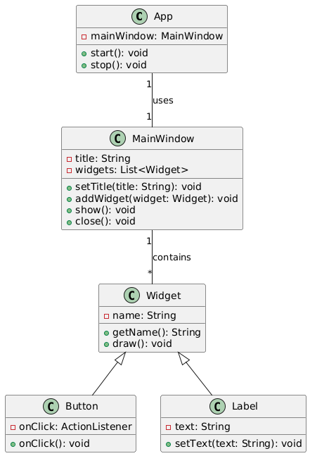

## Component Diagram

** Illustrates the high-level components of the system (e.g., `App`, `index.jsx`, `index.css`), their dependencies, and interfaces. Good for showing the overall structure of the React application.

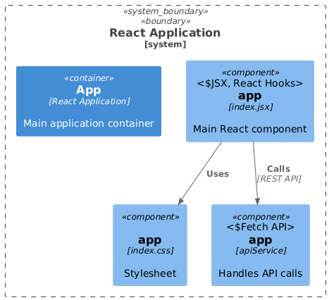

## Package Diagram

** Represents the organization of the code into packages or namespaces (if any are explicitly defined, though not directly evident here). Could show the relationship between `src` and its contents.

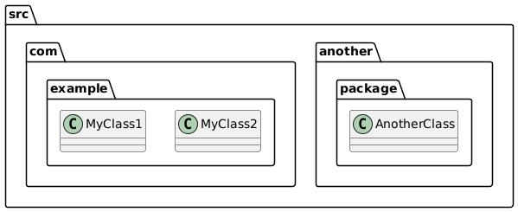

## Deployment Diagram

** While not strictly necessary for such a small system, it could show the deployment environment (e.g., web server, client machine) and how the application components are distributed.

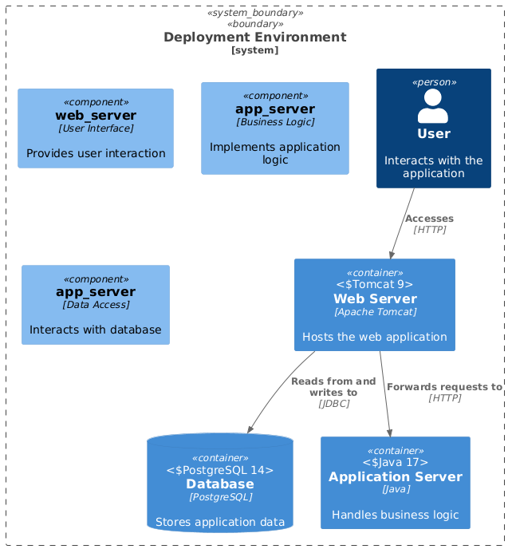

## Sequence Diagram

** Could be used to model the interactions between user actions (implied in the instructions), the React components, and any backend systems (if any existed). Useful if more detail about user flow is available.

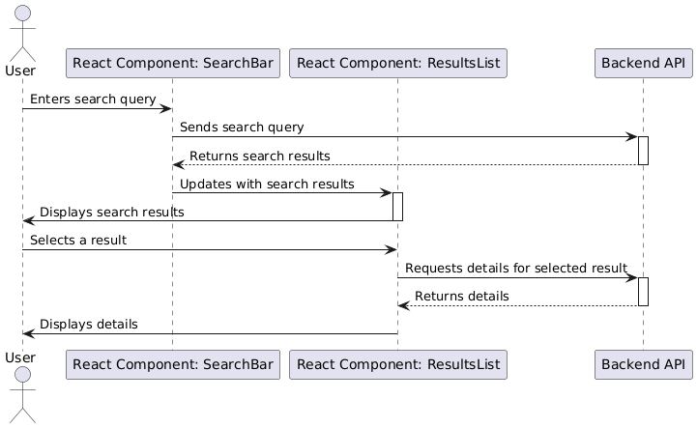

## Activity Diagram

** Could visualize the workflow of the documentation generation process itself, showing steps like code analysis, UML diagram generation, and report creation.

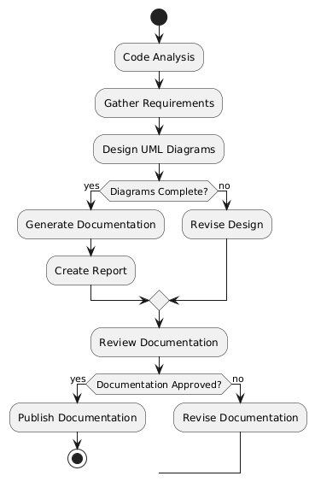

## Use Case Diagram

** Useful to depict the user's interactions with the system from a high-level perspective. In this case, it would show the user creating documentation (generate a detailed Word document and UML diagrams).

