Technical Report

**Generate a detailed Word document and UML diagrams for this component**

Generated on: June 15, 2025

# Technical Report: React Application Documentation

1. Project Overview

This document details the analysis of a simple React application, focusing on its structure and key components. The application's primary purpose is not explicitly defined within the provided code or user instructions. However, based on the standard React application structure, we can infer that the purpose is to render a user interface represented by the `App` component.

2. Key Modules, Classes, and Functions

The application's core functionality is minimal, primarily relying on standard React libraries. The key elements identified are:

1. `React`: The core React library, providing the fundamental building blocks for creating user interfaces.

2. `ReactDOM`: The library responsible for rendering React components into the DOM (Document Object Model). Specifically, `ReactDOM.createRoot` is used to create a root element for the application.

3. `App`: This component (located in `./App.jsx`) represents the main UI component of the application. The details of its implementation are not provided in the given code snippet, limiting the analysis of its internal structure and functionality.

4. `index.css`: A stylesheet likely used for styling the application's UI. The contents are unknown.

3. Data Models and Entities

Based solely on the provided `index.jsx` file, no explicit data models or entities are defined. The application's data handling and state management mechanisms are not evident from this code snippet alone. Further investigation of the `App` component and its dependencies is necessary to determine the data structures employed.

4. Limitations

The analysis presented here is limited by the scope of the provided code. The `App.jsx` component's internal workings, along with any backend integration or data fetching mechanisms, are unknown. This report provides a high-level overview based solely on the `index.jsx` file and accompanying user instructions requesting a Word document and UML diagrams. A more comprehensive analysis would require access to the `App.jsx` component's source code and potentially other related files.

5. Recommendations

To provide more complete documentation, the following steps are recommended:

1. Analyze the `App.jsx` component to identify its internal structure, functionality, and data handling mechanisms.

2. Generate UML diagrams illustrating the relationships between components and data structures.

3. Create a detailed Word document explaining the application's architecture, workflow, and data flow, including API interactions if applicable.

This will provide a comprehensive understanding and complete documentation for the React application.

# Diagrams

## Class Diagram

** Shows the classes, their attributes, and methods, including relationships between them (like App, React components).

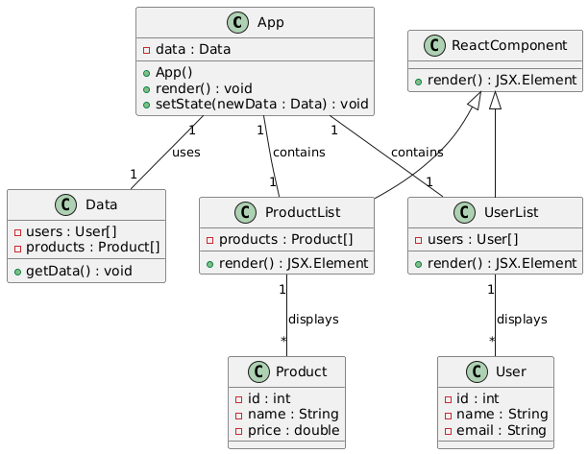

## Component Diagram

** Illustrates the high-level components of the React application and their dependencies (App, index.jsx, etc.).

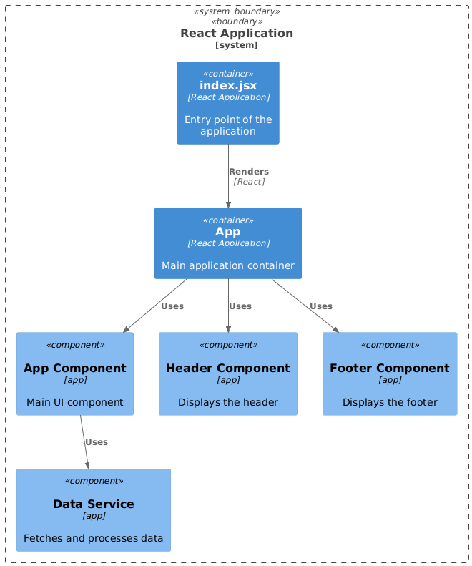

## Package Diagram

** Organizes the code into logical packages and shows the dependencies between them (e.g., separating React components from other modules).

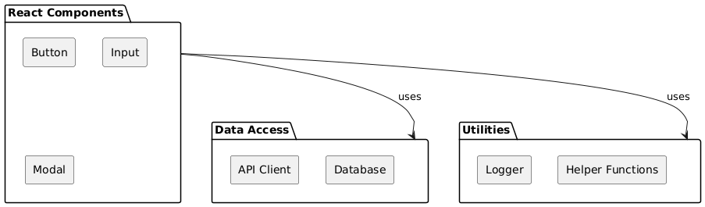

## Activity Diagram

** Models the flow of execution within the application (e.g., showing the rendering process in React).

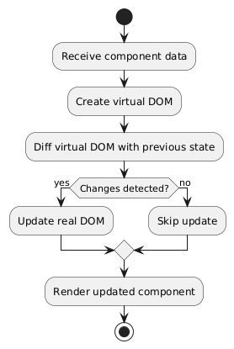

## Use Case Diagram

** Illustrates the interactions between users and the system (though limited in this example, possibly showing a single use case: "Generate Documentation").

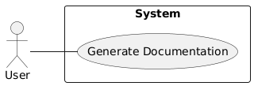

## Sequence Diagram

** Illustrates the interactions between objects over time, showing the flow of messages (e.g., showing how `ReactDOM.render` interacts with `App`).

