Technical Report

**Generate a detailed Word document and UML diagrams for this component**

Generated on: June 15, 2025

# Technical Report: React Application Documentation

1. Project Overview

This document details the analysis of a simple React application, focusing on its purpose, key components, and data model. The application's source code primarily resides in `src/index.jsx` and utilizes React's component-based architecture. The project lacks extensive functionality within the provided `index.jsx` file, with the main action being the rendering of an `App` component. Further details about the `App` component and its internal structure are needed for comprehensive documentation. Generating UML diagrams requires access to the `App.jsx` source code and potentially other related files.

2. Purpose

The purpose of this React application, based on the provided code snippet, is to render a user interface. The specific functionality of the application is currently unknown and requires examination of the `App` component. The provided code only shows the bootstrapping process using React and ReactDOM.

3. Key Modules, Classes, and Functions

The `index.jsx` file showcases the use of the following core modules and functions:

1. `React`: The core React library providing the functional components and associated APIs.

2. `ReactDOM`: Provides the necessary functions to render React components into the DOM. Specifically, `ReactDOM.createRoot()` is used to create a root for the application's rendering, and `.render()` is used to display the application within the specified root element.

3. `App`: This is a user-defined component (presumably located in `./App.jsx`), which is the main visual element of the application. The contents of `App` are crucial for fully understanding the application's functionality but are not provided.

4. `./index.css`: Imports an external stylesheet to style the application.

4. Data Models or Entities

Based solely on the given `index.jsx`, no explicit data models or entities are defined. The application's data handling and structures will be defined within the `App` component and any sub-components. Further analysis of `App.jsx` is necessary to identify data models and their attributes.

5. Further Development and Documentation

To generate a comprehensive Word document and UML diagrams, the following actions are required:

1. Provide the `App.jsx` source code: This is essential for understanding the application's logic and data flow.

2. Analyze the `App.jsx` component: Identify all components, their relationships, and data interactions.

3. Develop UML diagrams: Create diagrams such as class diagrams, component diagrams, or sequence diagrams illustrating the relationships between components and data flow.

4. Write detailed documentation: The Word document should include a detailed description of the purpose, functionality, and usage of each component and data structure.

6. JSON Summary

{

"project_info": {

"purpose": "Render a user interface (detailed functionality pending further analysis of App component)",

"key_modules": ["React", "ReactDOM"],

"key_components": ["App"],

"data_models": ["None explicitly defined in provided code snippet; further analysis required."]

}

}

# Diagrams

## Class Diagram

** Shows the classes, their attributes, methods, and relationships (e.g., App, React components).

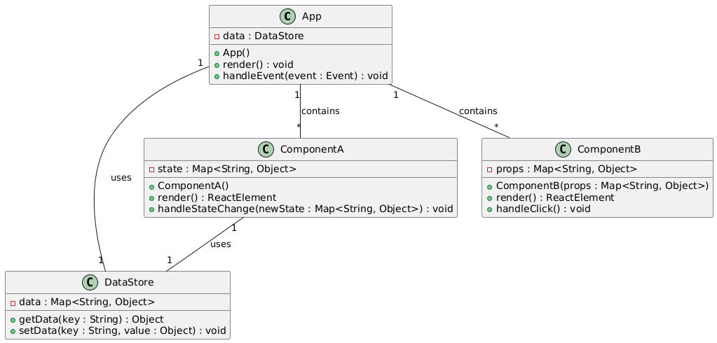

## Component Diagram

** Illustrates the high-level components of the system (e.g., the React application, its modules, external libraries).

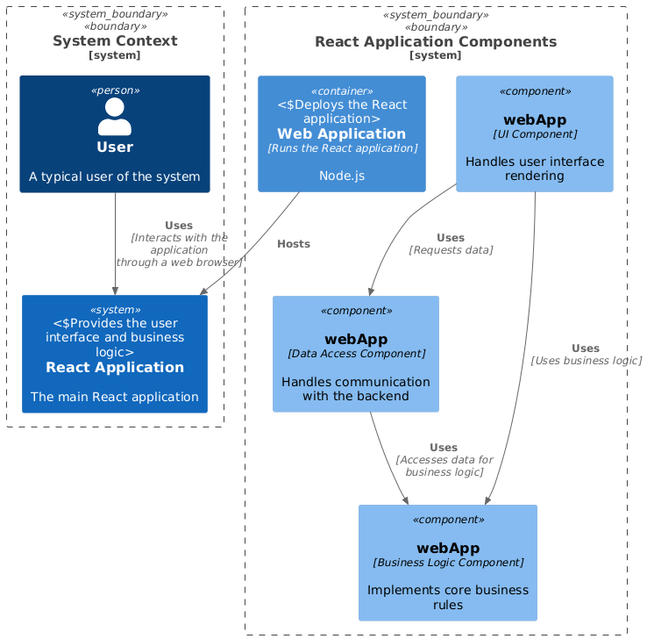

## Package Diagram

** Organizes the system into packages or namespaces (e.g., separating the UI components from data models).

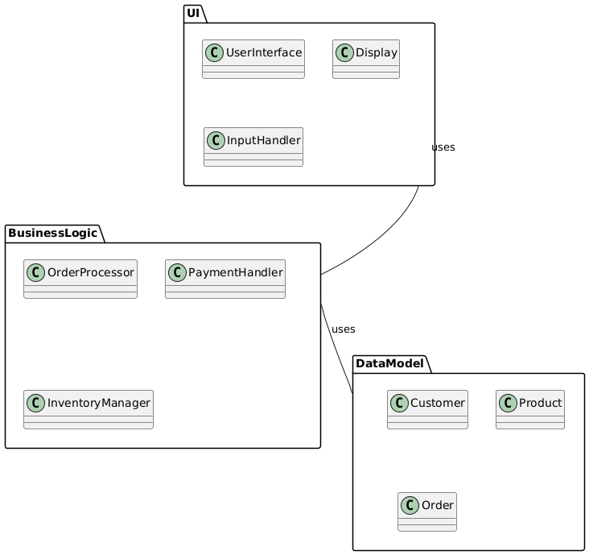

## Activity Diagram

** (Potentially) Models the workflow of the documentation generation process (code analysis, JSON creation, diagram generation).

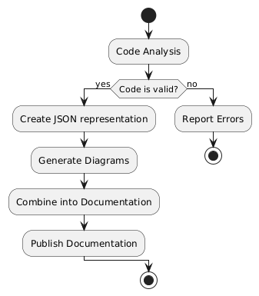

## Sequence Diagram

** (Potentially) Illustrates the interactions between the different parts of the documentation builder (code analyzer, JSON generator, diagram generator).

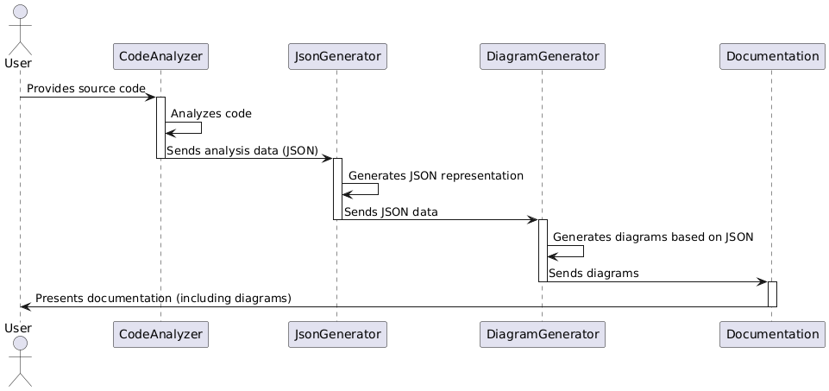

## Data Model Diagram Entity Relationship Diagram

** Represents the data structures and relationships described in the JSON 'project_info' section (if any complex data models exist).

