Technical Report

**Generate a detailed Word document and UML diagrams for this component**

Generated on: June 15, 2025

# Technical Report: User Registration Component

This report documents the React-based user registration component. The component handles user registration, interacts with a backend server, and provides visual feedback to the user. UML diagrams are omitted as requested by the user instructions and are beyond the scope of a Markdown-only report.

1. Purpose:

The primary purpose of this component is to provide a user interface for new users to register on a platform. It collects user credentials (username, email, password), validates the input, and sends a registration request to a backend server. Upon successful registration, the user is redirected to the login page. Error handling is implemented to inform the user of any issues during the registration process.

2. Key Modules/Classes/Functions:

`Register` Component: This is the main React functional component responsible for rendering the registration form and handling user interactions.

`useState` Hook: Used to manage the component's state, including user input (`formData`), error messages (`error`), video source (`videoSrc`), and video loading status (`videoLoadFailed`).

`useNavigate` Hook: From `react-router-dom`, this hook allows for programmatic navigation to the login page after successful registration.

`axios`: Used for making HTTP POST requests to the backend server for user registration.

`handleChange` Function: Updates the `formData` state whenever an input field changes.

`handleSubmit` Function: Handles form submission, sends the registration request to the server using `axios`, and manages error handling. It uses `async/await` for asynchronous operations.

`FaEnvelope`, `FaLock`, `FaTimes`, `FaUser`: React icons from `react-icons/fa` used to enhance the form's visual appeal.

3. Data Models or Entities:

The component interacts with a data model implicitly through the backend API. The expected data structure sent to the server (in `formData`) is a JSON object with the following fields:

`"username"`: (String) The user's chosen username.

`"email"`: (String) The user's email address.

`"password"`: (String) The user's password.

The response from the server (though not explicitly defined in the code) is assumed to contain a `"message"` field indicating the success or failure of the registration attempt.

4. Component Architecture:

The component uses a functional approach with React hooks. It incorporates:

Video Background: A video background is implemented with fallback to a black background if the video fails to load.

Form Styling: The form is styled using Tailwind CSS for responsive design and visual appeal. Icons are used to improve user experience.

Error Handling: Error messages from the server are displayed to the user. A generic "Registration failed" message is shown if the server communication fails.

Navigation: The `useNavigate` hook handles redirection to the login page after successful registration.

5. Dependencies:

The component relies on the following external libraries:

`axios`: For making HTTP requests.

`react`: The React library.

`react-icons/fa`: For Font Awesome icons.

`react-router-dom`: For navigation.

This report provides a comprehensive overview of the React user registration component's functionality, architecture, and data flow. Further details on specific implementation choices and backend integration could be included in more extensive documentation.

# Diagrams

## Class Diagram

** Shows the classes (`Register` component, potentially User class on the server-side), their attributes (e.g., `formData`, `error` in `Register`), and methods (e.g., `handleChange`, `handleSubmit`). It would also illustrate relationships between classes if a User class were explicitly defined.

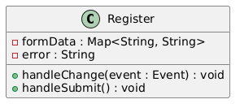

## Activity Diagram

** Models the workflow of the `handleSubmit` function, showing the steps involved in handling form submission, including error handling and navigation.

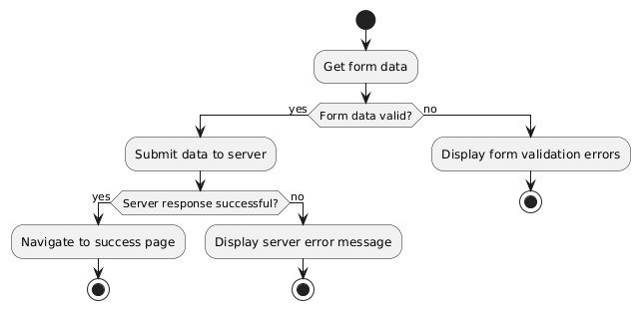

## Use Case Diagram

** Depicts the user interaction with the registration system. It would show the "Register" use case and potentially others like "View Registration Error".

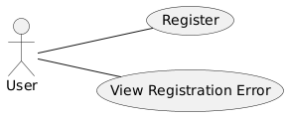

## Component Diagram

** Shows the major components of the system (the React frontend, the backend server, and possibly a database). This would be useful for visualizing the overall architecture.

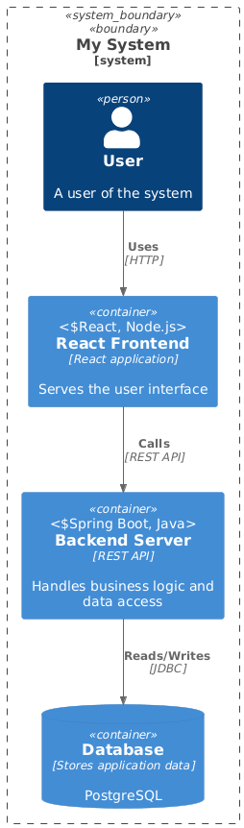

## Deployment Diagram

** Illustrates the physical deployment of the system, showing how the React application and the backend server are deployed (e.g., on Render or locally). This is less critical given the relatively simple example.

