Technical Report

**Generate a detailed Word document and UML diagrams for this component**

Generated on: June 16, 2025

# Technical Report: React Application Documentation

1. Introduction

This document details the analysis of a simple React application and outlines the information necessary for comprehensive documentation, including a JSON summary and a proposed structure for a Word document and UML diagrams. The application's primary purpose is to render the `App` component, which is imported from the `./App.jsx` file. Further details regarding the functionality of `App` are not available from the provided code snippet.

2. Project Summary (JSON)

The following JSON object summarizes the project information gleaned from the code and instructions:

{

"project_info": {

"purpose": "Render the main application component ('App') using React.",

"key_modules": ["react", "react-dom/client"],

"key_components": ["App"],

"data_models": [],

"functions": ["createRoot"]

}

}

3. Key Modules and Components

`react`: The core React library, providing the fundamental building blocks for creating user interfaces.

`react-dom/client`: Provides the functionality to render React components into the DOM (Document Object Model). Specifically, `createRoot` is used to render the application into the element with the ID 'root'.

`App` (from `./App.jsx`): This is the main application component. Its internal structure and functionality are not visible in the provided code snippet and would require further investigation. The `App` component's definition and associated sub-components would be the focus of the UML diagrams and detailed Word document.

4. Data Models and Entities

Based on the limited code provided, no explicit data models or entities are identified. This section would be expanded in the full documentation to include any relevant data structures used within the `App` component.

5. Proposed Word Document Structure

A detailed Word document would include the following sections:

1. Introduction: Overview of the application and its purpose.

2. Architecture: High-level description of the application's structure, including the relationships between components.

3. Component Details: In-depth explanation of the `App` component, including its internal structure, state management (if any), and interactions with other components.

4. Data Flow: Diagram illustrating how data flows through the application.

5. User Interface (UI) Design: Description of the user interface elements and their functionality.

6. Testing: Description of testing strategies and results.

6. Proposed UML Diagrams

The UML diagrams would primarily focus on visualizing the `App` component and its relationships with other components or external services. Diagrams to consider include:

Class Diagram: Showing the classes and their attributes and methods, specifically focusing on the structure within the `App` component.

Component Diagram: Showing the overall structure and dependencies between components (including `App` and any other relevant components).

Sequence Diagram: Illustrating the interactions and sequence of calls during a specific user action or application workflow within the `App` component.

7. Conclusion

This report provides a preliminary analysis of the React application. Further investigation of the `./App.jsx` file is required to complete the comprehensive documentation as specified in the user instructions. This report serves as a foundation for generating a detailed Word document and associated UML diagrams.

# Diagrams

## Class Diagram

** Illustrates the classes, their attributes, methods, and relationships (like inheritance and association) within the application.

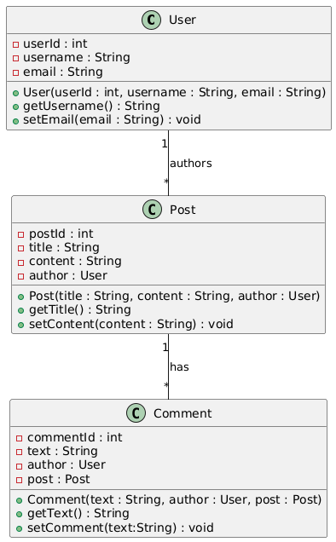

## Component Diagram

** Shows the high-level components of the system (e.g., the React application, the JSON generator, the Word document generator). Could also show dependencies between components.



## Package Diagram

** Represents the organization of the codebase into packages or modules (e.g., separating the React components from the JSON processing logic).

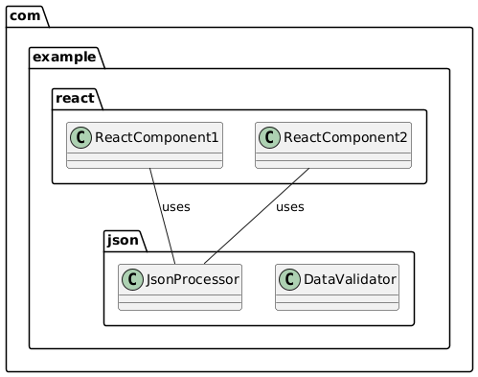

## Activity Diagram

** Models the workflow of the documentation builder, from code analysis to JSON and Word document generation.

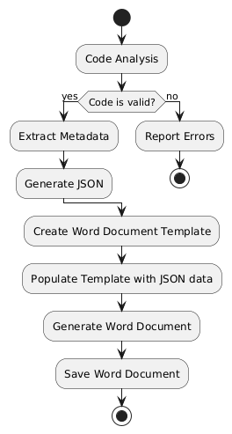

## Sequence Diagram

** Details the interactions between different parts of the system (e.g., the code analyzer interacting with the JSON generator). Could show how the React app interacts with other parts.

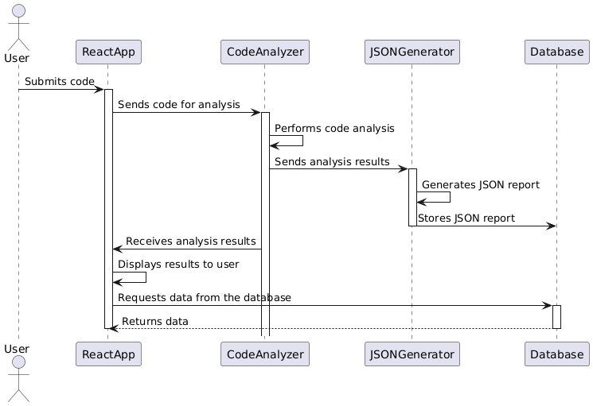

## Use Case Diagram

** Might be useful to show different ways the documentation generation tool could be used (e.g., different types of input, different types of output).

