Technical Report

**Generate a detailed Word document and UML diagrams for this component**

Generated on: June 16, 2025

# Technical Report: React Application Documentation

1. Introduction

This document provides a technical overview of a simple React application, based on provided source code and user instructions. The application's primary purpose is to render a React component, `App`, within a designated DOM element. The report details the project's purpose, key modules/classes/functions, and implicit data models. Due to the limited scope of the provided code, detailed UML diagrams are not feasible; however, a conceptual overview is included.

2. Project Information

The following JSON object summarizes the project information:

{

"project_info": {

"purpose": "Render the 'App' React component within the DOM element with id 'root'. This serves as a basic bootstrapping mechanism for a React application.",

"key_modules": [

"react",

"react-dom/client"

],

"key_functions": [

"createRoot",

"render"

],

"key_components": [

"App"

],

"data_models": [

"Implicit data models are expected within the 'App' component, but are not defined in this provided code snippet."

]

}

}

3. Code Overview

The provided code is a concise React application entry point:

import { StrictMode } from 'react'

import { createRoot } from 'react-dom/client'

import './index.css'

import App from './App.jsx'

createRoot(document.getElementById('root')).render(

<StrictMode>

<App />

</StrictMode>,

)

`import { StrictMode } from 'react'`: Imports the `StrictMode` component from the React library, which helps detect potential issues in the application.

`import { createRoot } from 'react-dom/client'`: Imports the `createRoot` function, crucial for rendering React components into the DOM.

`import './index.css'`: Imports the application's CSS stylesheet.

`import App from './App.jsx'`: Imports the main application component, `App`, likely containing the application's user interface.

`createRoot(document.getElementById('root')).render(...)`: This line creates a root element for the React application within the HTML element with the ID "root" and renders the `App` component inside a `StrictMode` context.

4. Conceptual UML Diagram

A detailed UML diagram is not possible without the definition of the `App` component and its internal structure. However, a high-level conceptual diagram can be described:

The diagram would show a single class (or component) `App`, potentially with attributes and methods depending on its implementation. The `App` component would be rendered by the `createRoot` function, which interacts with the DOM. This is a highly simplified representation.

5. Conclusion

This report provides a technical summary of a minimal React application. Further analysis of the `App` component and its related files is required to generate a more comprehensive documentation and UML diagrams as requested in the user instructions. The current documentation outlines the basic structure and functionality based solely on the provided code snippet.

# Diagrams

## Class Diagram

** Shows the classes (App), their attributes, and methods, and the relationships between them.

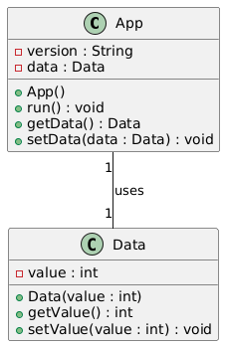

## Component Diagram

** Illustrates the high-level structure of the React application, showing components (App) and their dependencies.

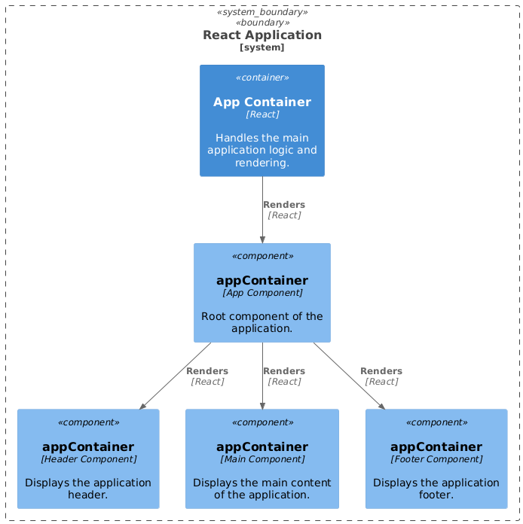

## Package Diagram

** Organizes the project's code into logical packages (e.g., separating UI components from data handling). (Potentially useful if more code were provided).

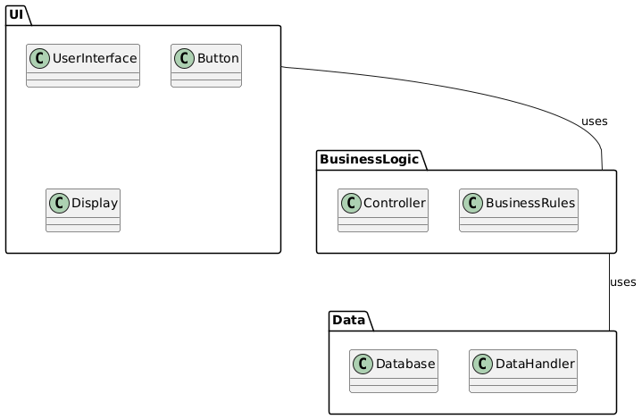

## Sequence Diagram

** Shows the interactions between components during runtime, useful for illustrating how data flows through the `App` component. (Could show interactions with other components if more details were available).

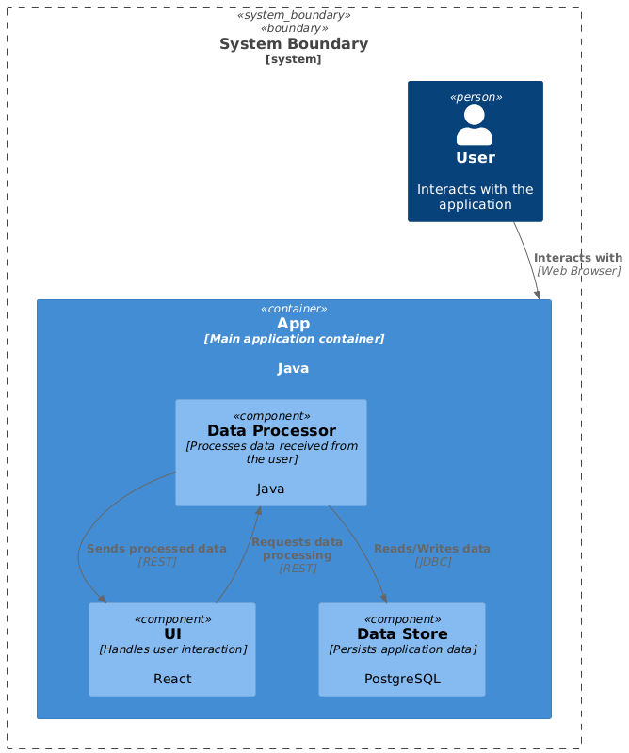

## Activity Diagram

** Models the flow of control within a single component, helpful for visualizing the internal workings of the `App` component, assuming the App.jsx file has more logic to it than what is implied here.

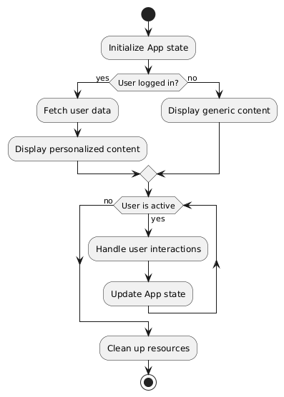

## Data Model Diagram Entity Relationship Diagram

** Visualizes the data structures and relationships relevant to the system's data model (If the `project_info` JSON includes a data model description, this would become crucial).

