Technical Report

**Generate a detailed Word document and UML diagrams for this component**

Generated on: June 16, 2025

# Technical Report: React Application Documentation

This report documents the analysis of a simple React application and outlines the process for generating comprehensive documentation, including a JSON summary and considerations for UML diagrams and a Word document.

## 1. Project Overview

1.1 Purpose:

The purpose of this React application is to render a main application component, `App`, within a StrictMode environment. This is a basic bootstrapping structure for a React application, providing a foundation for more complex features and functionality. The application's core functionality is entirely encapsulated within the `App` component (located in `./App.jsx`), which is not directly analyzed in this report due to the lack of its source code.

1.2 Key Modules/Classes/Functions:

The provided code snippet utilizes several key modules and functions from the React library:

1. `StrictMode` from `'react'`: Enables additional checks and warnings during development to help identify potential issues in the application.

2. `createRoot` from `'react-dom/client'`: Creates a root for rendering React components into the DOM. This is the entry point for rendering the application.

3. `App` from `'./App.jsx'`: The main application component. The specific functionality and internal structure of this component are unknown without access to the `App.jsx` file.

1.3 Data Models or Entities:

Based solely on the provided code snippet, no explicit data models or entities are defined. Any data handling or state management would reside within the `App` component and its associated sub-components. Further analysis of `App.jsx` would be required to identify these aspects.

## 2. Documentation Generation Plan

The user instructions request a detailed Word document and UML diagrams. The following outlines a plan for generating these:

2.1 Word Document: The Word document should include:

Introduction: A brief overview of the application's purpose and functionality, drawing upon the analysis provided in Section 1.

Component Architecture: A description of the component hierarchy, starting with the `App` component and detailing its sub-components (requires access to `App.jsx`).

Data Flow: An explanation of how data flows through the application, including data sources, transformations, and destinations (requires access to `App.jsx`).

State Management: A description of the application's state management strategy (if applicable, requires access to `App.jsx`).

Error Handling: Discussion of any error handling mechanisms implemented (requires access to `App.jsx`).

Testing: Summary of testing procedures and results (if available).

2.2 UML Diagrams:

UML diagrams, such as class diagrams (showing the classes and their relationships within the `App` component and its sub-components) and component diagrams (showing the overall architecture of the application), should be included. Creating these diagrams requires access to the `App.jsx` source code to properly represent the components and their relationships.

## 3. JSON Summary

The following JSON object summarizes the project information:

{

"project_info": {

"purpose": "Render the main application component, 'App', within a StrictMode environment.",

"key_modules": ["StrictMode", "createRoot", "App"],

"data_models": "None explicitly defined in provided code. Requires further analysis of 'App.jsx'."

}

}

This report provides a preliminary analysis based on limited information. A complete documentation set necessitates access to the `App.jsx` source code and any supporting documentation.

# Diagrams

## Class Diagram

** Shows the classes, their attributes, methods, and relationships (inheritance, association, etc.) within the application.

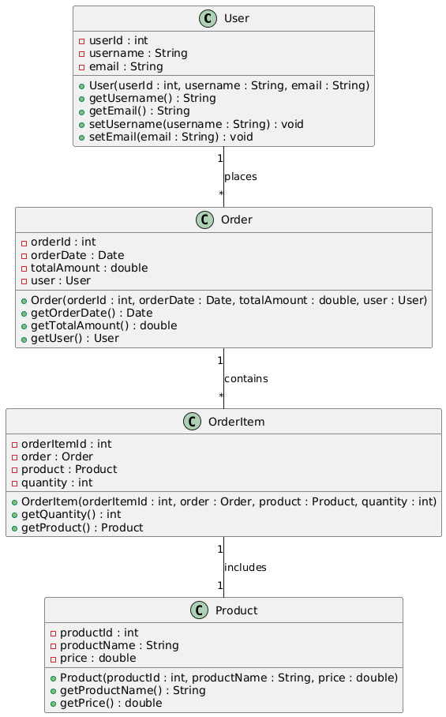

## Component Diagram

** Illustrates the system's high-level components and their dependencies, focusing on the React components (App, etc.) and their interactions.

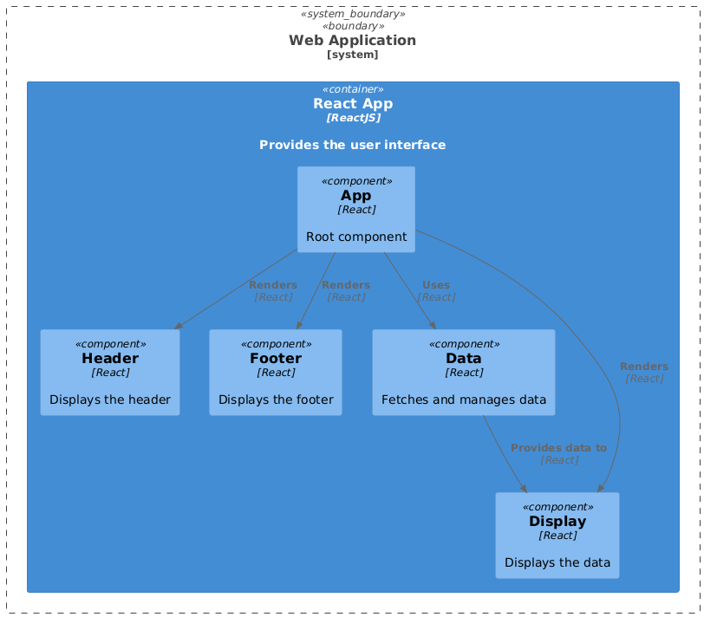

## Package Diagram

** Organizes the system into logical packages (e.g., grouping React components, utilities, data models).

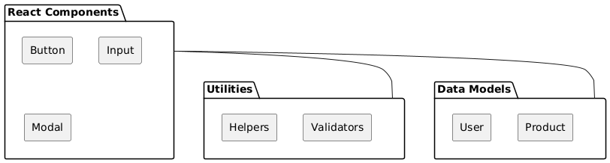

## Deployment Diagram

** Shows how the application is deployed on the physical or virtual infrastructure (if relevant for documentation). This might only be a basic diagram in this case.

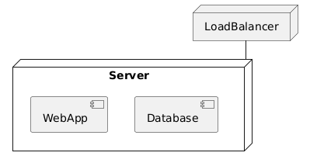

## Activity Diagram

** (Optional, but helpful) Models the workflow of the documentation generation process: code analysis, JSON creation, Word document generation, UML diagram creation.

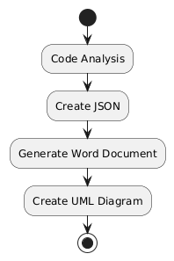

## Sequence Diagram

** (Optional, but helpful) Illustrates the interactions between objects/components during the execution of a specific task, such as rendering the React application. Might show the interaction of the main component with other elements.

