Technical Report

**Generate a detailed Word document and UML diagrams for this componen**

Generated on: June 17, 2025

# Technical Report: React Application Documentation

This report documents the analysis of a React application based on provided source code and user instructions. The goal is to generate a JSON summary of the project's key components for documentation purposes.

## 1. Project Purpose

The purpose of this React application is not explicitly defined within the provided code or user instructions. However, based on the standard structure of a React application, it is inferred that the application's purpose is to render a user interface (UI) controlled by the `App` component, using the React library. The application's functionality and specific purpose would require further investigation of the `App.jsx` file, which is currently not provided.

## 2. Key Modules/Classes/Functions

The provided source code snippet demonstrates a basic React application setup. Key components identified are:

1. `StrictMode` (from 'react'): This component is used to help detect potential issues in the application during development. It activates additional checks and warnings.

2. `createRoot` (from 'react-dom/client'): This function is crucial for rendering the React application within the DOM. It takes the root element (`document.getElementById('root')`) and renders the application's main component within it.

3. `App` (from './App.jsx'): This is the primary component of the application. The actual implementation and logic of the user interface are contained within this component (which is not provided in this analysis).

4. `'./index.css'`: This import suggests the application utilizes a stylesheet for visual styling of the UI elements.

## 3. Data Models or Entities

No explicit data models or entities are defined in the provided code snippet. The data models used within the application will depend on the implementation within the `App.jsx` component and are currently unknown. Further analysis of the `App.jsx` file would be needed to identify any data models or entities utilized.

## 4. Limitations

This report is limited by the absence of the crucial `App.jsx` file. A complete understanding of the application's purpose, functionality, and data models requires analysis of this missing component. The report provides an overview based solely on the provided code snippet, offering inferences where direct evidence is lacking.

## 5. JSON Summary (Partial)

Based on the limited information available, the following JSON object partially summarizes the project:

{

"project_info": {

"purpose": "Render a user interface (UI) - further details require analysis of App.jsx",

"key_modules": ["react", "react-dom/client"],

"key_components": ["App", "StrictMode"],

"data_models": ["Further analysis of App.jsx required"]

}

}

# Diagrams

## Class Diagram

** Shows the classes, their attributes, and methods, including relationships between classes (like inheritance and association).

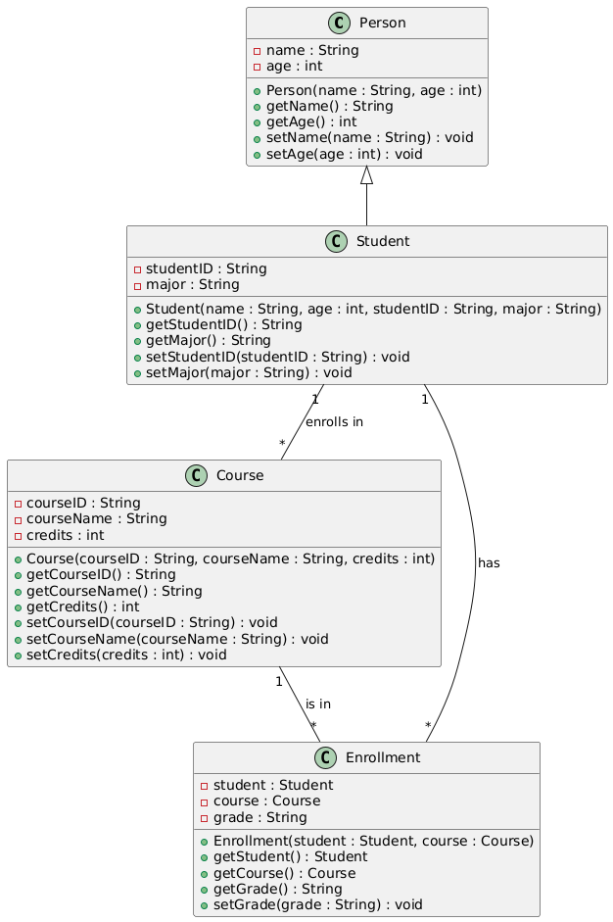

## Package Diagram

** Organizes the system into logical packages (e.g., user interface, data processing, documentation generation).

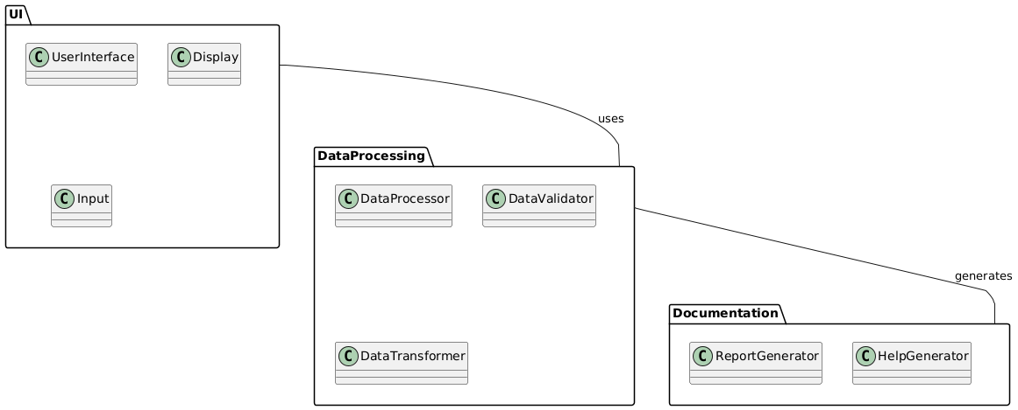

## Activity Diagram

** Models the workflow of the documentation generation process, including code analysis, data extraction, and document creation.

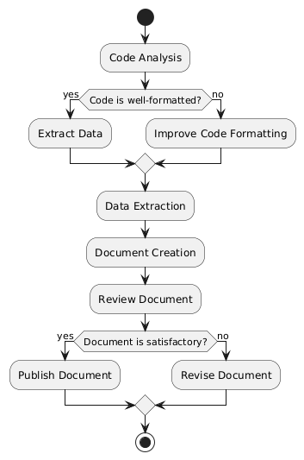

## Sequence Diagram

** Shows the interactions between different parts of the system (e.g., how the React app interacts with the documentation generator).

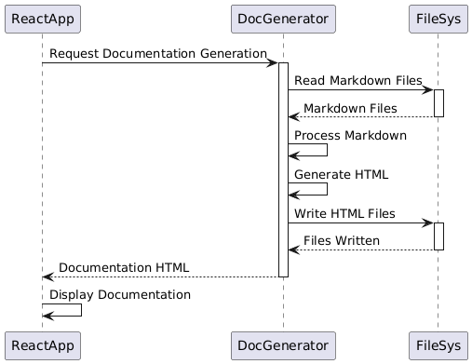

## Use Case Diagram

** Depicts how users interact with the system (though limited usefulness given the focus on internal workings).

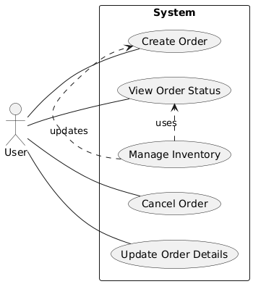

## Deployment Diagram

** Illustrates the runtime architecture (though simple in this case, potentially showing deployment on a server).

