# Aamir Khan: HTML Spring 2023 Assignment #1

**Part 1: Your "Brackets and Live Preview" Screen shot**

[Paste your part 1 screen shot here. It should show both your Brackets editor window (with your code showing) and your Live Preview (or normal browser) window (with the heading showing your name) together in one screen shot. Resize or crop your screen shot image as needed for best grading purposes here in Word. Make sure your code is readable and your extensions are visible.]   
Paste your part 1 screen shot BELOW THIS LINE!]

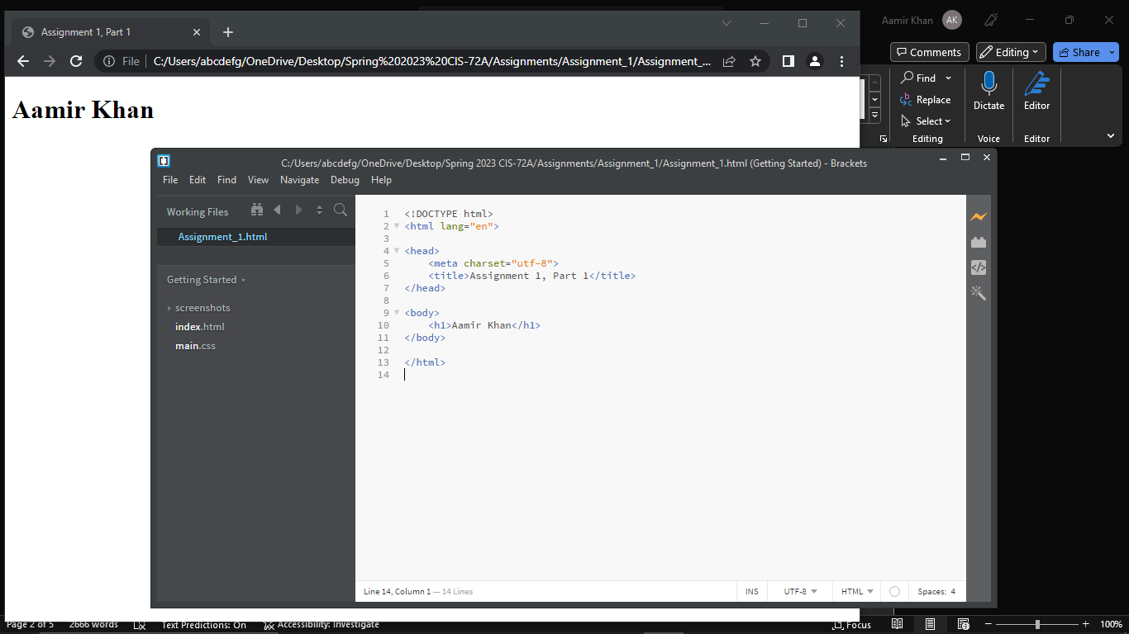

Paste your part 1 screen shot ABOVE THIS LINE!   
After pasting, then scroll down to the next page to paste your part 2 items.

**Part 2: Your "Resume" Screen shot(s)**

[Paste your part 2 screen shot(s) here. It should show your entire resume within the browser window (not in Brackets or another editor). No HTML code should be visible here – just your resume page in the browser. If you need more than 1 screen shot to capture the whole resume, that is fine. If it takes multiple pages in Word to contain them, that is fine too -- do not reduce the size of screen shots after pasting them into Word here just to fit them all on one page – the details of your screen shot must clearly visible for grading purposes.]   
Paste your part 2 screen shot(s) BELOW THIS LINE!

Paste your part 2 screen shot(s) ABOVE THIS LINE!   
After pasting, then scroll down to the next page to paste your part 2 code.

**Part 2: Your Resume Page Code**

[Paste your Resume Code below – Be sure to copy and paste ALL of the HTML code for the page (it is ok if it takes multiple pages here in Word). **Do NOT paste screen shots of your code** – paste the actual code from within Brackets (or other editor). After pasting, to help make the code more readable, please select the code and bold it here in Word. Then change the font to “Courier New” (or another monospace font) to further enhance its readability as needed. ]  
Paste your part 2 CODE BELOW THIS LINE!]

**<!DOCTYPE html>**

**<html lang="">**

**<head>**

**<meta charset="utf-8">**

**<title>Aamir Khan's Resume Page</title>**

**</head>**

**<body>**

**<header>**

**<h1>Aamir Khan's Resume</h1>**

**<p>123 Any Street, Whatevercity, Somestate 92837<br>**

**akhan43@student.rccd.edu -- 951-987-4321</p>**

**</header>**

**<section>**

**<h2>Objective</h2>**

**<p>To obtain an extremely high paying position with limitless upward mobility in a**

**stress free working environment.</p>**

**<h2>Skills</h2>**

**<ul>**

**<li>Interpersonal and Communication Skills</li>**

**<li>Problem Solving Skills</li>**

**<li>Big Picture Thinking</li>**

**</ul>**

**<h2>Education</h2>**

**<ul>**

**<li>2015 Graduate of Riverside East High School, GPA 3.5</li>**

**<li>2017 Web Developer Certificate from Riverside City College</li>**

**<li>Finished my A.S degree in Computer Science with a plan to transfer</li>**

**</ul>**

**<h2>Work Experience</h2>**

**<h3>Fidget Spinner Salesperson</h3>**

**<ul>**

**<li>May 2016 - January 2017</li>**

**<li>World Wide Imports, LLC</li>**

**<li>Salesperson of the month for July 2016</li>**

**</ul>**

**<h3>Writing Center English Tutor</h3>**

**<ul>**

**<li>February 2020 - December 2021</li>**

**<li>Mount San Antonio Community College</li>**

**<li>Completed Additional Training in English Tutoring</li>**

**</ul>**

**<h2>References</h2>**

**<dl>**

**<dt>Dinah Sore</dt>**

**<dd>National History Museum, 951-222-3456</dd>**

**<dt>Mike Rowave</dt>**

**<dd>ABC Appliances, 951-333-4567</dd>**

**<dt>Chic Hen</dt>**

**<dd>All Natural Farms, 951-000-9898</dd>**

**</dl>**

**</section>**

**<footer>**

**<p>Resume page created by Aamir Khan</p>**

**</footer>**

**</body>**

**</html>**

Paste your part 2 CODE ABOVE THIS LINE!   
After pasting, save the page and exit Word. Then go to Canvas to submit it.