Aamir Khan HTML Spring 2023 Assignment #2

**Part 1: Answer the 7 questions** below, covering the "Links" video, by selecting the correct answer and **bolding and changing its text highlight color to yellow just like this text!** …

1. What HTML tag is used in the video to create links?

a) <nav> b) <link> **c) <a>** d) <www> e) <http>

2. In the video, the links that go to Google and Dog Pile are surrounded by what tag?

a) <ul> b) <li> c) <dd> **d) <dt>** e) <nav>

3. Links that are supposed to launch an email when clicked are created in HTML by placing what characters at the start of the link's “href” value?

a) email: b) email-to- c) mail: **d) mailto:** e) sendto:

4. How many actual working links (count all links that take their intended action when clicked) are there in the “links.htm” page when shown in the video around the 7th minute?

**a) 0** b) 1 c) 2 d) 5 e) 10

5. How many actual working links (count all links that take their intended action when clicked) are there in the “links.htm” page at the very end of the video?

a) 0 b) 5 c) 9 d) 12 **e) 15**

6. How many email links (links that will try to initiate an email when clicked) are there within the completed “links.htm” page (at the end of the video)?

a) 0 **b) 1** c) 2 d) 3 e) 5

7. Which one of the following links would actually work to get to the "ebay" web site?

a) <a href=ebay.com>ebay</a>

b) <a href="#ebay.com">ebay</a>

c) <a href="www.ebay.com">ebay</a>

**d) <a href="http://www.ebay.com">ebay</a>**

e) <a href="mailto:www.ebay.com">ebay</a>

**Part 2: Your Favorite Links Web Page Screenshot in the Browser**

[Paste your part 2 screenshot here. Use 2 screenshots if necessary to show the whole favorite links page showing in the browser (no HTML code should be showing). Then move to the next page below to paste your HTML code.]

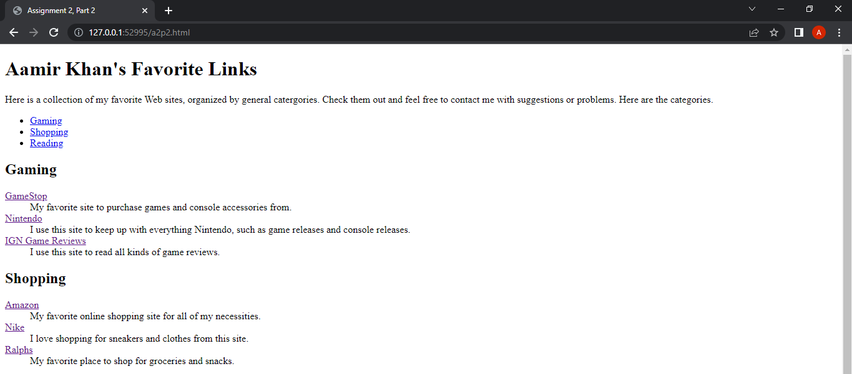

**Part 2: Your Favorite Links Web Page Code**

[Paste your Links page Code below – No Screen shots please! Be sure to select, copy, and paste ALL the HTML code for the page from within your editor. Use “Courier New” or another monospace font to make your code more readable. Bold the code too if that helps make it more readable. Then move on to the next page below for part 3.]

**<!DOCTYPE html>**

**<html lang="en">**

**<head>**

**<meta charset="utf-8">**

**<title>Assignment 2, Part 2</title>**

**</head>**

**<body>**

**<header>**

**<h1>Aamir Khan's Favorite Links</h1>**

**<p>Here is a collection of my favorite Web sites, organized by general catergories. Check them out and feel free to contact me with suggestions or problems. Here are the categories.</p>**

**</header>**

**<section>**

**<ul>**

**<li><a href="#gaming">Gaming</a></li>**

**<li><a href="#shopping">Shopping</a></li>**

**<li><a href="#reading">Reading</a></li>**

**</ul>**

**<h2 id="gaming">Gaming</h2>**

**<dl>**

**<dt><a href="https://www.gamestop.com/">GameStop</a></dt>**

**<dd>My favorite site to purchase games and console accessories from.</dd>**

**<dt><a href="https://www.nintendo.com/">Nintendo</a></dt>**

**<dd>I use this site to keep up with everything Nintendo, such as game releases and console releases.</dd>**

**<dt><a href="https://www.ign.com/reviews/games">IGN Game Reviews</a></dt>**

**<dd>I use this site to read all kinds of game reviews.</dd>**

**</dl>**

**<h2 id="shopping">Shopping</h2>**

**<dl>**

**<dt><a href="https://www.amazon.com/">Amazon</a></dt>**

**<dd>My favorite online shopping site for all of my necessities.</dd>**

**<dt><a href="https://www.nike.com/">Nike</a></dt>**

**<dd>I love shopping for sneakers and clothes from this site.</dd>**

**<dt><a href="https://www.ralphs.com/">Ralphs</a></dt>**

**<dd>My favorite place to shop for groceries and snacks.</dd>**

**</dl>**

**<h2 id="reading">Reading</h2>**

**<dl>**

**<dt><a href="https://www.barnesandnoble.com/">Barnes & Noble</a></dt>**

**<dd>I love picking up my books from this site.</dd>**

**<dt><a href="https://www.goodreads.com/recommendations">GoodReads Recommendations</a></dt>**

**<dd>My favorite site to get some reading recommendations.</dd>**

**<dt><a href="https://www.rightstufanime.com/">RightStufAnime</a></dt>**

**<dd>My favorite site to purchase manga from.</dd>**

**</dl>**

**</section>**

**<footer>**

**<p>If you have any suggestions for changes or new links, please send me an email at <a href="mailto:akhan43@rccd.edu">akhan43@student.rccd.edu</a></p>**

**</footer>**

**</body>**

**</html>**

**Part 3: Your Rock Climbing Web Page Screenshot**

[Paste your part 3 screenshot here. Use 2 screenshots if necessary to show the whole rock climbing page in the browser (no HTML code showing here). Then move to the next page below to paste your HTML code.]

**Part 3: Your Rock Climbing Web Page Code**

[Paste your rock climbing page Code below – No Screen shots please! Be sure to select, copy, and paste ALL the HTML code for the page from within your editor. Use “Courier New” or another monospace font to make your code more readable. Bold the code too if that helps make it more readable.]

**<!DOCTYPE HTML>**

**<html lang="en">**

**<head>**

**<meta charset="utf-8" />**

**<title>Rock Climbing Fun</title>**

**</head>**

**<body>**

**<header style="text-align: center">**

**<img src="rockclimber.jpg" width="450" height="300" alt="Rock climber" />**

**</header>**

**<section>**

**<article>**

**<p>Rock Climbing Fun has recently opened a school at the base of Mount Rainier. We have programs for advanced rock climbers as well as for beginners. Rock climbing is a widely popular sport, especially in the state of Washington. Classes run from early morning to mid afternoon, and private climbing lessons are available. Come join our classes and experience the fun and great exercise that rock climbing can provide. Call 1-800-555-CLIMB for more information.</p>**

**<h2 style="color:#384738">Equipment needed to get started:</h2>**

**<ul style="list-style-type: square">**

**<li>Comfortable climbing shoes</li>**

**<li>Backpack</li>**

**<li>Harness</li>**

**</ul>**

**</article>**

**</section>**

**<hr style="height:8px; background-color: #384738; width: 50%" />**

**<footer style="text-align: center; font-style: italic">**

**Rock Climbing Fun by Aamir Khan**

**</footer>**

**</body>**

**</html>**