Aamir Khan **HTML Spring 2023 Assignment #3**

**Part 1 Screenshot: Your Coffee House “About Us” Page Screenshot**

[Paste your part 1 “About Us” page screenshot below. Use 2 screenshots if necessary to show the whole page. Your name should show on the browser's tab if you modified the "title" correctly.]

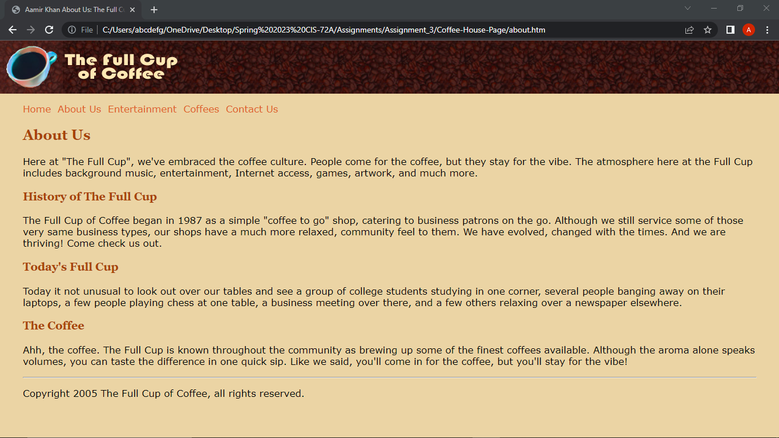

**Part 1 CSS Code: Your “main.css” CSS Code**

[Paste your “main.css” Cascading Style Sheet (CSS) Code text below – Your name should show as the "author" toward the top of the file. **No Screen shots here!** Be sure to paste ALL of the CSS code for the file. **NO HTML code** -- just the **CSS**! Use “Courier New” or another monospace font to make your code more readable. Bold the code too if that helps make it more readable. ]

**/* Full Cup of Coffee main styles**

**Author: Aamir Khan**

**Description:**

**\*/**

**body { margin: 0 40px; font: 105%/1.2 Verdana, Arial, sans-serif; background-color: #E6D5A4; color: black; }**

**h1 {background: url(bg_coffeebeans.jpg); margin: 0 -40px;}**

**h2,h3 {font-family: Georgia, Times, serif; color: #994818;}**

**a {color: #CC6633; text-decoration: none;}**

**ul {list-style-image: url(bean_bullet.gif);}**

**Part 2:** Answer the questions below, covering the “IDs and Classes” video, by selecting the correct answer and **bolding and changing its text highlight color to yellow just like this text!**

**1. How many style sheets are affecting the coffee house site shown in the video?**

a) none b) 1 **c) 2** d) 3 e) 4

**2. What is the background color being used for the links across the top of each page?**

a) #EEBBAA b) #E6D5A4 c) rgb(76,39,31) **d) #BB9966** e) #774818

**3. What is the font size of the copyright area after it is styled with CSS?**

a) 12pt b) 12px **c) 80%** d) h2

**4. The navigation bar paragraph and the copyright paragraph are both styled using an ID.**

**a) True** b) False

**5. Use a "class" instead of an "id" whenever the item you are styling may exist...**

a) at the very top of the page  
b) at the very bottom of the page  
c) on more than one page  
**d) more than once on the same page**  
e) on a page requiring high security such as an e-commerce transaction page

**Part 3 HTML Code: Your “Underwatertours.html” Page Code (from your Ch 3 textbook work)**

[Paste your “HTML” Code text from your “**Underwatertours.html**” pagebelow – Be sure to paste ALL of the code for the file. No screen shots! Use “Courier New” or another monospace font to make your code more readable. Bold the code too if that helps make it more readable. ]

**<!DOCTYPE HTML>**

**<html lang="en">**

**<head>**

**<meta charset="utf-8" />**

**<title>Underwater Tours by Aamir Khan</title>**

**<style type="text/css">**

**<!--**

**body {font-family: Arial, Verdana, Garamond;**

**font-size: 11pt;}**

**h1, h2, h3 {color: #020390;}**

**a {text-decoration: none;**

**color: #020390;}**

**a:hover {background: #020390;**

**color: #01d3ff;}**

**-->**

**</style>**

**</head>**

**<body>**

**<header>**

**<img src="underwaterlogo.jpg" width="581" height="450" alt="Underwater Tours logo" />**

**</header>**

**<section>**

**<article>**

**<p><span style="color:#020390; font-weight: bold">Underwater Tours by Aamir Khan</span> is a company that specializes in underwater photography tours. Instructors highlight both technical and creative photography support. Tours can be requested for individuals or groups.</p>**

**<p>Be tempted by some of our <a href="samplephotos.html">sample photographs</a> or learn about <a href="http://www.nps.gov/state/hi/index.htm">one of our fabulous tour destinations</a>. For questions or comments, please call us at (999) 555-ELOISE or e-mail us at <a href="mailto:underwatertoursbyeloise@isp.com"> underwatertoursbyeloise@isp.com</a>.</p>**

**</article>**

**</section>**

**</body>**

**</html>**

**Part 3 Screenshot: Your “Underwatertours.html” Page Screenshot**

[Paste your part 1 “**Underwatertours.html**” page screenshot here. Use 2 screenshots if necessary to show the whole page.]

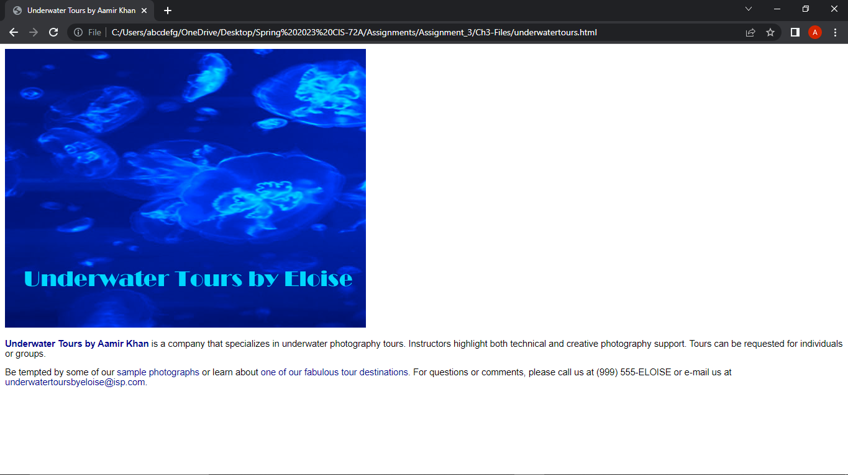

**Part 3 HTML Code: Code for the "Samplephotos.html" page (from your Ch 3 textbook work)**

[Paste your “HTML” Code from your “**Samplephotos.html**” pagebelow – Be sure to paste ALL of the code for the file. **No screen shots here!** Use “Courier New” or another monospace font to make your code more readable. Bold the code too if that helps make it more readable. ]

**<!DOCTYPE HTML>**

**<html lang="en">**

**<head>**

**<meta charset="utf-8" />**

**<title>Sample Photos</title>**

**<style type="text/css">**

**<!--**

**body {font-family: Arial, Verdana, Garamond;**

**font-size: 11pt;}**

**h1, h2, h3 {color: #020390;}**

**a {text-decoration: none;**

**color: #020390;}**

**a:hover {background: #020390;**

**color: #01d3ff;}**

**img.align-left {float: left;**

**margin-left: 5px;**

**margin-right: 5px;}**

**img.align-right {float: right;**

**margin-left: 5px;**

**margin-right: 5px;}**

**-->**

**</style>**

**</head>**

**<body>**

**<a id="top"></a>**

**<div>**

**<a href="underwatertours.html" style="background-color: transparent; text-decoration: none">**

**<img style="border-color: transparent" src="underwaterlogosm.jpg" width="158" height="49" alt="Back to home page" /></a>**

**</div>**

**<header>**

**<h1>SAMPLE PHOTOGRAPHS</h1>**

**</header>**

**<p><span style="color: #19212d; font-weight: bold">Underwater Tours by Aamir Khan</span> arranges a wide variety of full-day and half-day dives for families, friends, and teams. Imagine yourself taking photographs of beautiful underwater animals and scenes. Stop by our office to see pictures from the underwater tours that are available.</p>**

**<h2>Pictures from our half-day Maui tour:</h2>**

**<ul style="list-style-type: square">**

**<li><a href="#fish">Frog Fish</a></li>**

**<li><a href="#lobster">Colorful Lobster</a></li>**

**</ul>**

**<a id="fish"></a>**

**<h3>Frog Fish</h3>**

**<p><img class="align-left" src="fish.jpg" width="259" height="387" alt="Frog fish" /></p>**

**<p style="margin-right: 200px">This beautiful red fish is called a Frog Fish. It is just one example of the colorful sights that you will see underwater. We find Frog Fish during our Maui dives. Instructors on all tours show you how to make the best use of your equipment to take dynamic and lively photos of life underwater.</p>**

**<p>Visit our Web site or stop by our office to learn about the many exciting underwater tours that we offer. We can design a tour to meet the needs and desires of you and your group.</p>**

**<br style="clear: left" />**

**<p><a href="#top"><span style="font-size: small">To top</span></a></p>**

**<a id="lobster"></a>**

**<h3>Colorful Lobster</h3>**

**<p><img class="align-right" src="lobster.jpg" width="387" height="259" alt="Lobster" /></p>**

**<p>This picture highlights another Maui underwater tour sight. The colorful Hawaiian spiny lobster is often seen on this and other dives. The half-day Maui dive is chosen for its wonderful photographic opportunities of a variety of sea creatures. Beautiful photos of the sea animals and the surrounding environment can be taken on this tour.</p>**

**<p>There are many other full-day and half-day scenic underwater tours that you can experience with Underwater Tours by Eloise. You can design your dream tour by place or activity level.</p>**

**<br style="clear: right" />**

**<p><a href="#top"><span style="font-size: small">To top</span></a></p>**

**<p>These pictures, taken from the half-day Maui tour, show a sample of the many beautiful sights that you can see while enjoying your underwater tour.</p>**

**<p>To book your own trip, please call us at (999) 555-ELOISE or e-mail us at**

**<a href="mailto:underwatertoursbyeloise@isp.com">underwatertoursbyeloise@isp.com</a>. Please include the following information: (1) your address and phone number, (2) a list of your favorite photography activities, and (3) a few days and times that are convenient for us to contact you. We will respond immediately when we receive your request.</p>**

**<p><a href="underwatertours.html"><span style="font-size: small">Back to home page</span></a></p>**

**</body>**

**</html>**

**Part 4:** Answer the questions below, covering the “HTML5 and CSS3” longer YouTube video, by selecting the correct answer and **bolding and changing its text highlight color to yellow just like this text!**

**1. On the 3 page web site shown in the YouTube video, what HTML tag is shown in the video as having an "id"?**

a) body b) h2 c) header d) nav **e) section**

**2. What 2 different background colors are set with CSS and shown in the video for use on the "body" of the page?**

**a) aqua and silver**b) aqua and beige  
c) silver and brown  
d) yellow and white  
e) goldenrod and milktoast

**3. What code editor is used to modify the HTML and CSS code of the site shown in the video?**

a) Notepad **b) Brackets** c) Dreamweaver d) Text Edit e) BB Edit

**4. What is the height of the header area as set in the video's CSS code?**

a) 150px b) 20% **c) 175px** d) 15% e) 200px

**5. When an image being used for a background is too big to properly fit within the given width and height of an object it is being applied to with CSS, consider using the CSS property ________ and using a property value of "cover" or "contain", as shown in the "header" area of the pages in the video.**

a) background-repeat b) background-image **c) background-size** d) none of these

**6. What CSS property is used in the video to create a 3D effect for the text of the main heading on each page?**

a) h1 b) text-align c) text-decoration d) text-indent **e) text-shadow**

**7. What is the width of the left hand column (where the links are) in the layout of the pages in the video?**

a) 15% b) 20% c) 150px **d) 200px** e) 175px

**8. When you want to write a CSS style that will affect only links that are inside the "nav" area of a page, which selector was shown in the video as being successful?**

a) a b) a:hover **c) nav a** d) a hover e) nav hover

**9. As part of "de-emphasizing" the copyright area of the pages, what kind of margin was placed on the footer in the video?**

a) left and right b) top and bottom c) bottom only **d) top only** e) all 4 sides were set

**10. What is the name of the class given to the 2 skateboard images that appear on the "boards" page in the video?**

a) boards b) skateboard c) product **d) productpic** e) main