Aamir Khan HTML Spring 2023 Assignment #5

**Part 1 Screenshot: Your “Feedback Form Page” in the browser (after the HTML 5 Forms YouTube Video)**

[Paste your part 1 Feedback form page screenshot here. Use 2 screenshots if necessary to show the whole page.]

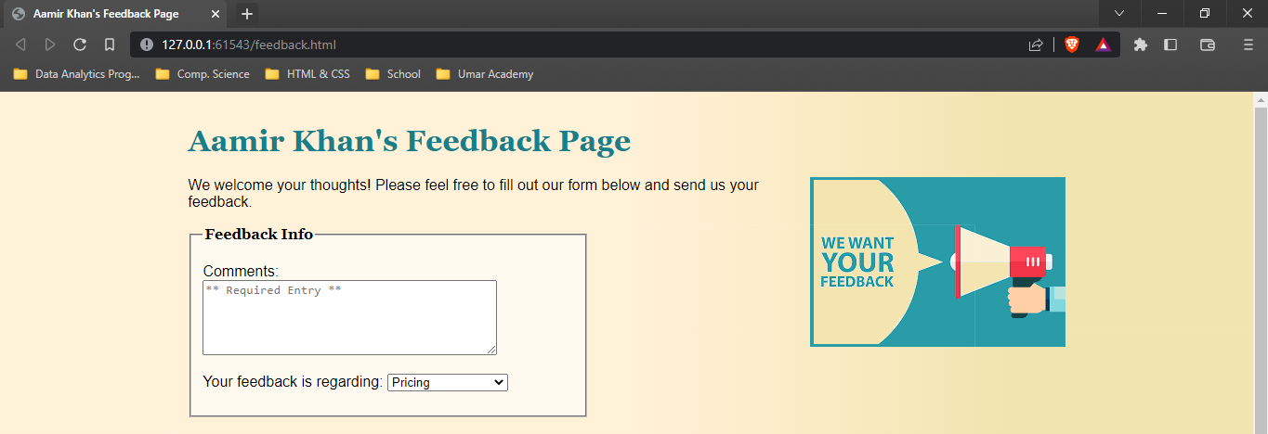

**Part 1 HTML Code: Your “feedback.html” HTML 5 Forms Feedback form page HTML Code**

[Paste your “feedback.html” HTML Code below – Be sure to paste ALL of the HTML code for the file. No screen shots here! Use “Courier New” or another monospace font to make your code more readable. Bold the code too if that helps make it more readable. ]

**<!DOCTYPE html>**

**<html lang="en">**

**<head>**

**<meta charset="utf-8">**

**<title>Aamir Khan's Feedback Page</title>**

**<link rel="stylesheet" href="site.css">**

**<link rel="stylesheet" href="form.css">**

**</head>**

**<body>**

**<header>**

**<h1>Aamir Khan's Feedback Page</h1>**

**<p><img class="floatright" src="want-feedback.png" alt="Want Feedback"></p>**

**</header>**

**<p>We welcome your thoughts! Please feel free to fill out our form below and send us your feedback. </p>**

**<form action="response.html" method="get">**

**<fieldset id="feedbackinfo"><legend>Feedback Info</legend>**

**<p><label for="comments">Comments: </label><textarea rows="5" cols="40" name="comments" id="comments" required="required" placeholder="** Required Entry **"></textarea>**

**</p>**

**<p><label for="re">Your feedback is regarding:</label>**

**<select name="re" id="re">**

**<option value="none">Choose One!</option>**

**<option value="products">Products</option>**

**<option value="cust-serv">Customer Service</option>**

**<option value="site">Website</option>**

**<option value="shipping">Shipping</option>**

**<option value="pricing">Pricing</option>**

**<option value="other">Other</option>**

**</select>**

**</p>**

**</fieldset>**

**<fieldset id="contactinfo"><legend>Contact Info</legend>**

**<p><label for="name">Name: </label><input type="text" name="name" id="name" required="required" placeholder="** Required Entry **"></p>**

**<p>How can we contact you? (check all that apply)<br>**

**<input type="checkbox" name="call" id="call"><label for="call"> Call? </label> <input type="checkbox" name="text" id="text"><label for="text"> Text? </label> <input type="checkbox" name="email" id="email"><label for="email"> Email? </label>**

**</p>**

**<p><label for="phonenum">Phone: </label><input type="tel" name="phonenum" id="phonenum" pattern="\d{3}[\-]\d{3}[\-]\d{4}" placeholder="Use xxx-xxx-xxxx"></p>**

**<p><label for="emailaddy">Email: </label><input type="email" name="emailaddy" id="emailaddy"></p>**

**</fieldset>**

**<p><input type="submit" value="Send Feedback"></p>**

**</form>**

**<footer>**

**<p>Copyright Aamir Khan, all rights reserved.</p>**

**</footer>**

**</body>**

**</html>**

**Part 2 Screenshot: Your “Blue Wav Music” textbook form page displaying in the browser.**

[Paste your part 2 “Blue Wav Music” textbook form page screenshot here. Use 2 screenshots if necessary to show the entire page.]

**Part 2 HTML Code: Your “Blue Wav Music” textbook form page HTML Code:**

[Paste your “Blue Wav Music” page (“bluwavform.html”) HTML Code below – Be sure to paste ALL of the HTML code for the page – it is ok if it takes several pages. No screen shots here! Use “Courier New” or another monospace font to make your code more readable. Bold the code too if that helps make it more readable. ]

**<!DOCTYPE HTML>**

**<html lang="en">**

**<head>**

**<meta charset="utf-8" />**

**<title>Blu Wav Music</title>**

**<style type="text/css">**

**<!--**

**legend {float: left;**

**color: #0000fe;**

**font-style: italic;**

**font-size: small;}**

**-->**

**</style>**

**</head>**

**<body>**

**<form method="post" action="mailto:bluwav@isp.com">**

**<header>**

**<img src="bluwavlogo.jpg" width="410" height="139" alt="Blu Wav logo" />**

**</header>**

**<p>Aamir Khan would like to know what types of music you enjoy so we can provide that music via streaming and download. Please complete our survey.</p>**

**<fieldset><legend>Listener Information</legend>**

**<p>First Name: <input name="firstname" type="text" size="25" /> &nbsp; &nbsp;**

**Last Name: <input name="lastname" type="text" size="25" /> &nbsp; &nbsp;**

**E-mail Address: <input name="email" type="text" size="25" /></p>**

**</fieldset>**

**<fieldset><legend>Music Genre and Purchasing Habits</legend>**

**<br />Select the type(s) of music that you prefer:**

**<br /><input name="musictype" type="checkbox" value="country" />Country &nbsp;**

**<input name="musictype" type="checkbox" value="folk" />Folk &nbsp;**

**<input name="musictype" type="checkbox" value="jazz" />Jazz &nbsp;**

**<input name="musictype" type="checkbox" value="latin" />Latin &nbsp;**

**<input name="musictype" type="checkbox" value="pop" />Pop &nbsp;**

**<input name="musictype" type="checkbox" value="rap" />Rap &nbsp;**

**<input name="musictype" type="checkbox" value="rock" />Rock**

**<p>Where do you make most of your music purchases:**

**<br /><input name="purchases" type="radio" value="none" />Don't buy music &nbsp;**

**<input name="purchases" type="radio" value="itunes" />iTunes &nbsp;**

**<input name="purchases" type="radio" value="amazon" />Amazon &nbsp;**

**<input name="purchases" type="radio" value="online" />Other online store &nbsp;**

**<input name="purchases" type="radio" value="retail" />Retail store &nbsp;**

**</p>**

**</fieldset>**

**<fieldset><legend>Radio Stations</legend>**

**<p>Favorite Internet radio station:**

**<select name="station">**

**<option>Google</option>**

**<option>Live 365</option>**

**<option>Pandora</option>**

**<option>Slacker</option>**

**<option>Spotify</option>**

**</select>**

**&nbsp; &nbsp;Name station not listed:**

**<input name="additstation" type="text" size="30" maxlength="30" />**

**</p>**

**</fieldset>**

**<br />What else can you tell us about your music preferences?**

**<br /><textarea name="other" rows="3" cols="100"></textarea>**

**<p><input type="submit" value="Submit" />**

**<input type="reset" value="Reset" />**

**<br />Thank you for your completing our survey.</p>**

**</form>**

**</body>**

**</html>**