CIS-72B Lab Hours Timesheet

Your Name: < **Aamir Khan** >

|  |  |  |  |  |  |  |
| --- | --- | --- | --- | --- | --- | --- |
| **#** | **Date** | **Start Time** | **End Time** | **Time Spent** | **Total So Far** | **Activity Description** |
| 1 | 4/17/23 | 12:00 PM | 12:25 PM | 0:25 | 0:25 | Introduction to CSS (6 min. video), CSS Terminology (5 min. video), and DevTips’ CSS Basics Video (Part 1: 5 min. video) + Notes |
| 1 | Evidence Description: Notes on these videos written below. | | | | | |
| 2 | 4/17/23 | 12:25 PM | 12:40 PM | 0:15 | 0:40 | Introduction to Brackets by Scott Mcleod |
| 2 | Evidence Description: Screenshot of Brackets pasted below. | | | | | |
| 3 | 4/17/23 | 12:40 PM | 1:15 PM | 0:35 | 1:35 | W3Schools HTML Introduction Tutorial + Notes |
| 3 | Evidence Description: Notes on this tutorial written below. | | | | | |
| 4 | 4/17/23 | 1:15 PM | 2:15 PM | 1:00 | 2:35 | Week 1 Recording + Notes |
| 4 | Evidence Description: Notes on the recording written below. | | | | | |
| 5 | 4/17/23 | 5:00 PM | 5:45 PM | 0:45 | 3:20 | HTML5 and CSS3 Tutorial Video |
| 5 | Evidence Description: Screenshot of the code pasted below. | | | | | |
| 6 | 4/24/23 | 11:00 AM | 11:50 AM | 0:50 | 4:10 | Basic CSS Selection Techniques Video + Notes (50 min.) |
| 6 | Evidence Description: Screenshot of the code pasted below. | | | | | |
| 7 | 4/24/23 | 12:10 PM | 12:35 PM | 0:25 | 4:35 | CSS Text Styling Tutorial + Notes (25 min.) |
| 7 | Evidence Description: Notes on this video written below. | | | | | |
| 8 | 4/26/23 | 5:00 PM | 6:30 PM | 1:30 | 6:05 | Week 2 Recording + Notes ( & Following Along) |
| 8 | Evidence Description: mystyles.css code included with modifications and comments below. | | | | | |
| 9 | 4/27/23 | 11:30 AM | 12:00 PM | 0:30 | 6:35 | Preparation & Practice Midterm |
| 9 | Evidence Description: Practice midterm completed in Canvas. | | | | | |
| 10 | 5/1/23 | 12:00 PM | 1:30 PM | 1:30 | 8:05 | Week 3 Recording + Notes ( & Following Along) |
| 10 | Evidence Description: mystyles.css code included. | | | | | |
| 11 | 5/1/23 | 1:30 PM | 2:30 PM | 1:00 | 9:05 | DevTips’ CSS Basics: Parts 2-5 (Videos + Notes) |
| 11 | Evidence Description: Notes on these videos written below. | | | | | |
| 12 | 5/8/23 | 1:00 PM | 2:30 | 1:30 | 10:35 | Box Properties Video (73 min) + Following Along |
| 12 | Evidence Description: spin_box.css file code included below. | | | | | |
| 13 | 5/8/23 | 2:30 PM | 3:15 PM | 0:45 | 11:20 | Net Ninja: Backgrounds, Multiple Backgrounds, and Background Gradients Videos + Notes |
| 13 | Evidence Description: Notes on these videos written below. | | | | | |
| 14 | 5/15/23 | 10:30 AM | 12:30 PM | 2:00 | 13:20 | Midterm Preparation and Review |
| 14 | Evidence Description: Preparation notes for the midterm written below. | | | | | |
| 15 | 5/22/23 | 11:00 AM | 12:20 PM | 1:20 | 14:40 | CSS Final Project Part 1 + Following Along |
| 15 | Evidence Description: Work is found in my final project. | | | | | |
| 16 | 5/29/23 | 12:00 PM | 2:00 PM | 2:00 | 16:40 | CSS Final Project Parts 2-3 + Following Along |
| 16 | Evidence Description: Work is found in my final project. | | | | | |
|  | | | | | | |
|  | **SAMPLE ENTRIES:** | | | | | |
|  | **5/22** | **9:30am** | **10:10am** | **0:40** | **0:40** | **Brackets YouTube Video** |
|  | Evidence Description: Screenshot of my code shown in the Brackets editor app (pasted below) | | | | | |
|  | **5/28** | **10am** | **11am** | **1:00** | **1:40** | **Khan Academy: Intro To CSS** |
|  | Evidence Description: My CSS code created during the tutorial (pasted below) | | | | | |

**Notes**: Use Word to fill this out each time you do lab work. Your goal is to show at least 1 hour of work weekly (including the first and last weeks), and accumulate at least 18 hours by the semester's end. You must submit this as proof of your lab hours at the end of the semester. **Assignment coding does not count, so do not mention assignments in your activity descriptions, mention the topics / skills development involved.** Use a 2nd sheet as needed.

**Include evidence of your work done (screen shots/code/etc) on the following pages,one per page, in the same numbered order as the activities above.**

|  |  |  |  |  |  |  |
| --- | --- | --- | --- | --- | --- | --- |
| **#** | **Date** | **Start Time** | **End Time** | **Time Spent** | **Total So Far** | **Activity Description** |
| 17 | 5/29/23 | 1:00 PM | 1:30 PM | 0:30 | 17:10 | Final Project Layout Guide + Following Along |
| 17 | Evidence Description: Work is found in my final project. | | | | | |
| 18 | 5/29/23 | 2:00 PM | 2:25 PM | 0:25 | 17:35 | Logo Experimentation With Canva |
| 18 | Evidence Description: Work is found in my final project. | | | | | |
| 19 | 6/6/23 | 12:00 PM | 12:30 PM | 0:30 | 18:05 | Week 7 Recording + Notes (30 min.) |
| 19 | Evidence Description: Notes on the recording written below. | | | | | |
|  | | | | | | |
|  | **SAMPLE ENTRIES:** | | | | | |
|  | **5/22** | **9:30am** | **10:10am** | **0:40** | **0:40** | **Brackets YouTube Video** |
|  | Evidence Description: Screenshot of my code shown in the Brackets app (pasted below) | | | | | |
|  | **5/28** | **10am** | **11am** | **1:00** | **1:40** | **Khan Academy: Intro To CSS** |
|  | Evidence Description: My CSS code created during the tutorial (pasted below) | | | | | |

**Copy/Paste Your Activity Evidence Below on the following pages**

**Evidence Page for Lab Activity #1: (paste your evidence below)**

**CSS allows us to style our webpages to make them more presentable. In the same way we can change our outfits to change our looks, we can also “change the outfits” of our webpages to give them different designs or themes. In CSS, we have properties that are essentially aspects of presentation. Anytime you have a property, a value follows right after. Moreover, the value and property are separated by a colon always. You always want to follow property values with a semicolon so that there is a separation between different properties. A declaration includes a property, its property value, and the semicolon after the value. A series of declarations is called a declaration block. These declaration blocks are always surrounded by curly braces. Just before a declaration block will be a selector. A selector specifies what elements are being selected to have the styles mentioned in the declaration block applied to them. The selector and its declaration block is referred to as a single rule. HTML is geared towards the actual content that makes up a webpage. CSS is geared towards adding style to those very same webpages. External style sheets allow us to make changes to the styles of a webpage all while editing a single file.**

**Evidence Page for Lab Activity #2: (paste your evidence below)**

**Evidence Page for Lab Activity #3: (paste your evidence below)**

**HTML stands for hyper-text markup language, and it is the standard markup language used to create webpages. It defines the structure of a webpage. The <!DOCTYPE html> declaration indicates that our document is an html5 document. All html pages must have an html tag as it’s the root element of all html documents. The head section contains metadata about our html document. The title tag specifies the title of our webpage. The body tag defines the webpage’s body. This body is where all the visible information is placed, such as lists, tables, etc. We use h1-h6 elements to define headings and p elements to define paragraphs. An element consists of a start tag, content, and a corresponding end tag. Web browsers take these html documents and read their contents to display their contents to the viewer.**

**Evidence Page for Lab Activity #4: (paste your evidence below)**

**There are many ways to get help in this class, such as through the CSS validation sites, by emailing you through canvas or our student email, referring to CSS resources, scheduling office hours with you, etc. CSS is a very useful language that allows us to modify the appearance of our websites and make them more visually pleasing. We can add CSS rules directly into the head section of our html document, but the best way to add styles is through an external style sheet. Here, we’d be able to modify the appearance of all of our webpages from a single file. Within our style sheet, we can have as many rules to define our webpage’s appearance. Each rule consists of a selector and a declaration block. One rule we will most often have is a rule for our body to set some general styles in place. We will have assignments throughout our 8-week period that will usually consist of some questions, follow-along video tutorials, and some textbook tutorials. Our homework will make up 45% of our grade, and the final project will essentially be like another assignment worth 30% of our grade. We have to record weekly lab activities and gather up at least 18 hours per the lab hours requirement. We need to show at least 1 hour of lab activity during the first week to show activity and participation. We also need to introduce ourselves as our first participation activity. Lastly, we need to have the textbook ready by next week or as soon as possible as only the first assignment doesn’t need the textbook. All other assignments will require the textbook.**

**Evidence Page for Lab Activity #5: (paste your evidence below)**

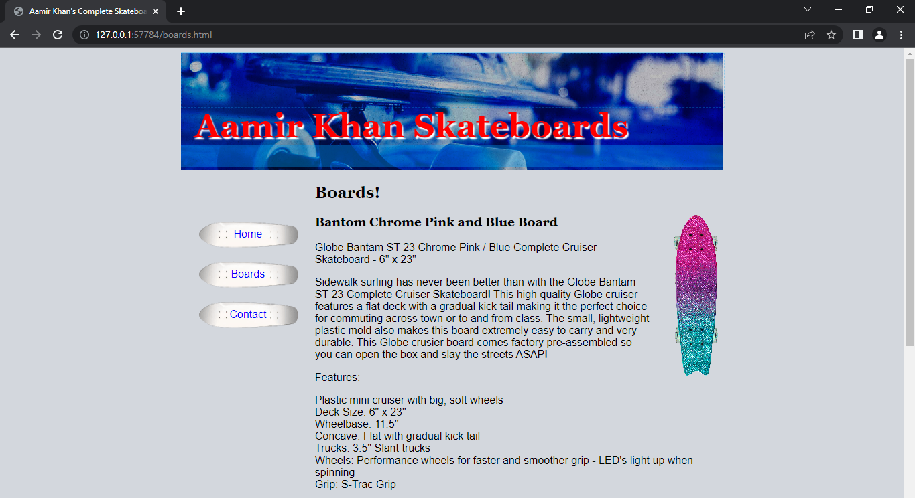



**Evidence Page for Lab Activity #6: (paste your evidence below)**

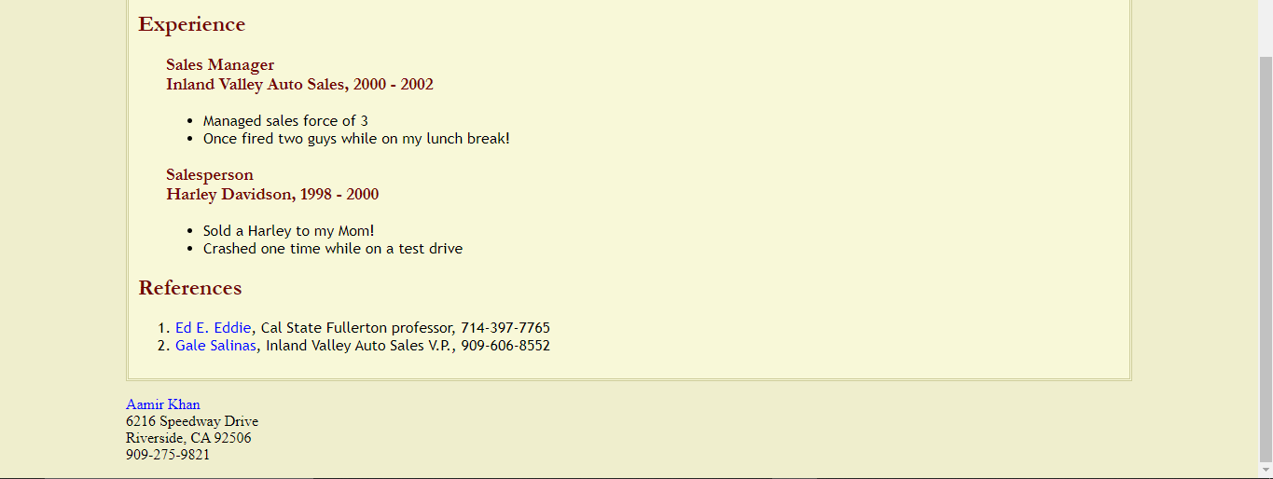

**Evidence Page for Lab Activity #7: (paste your evidence below)**

**There are various color and text properties that we can use to style different elements and add unique formatting to our webpages. Some of these properties include: font-family, font-size, text-alignment, text-decoration, text-indent, text-transform, color, letter-spacing, and line-height. We can use font-family to set the fonts that we’d like to use. We use font-size to appropriately set the size of our font. Text-alignment is used to align our text in various ways, such as centering our text. We can use text-decoration to add decorations to our text, such as underlining our text. Additionally, we can also indent our text in any way we like. The text-transform property allows us to transform our text, such as capitalizing, lowercasing, and uppercasing our text. Letter-spacing and word-spacing allow us to specify how much space we’d like in between letters or words, respectively. Lastly, line-height allows us to specify how much space we’d like in between our lines.**

**Evidence Page for Lab Activity #8: (paste your evidence below)**

**body**

**{**

**background: #10aaa8;**

**font-family: Arial, sans-serif;**

**color: antiquewhite;**

**font-weight: 100;**

**}**

**/* Group selector. */**

**h1, h2, h3**

**{**

**font-family: Georgia, serif;**

**color: black;**

**margin-bottom: 0px;**

**}**

**/* Sibling selectors: We're selecting all elements that come directly after h2 and h3 headings in our webpage. We use to * to indicate all elements. */**

**h2 + *, h3 + *{**

**margin-top: 5px;**

**}**

**a {**

**color: antiquewhite;**

**}**

**/* Pseudo-class selector. */**

**a:visited {**

**color: darkblue;**

**}**

**/* Pseudo-class selector. */**

**a:hover**

**{**

**color:red;**

**}**

**/* Descendant pseudo-class selector. */**

**nav a:hover{**

**background-color: blanchedalmond;**

**color: palevioletred;**

**}**

**/* Targeting an ID. */**

**#main{**

**border-left: dotted 1px black;**

**padding-left: 15px;**

**}**

**Evidence Page for Lab Activity #10: (paste your evidence below)**

**body {**

**background: #50bac8;**

**font-family: Arial, Verdana, sans-serif;**

**color: antiquewhite;**

**font-weight: 100;**

**}**

**h1, h2, h3 {**

**font-family: Georgia, Times, serif;**

**color: black;**

**margin-bottom: 0px;**

**font-weight: bold;**

**}**

**h1 {**

**font-size: 140%;**

**}**

**h2 {**

**font-size: 125%;**

**}**

**h3 {**

**font-size: 100%;**

**color: gray;**

**}**

**h2 + *, h3 + * {**

**margin-top: 0px;**

**}**

**#main p:nth-child(2) {**

**font-size: 105%;**

**font-style: italic;**

**font-weight: bold;**

**}**

**a:hover**

**{**

**color:beige;**

**}**

**nav a:hover{**

**background-color: white;**

**color: aqua;**

**}**

**#main{**

**border-left: dotted 1px gray;**

**padding-left: 25px;**

**}**

**Evidence Page for Lab Activity #11: (paste your evidence below)**

**With CSS, we can target many HTML elements across different pages through a single style sheet. Using CSS, we can apply rules to HTML elements, but we’re not limited to just one rule. Rather, we can apply as many rules to the same HTML elements to customize them in various different ways. We can use special attributes to target elements, such as id’s and class’s to target specific elements. We use id’s to target a single, unique element. Only 1 instance of an id can exist on a page as it’s used for a distinct element. However, multiple instances of a class can exist on a single webpage. Moreover, many classes can be attached onto a single element. To write styles, we enclose properties with their corresponding values in curly braces. We can’t forget our selector that targets the elements we’re styling. All of these components make up a style rule for our webpage. There are many kinds of selectors to choose from including stacked selectors, descendant selectors, etc. A direct descendant selector only selects elements that are direct children of another element. For example, if we had p > li, we’d be targeting all li’s that are direct children of p elements. We can also use adjacent/sibling selectors to only target a specific element that comes directly after another element. A sibling combinator selector is like an extension of the adjacent selector. It selects all the instances of a specific element that comes after another element. For example, if we had p ~ span, we’d be targeting all spans that come after p elements (~ is used for a sibling combinator selector).**

**Evidence Page(s) for Lab Activity #12: (paste your evidence below)**

**/* Box Styles for Aamir Khan's Daily Spin -- Complete Blog Pages */**

**div#page {**

**border: solid 4px #770000;**

**background-color: #D8D8D8;**

**padding: 10px;**

**}**

**div#content {**

**border: solid 1px #3366CC;**

**}**

**div#masthead {**

**padding: 0 20px 30px 20px;**

**}**

**h2 {**

**float: right;**

**margin: -2em 25px 0 0;**

**}**

**div#links {**

**float: left;**

**width: 20%;**

**border: solid 1px #3366CC;**

**border-left-width: 0;**

**background-color: #D8D8D8;**

**margin-left: -1px;**

**}**

**#links p {**

**text-indent: 10px;**

**margin: 0;**

**padding: 1px 0;**

**border-bottom: 1px solid #E0E0E0;**

**}**

**#links .level2 p {**

**text-indent: 25px;**

**}**

**#links a {**

**display: block;**

**width: 100%;**

**}**

**#links a:link, #links a:visited {**

**padding: 0 0 1px 3px;**

**}**

**#links a:hover, #links a:active {**

**padding: 0;**

**border-left: 3px #770000 solid;**

**border-bottom: 1px #770000 solid;**

**}**

**h3 {**

**margin: 0 0 5px 40px;**

**}**

**div#blogs {**

**float: left;**

**width: 65%;**

**}**

**#blogs p {**

**margin-top: 0;**

**margin-bottom: 1.5em;**

**margin-left: 40px;**

**text-align: justify;**

**}**

**#blogs .pullquote {**

**float: right;**

**background-color: #F0F0F0;**

**width: 25%;**

**color: #770000;**

**font: 1.4em Georgia, Times, serif;**

**margin: 0 0 0 15px;**

**padding: 2px 2px 0 5px;**

**border: solid #770000;**

**border-width: 1px 3px 0 0;**

**}**

**div#footer {**

**clear: both;**

**}**

**Evidence Page for Lab Activity #13: (paste your evidence below)**

**There are many different background properties that one can take advantage of. A few include: background-color, background-image, background-repeat, background-position, and background-size. All of these properties can be used to modify the appearance of your background and to customize how exactly you want your background to look like. Additionally, you can use multiple backgrounds by specifying as many background images you’d like in the background-image property. You do have to separate these images using commas. For every other background property, you now would have to specify values for both images being used by separating your values with commas like you did before. An example of a unique customization we can add is gradients. In the background property, we’d type our “background: linear-gradient()” and specify some values within the parentheses. The very first value we specify will be the direction of our gradient. It is the direction the gradient will run from, so if we typed “top” for example, the gradient would run from top to bottom. The next values will be the starting color as well as the position we want to start it from. For example, “background: linear-gradient(top, #606060 0%, …)” would start our gradient 0% from the top with the given color. The final values will be the ending color of our gradient as well as the position we want to end it at. For example, “background: linear-gradient(top, #606060 0%, #808080 100%)” would start our gradient 0% from the top with the first color and end it 100% from the top with the second color. To make the process easier, there are CSS gradient generators out on the web that generate gradients for you at the click of a button, so you don’t have to worry about making mistakes with your gradients.**

**Evidence Page for Lab Activity #14: (paste your evidence below)**

**Margins are just one of the many CSS properties that we can add to our website. One thing to note is that the role of HTML is to structure the page, while the role of CSS is to format and style the page. If you feel you’ve made any mistakes in your CSS, W3C offers a validation tool for CSS and even HTML. We can style elements in distinct ways, and one way we can do this is by targeting an id. When using ids, we reference them by using a # sign followed by the name of the id we’ve chosen to give an element. When we style elements, we use style declarations on our selector. We can specify multiple declarations as long as they’re separated by semicolons. The best way to style a website with consistent styling is through an external CSS style sheet as opposed to using style tags within the head section or using inline CSS. One general tip when it comes to styling is that if you want to make general changes to the appearance of the whole page and how text appears on the whole page, we want to use the body tag to do this. In general, browsers already have some default settings in place for elements such as margins, font sizes, and colors, but you can modify these settings using CSS and a body tag as mentioned above. Alternatively, you could also just style them using a separate selector. Another way of styling elements is by using classes. Classes are more flexible than ids in that you can have same class applied to multiple, related elements, but ids can only be unique. Classes allow you to target multiple, related elements and style them all together.**

**Evidence Page for Lab Activity #19: (paste your evidence below)**

**One of the focus areas for this final project is the layout we choose to implement for our theme. There are many elements that we can play around with to get our desired look, such as adjusting margins and paddings. When using the margin property, you can specify only 2 values as shorthand. The first value affects the top and bottom margins and the second value affects the right and left margins. Another useful property we can adjust is the position of our elements. If we choose to float items, these items will stay at the same location on the page but float to the right or left. Items around our object will end up floating around it. However, we can also specifically choose where to position elements by using absolute positioning. This allows us to clearly specify where to position certain elements. If you want to position certain elements relative to another element, you’d use relative positioning on that other element, like we did with the page wrap id. This makes it so that the items you position are relative to some other larger element.**