**EXPERIMENT -3**

1. **View all Volume in Docker**

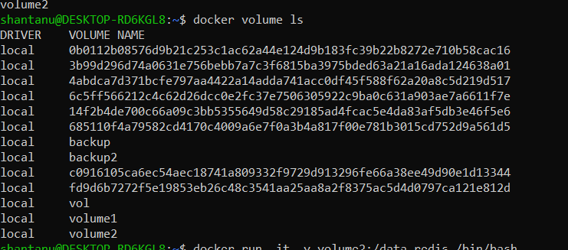

1. **Create a new Volume**

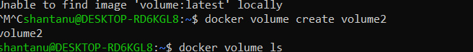

1. **Mount a Volume with a container** 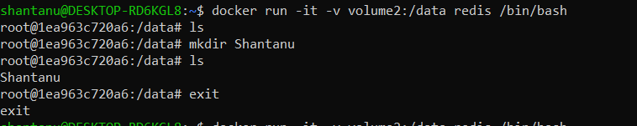
2. **Create another container and Mount with the same Volume**  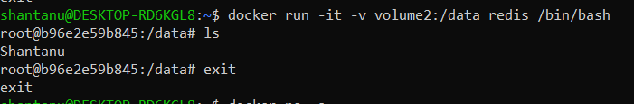
3. **See the complete working of container**

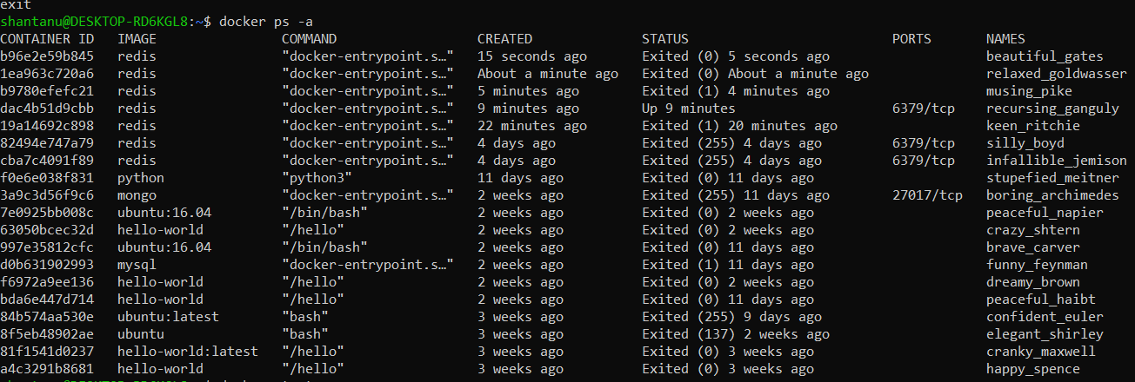

1. **Exited from container and restart again to see the persistent of Docker Volume**

