**EXPERIMENT 3**

**AIM:** Working with Docker Volume

1. View all Volume in Docker.

Command: **docker volume ls**

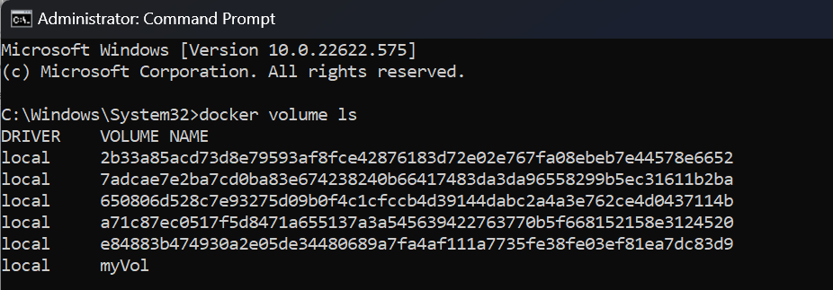

1. Create a new Volume.

Command: **volume create myVol2**

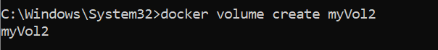

Command: **docker volume ls**

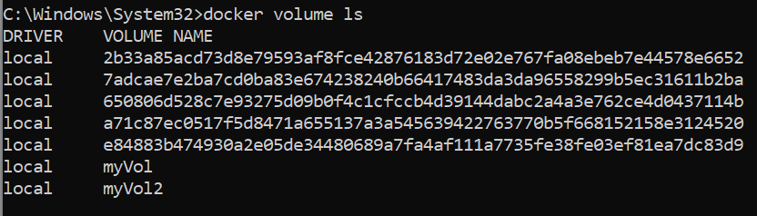

1. Mount a Volume with a container.

Command: **docker run -it -v myVol2:/data redis /bin/bash**

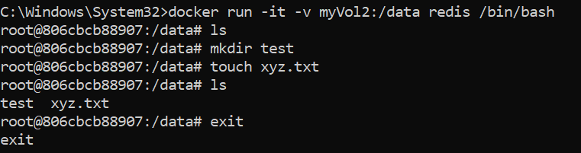

1. Create another container and Mount with the same Volume.

Command: **docker run -it -v myVol2:/data redis /bin/bash**

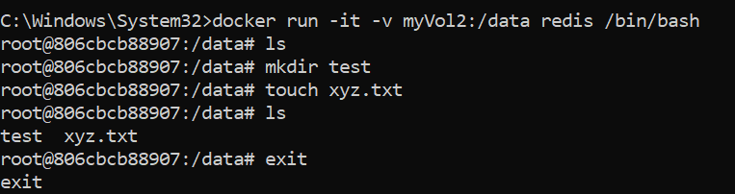

1. See the complete working of container.

Command: **ls, mkdir, touch**

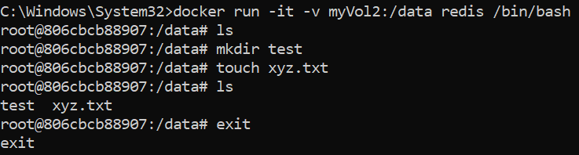

1. Exited from container and restart again to see the persistent of Docker Volume.

Command: **docker start 806cbc**

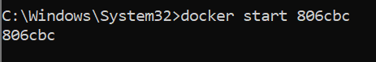

**docker attach 806cbcb88907**

