Experiment 5

**AIM:** Working with Dockerfile to Build and Push Docker Image.

1. Create a Dockerfile.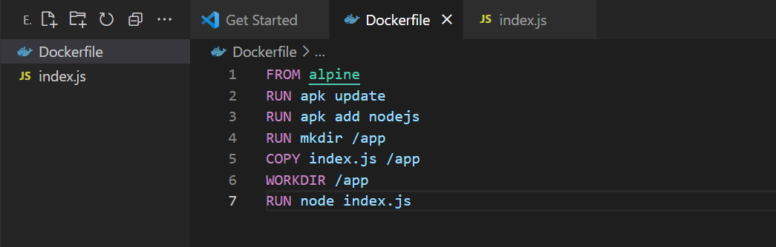
2. Build the Dockerfile.

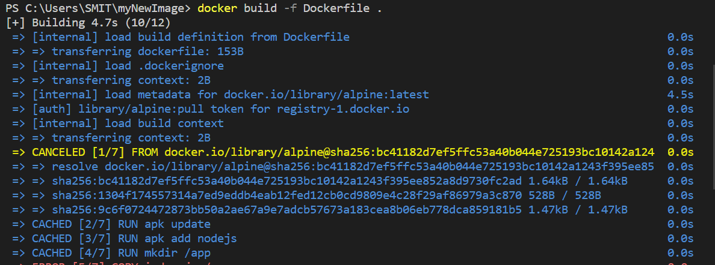

1. Now we have dockerized the app, we will Build image from Dockerfile.

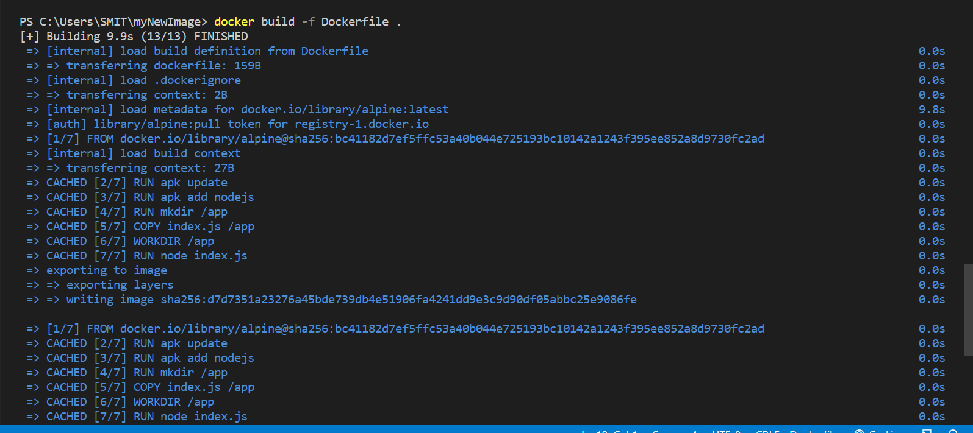

1. Create account on Dockerhub and create a repository in it.

Public view: <https://hub.docker.com/r/smit2802/mynode>

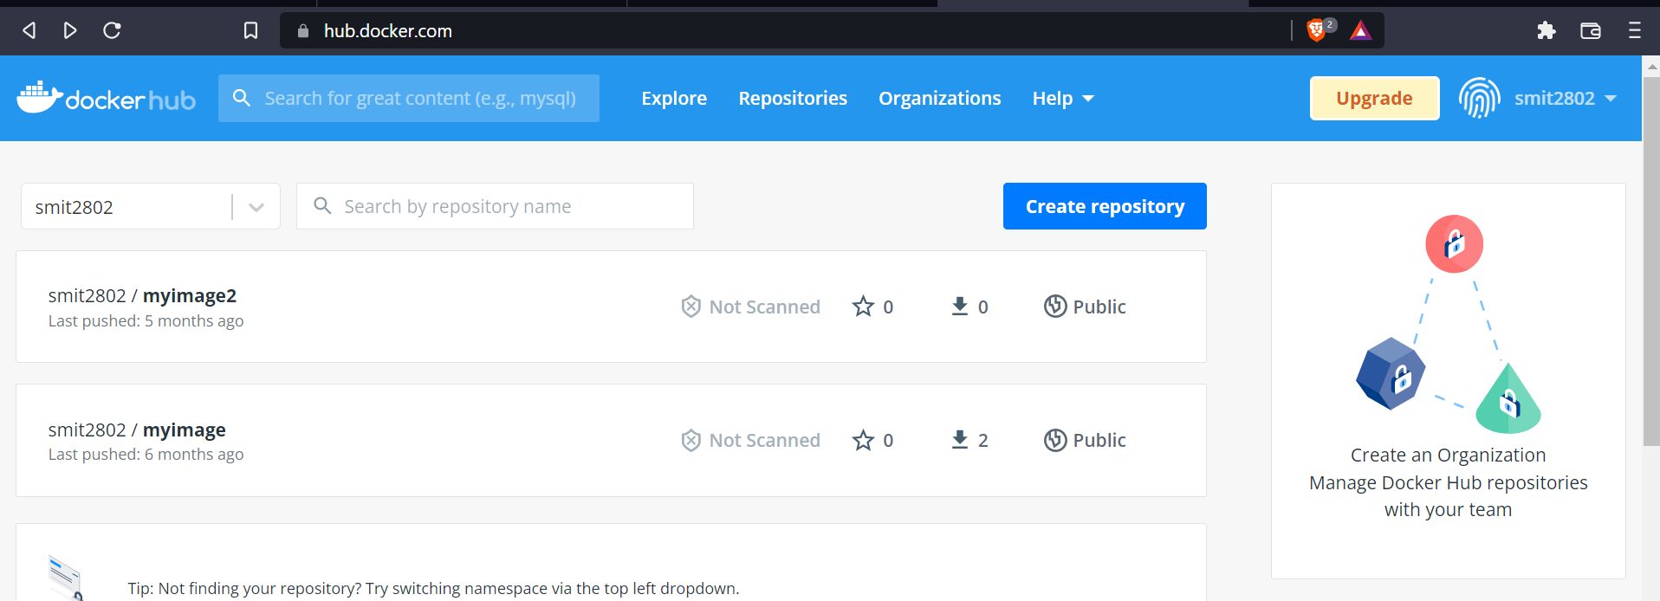

1. Tag the recently created image using following command.



1. Now push the image on Dockerhub using following command.

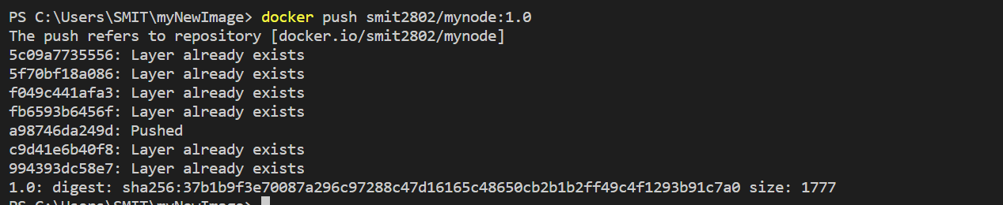

1. Pull and Run the container of your deployed image on docker hub.

