**EXPERIMENT 6**

**AIM:** Working with Docker Compose File to Control Multiple Containers.

**Steps to Complete:**

* Create a directory named nginx in your root.

Command : mkdir nginx

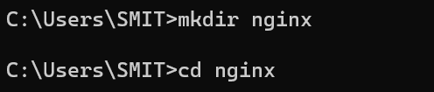

* Switch to that directory and create a file named docker-compose.yaml

Command: cd nginx



Command: vi docker-compose.yml

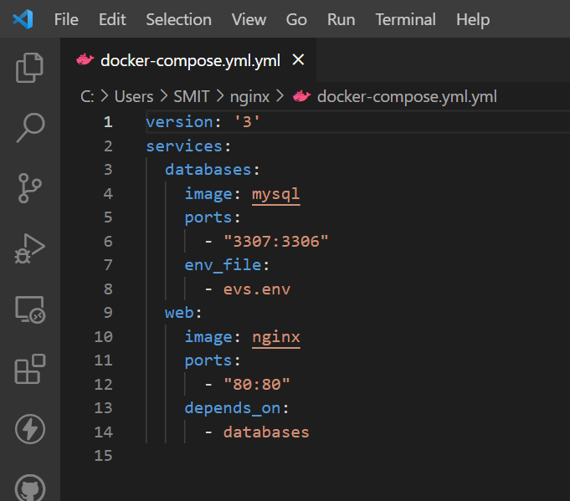

Command: vi evs.env

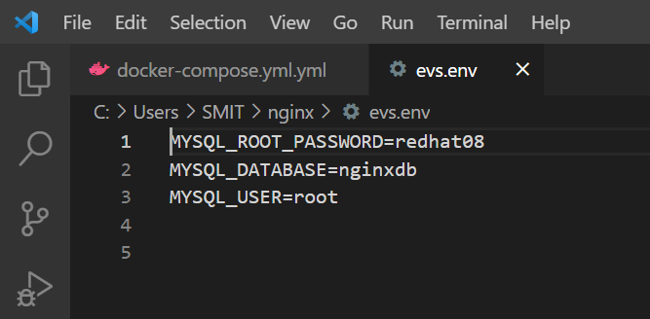

Save docker-compose.yaml file and do docker-compose up.

Command: docker-compose up -d

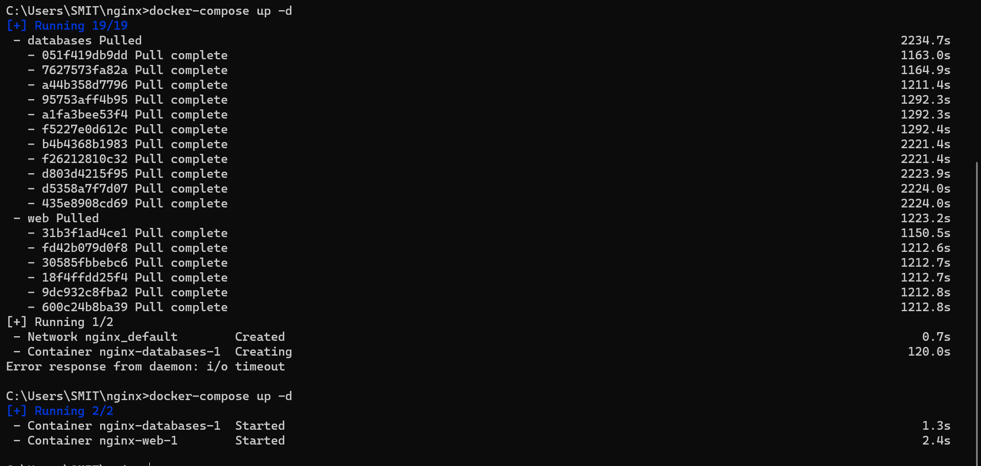

Verify nginx service is up and is accessible on machine.

Command: curl localhost:80

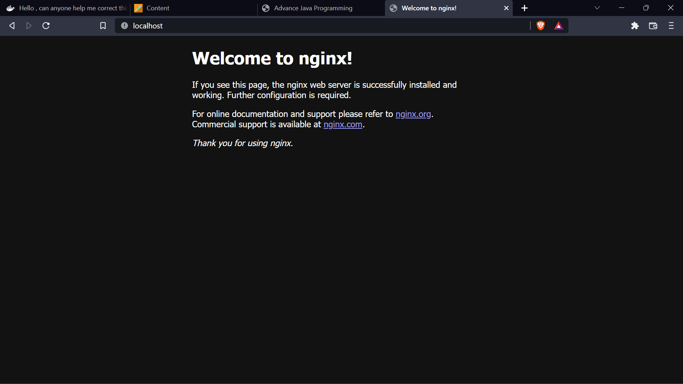

Stop and remove your docker container using docker-compose.

Command: docker-compose down

