EXPERIMENT – 6

AIM: Working with Docker Compose File to Control Multiple Containers

Create a directory named nginx in your root.

Command: -

**mkdir nginx**



Switch to that directory and create a file named docker-compose.yaml

**cd nginx**



**vi docker-compose.yml**

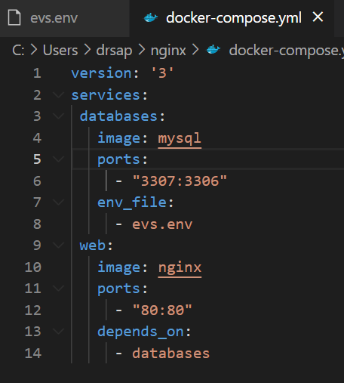

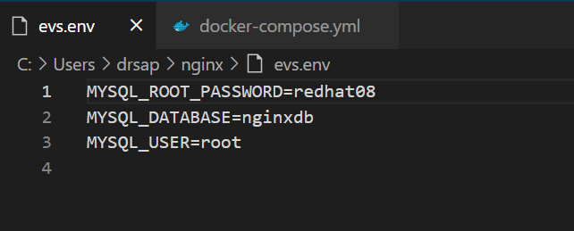

Running images using docker-compose

Save docker-compose.yaml file and do docker-compose up.

Command: - **docker-compose up -d**

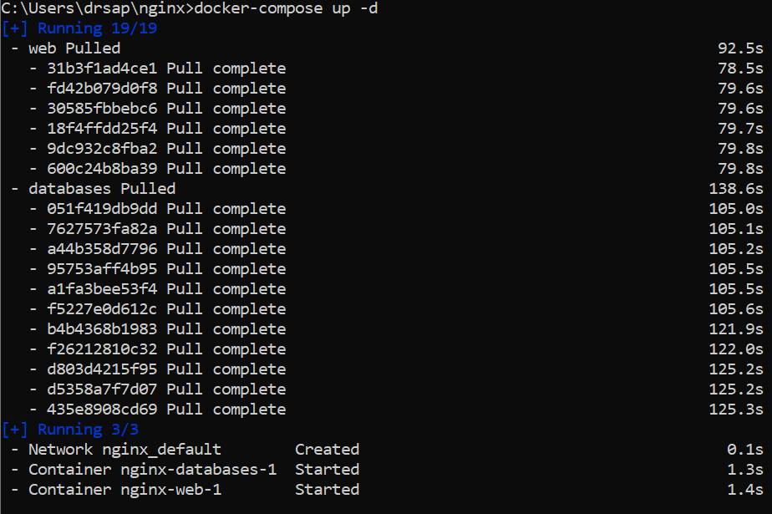



Stop and remove your docker container using docker-compose.

Command: -**docker-compose down**

