**Experiment-4**

Step 1 - Create Network

The first step is to create a network using the CLI. This network will allow us to attach multiple containers which will be able to discover each other. In this example, we're going to start by creating a backend-network. All containers attached to our backend will be on this network.

Task: Create Network To start with we create the network with our predefined name.

Command: -

**docker network create backend-network**



Task: Connect to Network When we launch new containers, we can use the --net attribute to assign which network they should be connected to.

Command: -

**docker run -d --name=redis --net=backend-network redis**



Step 2 - Network Communication Unlike using links, docker network behave like traditional networks where nodes can be attached/detached.

Command: -

**docker run --net=backend-network alpine ping -c1 redis**

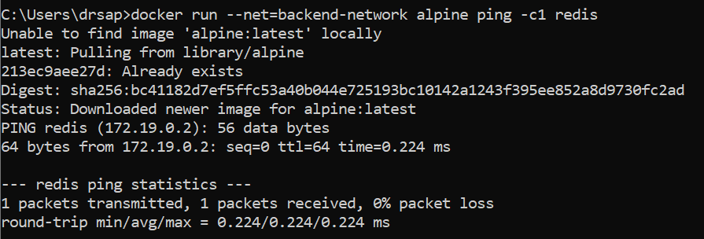

Step 3 - Connect Two Containers

Docker supports multiple networks and containers being attached to more than one network at a time.

For example, let's create a separate network with a Node.js application that communicates with our existing Redis instance.

Command: -

The first task is to create a new network in the same way.

**docker network create frontend-network**



When using the connect command it is possible to attach existing containers to the network

**docker network connect frontend-network redis**



When we launch the web server, given it's attached to the same network it will be able to communicate with our Redis instance.

**docker run -d -p 3000:3000 --net=frontend-network katacoda/redis-node-docker-example**

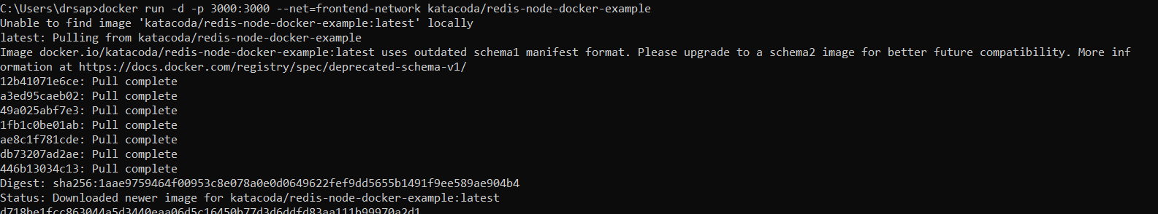

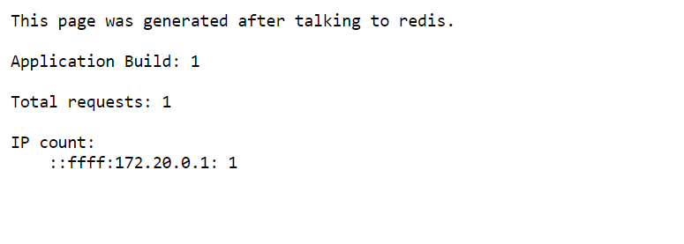

Step 4 - Create Aliases Links are still supported when using docker network and provide a way to define an Alias to the container name. This will give the container an extra DNS entry name and way to be discovered. When using --link the embedded DNS will guarantee that localised lookup result only on that container where the --link is used

Connect Container with Alias

The following command will connect our Redis instance to the frontend-network with the alias of db.

Command: -

**docker network create frontend-network2**



**docker network connect --alias db frontend-network2 redis**



When containers attempt to access a service via the name db, they will be given the IP address of our Redis container.

**docker run --net=frontend-network2 alpine ping -c1 db**

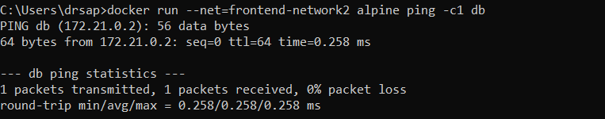

Step 5 - Disconnect Containers With our networks created, we can use the CLI to explore the details. The following command will list all the networks on our host.

Command: -

**docker network ls**

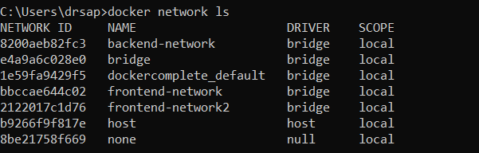

We can then explore the network to see which containers are attached and their IP addresses.

Command: - **docker network inspect frontend-network**

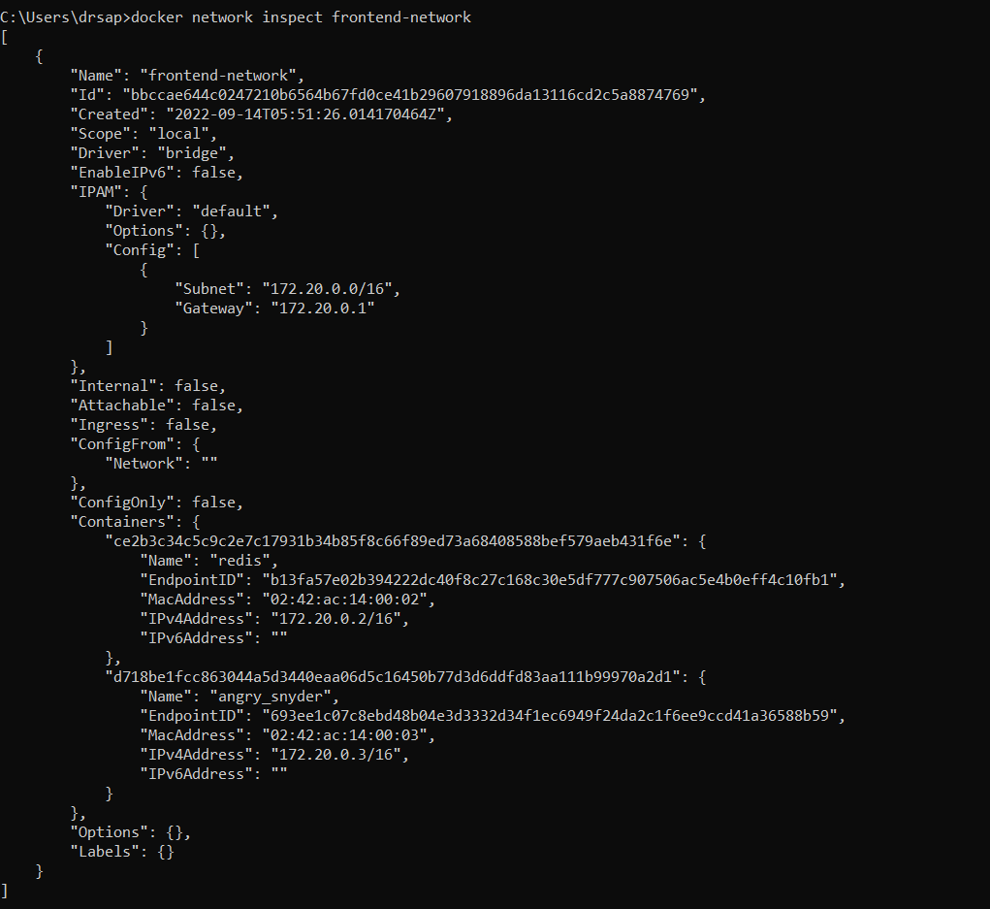

The following command disconnects the redis container from the frontend-network.

Command: - **docker network disconnect frontend-network redis**

