EXPERIMENT 4 & 5

Name : Urvashi Rathore

SAP ID : 500083262

Batch : Devops.

1. Create following Dockerfile

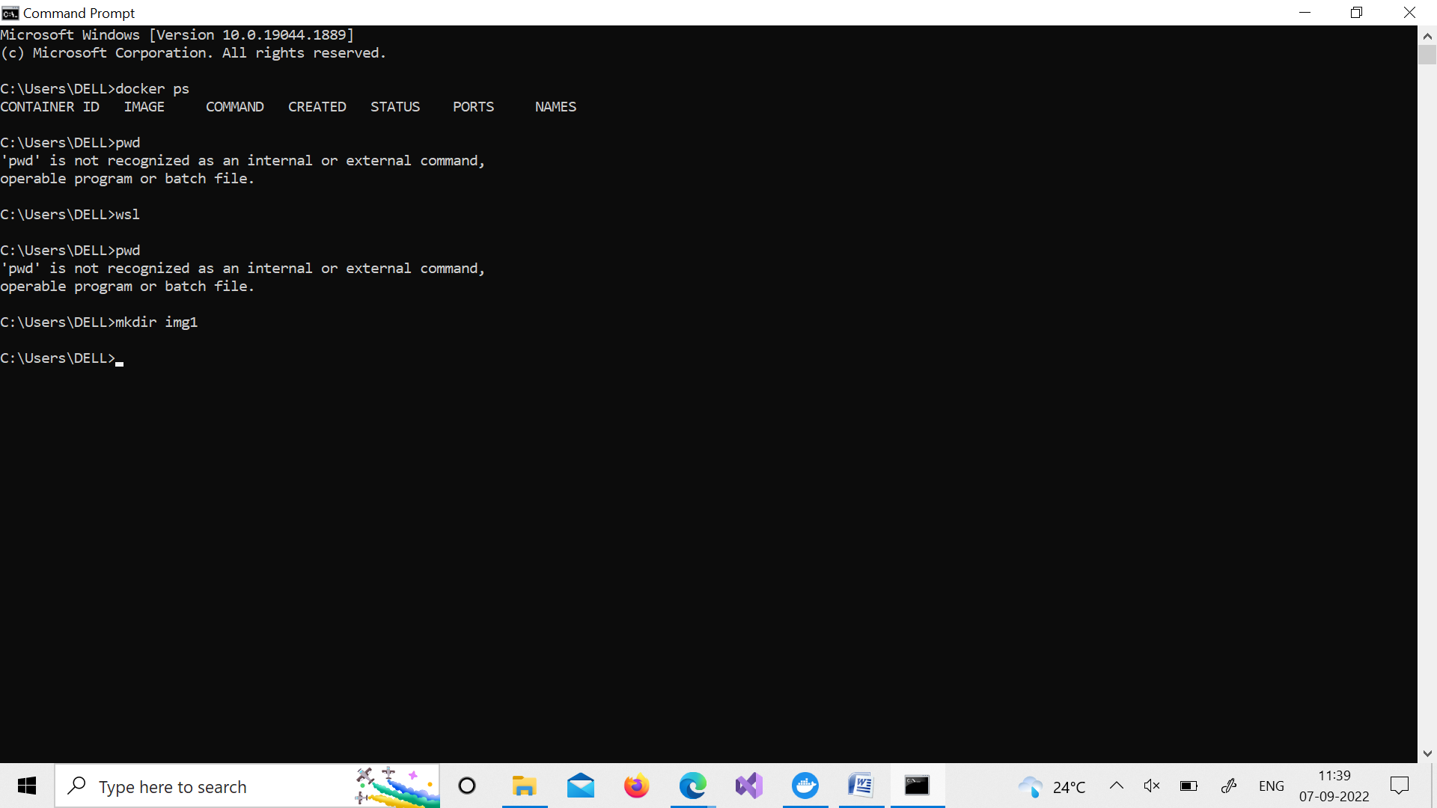

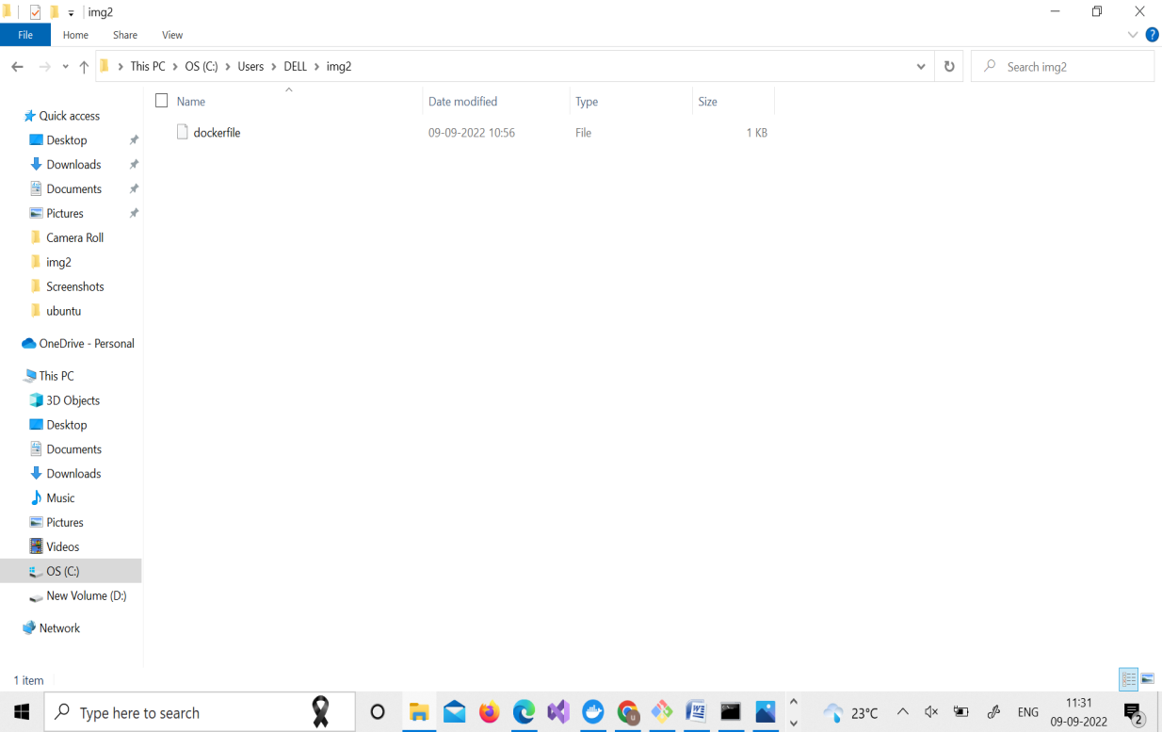

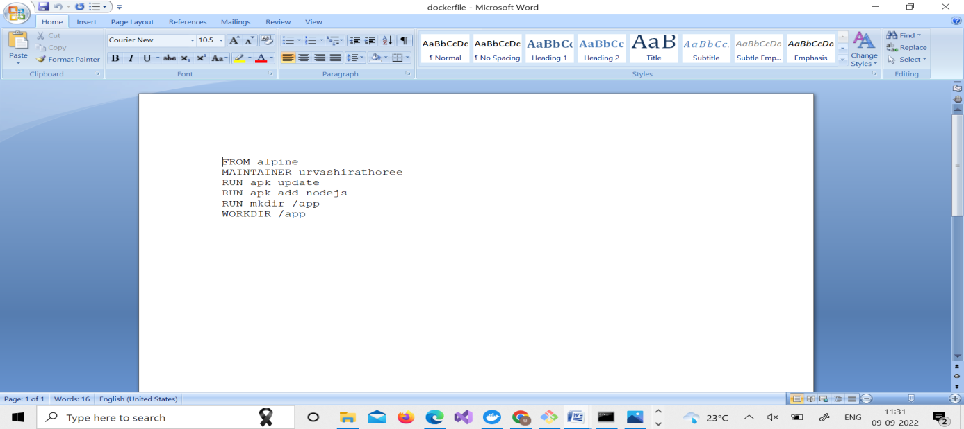

2.Now we have dockerized the app, we will Build image from Dockerfile.

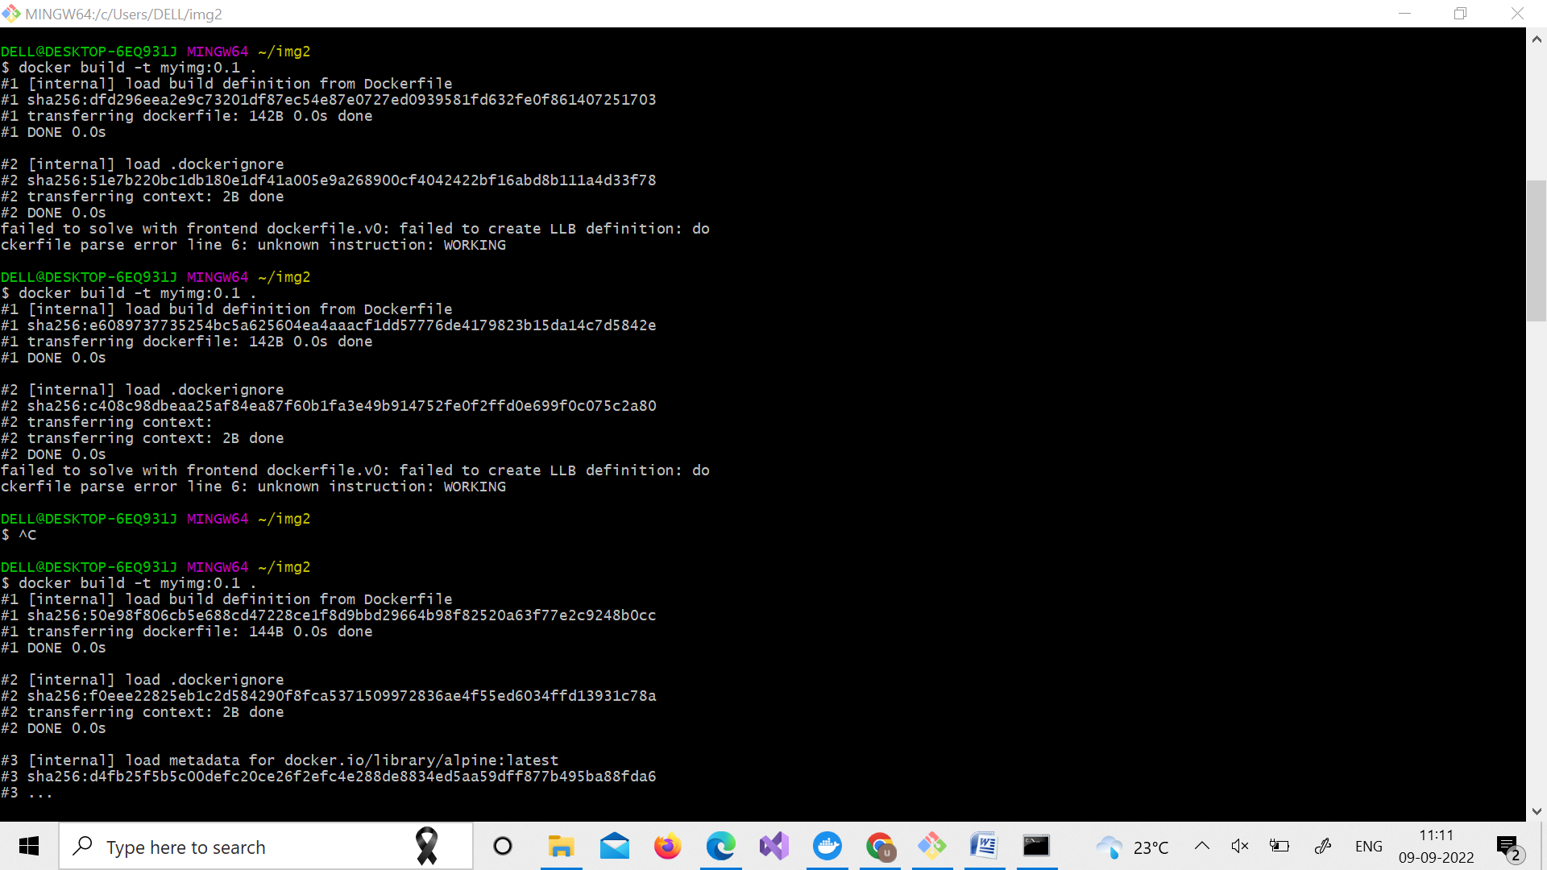

3.Create account on Dockerhub and create a repository in it.

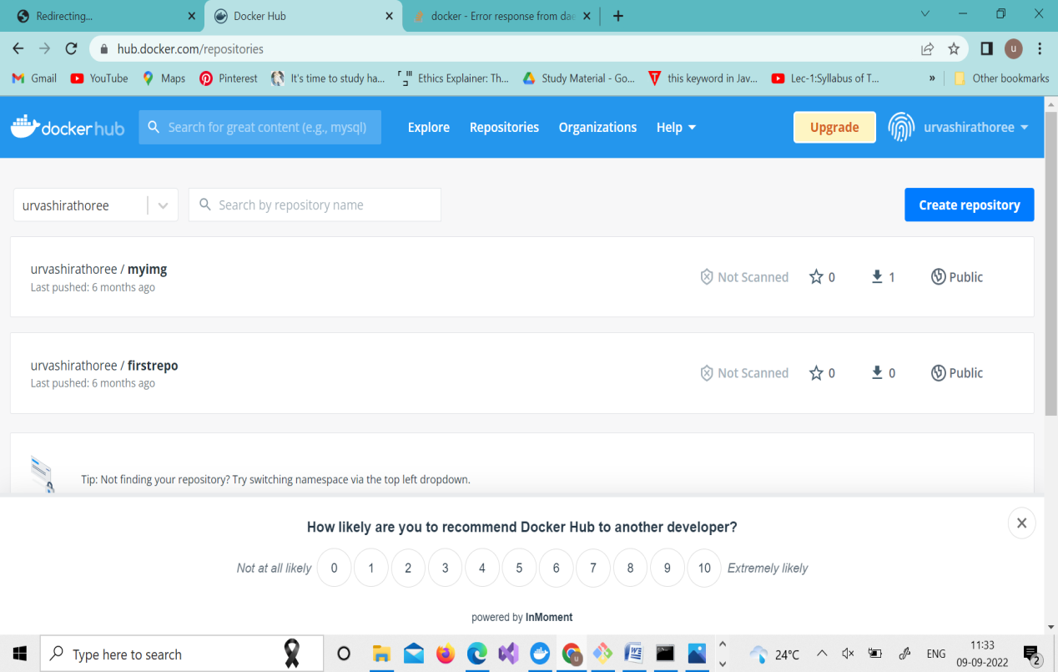

4.Tag the recently created image using following command.

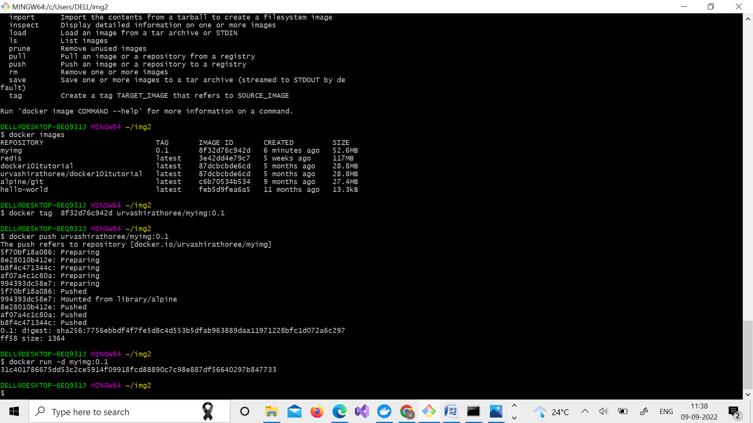

5. Login to Dockerhub from console using following command

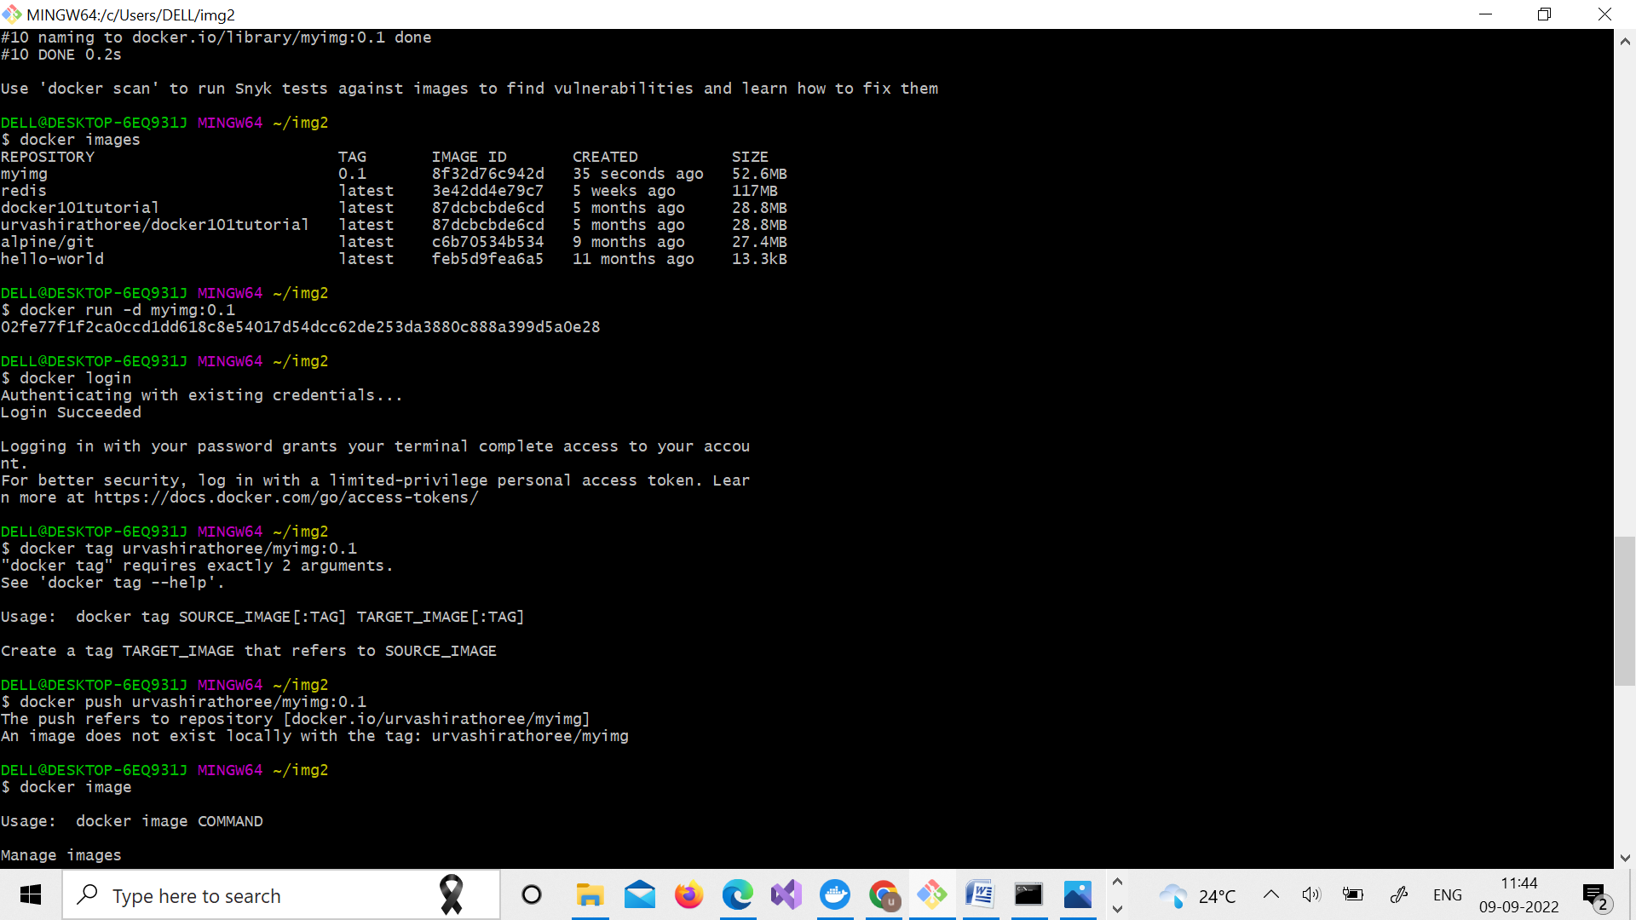

6.Now push the image on Dockerhub using following command.



7.Pull and Run the container of your deployed image on docker hub

