**UNIVERSITY OF PETROLEUM & ENERGY STUDIES**

**College of Engineering Studies**

**Dehradun**

**Lab Exercise 3**

Programme: B. Tech in Computer Science and Engineering with

Specialization in DevOps

Course: Application containerization & Orchestration Lab

Semester: V

Session: August – December 2022

Batch: 2020-2024

Faculty : Dr Hitesh Kumar Sharma

**Submitted By:**

|  |  |  |
| --- | --- | --- |
| **Name** | **SAPID** | **ROLL NO** |
| **Jasmine Wadhwa** | **500086813** | **R2142201778** |

**Cybernetics Cluster**

**School of Computer Science**

**University of Petroleum and Energy Studies**

**Dehradun-248007**

**Aim: Working with Docker volume**

**Steps to Complete:**

1. View all Volume in Docker

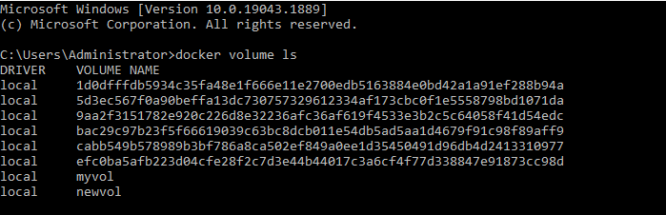

1. Create new volume

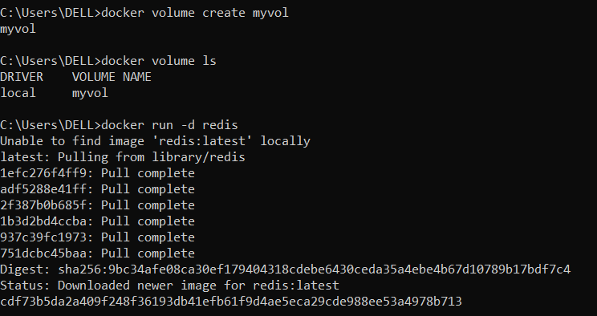

1. Mount a Volume with a container

**Commands : docker run -d ,**

**redis docker ps,**

**docker inspect <container id>**

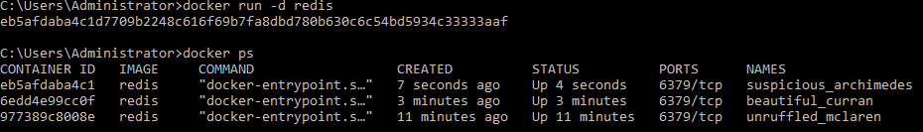

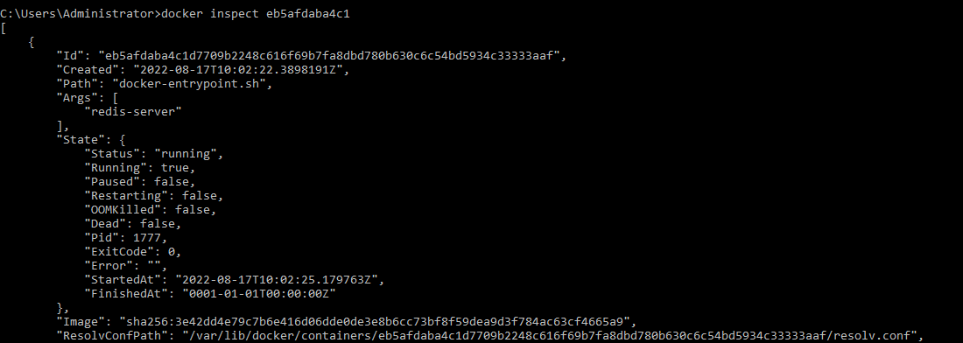

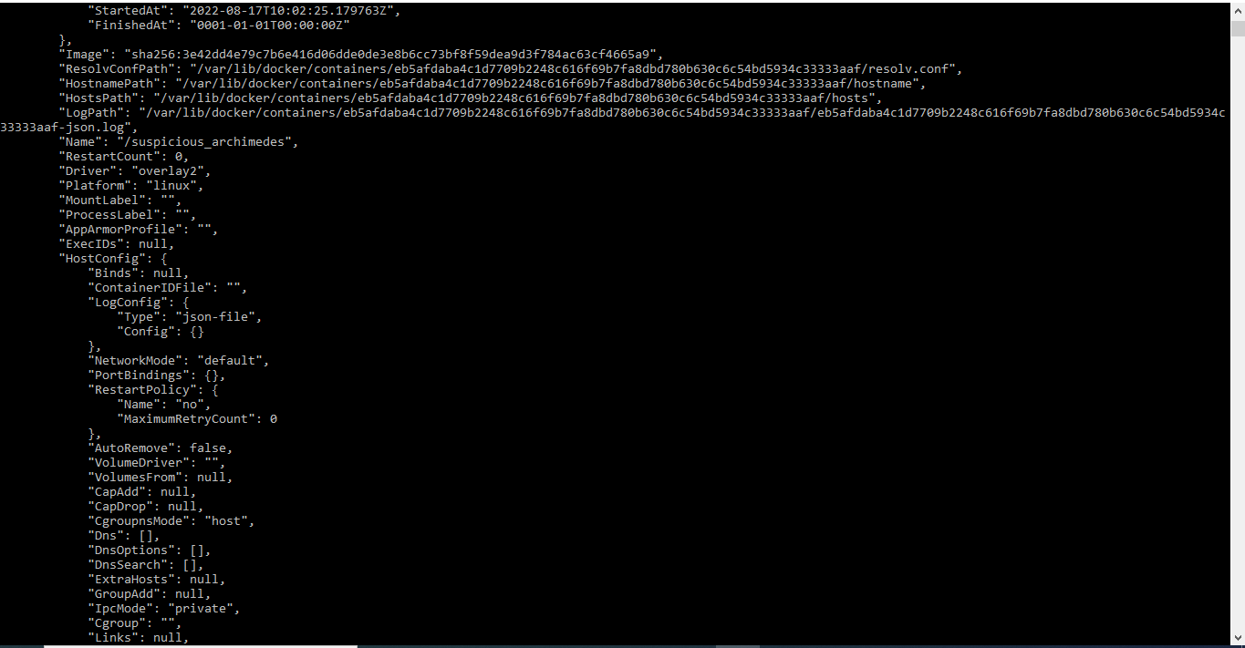

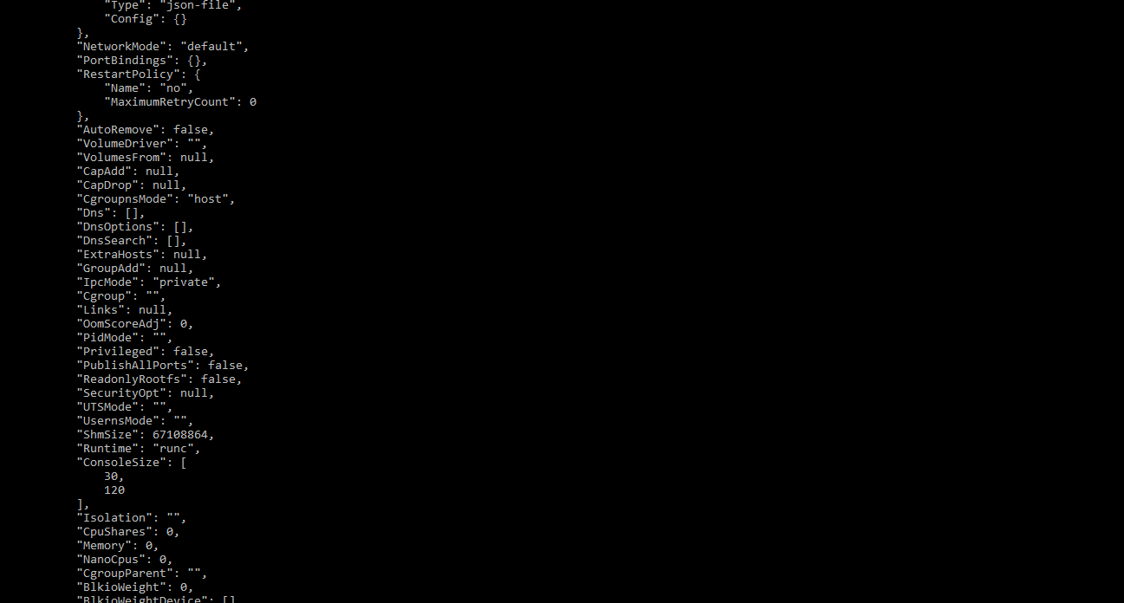

1. Create another container and Mount with the same Volume

Run again command- **docker run -it -v myvol:/data redis /bin/bash**

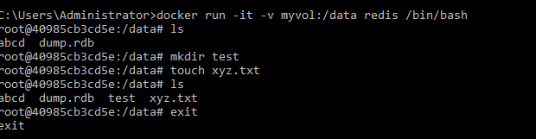

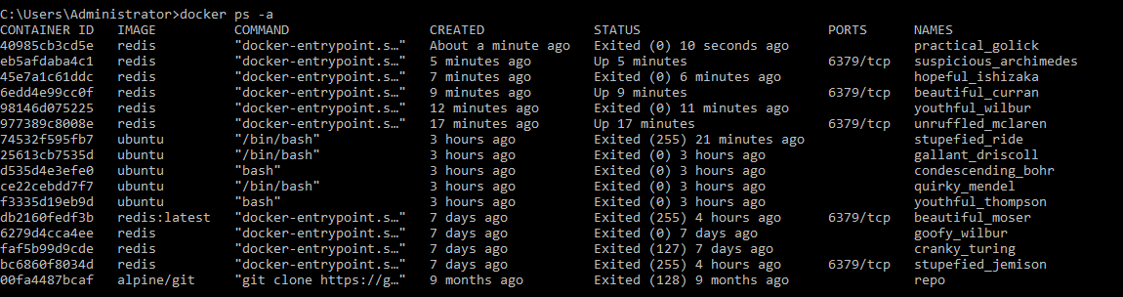

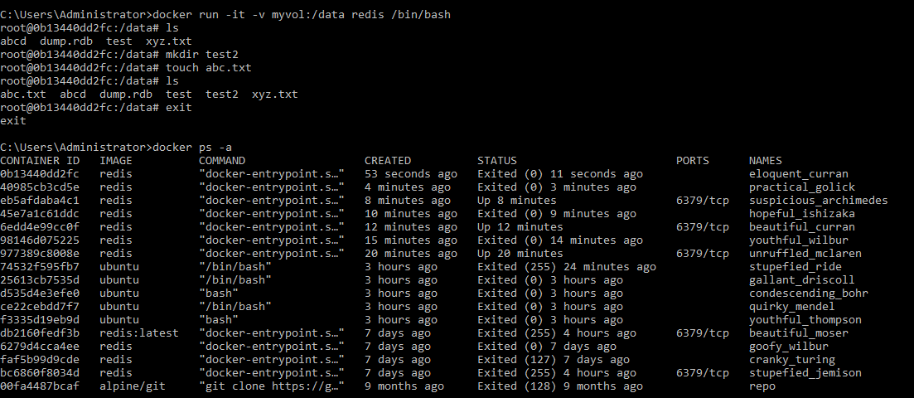

1. Exit the container and restart it again to see the persistent of docker volume.

