Name – Prerna Choudhary

Sap id - 500083151

Roll no. – R214220864

EXPERIMENT 3

AIM: Working with Docker Volume Steps to Complete:

1. View all Volume in Docker



1. Create a new Volume



1. Mount a Volume with a container

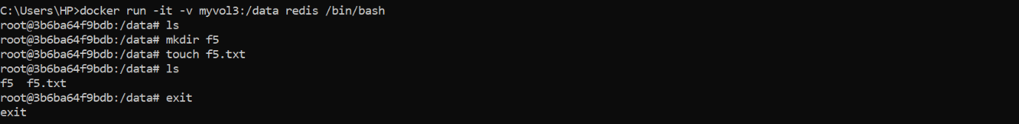

1. Create another container and Mount with the same Volume



1. See the complete working of container

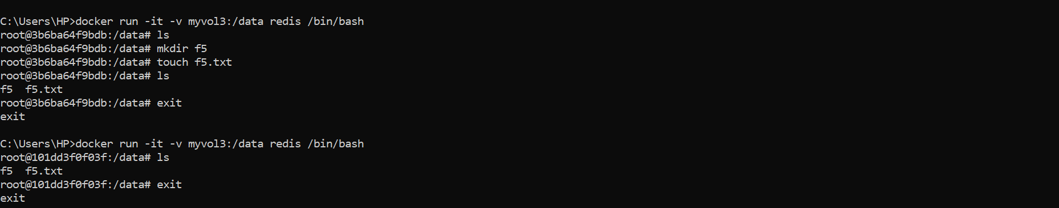

1. Exited from container and restart again to see the persistent of Docker Volume

