Experiment 2

Aim :- Working with docker (basic commands)

1. Searching a Redis image on Dockerhub

Solution :-

Very first we need to search an image of Redis on docker hub using below command.

**Command :- docker search redis**

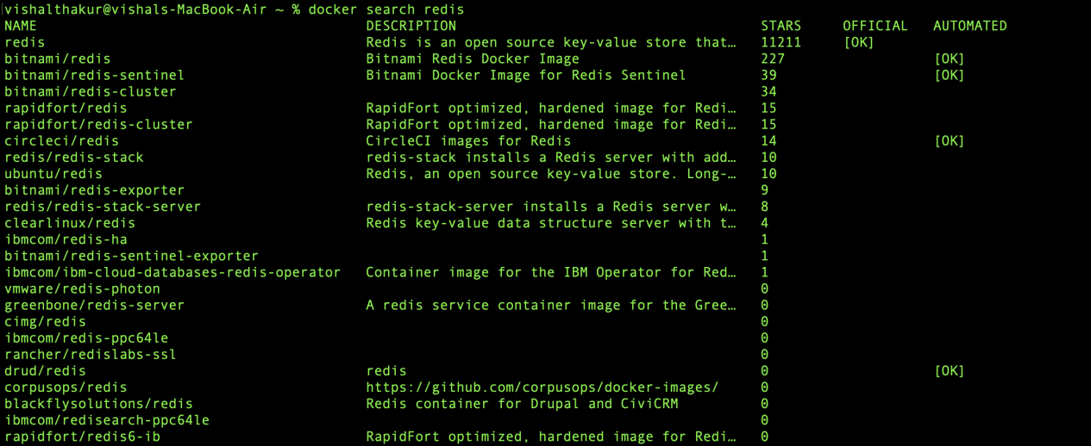

1. Run docker Container of Redis Image in background

Solution :-

**Command :- docker run -d redis**



1. Run docker ps and docker ps -a

Solution :-

**Command :- docker ps**

Docker ps command shows all the active processes or container running .



**Command :- docker ps -a**

Docker ps -a command shows all the active and unactive processes or container running.



1. Run Docker Container and take its console

Solution :-

**Command :- docker run -it redis /bin/bash**

We give ‘/bin/bash’ address because the terminal file is stored in it and we must specify it to access that file particularly.

dokcer4

1. Create a docker volume and connect it

Solution :-

**Command :- docker run -it -v myvol:/data redis /bin/bash**

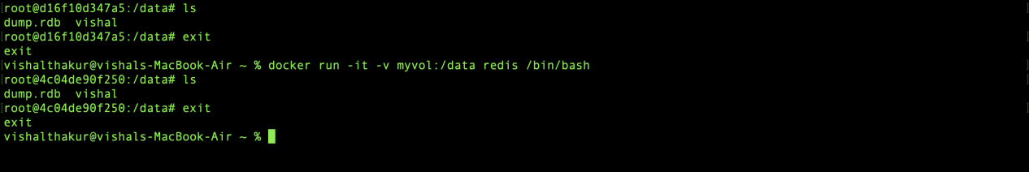

Submitted by :- Submitted to:-

Name :- Vishal Name :- Hitesh Sharma

SAPID :- 500084112

Roll no. :- R2142201315