

**Bhartiya Vidya Bhavan’s**

**Sardar Patel Institute of Technology**

Bhavans Campus, Old D N Nagar, Munshi Nagar, Andheri West

**Statement of Marks**

**UID:** {student_uid}

**Semester:** {semester}

**Graduation Year:** {student_batch}

**Name:** {student_name}

**Branch:** {student_branch}

**Date of Result:** {date_of_result}

|  |  |  |  |
| --- | --- | --- | --- |
| **Course Code** | **Course Name** | **Credits** | **Grade** |
| {#courses}{course_code} | {course_name} | {course_credits} | {grade}{/ courses } |

|  |  |
| --- | --- |
| **SGPA** | {sgpa} |
| **CGPA** | {cgpa} |

**Sign:**

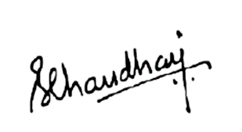

Dr. B.N. Chaudhari  
(Principal)



**Scan to Verify**

This scorecard can be verified for authenticity using EduChain