## Ex.No.7 Implementation of Visualize Data using Any Plotting Framework

### AIM

To implement Data visualization is to provide an efficient graphical display for summarizingand reasoning about quantitative information.

#### Pre-Lab Discussion Theory

**1. Histogram**

Histogram is basically a plot that breaks the data into bins (or breaks) and shows frequencydistribution of these bins. We can change the breaks also and see the effect it has data visualizationin terms of understandability.

#### Line Chart

The line chart showing the increase in air passengers over given time period. Line Chartsare commonly preferred when we are to analyses a trend spread over a time period. Furthermore,line plot is also suitable to plots where we need to compare relative changes in quantities across some variable (like time).

#### Bar Chart

Bar Plots are suitable for showing comparison between cumulative totals across several groups.Stacked Plots are used for bar plots for various categories.

#### Box Plot

Box Plot shows 5 statistically significant numbers the minimum, the 25th percentile, the median, the 75th percentile and the maximum. It is thus useful for visualizing the spread of the data is and deriving inferences accordingly.

#### Scatter Plot (including 3D and other features)

Scatter plots help in visualizing data easily and for simple data inspection.

1. **Heat Map**

One of the most innovative data visualizations in R, the heat map emphasizes color intensity to visualize relationships between multiple variables. The result is an attractive 2D imagethat is easy to interpret. As a basic example, a heat map highlights the popularity of

competing items by ranking them according to their original market launch date. It breaks it down further byproviding sales statistics and figures over the course of time.

#### Correlogram

Correlated data is best visualized through corrplot. The 2D format is similar to a heat map, but ithighlights statistics that are directly related. Most correlograms highlight the amount of correlation between datasets at various points in time.Comparing sales data between different months or years is a basic example.

#### Area Chart

Area charts express continuity between different variables or data sets. It's akin to the traditionalline chart you know from grade school and is used in a similar fashion. Most area charts highlight trends and their evolution over the course of time, making them highly effective when trying to expose underlying trends whether they're positive or negative.

### PROGRAM:

print(' 1.HISTOGRAM ')

install.packages('RColorBrewer') library(RColorBrewer) data(VADeaths) par(mfrow=c(2,3))

hist(VADeaths,breaks=10, col=brewer.pal(3,"Set3"),main="Set3 3 colors") hist(VADeaths,breaks=3 ,col=brewer.pal(3,"Set2"),main="Set2 3 colors") hist(VADeaths,breaks=7, col=brewer.pal(3,"Set1"),main="Set1 3 colors") hist(VADeaths,,breaks= 2, col=brewer.pal(8,"Set3"),main="Set3 8 colors")

hist(VADeaths,col=brewer.pal(8,"Greys"),main="Greys 8 colors")

hist(VADeaths,col=brewer.pal(8,"Greens"),main="Greens 8 colors") print(' -2.1. Line Chart ') data(AirPassengers)

plot(AirPassengers,type="l") #Simple Line Plot

print(' 2.2. Bar Chart ') data("iris")

barplot(iris$Petal.Length) #Creating simple Bar Graph barplot(iris$Sepal.Length,col = brewer.pal(3,"Set1"))

barplot(table(iris$Species,iris$Sepal.Length),col = brewer.pal(3,"Set1")) #Stacked Plot print(' 3. Box Plot ')

data(iris) par(mfrow=c(2,2))

boxplot(iris$Sepal.Length,col="red") boxplot(iris$Sepal.Length~iris$Species,col="red") boxplot(iris$Sepal.Length~iris$Species,col=heat.colors(3)) boxplot(iris$Sepal.Length~iris$Species,col=topo.colors(3)) boxplot(iris$Petal.Length~iris$Species)

print(' 4.Scatter Plot ') plot(x=iris$Petal.Length) #Simple Scatter Plot plot(x=iris$Petal.Length,y=iris$Species) #Multivariate Scatter Plot print(' 5. Heat Map ')

X<-rnorm(10,mean=rep(1:5,each=2),sd=0.7) y<-rnorm(10,mean=rep(c(1,9),each=5),sd=0.1) dataFrame<-data.frame(x=X,y=y) set.seed(143)

dataMatrix<-as.matrix(dataFrame)[sample(1:10),] # convert to class 'matrix', then shuffle the rows of the matrix

heatmap(dataMatrix) # visualize hierarchical clustering via a heatmap print(' 6. Correlogram ') install.packages("corrplot")

#data("mtcars") corr_matrix <- cor(mtcars) # with circles corrplot(corr_matrix)

# with numbers and lower

corrplot(corr_matrix,method = 'number',type = "lower") print(' Area Chart ') install.packages("magrittr")

install.packages("dplyr") \ install.packages('tidyverse') library(dplyr) library(magrittr)

library(tidyverse) data("airquality")

airquality %>% group_by(Day) %>% summarise(mean_wind = mean(Wind)) %>%

ggplot() + geom_area(aes(x = Day, y = mean_wind)) + labs(title = "Area Chart of Average Wind per Day",subtitle = "using airquality data", y = "Mean Wind")

# OUTPUT:

### HISTOGRAM

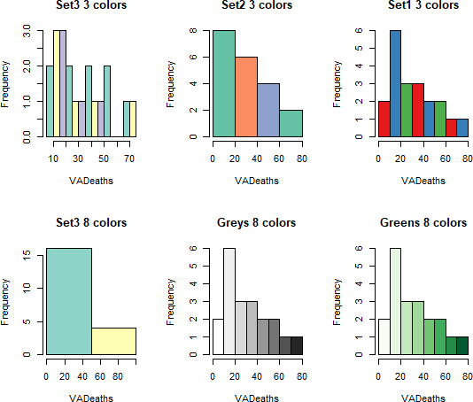

* 1. **Line Chart**

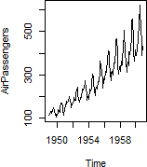

* 1. **Bar Chart**

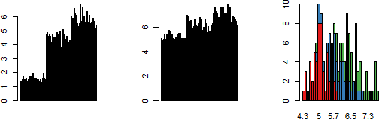

1. **Box Plot**

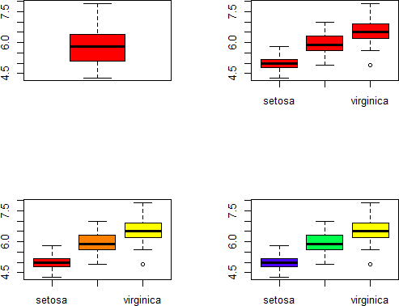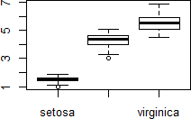

1. **Scatter Plot**

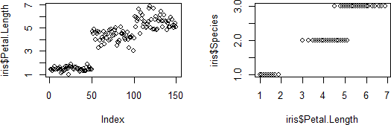

1. **Heat Map**

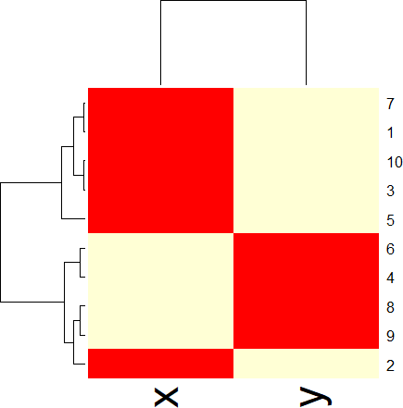

1. **Correlogram**

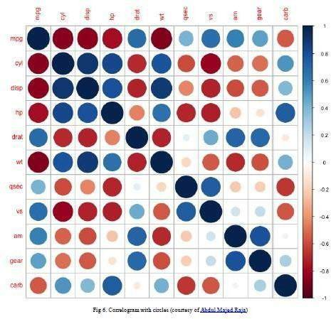

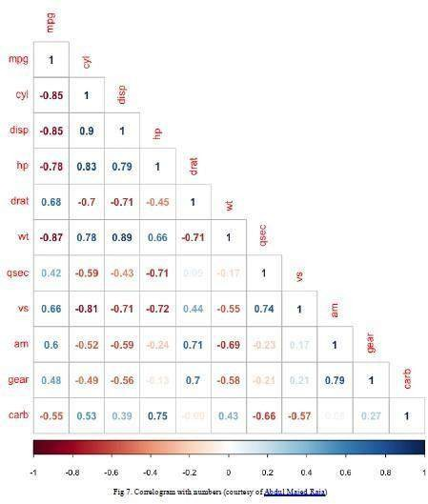

**Area Chart**

