JMON RTDM (Real Time Data Monitoring)
Installation & Configuration Steps

Prerequisites:
- InfluxDB – provided the same in the JMON package or download the same from https://portal.influxdata.com/downloads/ link - windows
- Telegraf – provided the same in the JMON package or download the same from https://portal.influxdata.com/downloads/ link - Basis the OS of your Web, App, DB servers that you need to monitor.
- Grafana – provided the same in the JMON package.
- Jmeter-InfluxDB-Writer_XXX.jar – provided the same in the JMON package.

JMeter:
- Copy the Jmeter-InfluxDB-Writer_XXX.jar file to apache-jmeter-XX\lib\ext location of Jmeter folder. Restart/Start Jmeter.
- Append ‘_TPS’ at the end of main timer of each scenario, '_Common' at the end of common pages and '_Encrypt' at the end of Encrypt/Decrypt logic pages.
- Add Backend Listener into your Jmeter project. (Need to add Backend listener in each Jmeter project.)
  - Right click on the Test Plan – Add – Listener – Backend Listener.
- Select Backend Listener Implementation Class – rocks.nt.apm.jmeter.JmeterInfluxDBBackendListenerClient
- Enter Parameter details as mentioned in the below snap.
  - testName: Specify your test/run id. (Mandatory)
  - nodeName: Specify unique nodeName per Load injector machine. E.g. TestNodeA, TestNodeB, TestNodeC, etc. (Mandatory)
  - influxDBHost: Specify IP address of InfluxDB Host machine. (Mandatory)
  - influxDBPort: Specify InfluxDB Port i.e. 8086
  - influxDBUser, influxDBPassword, influxDBDatabase: Specify InfluxDB User, Password and Database as mentioned in the snap.
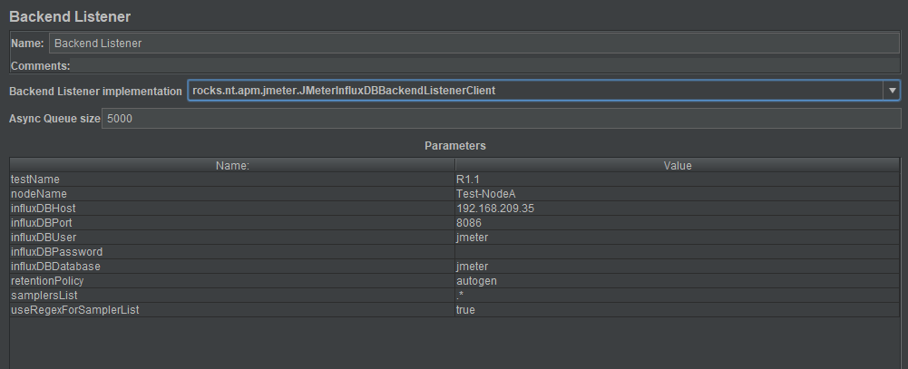

InfluxDB:
- Find the InfluxDB folder in the current package.
- Unzip the folder and open command prompt from the current location (Influx DB folder).
- Enter the below command to start influxDB.
influxd.exe -config influxdb.conf
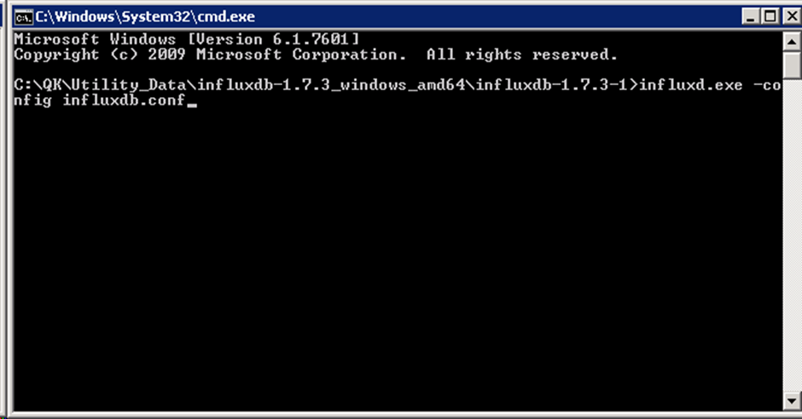
- InfluxDB started.
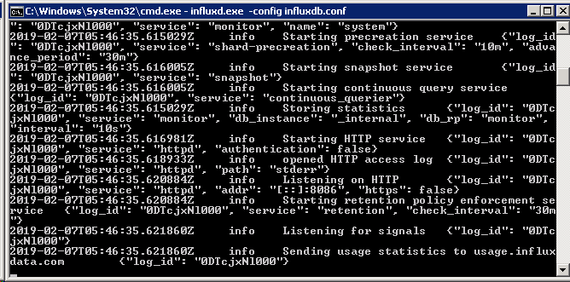
- Double click on influx.exe file.
- InfluxDB shell will be opened. Create databases with name 'jmeter' and 'telegraf' with following command.
CREATE DATABASE jmeter
CREATE DATABASE telegraf
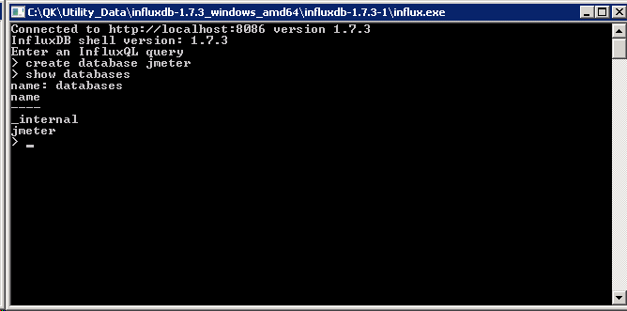

Telegraf:
Windows:
- Download the latest version of Telegraf or find the same in the current package.
- Unzip the folder and take backup of 'telegraf.conf' file.
[Windows - unzip telegraf-1.10.0_windows_amd64.zip
Linux - tar xf telegraf-1.10.0_linux_amd64.tar.gz
RedHat & CentOS - sudo yum localinstall telegraf-1.10.0-1.x86_64.rpm
Ubuntu & Debian - sudo dpkg -i telegraf_1.10.0-1_amd64.deb]
- Edit 'telegraf.conf' file and add following line into 'outputs.influxdb' section.
urls = ["http://<IP_of_InfluxDB>:8086"]
- Add below line.
for Application Servers : database = "jmeter"
for Load Injector : database = "telegraf"
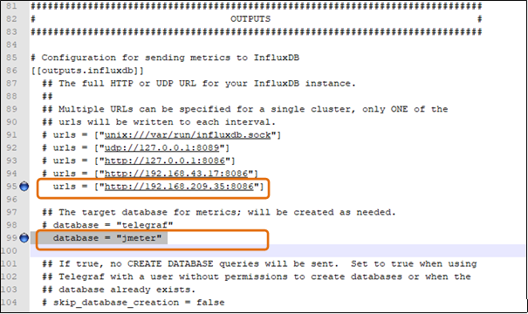
- Comment below line into 'inputs.win_perf_counters.object' section.
IncludeTotal = true
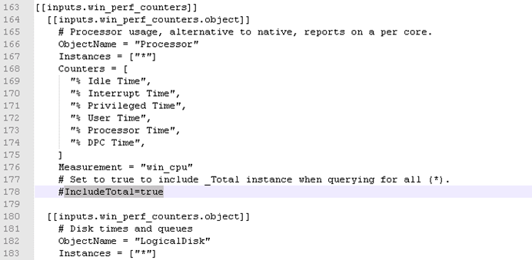

- Open command prompt and enter below command
telegraf.exe -config telegraf.conf
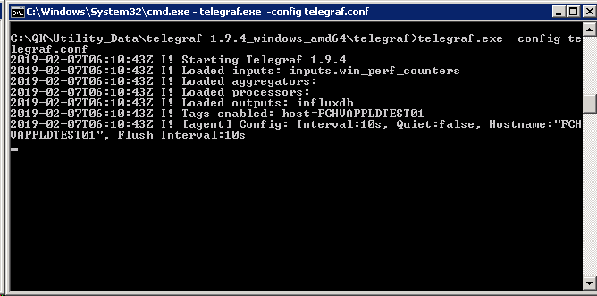

Linux/RedHat/CentOS/Ubuntu/Debian:
- Download the latest version of Telegraf or find the same in the current package.
- Go to the location where telegraf installation file (telegraf-1.10.0_linux_amd64.tar.gz/telegraf-1.10.0-1.x86_64.rpm/telegraf_1.10.0-1_amd64.deb) stored and enter following command.
Linux: sudo tar xf telegraf-1.10.0_linux_amd64.tar.gz
RedHat & CentOS: sudo yum localinstall telegraf-1.10.0-1.x86_64.rpm
Ubuntu & Debian: sudo dpkg -i telegraf_1.10.0-1_amd64.deb
- Go to /etc/telegraf folder. Edit 'telegraf.conf' file and add following line into 'outputs.influxdb' section.
urls = ["http://<IP_of_InfluxDB>:8086"]
- Add below line.
for Application Servers : database = "jmeter"
for Load Injector : database = "telegraf"
Then save file using esc - :wq! Command.
- Start telegraf service using following command.
sudo systemctl start telegraf OR sudo service telegraf start
- To check service status enter below command
systemctl status telegraf

Grafana:
- Unzip the Grafana folder shared with you.
- Start grafana by executing grafana-server.exe file located in the bin directory.
- Run grafana on your browser, enter http://localhost:8090/login.
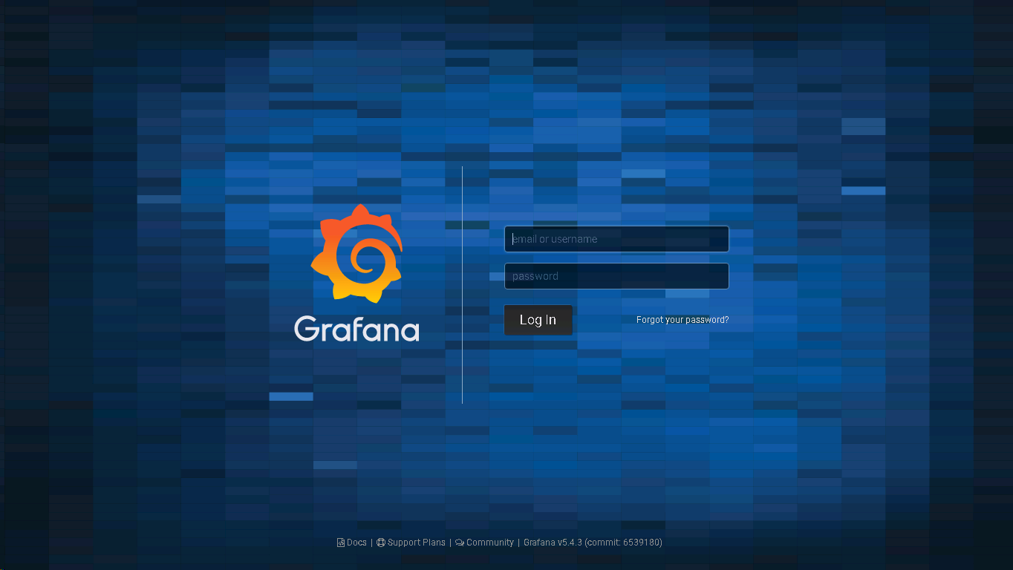
- Enter Credentials and Login.
- Your JMON RTDM (Real Time Data Monitoring) Dashboard is ready to use.

