Practical Training Report

On

Web Development

Submitted for Partial fulfillment of the course, Practical Training (CST 201)

Of

Bachelor of Technology



Department of Computer Science and Engineering
National Institute of Technology, Uttarakhand

Submitted by Submitted to
Akhilesh Yadav Dr. Maheep Singh
BT18CSE015 Assistant Professor
Department of CSE

DECLARATION

I declare that the Practical Training (CST201) report titled “Web Development” being submitted for the course Practical Training in partial fulfillment of the requirements for the award of the Degree of Bachelor of Technology in Computer Science and Engineering is the original work carried out by me. It has not formed the part of any other project work submitted for award of any degree or diploma, either in this or any other Institution.

Signature of the Student: Akhilesh yadav

Name of Student: Akhilesh Yadav

Roll Number: BT18CSE015
Place: Chandigarh
Date : 30/ 09/ 2020

CERTIFICATE FROM THE ORGANIZATION

Course Completion Certificate:

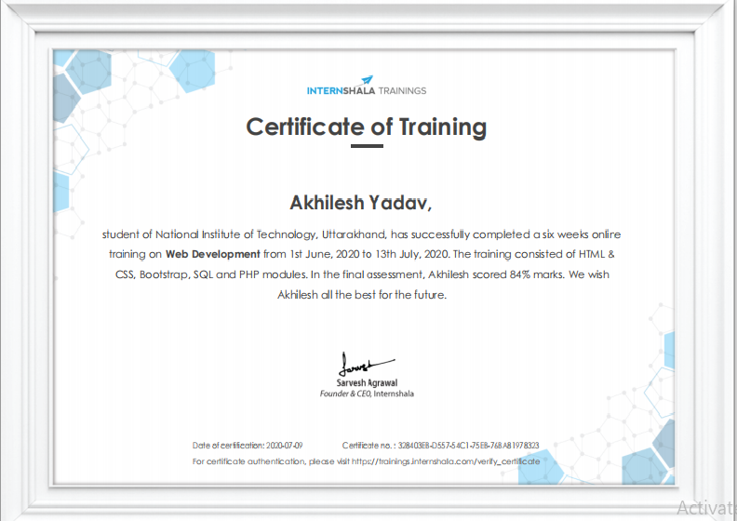

For certificate authentication, please visit https://trainings.internshala.com/verify_certificate
Certificate no: 328403EB-D557-54C1-75EB-76BA81978323

Certificate of Excellence:



For certificate authentication, please visit https://trainings.internshala.com/verify_certificate
Certificate no: 328403EB-D557-54C1-75EB-76BA81978323

ACKNOWLEDGEMENT

Web Development Training Program was very interesting and informative for me. It gave me opportunity to learn so many new things about website & it’s development and so on. For all my beautiful experience I would firstly like to thank Internshala’s team who gave us this wonderful opportunity of 6 weeks Training Program on Web Development during Pandemic to learn something very interesting and in building new skill and as well as giving new path to my future.
Also I would like to thanks Faculty of CSE Department and all NIT Uttarakhand Family for providing us this wonderful opportunity to gain something that helpful even during such conditions.
At last but not the least contribution in this Program I would like to thank my Parents, family members and friends for their great assistance in this program. Without their help it may not be possible for me to complete this Program.
So, thank you all for your kindly support.
Thank you
Akhilesh Yadav

ABSTRACT

This was a 6 weeks training program organized by Intersnhala for learning Web Development via Online mode. This course was divided into four segments -HTML &CSS, Bootstrap, MySQL and PHP. After completion of each segment at last there was an Assignment and then a module test to show our Progress.I learned with the help of recorded video lectures and several mini tests were also taken to see my progress.When I completed all the video lectures and mini assignments then they took final test to grade me accordingly.In Final I secured more than 80% so, they give me another assignment which gives a chance to get the certificate of Excellence. At the end of the Program we are finally able to create our own personal website at beginner’s level.

Table of Contents

S. NO. TITLE PAGE NO.

Declaration of the Student ii Certificate of the Guide iii Acknowledgement 1. List of Figures 3
List of Tables 4

1. INTRODUCTION 5
1.1 Introduction to web development

1.1.1 Front-End development
1.1.2 Back-End development
1.1.3 Full Stack development

1.2 Security Consideration
1.3 Need of web development

2. WORK DONE DURING TRAINING 9
2.1 Getting Started
2.2 HTML & CSS
2.3 Bootstrap

2.3.1 Signup page
2.3.2 Login page
2.3.3 stylesheet
2.3.4 settings page

2.4 SQL Database
2.5 PHP

2.5.1 PHP script

2.6 Final test

2.6.1 Home page
2.6.2 cart page

3. FUTURE & SCOPE 22
3.1.1 scope & opportunities

- CONCLUSION 25

- REFERENCES 26

LIST OF FIGURES

Figure No.  Fig 1.1 | Title  About Web Development | Page No.  6
Fig 2.1 | Index page of website | 10
Fig 2.2 | Sign-up page | 11
Fig 2.3 | Log-in page | 12
Fig 2.4 | Stylesheet | 13
Fig 2.5 | Settings Page | 14
Fig 2.6 | SQL Workspace | 17
Fig 2.7 | SQL Command Window | 17
Fig 2.8 | PHP Script | 19
Fig 2.9 | Home Page | 21
Fig 2.10 | Cart Page | 21
Fig 3.1 | Web Developer vs Others | 23
Fig 3.2 | Developers Pie Chart | 24

Chapter : 1

Introduction :

This Section is for the introductory part about Web Development and its use

  - Introduction to Web Development

Web development is the building and maintenance of websites; it’s the work that happens behind the scenes to make a website look great, work fast and perform well with a seamless user experience.
Web developers do this by using a variety of coding languages. The languages they use depends on the types of tasks they are preforming and the platforms on which they are working.
Web development skills are in high demand worldwide and well paid too – making development a great career option. It is one of the easiest accessible higher paid fields as you do not need a traditional university degree to become qualified

Web development is the work involved in developing a website for the Internet (world wide web) or an intranet (a private network). Web development can range from developing a simple single static page of plain text to complex Web-based Internet applications (Web apps), electronic businesses, and social networking sites. A more comprehensive list of tasks to which Web development commonly refers, may include Web Engineering, Web
design, Web content development, client liaison, client side/server-side scripting, web server and network security configuration, and e-commerce development

The field of web development is generally broken down into front-end (the user-facing side) and back-end (the server side). Let’s delve into the details.

1.1.1 Front-End Development :

A front-end developers takes care of layout, design and interactivity using HTML, CSS and JavaScript.
They take an idea from the drawing board and turn it into reality.What you see and what you use, such as the visual aspect of the website, the drop down menus and the text, are all brought together by the front-end developers, who writes a series of programmes to bind and structure the elements, make them look good and add interactivity. These programmes are run through a browser.

1.1.2 Back-End Development :

The back-end developer engineers what is going on behind the scenes. This is where the data is stored, and without this data, there would be no front-end. The back-end of the web consists of the server that hosts the website, an application for running it and a database to contain the data.

The back-end developer uses computer programmes to ensure that the server, the application and the database run smoothly together. This type of developer need to analyse what a company’s needs are and provide efficient programming solutions. To do all this amazing stuff they use a variety of server-side languages, like PHP, Ruby, Python and Java.

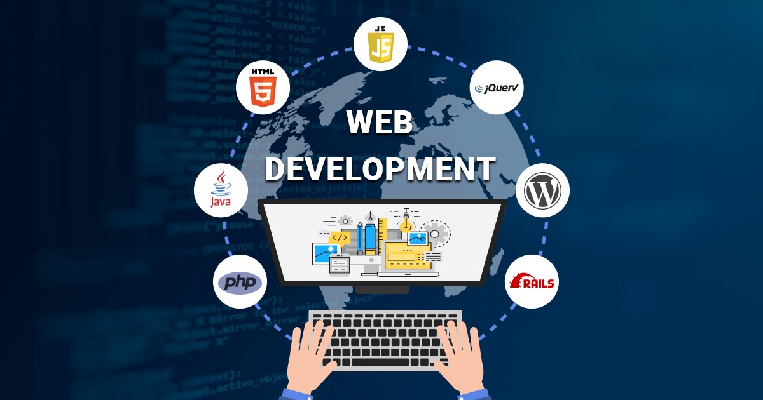

FIG 1.1 WEB DEVELOPMENT LANGUAGES

1.1.3 Full-Stack Development :

Full Stack Developers take cares of both the front-end and Back-end development of a website . I learned full stack development in this practical training program, where I learned both the front-end & back-end development languages and get to know how the website work on all levels.

  - Security Consideration

Web development takes into account many security considerations, such as data entry error checking through forms, filtering output, and encryption.Some of this is dependent on the server environment on which the scripting language, such as ASP,JSP,PHP , Python,Perl as or Ruby is running, and therefore is not necessarily down to the Web developer themselves to maintain.

Keeping a Web server safe from intrusion is often called Server Port Hardening. Many technologies come into play to keep information on the Internet safe when it is transmitted from one location to another. For instance TLS certificates (or "SSL certificates") are issued by certificate authorities to help prevent Internet fraud. Many developers often employ different forms of encryption when transmitting and storing sensitive information. A basic understanding of information technology security concerns is often part of a Web developer's knowledge.

Because new security holes are found in Web applications even after testing and launch, security patch updates are frequent for widely used applications. It is often the job of Web developers to keep applications up to date as security patches are released and new security concerns are discovered.

  - Need of Web Development

Full Design Control :
Your company may change or adjust the range of products you provide, pricing policy (holiday discounts, etc.) or even company structure, which you need to reflect on your page. Owning a website allows much more detailed customizations, as compared to using a landing page.

Increasing Brand Awareness :
Having a website allows adding a favicon to the page, creating RSS-feed to keep your audience tuned on latest updates, using comments to gather valuable customer feedback and replying to it, posting links to your site at forums and blogs. Many additional tools allow increasing brand awareness and customer pool.

Saving Money on Advertising :
Instead of paying for expensive offline and online ads, you can invest into SEO-promotion of your own page, which brings lasting results, as the funds you spend to promote your own page are the funds well spent. However, please do not mistake paid traffic Rudy Mendoza mentioned with investment into high-quality content, responsive website design, market trends analysis and well-thought special offers.

Saving Time on Asking Questions :
Whenever your customers need to know something about your business, having a contact form, a live chat, an option to comment or a phone number is a step towards them, which increases a possibility of sealing the deal

Confirming Your Credibility :
Everybody understands that building a professional website involves some serious investment, which most likely means the company is not going to disappear the next day, so the customers are more prone to order from you.

Referral Programs and Discounts :
Having your own page allows implementing a referral program or issuing discounts to your customers through the billing system. This is a feature free ad boards and social network groups cannot provide.

Chapter : 2
Work done during Training :

This Section is for the work that I learned during training.

2.1 Getting started

In this part of training I learned all about the basic setups that are required during training,
There was introductory videos that tells us what is to taught in further in this program, all the application required and their installment process.

2.2 HTML & CSS

This was the first module in which I learned hypertext mark-up language (HTML) and Cascading stylesheet (CSS).
Hypertext Markup Language (HTML) is the standard markup language for documents designed to be displayed in a web browser. It can be assisted by technologies such as Cascading Style Sheets (CSS) and scripting languages such as JavaScript.

This part taught me following topics:
- HTML Introduction and page structure
- Tags & Elements
- Text Formatting
- Attributes
- Hyperlinks
- Cascading Style Sheets
- Box Model
- Adding Colors, fonts,margin,padding
- Lists
- Creating Layouts
- Images
- Tables
- Navigation
- Forms
- Pseudo classes
- Miscellaneous

Here is the page that I created after the completion of the first module



FIG 2.1 INDEX PAGE OF WEBSITE

After Completion of this first assignments we have to submit this , then we have to give module test test to see the progress in this training .
Module test is based on the topics that is already taught and the question are mcq based , After giving the module test then only we can access the next module , till then the next module remain locked.

2.3 Bootstrap

Under this module, as till now we have already created our own web page now we have to make it look attractive with the help of pre-defined bootstrap classes so basically we are taught to design web pages through bootstrap. Following things are taught to add using bootstrap, as it is a more attractive and simple way :

- Introduction
- Breakpoints and Containing elements
- Jumbotron
- Glyphicons
- Tables
- Column / Rows
- Navbar
- Images
- Thumbnails
- Forms
- Panels

Here I have created some important web pages that I have created during the training after learning bootstrap .

2.3.1 Sign Up Page :

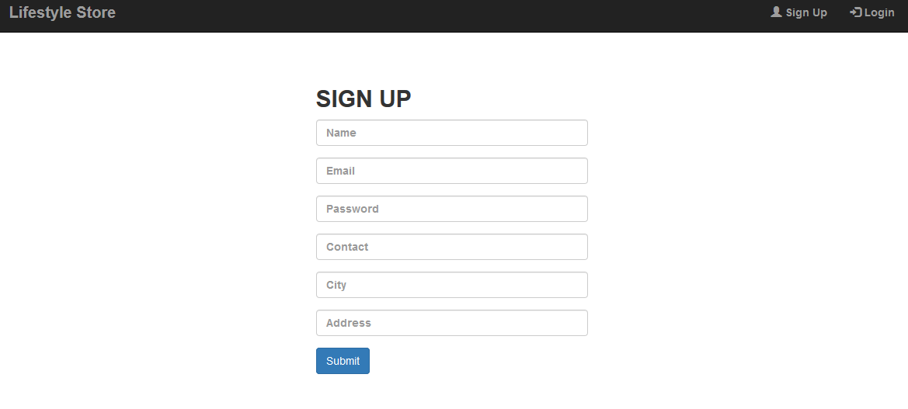

FIG 2.2 SIGNUP PAGE

Sign up page is used to create user account so, that using this page it get register himself ,
There are the fields to enter name , email, password , contact, city, address then at last there is a button to submit the entered information which is get stored in the database and can be used as authentication if user login again .

2.3.2 Login Page :

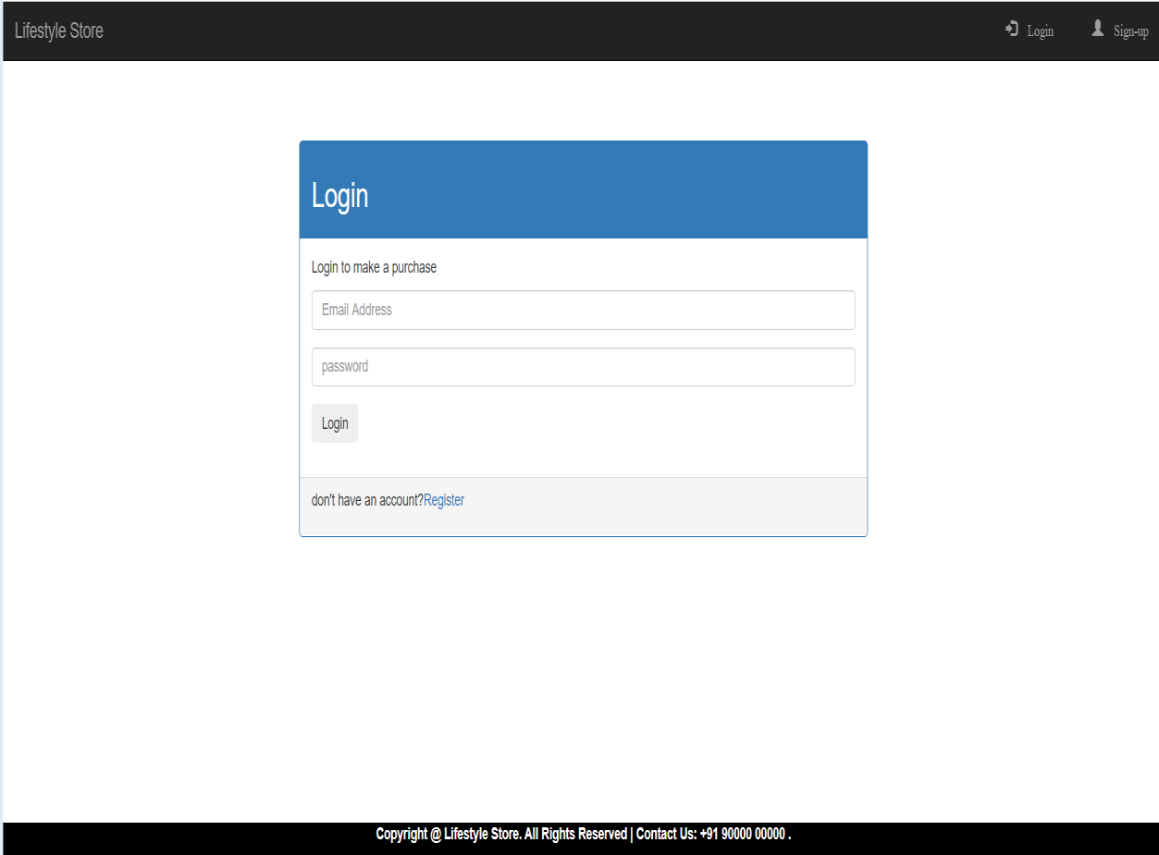

FIG 2.3 LOGIN PAGE

Login Page is created so that with the help of login page user can login himself again and again to access his account , there is authentication process behind the scene to authenticate the user as the details are already entered in the sign up form .
These to forms are common in each and every website so, making these two pages give me motivation that I know something new and informative which help in my future .

Here is the style sheet where the other required styling is added by me which make this page complete and looks better .
2.3.3 Stylesheet :

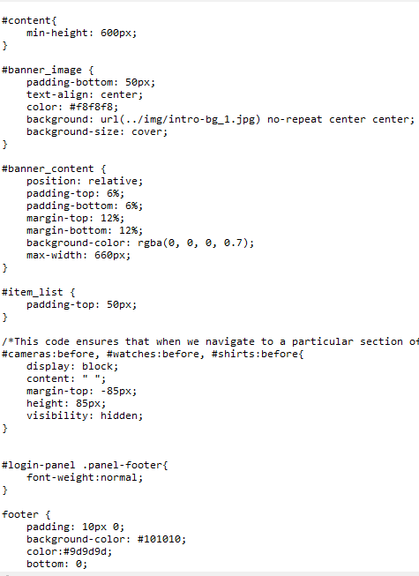

FIG 2.4 STYLESHEET

2.3.4 Settings Page :

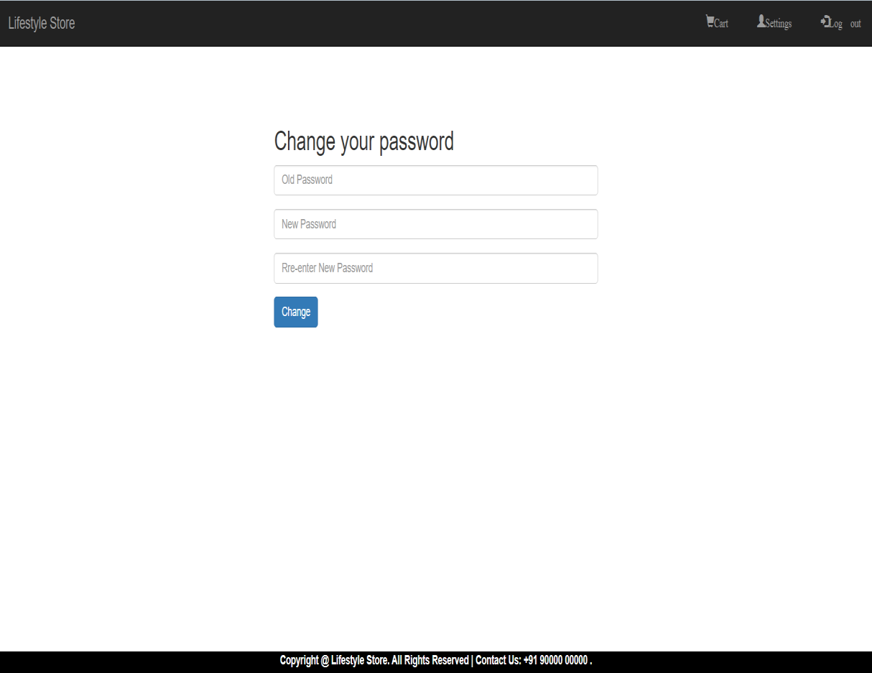

FIG 2.5 SETTTINGS PAGE

Use the Settings page is to specify a project's application settings. Application settings enable you to store and retrieve property settings and other information for your application dynamically. They also enable you to maintain custom application and user preferences on a client computer .

I make this settings Page where user can change it’s password of the account . It provides security feature to the website and it is good to have settings page in it .

Settings page may contain the general setting of the account like language setting , account setting , privacy setting to change personal details like image, email id , phone number ,
Payment details , address and so on ..

After completion of this module again there was a test , but at the end of this module.
I am finally able to create a good looking and multi-functioning website by linking the pages .
After this the front-end part get completed and Now onwards the back-end development get started .

2.4 SQL Database :

SQL "sequel" (Structured Query Language) is a domain-specific language used in programming and designed for managing data held in a relational database management system (RDBMS), or for stream processing in a relational data stream management system (RDSMS). It is particularly useful in handling structured data, i.e. data incorporating relations among entities and variables.

SQL offers two main advantages over older read–write APIs such as ISAM or VSAM. Firstly, it introduced the concept of accessing many records with one single command. Secondly, it eliminates the need to specify how to reach a record, e.g. with or without an index.

SQL deviates in several ways from its theoretical foundation, the relational model and its tuple calculus. In that model, a table is a set of tuples, while in SQL, tables and query results are lists of rows: the same row may occur multiple times, and the order of rows can be employed in queries (e.g. in the LIMIT clause).
Critics argue that SQL should be replaced with a language that returns strictly to the original foundation: for example, see The Third Manifesto. However, no known proof exists that such uniqueness cannot be added to SQL itself or at least a variation of SQL. In other words, it's quite possible that SQL can be "fixed" or at least improved in this regard such that the industry may not have to switch to a completely different query language to obtain uniqueness.

In this I learned how to create mysql database , I have created several tables and linked them using foreign key to store the data/details of the user and use them to make the pages dynamic by using these saved details to update the website . These information’s are useful in authenticating the users

All these details are to be stored in a database. For this purpose we use query languages to create a secured database and it comprises of the following topics :
- Introduction to Database
- Introduction to DBMS
- Creating First database
- Primary Keys
- Alter & Drop
    - Add column
    - Delete column
    - Rename column
    - Change properties
    - Reset primary Keys
    - Delete particular row
    - Delete all rows
    - Delete database
- Foreign Key & Truncate
- Data Manipulation Language
    - Insert
    - Update
    - Delete
    - Select
    - Limit
- SQL Joins
    - Inner Join
    - Left Join
    - Outer Join
- Additional SQL features
    - Backup Database
    - Export Database
    - Import Database
- Module test

Here is the Image of the table that I have created after learning SQL queries

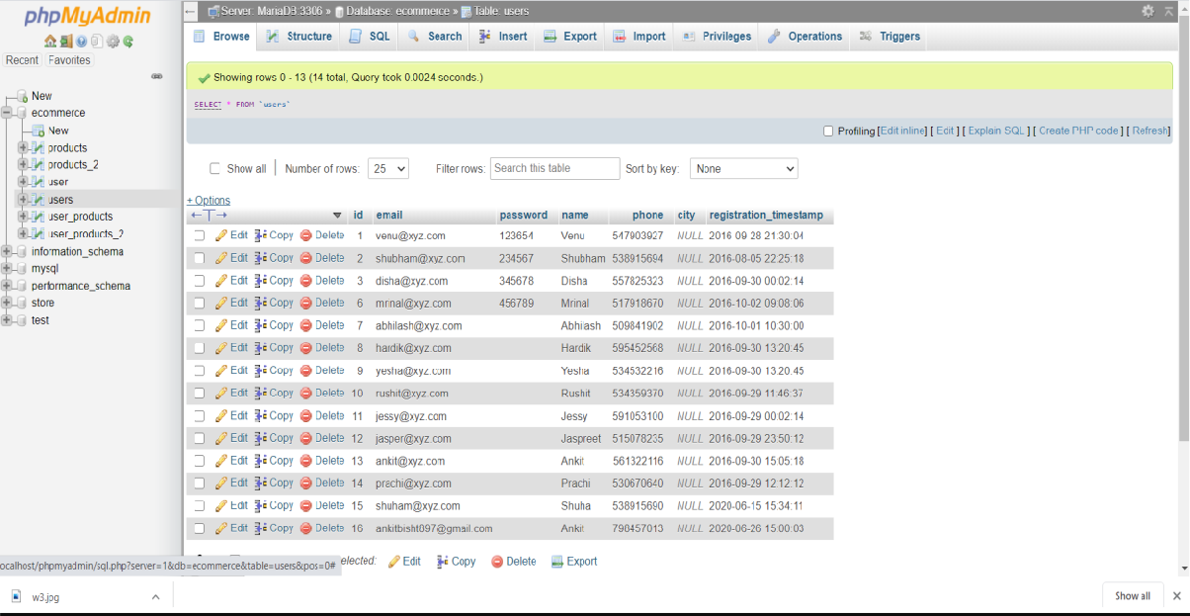

FIG 2.6 SQL WORKSPACE
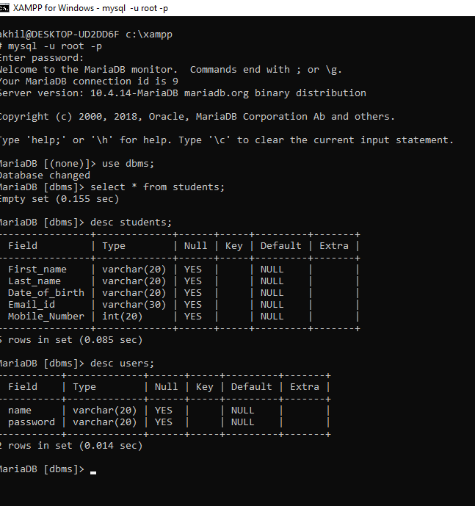

FIG 2.7 SQL COMMAND WINDOW

2.5 PHP :

PHP is a general-purpose scripting language especially suited to web development.The PHP reference implementation is now produced by The PHP Group. PHP originally stood for Personal Home Page, but it now stands for the recursive initialism PHP: Hypertext Preprocessor.

PHP is a server side scripting language, that is used to develop Static websites or Dynamic websites or Web applications. PHP stands for Hypertext Pre-processor, that earlier stood for Personal Home Pages. PHP scripts can only be interpreted on a server that has PHP installed. PHP is used to link Database with our web pages and also php is an advance language which provides better security as well as operations.

It comprises of the following topics:
- Basics
- Comments
- Variable declaration
- Concatenation
- Boolean variable
- Logical operators
- Equal operators
- Arrays
    - Associative array
    - 2-D array
- Functions
    - Keyword, calling
    - parameters
- Loops
- String
    - Strlen
    - Strrev
    - Strlower
    - Strtoupper
    - strpos
- conditions
- Database Connection
- SELECT Query with PHP
- INSERT Query with PHP
- Form
    - GET method
    - POST method
- Sessions
- Basic security
    - Password Encryption
- Validations with HTML5/PHP
- Module test

2.5.1 PHP Script :

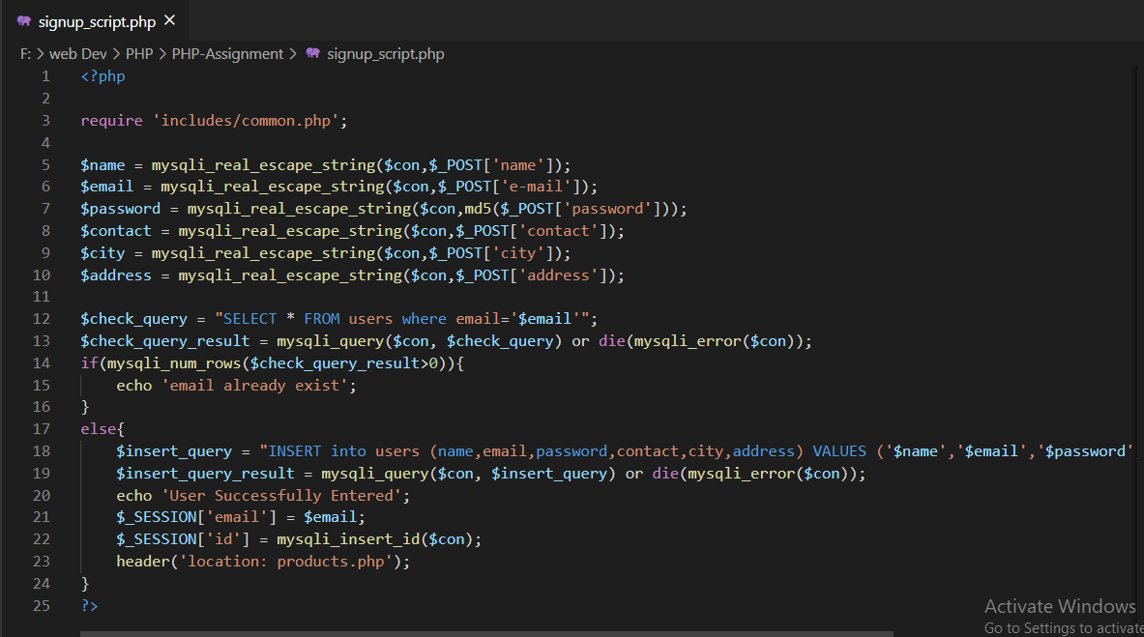

FIG 2.8 PHP SCRIPT

2.6 Final Test :

At the end of the of this training program when I completed all the video lectures they took test as the final assessment . In which I secured more than 80% marks , as my marks are more than 80% therefore they give me an extra assignment which gives me chance to avail certificate of excellence if I will make the assignment according to them. Which I did and avail the certificate of Excellence.
In final assignment I have to make a shopping website which includes front-end and back-end both parts .

Front-End part contains several pages like home page , login page , signup page, settings page, logout page, cart page etc these pages should be linked to each other and through this the user will interact with the website and order the products .
Back-End part contains creation of database which stores the details of the user which should be required for the authentication purpose and address of the user to deliver the product another table to store the details of the ordered products and their prices details and all these things .
It’s also contain the scripting part in which we have to create script that interact with database and fetch the data from database to check the authenticity , to provide the details to the user that what product he/she has already placed and ordered.

Here are the pages that I have made for the assignment :

2.6.1 Home Page : Fig:2.9



2.6.2 Cart Page : Fig:2.10



Chapter 3
Future Scope :

Web designing or web development is a short term professional job oriented course. There are huge opportunities available for the students who want to work in this field. Many private and public organizations hires web designer for their online work and website development.

The swelling wave of e-Commerce dominance fueling the need for organizations to establish their online presence has led to the emergence of Web Designing as an important organizational function. More and more organizations are recruiting internal Web Designing teams or are employing external agencies to dish out professional and functional websites for them.

In this scenario therefore, Web Designing in India as a career option has gained immense prominence. An increasing number of young enthusiasts are heading towards design institutes to be accredited with the mark of being an expert in Web design. However, there is a need to understand the discipline prior to jumping into the fray unprepared.
Understanding the Basics of Web Designing.

Web Designing is a promising career opportunity which displays immense scope for interested candidates. In India, one of the biggest industry, which provides a prospective scope for Web Designing as a career opportunity is the IT or the software industry. Clients interested in getting their online presence established are approaching the software giants to get their Web sites designed. Therefore, the software stalwarts recruit experienced professionals who would be sufficiently qualified in executing the deliverables in quick turn around time.

Technology is ever evolving. As a result, Web designs based on these technologies would also need to be redefined with every evolutionary phase. Nevertheless, there are several standard tools which would always be in demand by Web Designers. These include:
• HTML and CSS
• WYSWYG editors like Dreamweaver
• Graphic Editors like Adobe Photoshop
• Programming skills
• Flash

3.1.1 Scope & opportunities :

Job Opportunities and demand of web developers is decreased in past years but far better than the other developers like android developer and IOS developer .

So, you will surely get a job when you are good in web development. You will never regret on your decision to learn web development.

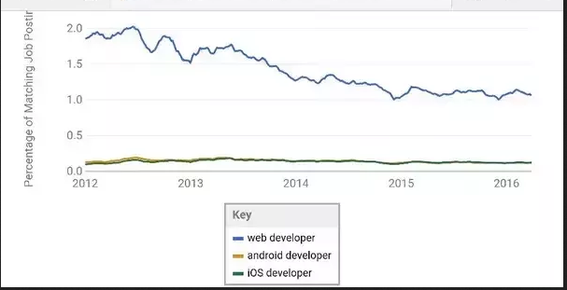

FIG 3.1 WEB DEVELOPER VS OTHERS

This Pie chart shows the demand of web developer in the market & Industry with comparison to other developers. This is the most common demand of IT industry because now a days almost everything is happening on websites . Therefore to create new website or management of the currently working websites we require web developers and with the passage of time this demand will keep on increasing..

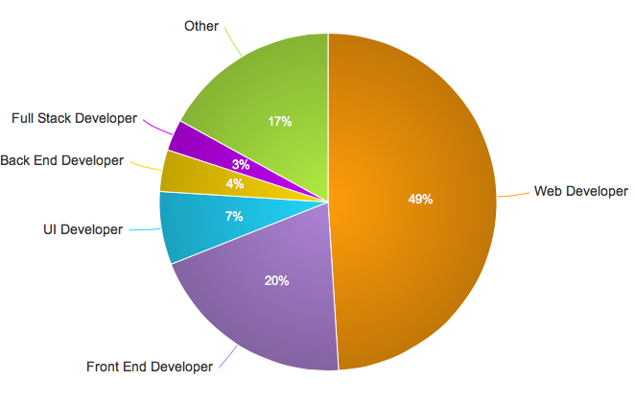

FIG 3.2 DEVELOPERS PIE CHART

CONCLUSION

After the 6 weeks training of Web Development that was organized by Internshala . I must say that this training really good opportunity for me and I am glad that I didn’t miss this opportunity . In this program I get to know that how a website gets developed and how all the small looking things, options, buttons really work in behind the scenes .
How these small thing are added to the website , how data is fetched and stored in the database and how this whole working happens.

I really enjoyed during this training and it was really an achievement for me as I have gained a new skill which is definitely going to help me in the future . As in this technological world where almost everything is dependent on the technology , having knowledge of multiple languages HTML,CSS,SQL,PHP etc. really going to be worthy for me .

References

[1] https://www.wikipedia.org/

