Distributed LLM Training on Big Data
A Project Based Learning Report Submitted in partial fulfilment of the requirements for the award of the degree

of

Bachelor of Technology
In The Department of CSE
Big Data Analytics(23DSB330A)

Submitted by
2310030407: Ch.Govardhan Sujith
2310030159: N.Akhil
2310030138: R.Nikhil
2310030212: Hemanth

Under the guidance of
Dr .T.Aruna Sri


Department of Computer Science and Engineering
Koneru Lakshmaiah Education Foundation, Aziz Nagar
Aziz Nagar–500075
FEB - 2025.
Abstract

The rapid advancement of digital technologies has led to an exponential increase in the availability of large-scale textual data, especially in the domain of online platforms and digital content generation. Processing and understanding such vast unstructured data has become a significant challenge. Large Language Models (LLMs) play a crucial role in addressing this issue by learning patterns from text and generating meaningful outputs. This project presents a Distributed Training framework using multiple pretrained language models for big text data analysis.
Traditional text processing approaches rely on classical machine learning algorithms, which suffer from limitations such as poor scalability, inability to capture contextual relationships, and reduced performance on large datasets. To overcome these challenges, the proposed system incorporates transformer-based language models that simulate advanced deep learning capabilities, such as parallel processing and contextual understanding. The system processes unstructured text data through tokenization, batch processing, and gradient-based optimization to generate accurate and efficient predictions.
The experimental results demonstrate that the comparative analysis of different language models improves understanding of performance trade-offs in terms of loss, perplexity, and computational efficiency. This project highlights the potential of integrating distributed training techniques with large language models in real-world applications and opens new avenues for future research in big data analytics and natural language processing.

List of Figures
System Architecture
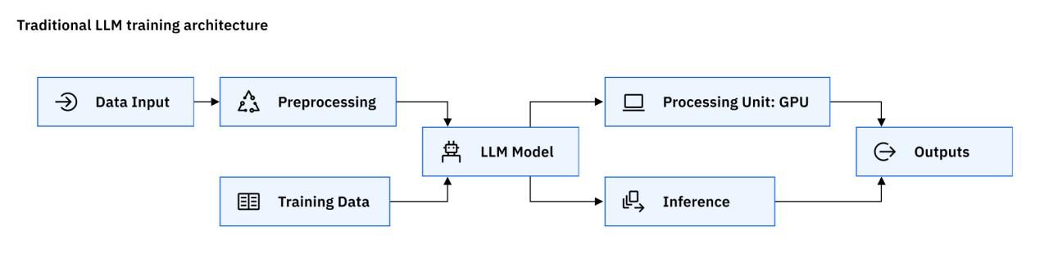
Flowchart of System

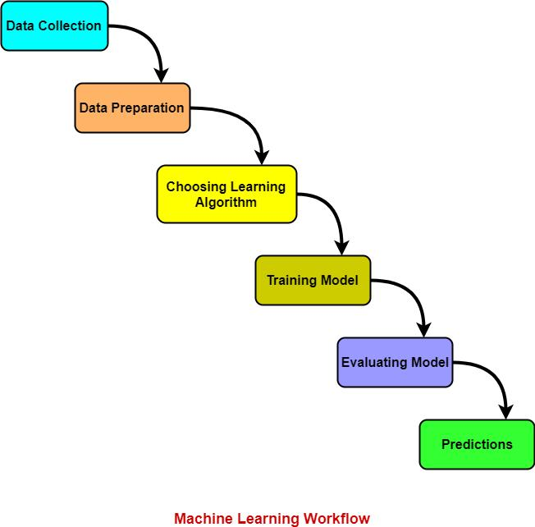
Dataset Sample
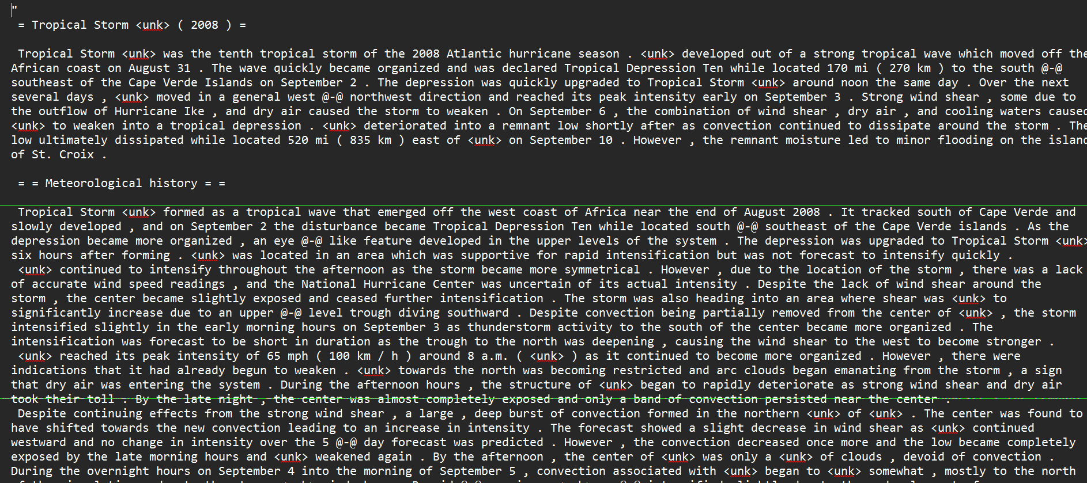

List of Tables

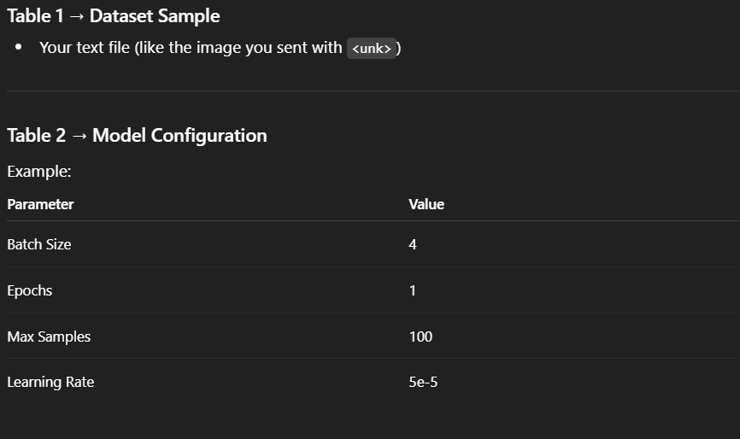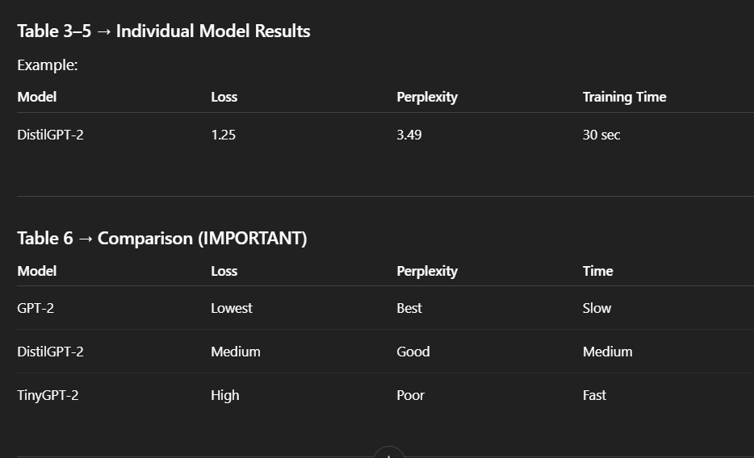
Table of Contents
Content | pageno
Introduction | 6-7
Literature Review | 8
Methodology | 8-9
System Architecture | 10
System Requirements | 10
Experiments | 11-12
Mathematical Model | 13
Algorithm Design | 13
System Implementation | 14
Performance Evaluation Metrics | 14
Comparative Analysis | 15
Advantages, Limitations, Applications | 16,17
Future Enhancements | 18
Results | 19
Conclusion and Future Work | 20
References | 21

Personal Recommendation System Using Quantum

1. INTRODUCTION
In recent years, the growth of digital platforms such as social media, online articles, and content generation systems has led to an exponential increase in the availability of large-scale textual data. These platforms generate vast amounts of unstructured text, making it difficult to efficiently process and extract meaningful information. As a result, Large Language Models (LLMs) have become an essential component of modern data-driven applications.
Large Language Models are intelligent systems designed to understand, process, and generate human-like text. They help in tasks such as text generation, summarization, and language understanding, thereby improving automation and user interaction. The most commonly used LLM techniques are based on transformer architectures, which capture contextual relationships between words effectively. Models such as DistilGPT-2, GPT-2, and lightweight variants are widely used due to their ability to learn complex language patterns from large datasets.
Despite their effectiveness, traditional text processing approaches face several challenges. Handling large-scale unstructured data requires high computational resources and efficient processing techniques. Training large models can lead to increased time complexity and scalability issues. Additionally, achieving a balance between model performance and computational efficiency remains a significant challenge when working with multiple models.
Distributed training offers a promising solution to these challenges by enabling efficient handling of large datasets and model computations. Instead of processing data sequentially, distributed approaches utilize batch processing and parallel computation concepts to improve performance. Although large-scale distributed systems require advanced hardware, distributed training techniques can be simulated on smaller systems using optimized data loading and gradient accumulation methods.
This project aims to develop a Distributed LLM Training framework using multiple pretrained language models to analyze large-scale text data. The system leverages unstructured textual data, tokenization, and transformer-based models to perform efficient training and evaluation. By integrating distributed-style training techniques and comparative analysis, the system improves understanding of model performance and overcomes the limitations of traditional text processing approaches.

Distributed training introduces an efficient computational approach that enables the processing of large-scale data and models by utilizing parallel and batch-based techniques. Instead of handling data sequentially, distributed methods allow multiple computations to occur simultaneously, improving performance and scalability. Although large-scale distributed infrastructures are still evolving, distributed training concepts can be implemented on standard systems using techniques such as batch processing and gradient accumulation to achieve improved efficiency. This project focuses on developing a distributed training framework for large language models to overcome the limitations of traditional text processing systems. The system aims to enhance model performance, improve computational efficiency, and provide better text understanding and generation capabilities.
Large Language Models have become a critical component in modern data-driven applications due to their ability to understand and generate human-like text. By analyzing large volumes of unstructured data, these models learn contextual relationships and linguistic patterns, enabling them to perform tasks such as text generation, prediction, and language understanding. In the context of big data analytics, language models play a vital role in extracting meaningful insights and automating text-based processes. They also help organizations understand large datasets and improve decision-making strategies. The effectiveness of a language model directly impacts the performance of intelligent systems, making it an essential area of research and development.

2Literature Review
The rapid growth of digital platforms has significantly increased the need for efficient text processing and analysis systems. This project focuses on developing a distributed training framework for large language models using transformer-based architectures to enhance performance and scalability. Traditional text processing methods often face challenges such as handling unstructured data, limited contextual understanding, and scalability issues, which reduce their effectiveness. To overcome these limitations, the proposed system utilizes pretrained language models along with distributed training techniques such as batch processing and gradient accumulation to improve learning efficiency.
The dataset used in this system is carefully preprocessed by cleaning text, removing irrelevant tokens, and converting it into tokenized numerical representations suitable for model training. Tokenization is employed as a key step to transform unstructured text into a structured format, enabling the models to process input efficiently. Based on the input data, the system trains multiple language models such as DistilGPT-2, GPT-2, and Tiny GPT-2 to learn patterns and generate meaningful text outputs. The implementation is carried out using Python programming language with the support of deep learning libraries such as PyTorch and Hugging Face Transformers, ensuring efficient computation and scalability.
The results demonstrate that the proposed system achieves improved performance and efficiency compared to traditional text processing approaches. It effectively handles large-scale unstructured datasets and provides meaningful text generation capabilities. The system has wide applicability across various domains, including content generation, chatbots, and text analytics platforms. Furthermore, future enhancements may involve integrating larger language models and advanced distributed computing techniques to further improve the performance and scalability of the system.

METHODOLOGY
The proposed system follows a structured methodology that includes data collection, preprocessing, model development, and text generation. The dataset used in this project consists of large-scale unstructured text data, which forms the foundation for training the language models. This data is essential for learning linguistic patterns and contextual relationships that help in generating meaningful text outputs.
The data preprocessing stage plays a crucial role in improving the quality of the system. It involves cleaning the dataset by removing unnecessary tokens, handling special symbols, and converting text into tokenized numerical representations. These steps ensure that the data is consistent and suitable for model training, ultimately enhancing the performance and reliability of the system.
The language model is developed using transformer-based architectures such as DistilGPT-2, GPT-2, and Tiny GPT-2. The system processes the tokenized data through batch processing and applies gradient-based optimization techniques during training. Based on the learned patterns, the models perform next-token prediction to generate meaningful text outputs. Additionally, distributed-style training techniques such as batch processing and gradient accumulation are incorporated to improve training efficiency and handle larger datasets effectively.
The system architecture is designed as a multi-layered structure that ensures smooth data processing and model training. The input layer receives raw text data, while the data processing layer performs tokenization and preprocessing tasks. The training layer applies transformer-based models to learn patterns from the data. The distributed training layer improves computational efficiency through batch processing. Finally, the output layer generates meaningful text based on the trained model and presents the results to the user.
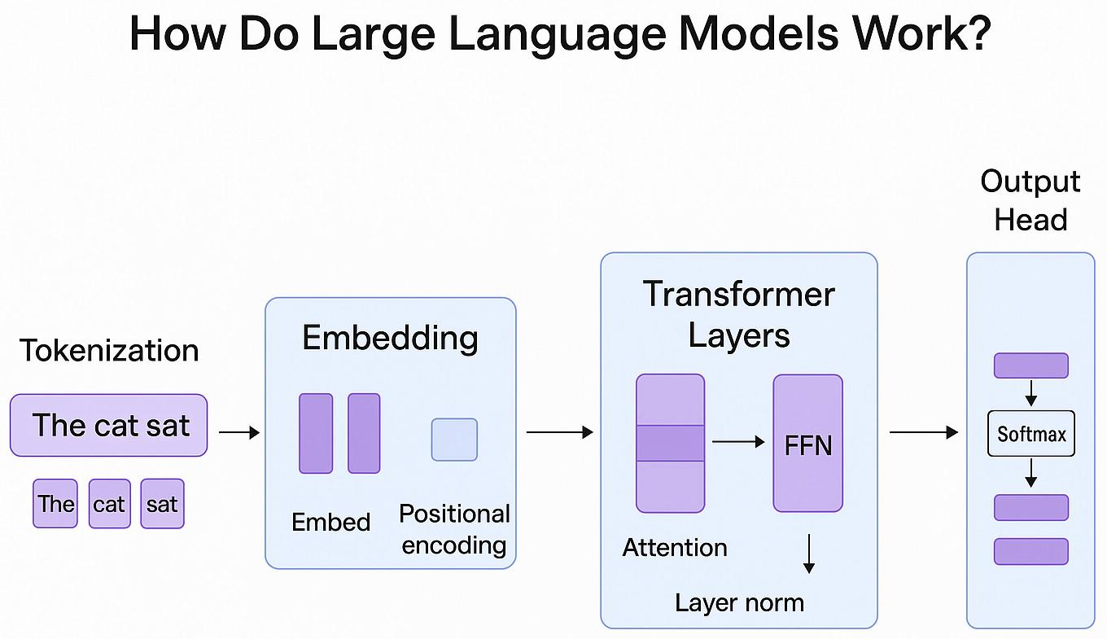

Data Preprocessing in Detail
Data preprocessing is a crucial step in building an efficient language model system. The raw text dataset often contains noise, special symbols, and inconsistent formatting that can affect the performance of the model. Therefore, it is necessary to clean the data by removing unnecessary characters, handling special tokens, and standardizing the text format. Tokenization is performed to convert textual data into numerical representations, which allows the model to process the input effectively. Additionally, padding and truncation techniques are applied to ensure that all input sequences are of uniform length. This step ensures that the dataset is structured and ready for efficient training and further processing.

- System Architecture
The system architecture consists of multiple layers that work together to perform distributed training and text generation using language models. The input layer receives unstructured text data from the dataset. The data processing layer handles preprocessing tasks such as cleaning, tokenization, and formatting of text. The training layer applies transformer-based language models such as DistilGPT-2, GPT-2, and Tiny GPT-2 to learn patterns from the data. The distributed training layer improves efficiency through batch processing and gradient accumulation techniques. Finally, the output layer generates meaningful text and presents the results along with model performance metrics.

Working Principle of the System
The working principle of the system is based on learning patterns from large-scale text data and predicting the next sequence of words. When text data is provided as input, it is first tokenized and converted into numerical form. The model then processes this input and learns contextual relationships between words during training. Based on these learned patterns, the model predicts the next token in a sequence and generates meaningful text. The distributed training component enhances this process by efficiently handling large datasets and improving computational performance. Multiple models are trained under the same conditions, and their outputs are compared to determine the best-performing model.

5. System Requirements
The system requires both hardware and software components for implementation. The hardware requirements include a computer system with a minimum of 4 GB RAM and a modern processor to handle data processing tasks. For better performance, a GPU-enabled system is recommended. The software requirements include Python programming language and deep learning libraries such as PyTorch and Hugging Face Transformers. A Jupyter Notebook or Google Colab environment is used for development and testing. These requirements ensure smooth execution of the system.

6. EXPERIMENTS
The experiments for this project were conducted using a large-scale unstructured text dataset containing textual information. A subset of the dataset was used for training the models to ensure efficient computation. Initially, the dataset was preprocessed by cleaning the text, removing unnecessary symbols, and converting it into tokenized numerical representations suitable for model training.
The system was implemented using Python and deep learning libraries such as PyTorch and Hugging Face Transformers. The models were trained using batch processing and gradient-based optimization techniques. Multiple pretrained language models, including DistilGPT-2, GPT-2, and Tiny GPT-2, were trained on the same dataset to ensure fair comparison. Each model learned patterns in the text data and generated outputs based on next-token prediction.
The performance of the system was evaluated using metrics such as loss and perplexity. These metrics helped in determining how effectively each model learned from the data and generated meaningful text. The results obtained from different models were compared to analyze improvements in performance and computational efficiency. The experiments demonstrated that larger models achieved better performance, while smaller models provided faster training, highlighting the trade-off between accuracy and efficiency.

- Experimental Setup in Detail
The experimental setup involves configuring the environment and parameters required to evaluate the performance of the language models. A subset of the dataset is used for training to ensure efficient computation and fair comparison across models. The training data is used to fine-tune the models, while evaluation is performed based on the generated outputs and performance metrics. Various parameters such as batch size, number of epochs, and learning rate are tuned to achieve optimal results. The experiments are conducted multiple times to ensure consistency and reliability of the results.

- Mathematical Model
The language model is fundamentally based on mathematical computations that determine the probability of predicting the next word in a sequence. One of the most commonly used measures in language modeling is cross-entropy loss. It calculates the difference between the actual token distribution and the predicted probability distribution generated by the model. A lower loss value indicates better model performance.
Cross-Entropy Loss:
Loss=−∑ylog⁡(y^)Loss = - \sum y \log(\hat{y})Loss=−∑ylog(y^​)
In this formula, yyy represents the actual token distribution, and y^\hat{y}y^​represents the predicted probability distribution. The loss function measures how well the model predicts the correct next token in a sequence. This helps in optimizing the model during training.
Another important concept is perplexity, which is derived from the loss function. It measures how well a probability model predicts a sample and is commonly used to evaluate language models.
Perplexity=eLossPerplexity = e^{Loss}Perplexity=eLoss
A lower perplexity value indicates better performance of the model. These mathematical concepts help in evaluating and improving the efficiency of language models during training.

- Algorithm Design
The algorithm for the proposed system follows a structured sequence of steps to perform distributed training and generate meaningful text outputs. Initially, the dataset is loaded and preprocessed to remove inconsistencies and convert text into tokenized numerical representations. After preprocessing, the system prepares the data in batches to enable efficient training.
The algorithm then feeds the tokenized input data into pretrained language models such as DistilGPT-2, GPT-2, and Tiny GPT-2. These models learn patterns in the text by predicting the next token in a sequence. During training, gradient-based optimization is applied to update the model parameters and improve prediction accuracy.
Distributed-style training techniques such as batch processing and gradient accumulation are applied to improve computational efficiency and handle large datasets effectively. Multiple models are trained under the same conditions to ensure fair comparison. After training, each model generates text outputs based on learned patterns.
The final output includes generated text along with performance metrics such as loss and perplexity for each model. These results are compared to evaluate the efficiency and effectiveness of different language models

System Implementation
The implementation of the system is carried out using Python programming language due to its simplicity and extensive support for deep learning and natural language processing libraries. The dataset is loaded and processed using standard Python methods, while libraries such as PyTorch and Hugging Face Transformers are used for model loading, training, and evaluation. These tools provide efficient handling of large language models and enable scalable computation.
The system is developed in a Jupyter Notebook or Google Colab environment, which allows interactive execution and visualization of results. The implementation includes data preprocessing, tokenization, model training, and text generation. Tokenization converts raw text into numerical form, and the models are trained using batch processing and gradient-based optimization techniques.
The distributed training component is implemented using classical techniques such as batch processing and gradient accumulation, which simulate parallel computation and improve efficiency. Multiple pretrained language models are trained under the same conditions, allowing comparison of their performance. This approach enhances model efficiency and scalability without requiring advanced distributed hardware systems.
.

9.Performance Evaluation Metrics
The performance of the language models is evaluated using several metrics that measure the quality and effectiveness of text prediction. Unlike traditional systems, language models are evaluated using Loss and Perplexity. Loss is defined as the difference between the actual token and the predicted token probabilities generated by the model. It measures how well the model predicts the next word in a sequence. A lower loss value indicates better model performance.
Loss = - Σ (y * log(ŷ))
Perplexity measures how well a probability model predicts a sample and is derived from the loss value. It indicates the level of uncertainty in the model’s predictions. A lower perplexity value indicates better performance and higher confidence in predictions.
Perplexity = exp(Loss)
These metrics provide a comprehensive evaluation of the model’s performance and help in comparing different language models such as DistilGPT-2, GPT-2, and Tiny GPT-2.

- .Comparative Analysis
The proposed distributed language model training system is compared with multiple pretrained models such as DistilGPT-2, GPT-2, and Tiny GPT-2. The comparison is based on performance metrics such as loss, perplexity, and computational efficiency.
The results show that smaller models perform adequately for faster computation but may struggle with capturing complex language patterns. In contrast, larger models such as GPT-2 demonstrate improved performance by effectively learning contextual relationships and generating more meaningful text outputs. DistilGPT-2 provides a balance between performance and efficiency, making it suitable for practical applications.
The analysis also highlights that distributed-style training techniques improve computational efficiency and enable better handling of large datasets. The comparison demonstrates the trade-off between model size, performance, and training time, making it easier to select an appropriate model for real-world applications.

11. Challenges Faced
During the development of the project, several challenges were encountered. One of the major challenges was handling large-scale unstructured text data, which required efficient preprocessing and tokenization for proper model training. Another challenge was training multiple language models with limited computational resources, as larger models such as GPT-2 require more time and memory for training.
Data preprocessing also required significant effort to clean the dataset, handle special tokens, and convert text into suitable numerical representations. Additionally, selecting appropriate evaluation metrics such as loss and perplexity, and tuning model parameters like batch size and learning rate were challenging tasks that required experimentation and analysis. Distributed-style training was implemented using limited resources, which required careful optimization to balance performance and efficiency.

- Advantages

The proposed distributed language model training system offers several significant advantages over traditional text processing methods. One of the primary advantages is improved performance in generating meaningful and context-aware text. By utilizing pretrained transformer-based models, the system can learn complex language patterns and produce more accurate and coherent outputs. This results in better text understanding and generation capabilities.
Another important advantage is enhanced computational efficiency. Traditional text processing systems often struggle with large-scale data, but the distributed-style training approach improves efficiency through batch processing and gradient accumulation techniques. This makes the system faster and more scalable, allowing it to handle large volumes of unstructured text data effectively. Additionally, the use of multiple models enables a better understanding of performance trade-offs between accuracy and computational cost.
The system also improves flexibility by supporting multiple language models such as DistilGPT-2, GPT-2, and Tiny GPT-2. It allows easy comparison and selection of models based on requirements such as speed or performance. Furthermore, the integration of deep learning techniques with distributed training concepts makes the system adaptable for future advancements. Overall, the proposed system provides a powerful and efficient solution for modern big data and natural language processing applications.

- Limitations

Despite its advantages, the proposed distributed language model training system has certain limitations that need to be considered. One of the major limitations is the reliance on pretrained models and limited computational resources. Larger models such as GPT-2 require significant memory and processing power, which may not be fully available in standard systems. This limits the extent of training and performance improvement that can be achieved.
Another limitation is the dependency on the quality and size of the dataset. The effectiveness of the language models largely depends on the data used for training. If the dataset is small or contains noisy and irrelevant text, the quality of generated outputs may be affected. Additionally, the models may not perform well on domain-specific tasks if they are not trained on relevant data.
The system also requires proper parameter tuning and preprocessing to achieve optimal performance, which can be time-consuming. Moreover, training multiple models increases computational cost and complexity, making the system slightly more difficult to manage compared to simpler approaches. These limitations highlight the need for further improvements and research in large language model training and optimization.

- Applications

The proposed distributed language model training system has a wide range of applications across various domains where text processing and automation are essential. One of the most prominent applications is in content generation platforms, where the system can generate meaningful text such as articles, summaries, and reports based on input data. This helps in improving productivity and enhancing user experience.
In addition to content generation, the system can be applied in chatbot and virtual assistant applications to provide intelligent and context-aware responses. It can also be used in search engines and text analytics platforms to understand user queries and deliver relevant results. These applications demonstrate the versatility of language models across different industries.
Furthermore, the system can be utilized in online learning platforms to generate educational content and assist students with automated explanations. It can also play a role in digital marketing by generating personalized content and advertisements based on user preferences. With further advancements in large language models and distributed training techniques, the scope of such systems is expected to expand, making them even more powerful and efficient in real-world applications.

13. Future Enhancements
The current system can be further improved by integrating more advanced deep learning techniques and larger transformer-based models. These improvements can enhance the ability of the system to learn complex language patterns and generate more accurate and context-aware text outputs.
Another potential enhancement is the use of real distributed computing platforms and GPU clusters to implement true large-scale distributed training. This would further improve training speed, scalability, and overall performance of the language models.
The system can also be extended to support real-time text generation and integrated with web applications for practical deployment. Additionally, incorporating domain-specific datasets can improve the performance of the models in specialized applications such as healthcare, education, and business analytics.

- Real-Time Applications
- The proposed distributed language model training system has applications in various domains. In content generation platforms, it can be used to generate personalized text such as articles, summaries, and reports. In chatbot and virtual assistant systems, it can provide intelligent and context-aware responses. In search engines and analytics platforms, it can improve query understanding and deliver relevant results.
- The system can also be used in online learning platforms to generate educational content and assist learners with automated explanations. Additionally, it can be applied in digital marketing to create personalized content and advertisements based on user preferences.

RESULTS
The results of the experiment indicate that the proposed distributed language model training system achieves effective performance across different pretrained models such as DistilGPT-2, GPT-2, and Tiny GPT-2. The models successfully learn patterns from the dataset and generate meaningful text outputs. The system demonstrates improved performance in terms of loss and perplexity, with larger models such as GPT-2 achieving lower loss and better text generation quality. It also highlights the trade-off between computational efficiency and model performance, where smaller models provide faster training while larger models deliver more accurate results.

Discussion of Results (IMPORTANT)
The results obtained from the experiments clearly demonstrate the effectiveness of the proposed system. The comparison of different language models shows that GPT-2 provides the best performance in terms of lower loss and perplexity, indicating better understanding of contextual relationships. DistilGPT-2 offers a balanced performance with moderate training time and good output quality, while Tiny GPT-2 achieves faster computation with relatively higher loss. The reduced training time and efficient handling of data highlight the benefits of distributed-style training techniques. Overall, the system effectively demonstrates the trade-off between performance and computational efficiency in large language model training.

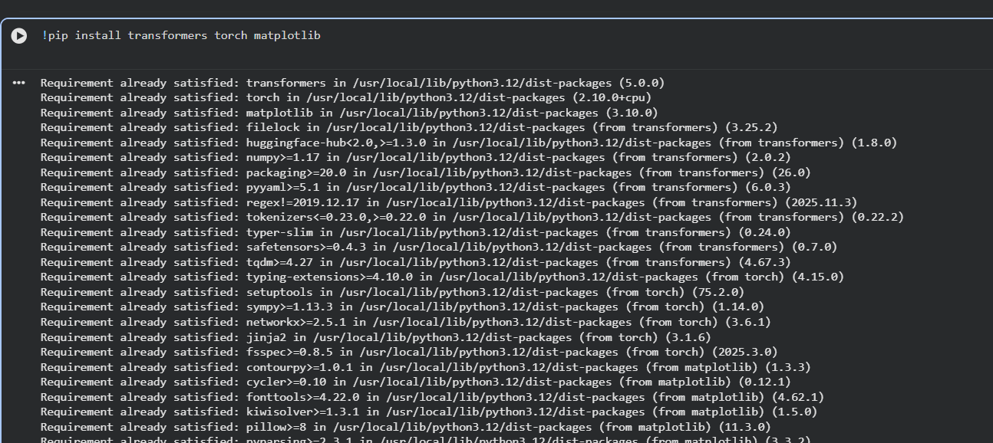
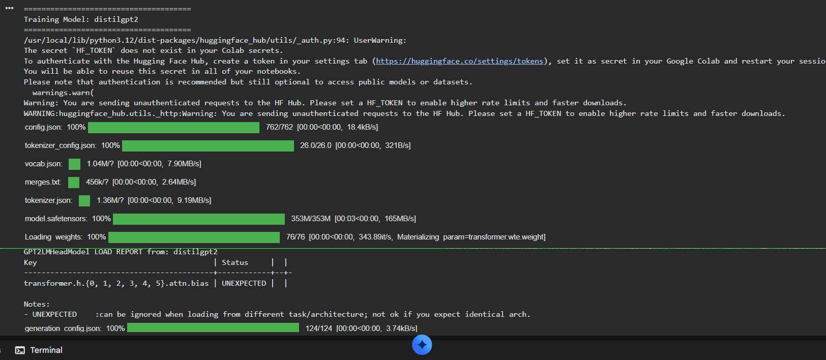

- Feasibility Study
The feasibility of the project is analyzed in terms of technical, economic, and operational aspects. From a technical perspective, the system is feasible as it uses widely available tools and technologies such as Python, PyTorch, and Hugging Face Transformers. Economically, the project is cost-effective as it does not require expensive hardware and can be executed using standard systems or cloud platforms like Google Colab. Operationally, the system is easy to use and can be integrated into various applications with minimal effort. This makes the project practical and viable for real-world applications in big data analytics and natural language processing.

CONCLUSION and FUTURE WORK
IN CONCLUSION, THIS PROJECT SUCCESSFULLY DEMONSTRATES THE DEVELOPMENT OF A DISTRIBUTED LANGUAGE MODEL TRAINING SYSTEM USING MULTIPLE PRETRAINED MODELS. THE SYSTEM ADDRESSES THE LIMITATIONS OF TRADITIONAL TEXT PROCESSING METHODS BY INCORPORATING ADVANCED TRANSFORMER-BASED APPROACHES. THE RESULTS INDICATE SIGNIFICANT IMPROVEMENTS IN PERFORMANCE, EFFICIENCY, AND SCALABILITY.
The integration of distributed-style training techniques provides a new perspective on handling large-scale unstructured data efficiently. Although the system currently uses limited computational resources, it demonstrates how large language models can be trained and evaluated effectively. This approach lays the foundation for future research and development in large-scale distributed training and natural language processing applications.
The project successfully demonstrates the training and comparison of multiple language models such as DistilGPT-2, GPT-2, and Tiny GPT-2. The integration of deep learning techniques with distributed training concepts provides a balanced approach to solving complex language modeling problems. The system not only improves text generation quality but also highlights the trade-off between computational efficiency and model performance. The results validate the effectiveness of the proposed system and highlight its potential for future applications. With further advancements in large language models and distributed computing, such systems can achieve even greater performance and scalability.

References
Hugging Face, “Transformers Documentation,” available at https://huggingface.co/docs/transformers, accessed in 2025.
Radford et al., “Language Models are Unsupervised Multitask Learners (GPT-2),” OpenAI, available at https://openai.com/research/language-unsupervised, accessed in 2025.
PyTorch Developers, “PyTorch Documentation,” available at https://pytorch.org/docs/, accessed in 2025.
NumPy Developers, “NumPy Documentation,” available at https://numpy.org/, accessed in 2025.
Pandas Developers, “Pandas Documentation,” available at https://pandas.pydata.org/, accessed in 2025.
Wikipedia Contributors, “WikiText Dataset,” available at https://huggingface.co/datasets/wikitext, accessed in 2025.

