**Assignment – 1**

**1.Write a c++ program that prints “Hello, World!” to the console.**

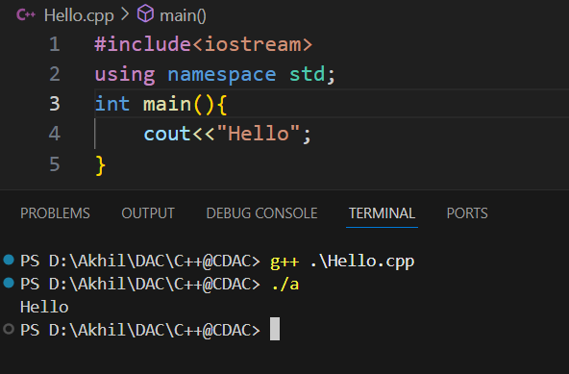

**2.Write a C++ program that takes two integers input from the user and prints their sum.**

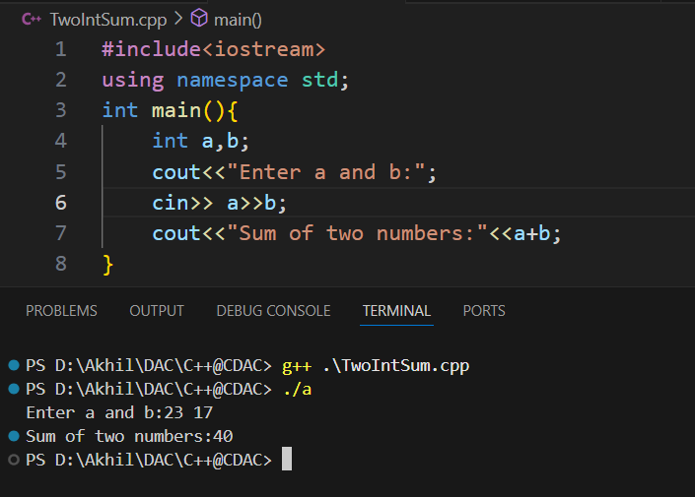

**3 Write a C++ program to swap two numbers without using third variable.**

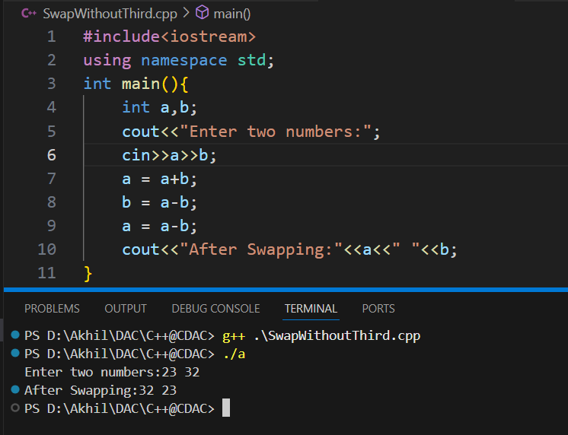

**4 Write a C++ program that checks whether a number entered by the user is even or odd.**

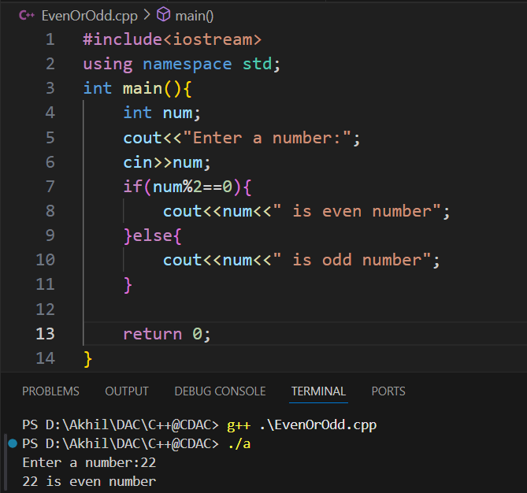

**5 Write a C++ program that takes two number and an operator(+,-,*,/) as input and performs the corresponding operation.**

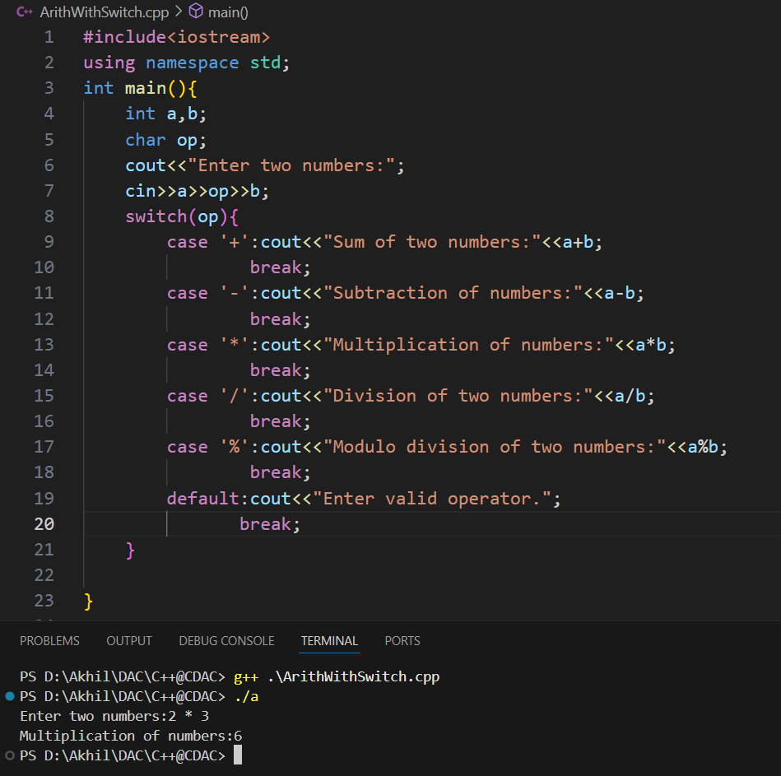

**6. Write a c++ program that takes n numbers as input , stores them in an array, and finds the largest number.**

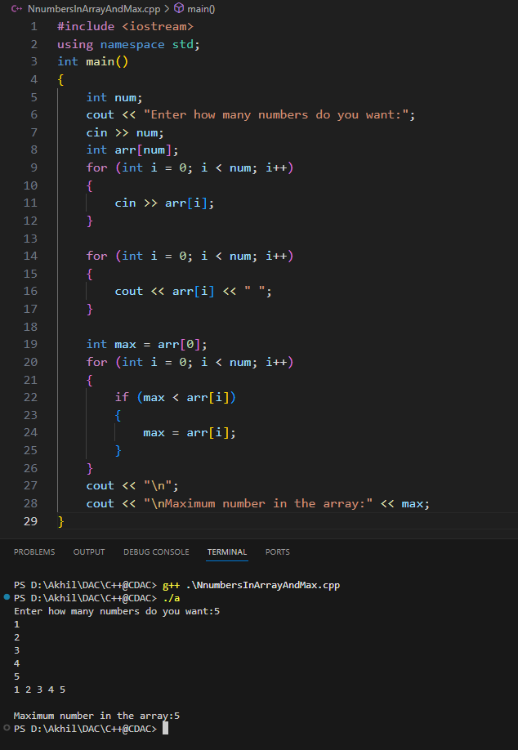

**7.Write a C++ program that takes an integer input and calculates the sum of digits**

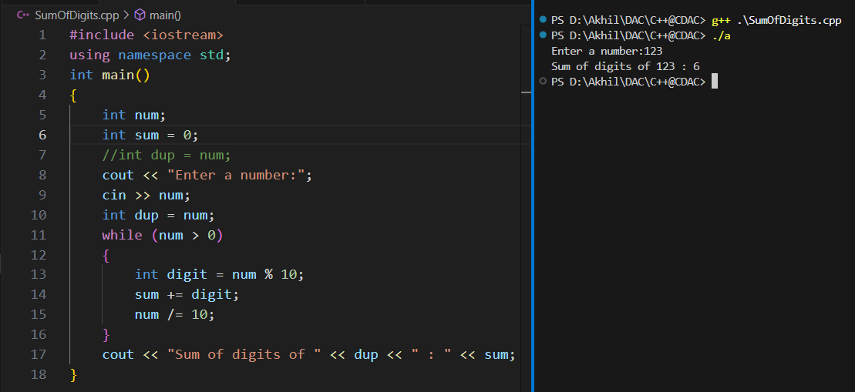

**8 Write a C++ program to take n elements in an array and print them in the reverse order.**

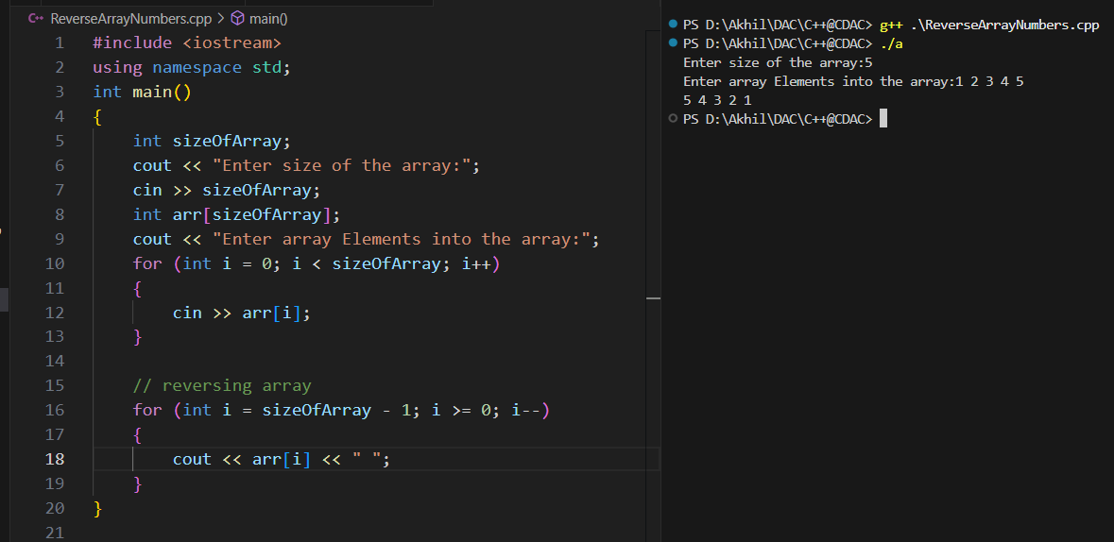

**9. Write a C++ program to check if a given number is palindrome or not**

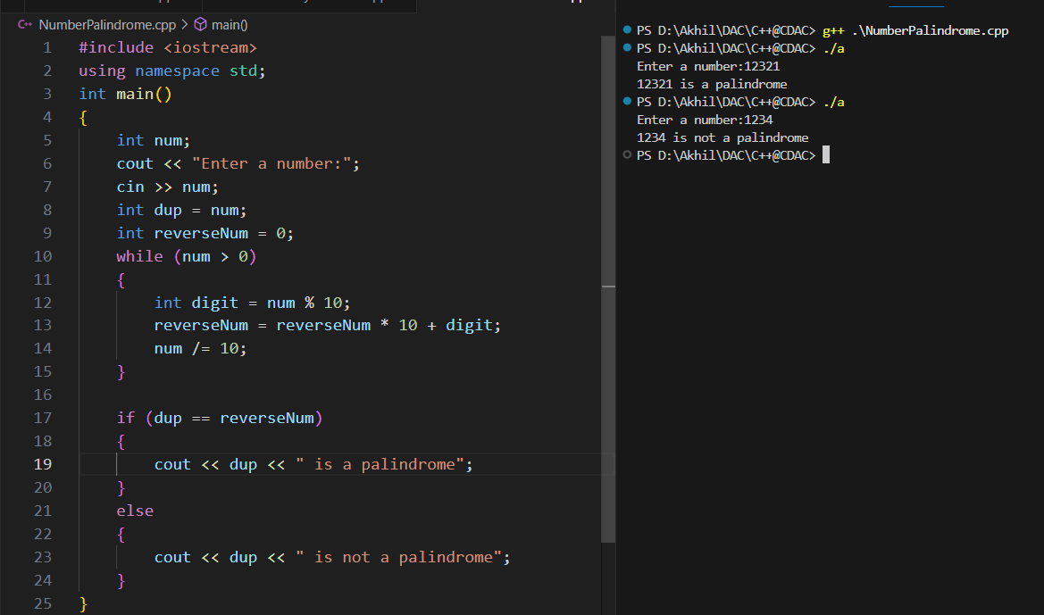

**10. Write a C++ program to print the Fibonacci series up to n terms.**

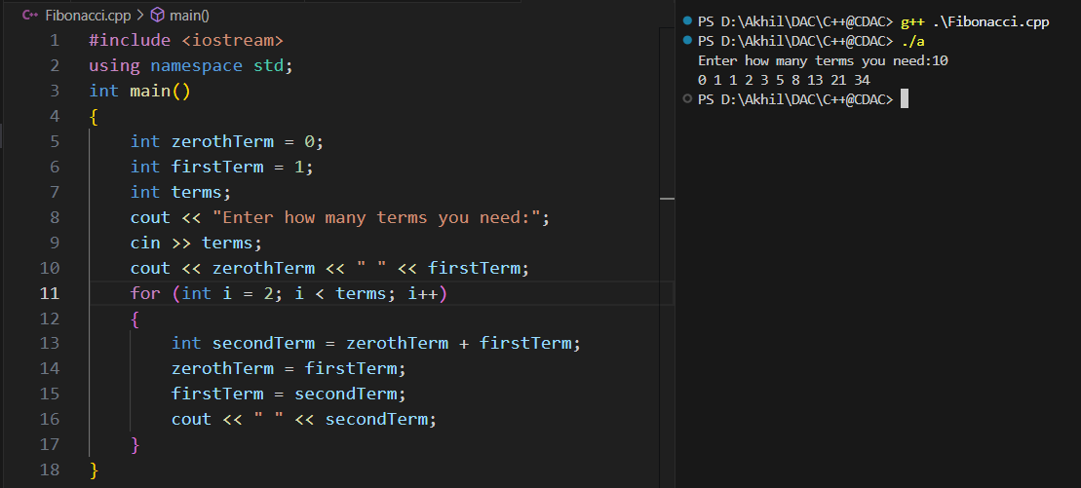

11. Write a C++ program that takes a string input and the counts the number of vowels. 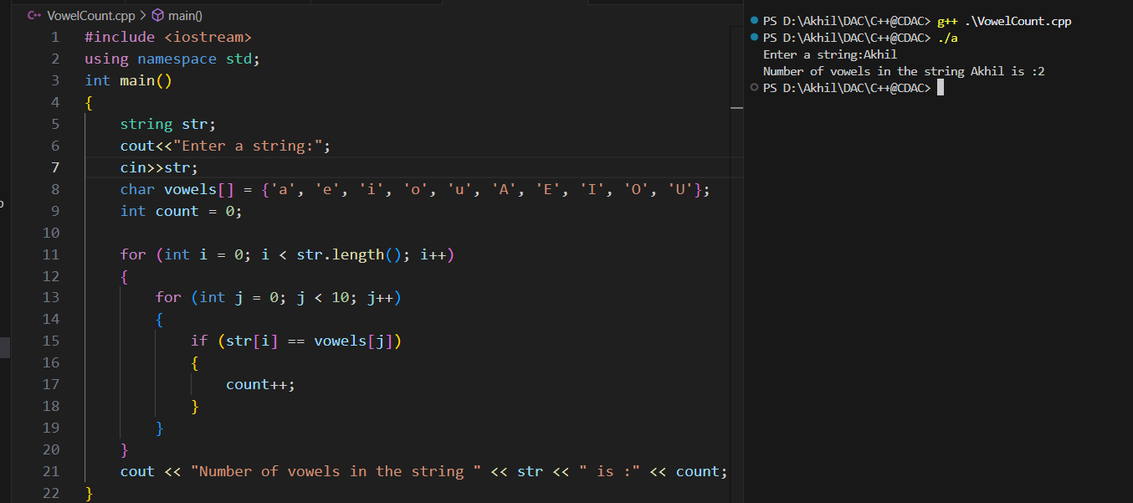

12.Write a C++ program to find the GCD of numbers.

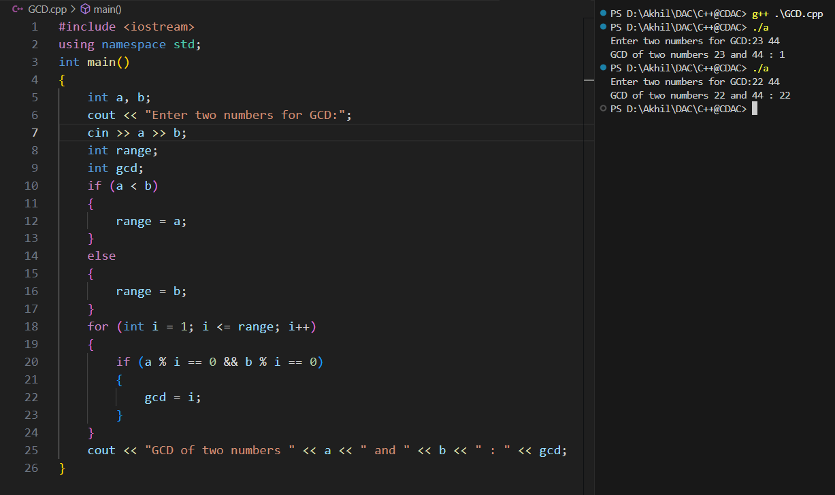

13. Write a C++ program to multiply two Matrices.

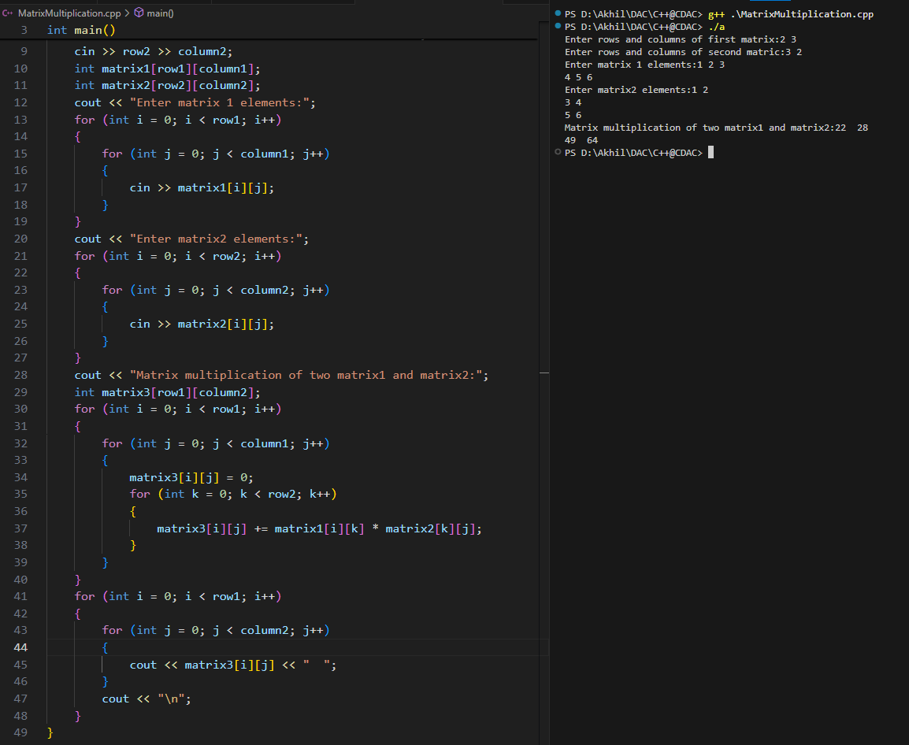

**14. Write a C++ program to check whether the given number is Armstrong number or not**

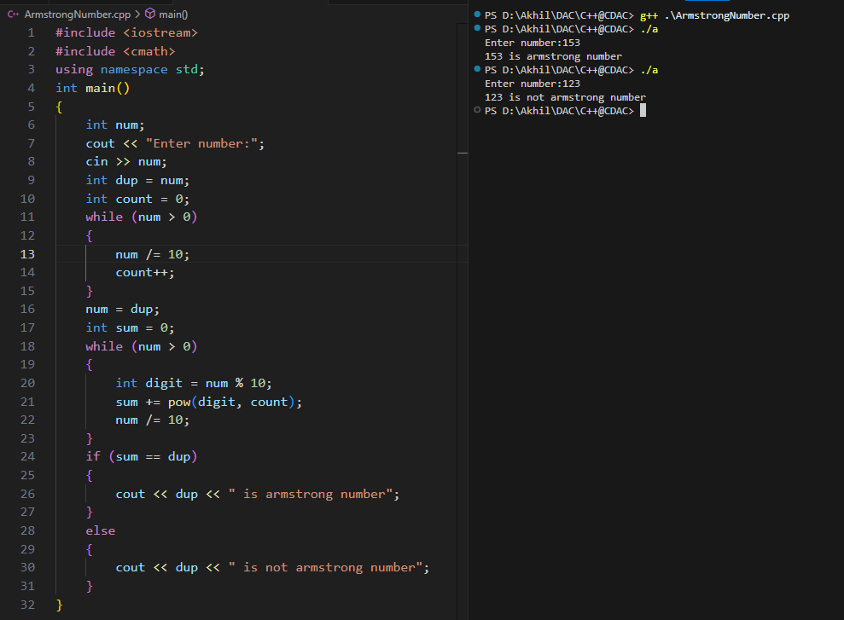

**15 Write a C++ program to Print Pascals Triangle upto n rows**

