ASSIGNMENT – 1
- Installing GitHub Copilot in VS Code:



TASK-1: Generate a Python program that calculates the factorial of a number without defining any functions.
Code:
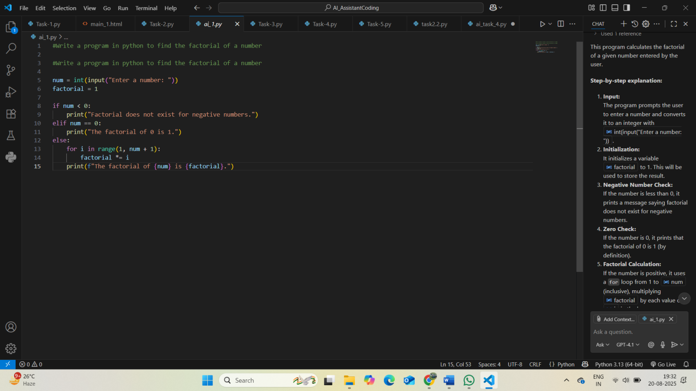
Output:
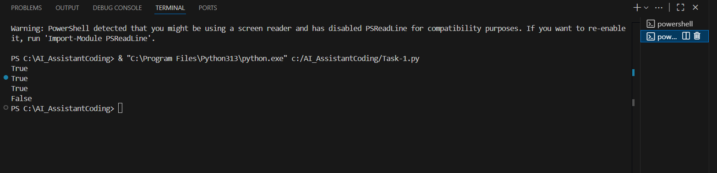
Explanation:
This program calculates the factorial of a given number entered by the user.
Step-by-step explanation:
- Input:
The program prompts the user to enter a number and converts it to an integer with int(input("Enter a number: ")).
- Initialization:
It initializes a variable factorial to 1. This will be used to store the result.
- Negative Number Check:
If the number is less than 0, it prints a message saying factorial does not exist for negative numbers.
- Zero Check:
If the number is 0, it prints that the factorial of 0 is 1 (by definition).
- Factorial Calculation:
If the number is positive, it uses a for loop from 1 to num (inclusive), multiplying factorial by each value of i in the loop.
- Output:
Finally, it prints the factorial of the entered number.
Example:
If the user enters 5, the output will be:
The factorial of 5 is 120.
TASK-2: -Generate code from Task 1 and demonstrate how its efficiency can be improved (e.g., removing unnecessary variables, optimizing loops).
Code:
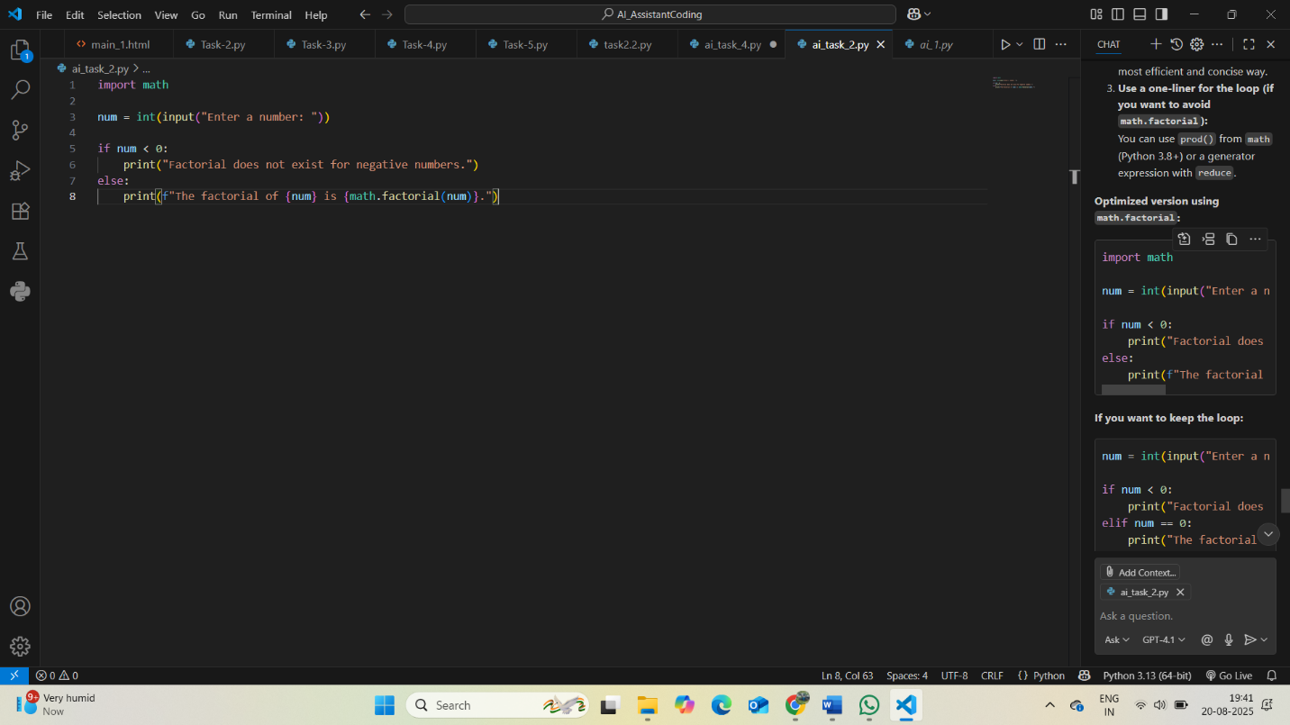
Output:
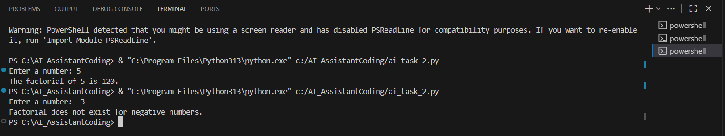
Explanation:
You can improve the efficiency and readability of this code in several ways:
- Remove unnecessary initialization:
You can move the factorial = 1 assignment inside the else block, since it's not needed for negative or zero cases.
- Use the math.factorial() function:
Python’s standard library provides a highly optimized factorial function. This is the most efficient and concise way.
- Use a one-liner for the loop (if you want to avoid math.factorial):
You can use prod() from math (Python 3.8+) or a generator expression with reduce.
TASK-3: Generate a Python program that calculates the factorial of a number using a user-defined function.
Code:
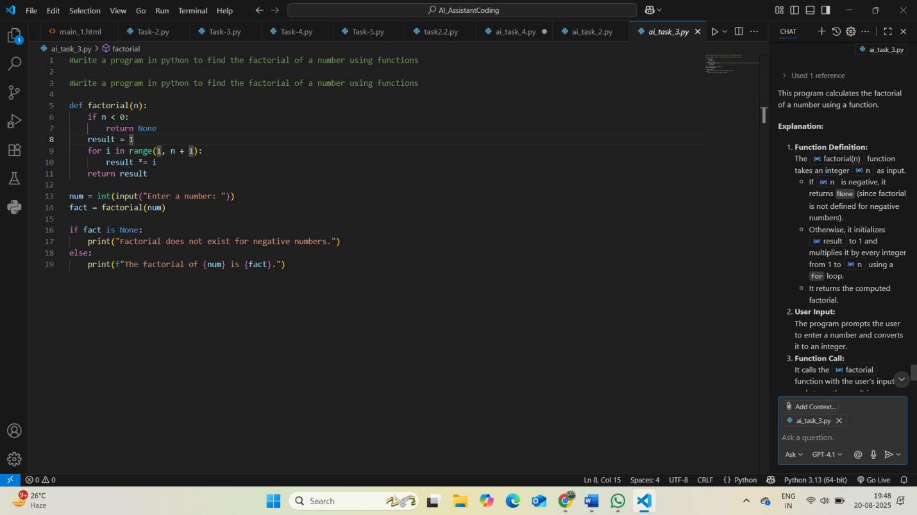
Output:
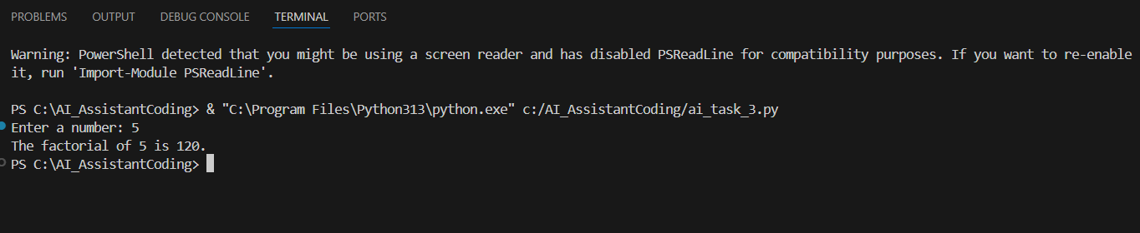
Explanation:
This program calculates the factorial of a number using a function.
Explanation:
- Function Definition:
The factorial(n) function takes an integer n as input.
  - If n is negative, it returns None (since factorial is not defined for negative numbers).
  - Otherwise, it initializes result to 1 and multiplies it by every integer from 1 to n using a for loop.
  - It returns the computed factorial.
- User Input:
The program prompts the user to enter a number and converts it to an integer.
- Function Call:
It calls the factorial function with the user's input and stores the result in fact.
- Output:
  - If fact is None, it prints a message that factorial does not exist for negative numbers.
  - Otherwise, it prints the factorial of the entered number.
Example:
If the user enters 4, the output will be:
The factorial of 4 is 24.
If the user enters -2, the output will be:
Factorial does not exist for negative numbers.

TASK-4: Differentiate between the factorial program with functions and without functions in terms of logic, reusability, and execution.
Comparison Table:
- Difference between factorial program with functions and without functions:
Aspect | With Functions (def factorial(n): ...) | Without Functions (direct code)
Logic | Logic is encapsulated inside a function. The main code calls this function with the required argument. | Logic is written directly in the main program, usually inside a loop or conditional block.
Reusability | Highly reusable. The function can be called multiple times with different inputs, or imported into other programs. | Not reusable. The code executes only once for the given input; to use it again, you must copy-paste or rewrite the logic.
Execution | The function is defined once and can be executed any number of times by calling it. Cleaner and more modular. | The code executes sequentially from top to bottom. No modularity; harder to maintain or extend.
Summary:
Using functions improves code organization, reusability, and maintainability, while direct code is simpler but less flexible and reusable.
TASK-5: Generate both iterative and recursive versions of the factorial function.
Code:
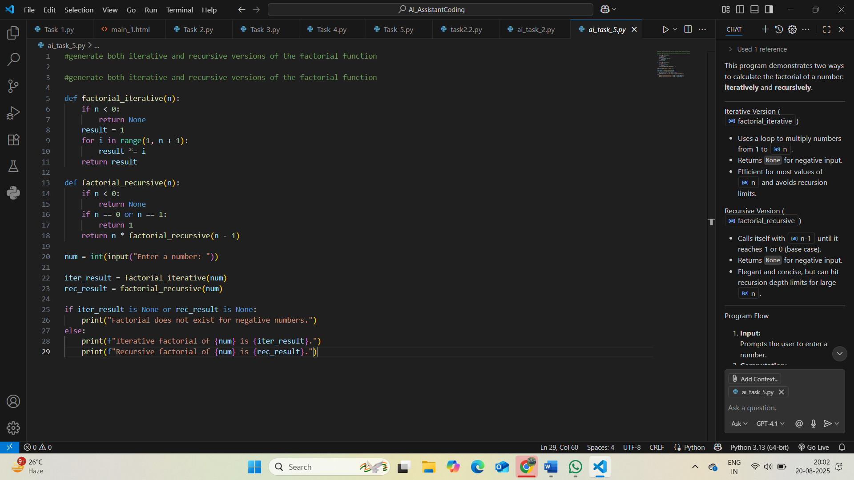
Output:
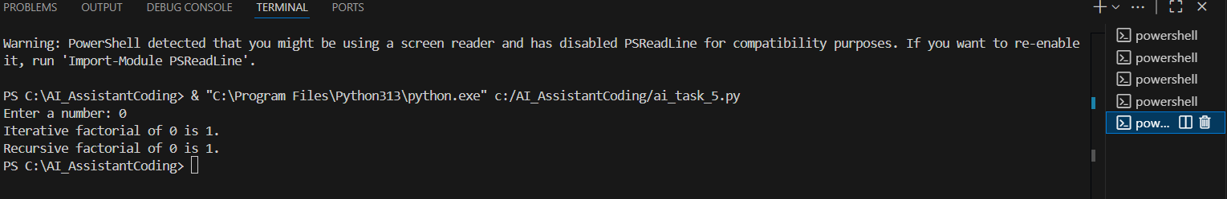
Explanation:
This program demonstrates two ways to calculate the factorial of a number: iteratively and recursively.

Iterative Version (factorial_iterative)
- Uses a loop to multiply numbers from 1 to n.
- Returns None for negative input.
- Efficient for most values of n and avoids recursion limits.
Recursive Version (factorial_recursive)
- Calls itself with n-1 until it reaches 1 or 0 (base case).
- Returns None for negative input.
- Elegant and concise, but can hit recursion depth limits for large n.

Program Flow
- Input:
Prompts the user to enter a number.
- Computation:
Calculates factorial using both iterative and recursive functions.
- Output:
  - If the input is negative, prints an error message.
  - Otherwise, prints both the iterative and recursive results.
Summary:
- Both methods return the same result for valid input.
- The iterative approach is generally more efficient for large numbers in Python.
- The recursive approach is more mathematical and elegant for small numbers.

