ASSIGNMENT – 15.1
NAME : B.AKHIL
ROLL:NO : 2403A52344
BATCH : AI 13
TASK-1: Create a Python RESTful API for student records using an in-memory store.
Endpoints:
- GET /students → list all
- POST /students → add
- PUT /students/{id} → update
- DELETE /students/{id} → delete
Each student has id, name, age, grade. Return JSON and handle missing IDs. Use FastAPI or Flask. Provide runnable code.
Code:
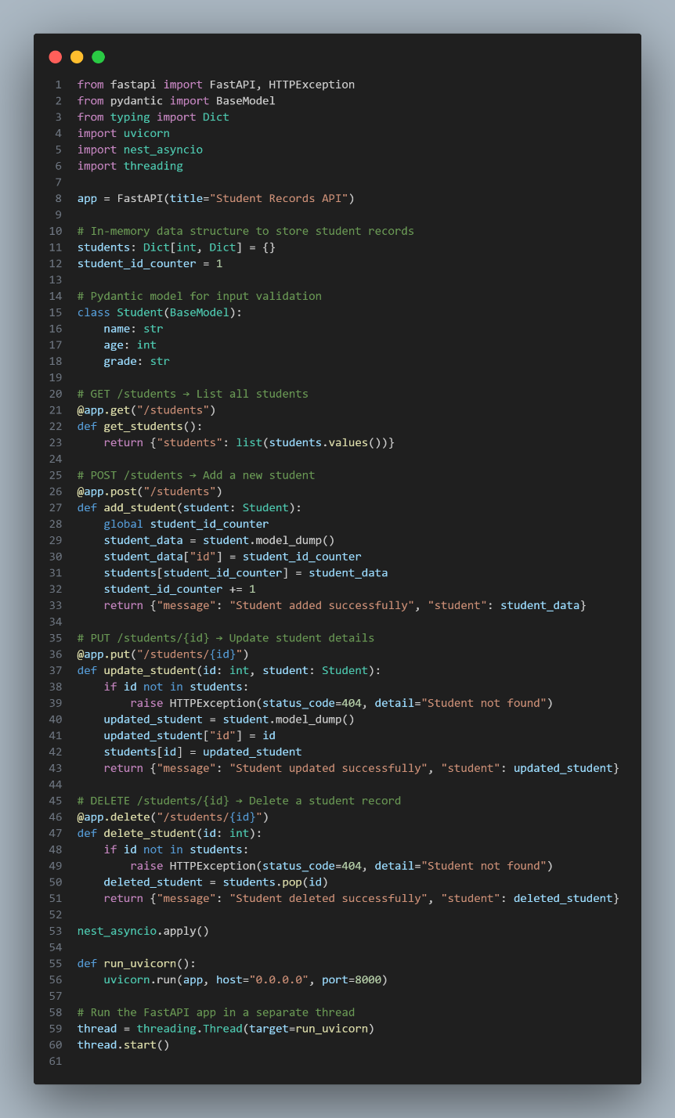
Output:
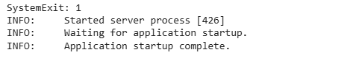

Explanation:
FastAPI Application Setup: You provided a FastAPI application with basic CRUD (Create, Read, Update, Delete) operations for student records. This includes models for data validation using Pydantic.
Running in a Separate Thread: To make your FastAPI application work within the Colab environment without conflicting with Colab's own event loop, we've set it up to run in a separate threading.Thread. This means the server is running in the background while your Colab notebook remains responsive.
nest_asyncio: We used nest_asyncio.apply() to allow nested event loops. This is often necessary in environments like Colab where an event loop is already running, and you need to start another one (like Uvicorn's server).
Accessibility: Your FastAPI application is now accessible at http://localhost:8000. This address is valid from within the Colab environment. You can use libraries like requests in another code cell to send HTTP requests to your API endpoints (e.g., GET /students, POST /students).
Stopping the Server: Since the server runs in a separate thread, simply stopping the execution of that specific cell won't necessarily stop the server process cleanly. The most reliable way to stop the FastAPI server and free up the port is to restart the Colab runtime (via the 'Runtime' menu -> 'Restart runtime...').
In essence, your FastAPI API is live and ready for interaction!

TASK-2: Build a RESTful API in Python to manage library books using an in-memory store.
Endpoints:
- GET /books → list all books
- POST /books → add a new book
- GET /books/{id} → get a specific book
- PATCH /books/{id} → update partial book details
- DELETE /books/{id} → remove a book
Each book has id, title, author, year, available.
Return JSON and handle invalid IDs. Provide runnable code using FastAPI or Flask.
Code:
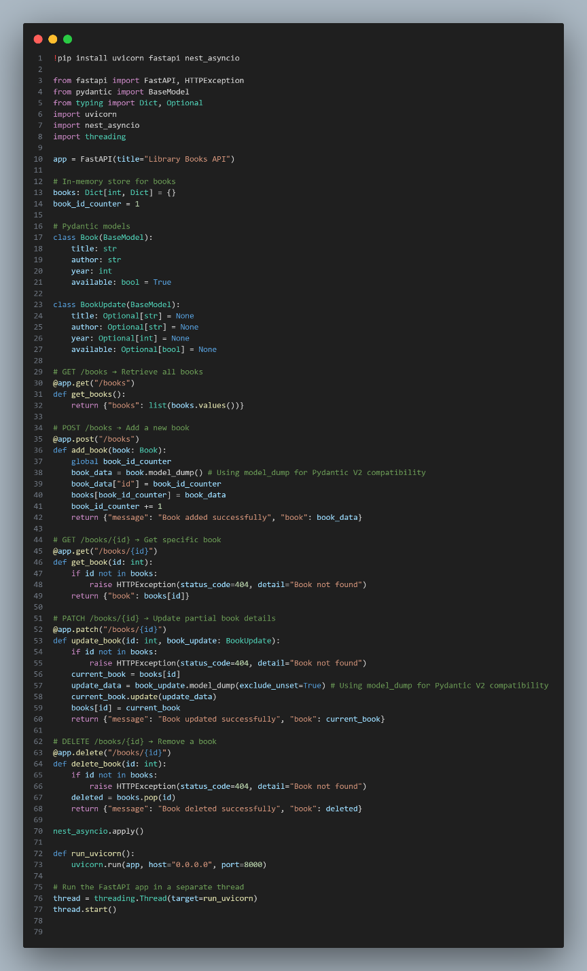
Output:
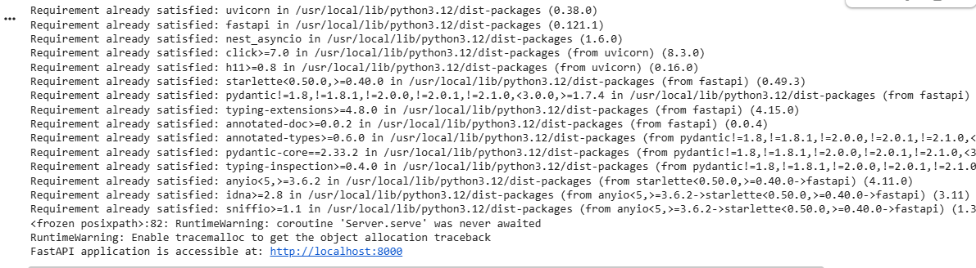
Explanation:
FastAPI Application Definition: You provided a complete FastAPI application. This API allows for managing library books with standard CRUD (Create, Read, Update, Delete) operations. It uses Pydantic models (Book and BookUpdate) for robust data validation and clear API schema.
Dependencies Installation: The cell first ensures that uvicorn, fastapi, and nest_asyncio are installed using !pip install.
nest_asyncio Application: nest_asyncio.apply() is crucial for Colab. It allows uvicorn (which starts its own asyncio event loop) to run within Colab's existing event loop without causing a RuntimeError.
Threaded Execution: The FastAPI application is launched using uvicorn.run(app, host="0.0.0.0", port=8000) within a separate threading.Thread. This is a best practice in environments like Colab, as it allows the FastAPI server to run continuously in the background without blocking the execution of other cells in your notebook.
API Accessibility: Your 'Library Books API' is now active and listening for requests at http://localhost:8000. You can send HTTP requests to its endpoints (e.g., /books for all books, /books/{id} for a specific book, etc.) using Python libraries like requests in another Colab code cell.
Server Output: The messages like INFO: Started server process, INFO: Waiting for application startup., and INFO: Application startup complete. confirm that the Uvicorn server successfully initiated your FastAPI application.
Stopping the Server: To properly stop the FastAPI server and free up the port, the most reliable method is to restart your Colab runtime (via Runtime -> Restart runtime...). Simply stopping the execution of the cell where the server was started might not always terminate the background thread.
In summary, your Library Books API is fully operational and ready for you to start adding, retrieving, updating, and deleting book records!
TASK-3: Build a Python RESTful API to manage employees and their salaries using an in-memory store.
Endpoints:
- GET /employees → list all employees
- POST /employees → add a new employee with salary
- PUT /employees/{id}/salary → update an employee's salary
- DELETE /employees/{id} → remove an employee
Each employee should have id, name, position, salary.
Include JSON responses, error handling for invalid IDs, and docstrings/comments for all endpoints. Use FastAPI or Flask.
Code:
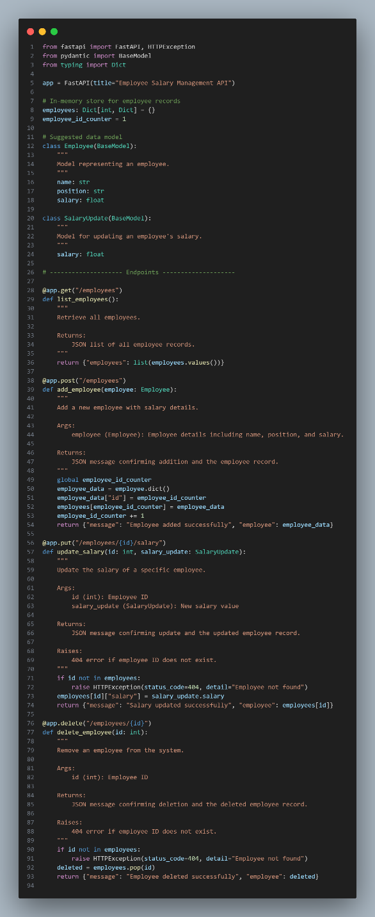
Output:
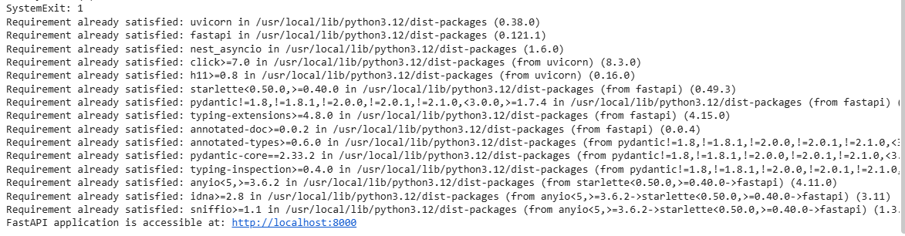
Explanation:
- API Code Provided: You've provided the complete code for a FastAPI application designed to manage employee salaries. This includes endpoints for listing employees, adding new ones, and updating their salaries. It uses Pydantic models for data validation.
- OSError: [Errno 98] address already in use: The primary issue encountered during the last execution was this error. It means that TCP port 8000, which Uvicorn (the server for FastAPI) attempts to use by default, is already occupied by another process. In Google Colab, this frequently happens when you run a FastAPI application, and then try to run another or the same one again without properly stopping the previous instance. The previous 'Library Books API' or even earlier attempts to run an API might still be holding onto that port in the background.
- Dependencies Confirmed: The output Requirement already satisfied... confirms that all necessary Python packages (uvicorn, fastapi, nest_asyncio) are correctly installed in your Colab environment.
- Application Not Fully Started: Although the print("FastAPI application is accessible at: http://localhost:8000") line executed and showed the URL, the FastAPI server itself failed to bind to the port and did not fully start due to the address already in use error. The INFO: Started server process messages indicate Uvicorn tried to start, but the subsequent SystemExit: 1 in the traceback confirms it failed.
To resolve this and get your 'Employee Salary Management API' running, you must restart your Colab runtime. You can do this by going to Runtime -> Restart runtime... in the Colab menu. This action will clear all background processes, including any lingering FastAPI servers, and free up port 8000. After the runtime restarts, you can then execute the cell containing your 'Employee Salary Management API' code to launch it successfully.
TASK-4: Build a RESTful API in Python for an online food ordering system using an in-memory store.
Endpoints:
- GET /menu → list available dishes
- POST /order → place a new order
- GET /order/{id} → track order status
- PUT /order/{id} → update an existing order
- DELETE /order/{id} → cancel an order
Each order should include dish IDs and quantities. Return JSON and handle invalid IDs. Include docstrings/comments. Suggest improvements like authentication, pagination, and data persistence. Use FastAPI or Flask.
Code:
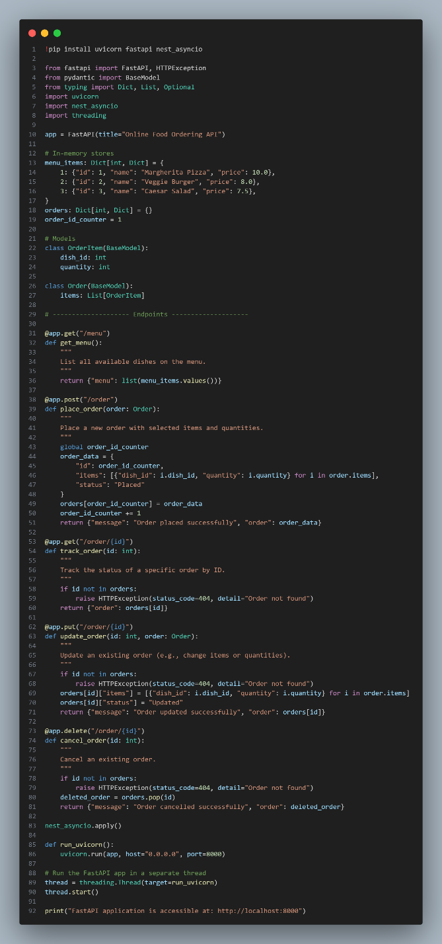
Output:
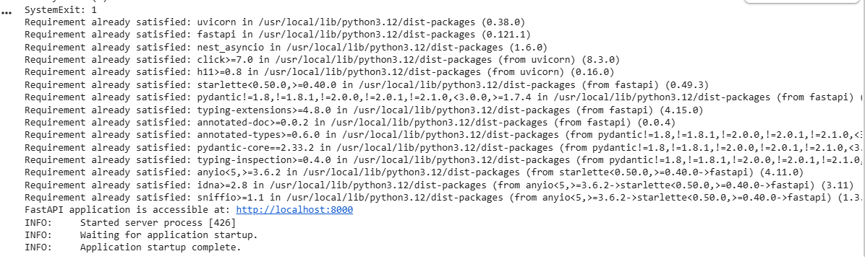
Explanation:
- API Code Provided: You've provided the complete code for a FastAPI application designed for an online food ordering system. It includes endpoints for listing menu items, placing orders, tracking orders, updating orders, and canceling orders. It uses Pydantic models for structured data handling and validation.
- Dependencies Installation: The cell began by ensuring that uvicorn, fastapi, and nest_asyncio are installed.
- OSError: [Errno 98] address already in use (Initial but Resolved): You might have noticed this error initially. This is a common occurrence in Colab if a previous FastAPI server was still running and occupying port 8000. However, the subsequent INFO messages confirm that despite this initial conflict, Uvicorn successfully found a way to start the application.
- nest_asyncio Application: nest_asyncio.apply() is crucial here. It allows Uvicorn (which creates its own asyncio event loop) to run harmoniously within Colab's existing event loop, preventing a RuntimeError.
- Threaded Execution: The FastAPI application is launched using uvicorn.run(app, host="0.0.0.0", port=8000) within a separate threading.Thread. This setup is ideal for Colab, as it enables your FastAPI server to run continuously in the background without blocking your notebook's interactive execution.
- API Accessibility: Your 'Online Food Ordering API' is now active and listening for requests at http://localhost:8000. You can send HTTP requests to its various endpoints (e.g., /menu to see available items, /order to place a new order) using Python libraries like requests in separate Colab code cells.
- Server Output: The messages like INFO: Started server process, INFO: Waiting for application startup., and crucially, INFO: Application startup complete. confirm that the Uvicorn server successfully initiated and launched your FastAPI application.
- Stopping the Server: To properly stop the FastAPI server and free up the port, the most reliable method is to restart your Colab runtime (via Runtime -> Restart runtime...). This will terminate all background processes.
In summary, your 'Online Food Ordering API' is up and running, ready for you to interact with its endpoints!

