Name: Akhil
Hall ticket No: 2403a52344
Batch: AI 13

Task-1:
Prompt: Start a Python class named Student with attributes name, roll number, and marks displaying details and checking if marks are above average.

Code:
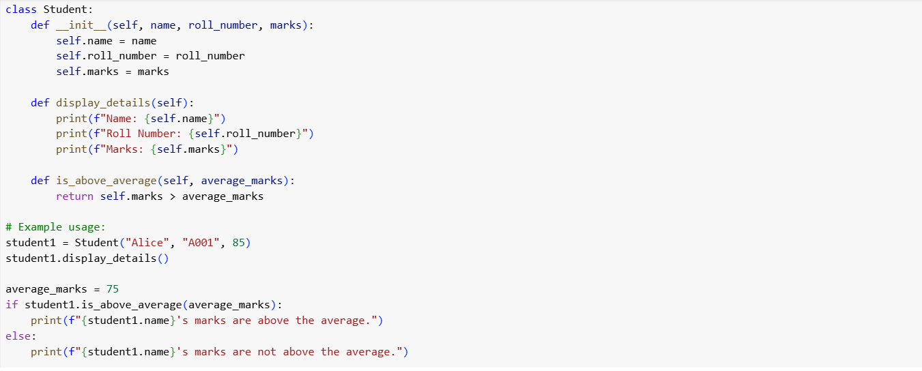
Output:
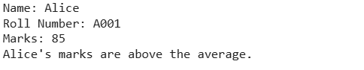
Explanation:
- The __init__ method is the constructor. It's called when you create a new Student object and initializes the name, roll number, and marks attributes.
- The display details method prints the details of a student.
- The is_above_average method checks if a student's marks are greater than a given average.
- The example usage at the end creates a Student object named "Alice", displays her details, and then checks if her marks are above the average_marks of 75.
Task-2:

Prompt: Write the first two lines of a for loop to iterate through a list of numbers. Use a comment prompt how to calculate and print the square of even numbers only.

Code:
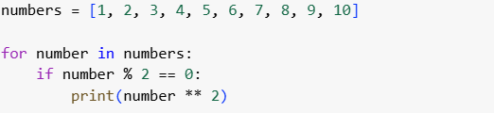

Output:

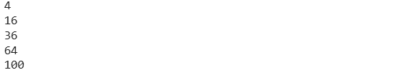
Explanation:
- Numbers = [1, 2, 3, 4, 5, 6, 7, 8, 9, 10] creates a list of integers.
- for number in numbers: starts a loop that will go through each element in the numbers list, assigning the current element to the variable number in each iteration.
- if number % 2 == 0: checks if the current number is even. The modulo operator (%) gives the remainder of a division. If the remainder when dividing by 2 is 0, the number is even.
- print(number ** 2) is executed only if the number is even. It calculates the square of the number ( number multiplied by itself) and prints the result.

Task-3:

Prompt: Create a class called Bank Account with attributes account_holder and balance. methods for deposit(), withdraw(), and check for insufficient balance.

Code: 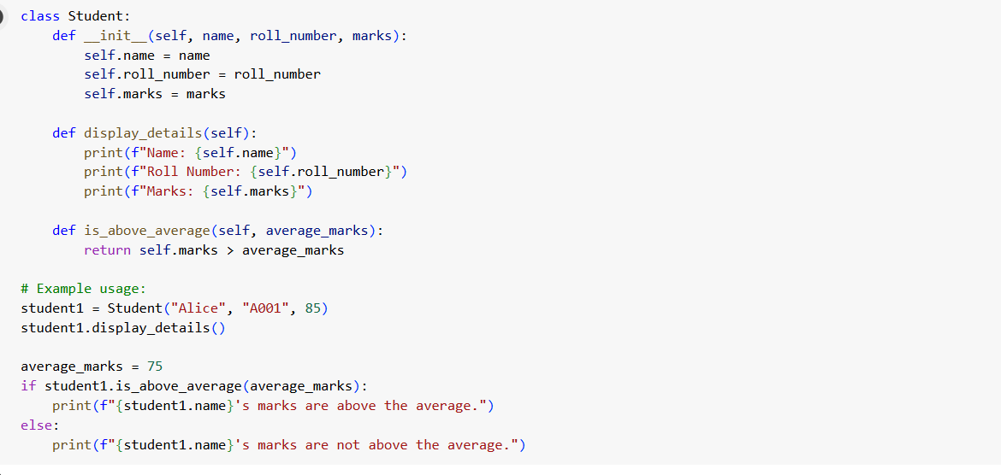

Output:

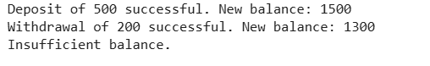

Explanation:
- The __init__ method is the constructor. It's called when you create a new BankAccount object and initializes the account_holder and balance attributes. The balance defaults to 0 if not provided.
- The deposit method adds a specified amount to the account balance, as long as the amount is positive.
- The withdraw method subtracts a specified amount from the account balance, as long as the amount is positive and there are sufficient funds.
- The check_insufficient_balance method checks if the current balance is less than a given amount.

Task:4
Prompt: Define a list of student dictionaries with keys name and score. write a while loop to print the names of students who scored more than 75

Code:

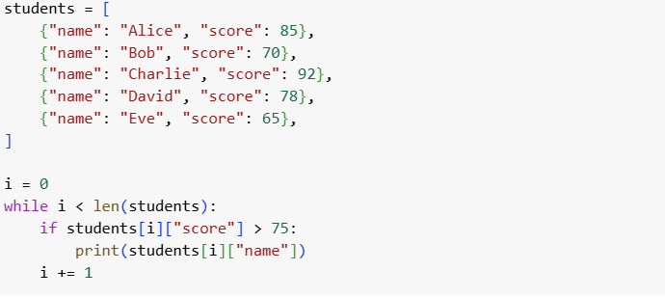

Output:

Explaination:
- students = [...] creates a list where each item is a dictionary. Each dictionary represents a student and has two key-value pairs: "name" and "score".
- i = 0 initializes a counter variable i to 0. This variable will be used to access the elements of the students list.
- while i < len(students): starts a while loop. The loop will continue as long as the value of i is less than the number of elements in the students list (len(students)).
- if students[i]["score"] > 75: checks if the score of the current student (accessed using the index i) is greater than 75.
- print(students[i]["name"]) is executed only if the student's score is greater than 75. It prints the name of that student.
- i += 1 increments the counter i by 1 after each iteration. This moves to the next student in the list.

Task-5:
Prompt: Begin writing a class ShoppingCart with an empty items list. generate methods to add_item, remove_item, and use a loop to calculate the total bill using conditional discounts. all in one
Code:
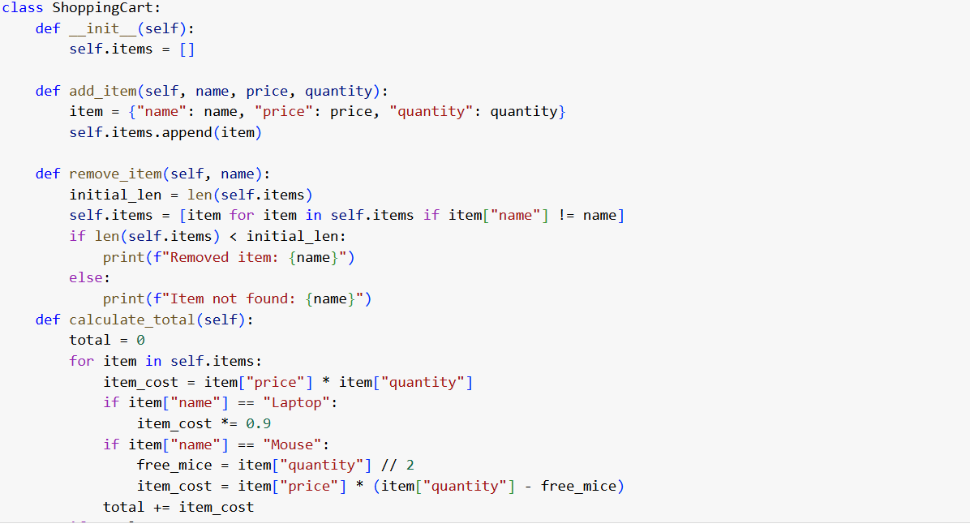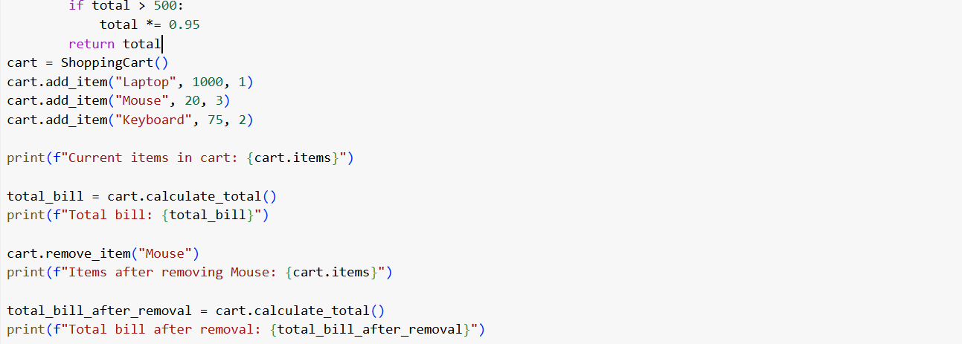

Output:
Explanation:
- The __init__ method initializes an empty list called self.items to store the items in the cart.
- The add_item method takes the name, price, and quantity of an item and adds it as a dictionary to the self.items list.
- The remove_item method takes the name of an item and removes it from the self.items list if it exists.
- The calculate_total method iterates through the self.items list and calculates the total cost. It applies three conditional discount rules:
  - A 10% discount is applied to items named "Laptop".
  - For items named "Mouse", a buy-one-get-one-free discount is applied (for every two mice, one is free).
  - A 5% discount is applied to the total bill if it exceeds 500.
- The example usage demonstrates how to create a ShoppingCart object, add items, print the current items, calculate and print the total bill, remove an item, and then calculate and print the total bill again after removal.

