Name: Akhil
Hall ticket: 2403a52344
Batch: AI 13
1) Prompt: generate a python program that contains at least 3 assert test cases for is_strong_password (password) and implement the validate function. Requirements Password must have at least 8 characters,
Code:
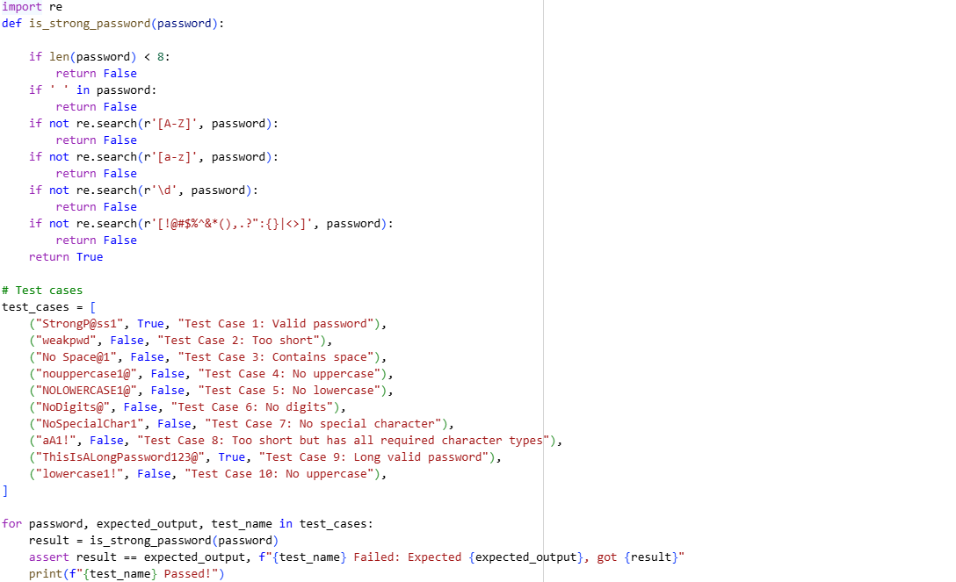
Output:
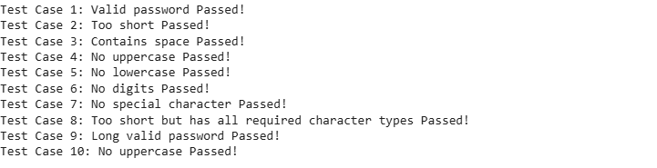
Explanation:
- Import re: This line imports the re module, which provides support for regular expressions. Regular expressions are used here to check for the presence of specific types of characters in the password.
- Def is_strong_password (password):: This defines the function is_strong_password that takes one argument, password, which is the string to be validated.
- if Len(password) < 8:: This checks if the length of the password is less than 8 characters. If it is, the function immediately returns False because the password is too short.
- if ' ' in password:: This checks if there is a space character within the password string. If a space is found, the function returns False.
- if not re.search(r'[A-Z]', password):: This line uses a regular expression to check if the password contains at least one uppercase letter (A-Z). re.search() looks for a pattern within the string. If no uppercase letter is found (not re.search(...)), the function returns False.
- if not re.search(r'[a-z]', password):: Similar to the previous step, this checks if the password contains at least one lowercase letter (a-z). If not, it returns False.
- if not research(r'\d', password):: This checks if the password contains at least one digit (0-9). \d is shorthand for any digit character in regular expressions. If no digit is found, it returns False.
- if not research(r'[!@#$%^&*(),.?":{}|<>]', password):: This checks if the password contains at least one special character from the specified set. If none of these special characters are found, it returns False.
- return True: If the password passes all the previous checks (meaning it's at least 8 characters long, has no spaces, and contains uppercase, lowercase, digits, and special characters), the function returns True, indicating that the password is strong.
- test cases = [...]: This section defines a list of test cases. Each test case is a tuple containing:
  - The password string to test.
  - The expected boolean result (True if strong, False if not).
  - A descriptive name for the test case.
- for password, expected output, test name in test_cases:: This loop iterates through each test case in the test cases list.
- result = is_strong_password(password): Inside the loop, the is_strong_password function is called with the current test password, and the result is stored in the result variable.
- assert result == expected output, f"{test name} Failed: Expected {expected output}, got {result}": This is an assertion statement. It checks if the result from the function call matches the expected output for the current test case. If they don't match, an Assertion Error is raised, and the message provided (including the test case name and the expected vs. actual result) is displayed. This helps identify which test case failed.
- print(f"{test name} Passed!"): If the assertion passes (meaning the function returned the expected result), this line prints a message indicating that the specific test case passed.
2)Prompt: generate a python program that contain at least 3 assert test cases for a classify_number(n) function. Implement using loops.
code: 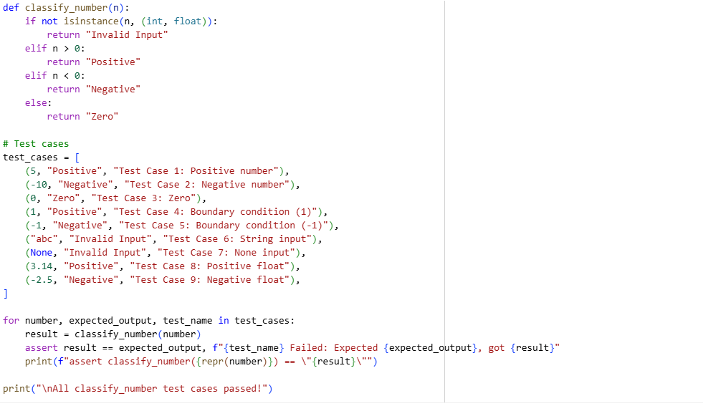
Output:
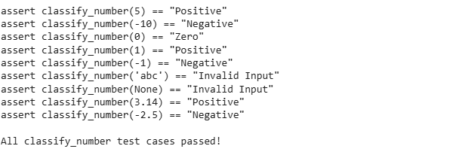
Explanation:
def classify_number(n):: This line defines the function classify_number that takes one argument, n, which is the input to be classified.
- if not insistence(n, (int, float)):: This checks if the input n is NOT an instance of either an integer (int) or a floating-point number (float). If it's not an integer or a float (meaning it's some other data type like a string or None), the function returns the string "Invalid Input".
- elif n > 0:: If the input is an integer or float, this condition checks if n is greater than 0. If it is, the function returns the string "Positive".
- elif n < 0:: If the input is not greater than 0, this condition checks if n is less than 0. If it is, the function returns the string "Negative".
- else:: If the input is not greater than 0 and not less than 0 (and it's an integer or float), it must be 0. In this case, the function returns the string "Zero".
- test_cases = [...]: This section defines a list of test cases. Each test case is a tuple containing:
- The input value (number) to be passed to the classify_number function.
- The expected_output string ('Positive', 'Negative', 'Zero', or 'Invalid Input') that the function should return for that input.
- A test_name string to describe the test case.
- for number, expected_output, test_name in test_cases:: This loop iterates through each test case in the test_cases list.
- result = classify_number(number): Inside the loop, the classify_number function is called with the current test number, and the returned classification is stored in the result variable.
- assert result == expected_output, f"{test_name} Failed: Expected {expected_output}, got {result}": This is an assertion statement. It checks if the result obtained from the function call is equal to the expected_output for the current test case. If they are not equal, an AssertionError is raised, and the provided message (which includes the test name and the expected vs. actual output) is displayed, indicating a failed test.
- print(f"assert classify_number({repr(number)}) == \"{result}\""): If the assertion passes (meaning the function returned the expected result), this line prints a string formatted like an assert statement. repr(number) is used to get a string representation of the number that is suitable for use in code (e.g., strings will be enclosed in quotes). This provides a clear output of the input and the function's classification for each successful test.
- print("\nAll classify_number test cases passed!"): After the loop finishes, this line prints a final message indicating that all the test cases passed.

3)Prompt: generate a python program that contains at least 3 assert test cases for is anagram(str1, str2) and implement the function.

Code: 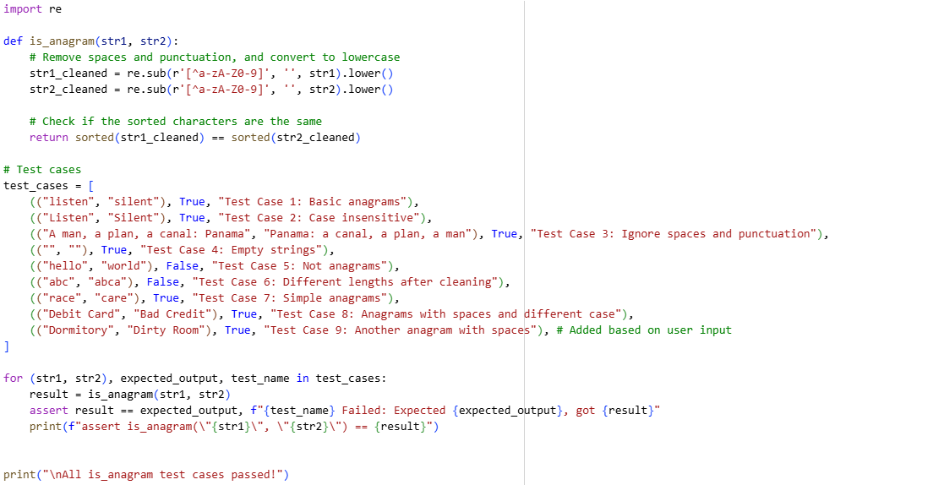Output:
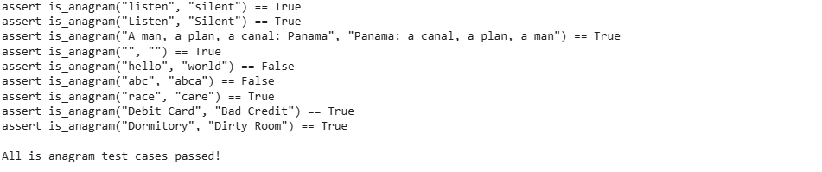
Explanation:
import re: This line imports the re module, which provides support for regular expressions. Regular expressions are used here to clean the input strings by removing unwanted characters.
def is_anagram(str1, str2):: This defines the function is_anagram that takes two arguments, str1 and str2, which are the strings to be compared.
str1_cleaned = re.sub(r'[^a-zA-Z0-9]', '', str1).lower(): This line cleans the first input string (str1).
re.sub(r'[^a-zA-Z0-9]', '', str1): This uses a regular expression to substitute (remove) any character that is NOT a letter (a-z, A-Z) or a digit (0-9) with an empty string. This effectively removes spaces and punctuation.
.lower(): This converts the resulting cleaned string to lowercase. The result is stored in str1_cleaned.
str2_cleaned = re.sub(r'[^a-zA-Z0-9]', '', str2).lower(): This line performs the same cleaning process on the second input string (str2) and stores the result in str2_cleaned.
return sorted(str1_cleaned) == sorted(str2_cleaned): This is the core logic for checking if the cleaned strings are anagrams.
sorted(str1_cleaned): This sorts the characters of the cleaned first string alphabetically and returns a list of characters.
sorted(str2_cleaned): This sorts the characters of the cleaned second string alphabetically and returns a list of characters.
... == ...: This compares the two sorted lists of characters. If the lists are identical (meaning they contain the same characters with the same frequencies, regardless of their original order), the function returns True (indicating they are anagrams). Otherwise, it returns False.
test_cases = [...]: This section defines a list of test cases. Each test case is a tuple containing:
A tuple of the two input strings (str1, str2) to be passed to the is_anagram function.
The expected_output Boolean value (True or False) that the function should return for these inputs.
A test_name string to describe the test case.
for (str1, str2), expected_output, test_name in test_cases:: This loop iterates through each test case in the test_cases list, unpacking the tuple into the respective variables.
result = is_anagram(str1, str2): Inside the loop, the is_anagram function is called with the current test strings, and the returned boolean result is stored in the result variable.
assert result == expected_output, f"{test_name} Failed: Expected {expected_output}, got {result}": This is an assertion statement. It checks if the result from the function call matches the expected_output for the current test case. If they don't match, an AssertionError is raised with a message indicating which test failed and the expected vs. actual results.
print(f"assert is_anagram(\"{str1}\", \"{str2}\") == {result}"): If the assertion passes, this line prints a string formatted like an assert statement, showing the input strings and the boolean result returned by the function.
print("\nAll is_anagram test cases passed!"): After the loop finishes, this line prints a final message confirming that all test cases passed.

4) Prompt: generate a python program that contains at least 3 assert test cases for is_anagram(str1, str2) and implement the function.

Code:
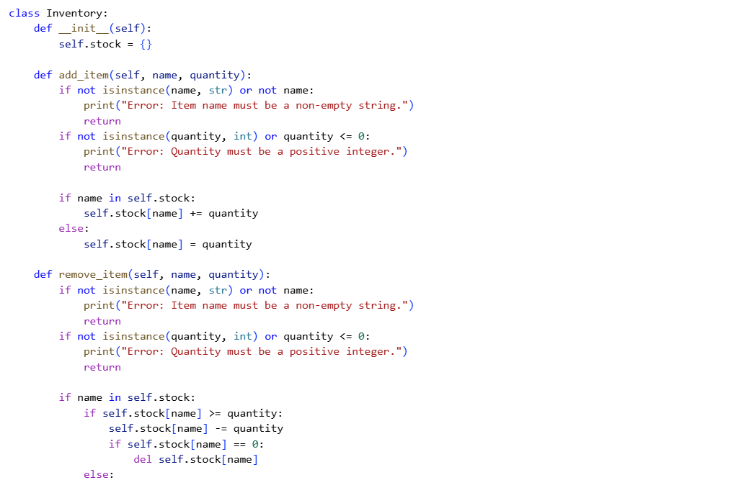
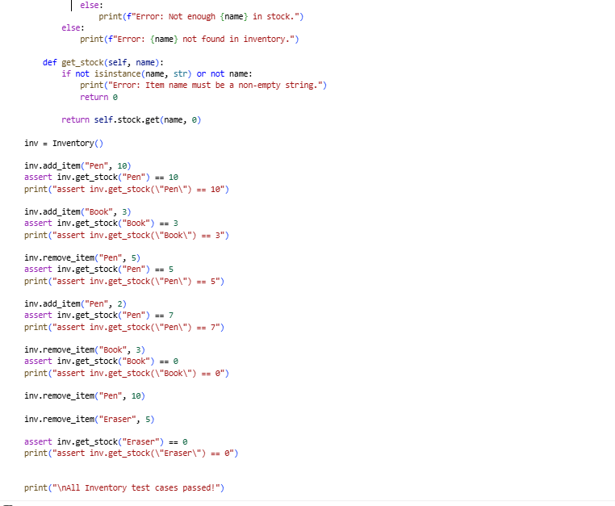
Output:
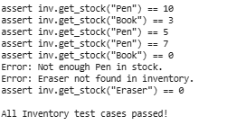

Explaination:
class Inventory:: This line defines the beginning of the Inventory class.
- def __init__(self):: This is the constructor method for the class. It's called when you create a new Inventory object.
- self.stock = {}: This initializes an empty dictionary called stock. This dictionary will be used to store the items in the inventory, where the keys will be the item names (strings) and the values will be the quantities (integers).
- def add_item(self, name, quantity):: This method is used to add a specified quantity of an item with a given name to the inventory.
- The first two if statements check for invalid input: if the name is not a non-empty string or if the quantity is not a positive integer. If either is invalid, an error message is printed, and the method returns.
- if name in self.stock:: If the item name already exists as a key in the stock dictionary, the quantity is added to the existing stock level (self.stock[name] += quantity).
- else:: If the item name is not in the stock dictionary, it's a new item, so it's added to the dictionary with the given quantity as its initial stock level (self.stock[name] = quantity).
- def remove_item(self, name, quantity):: This method is used to remove a specified quantity of an item with a given name from the inventory.
- The first two if statements again check for invalid input for name and quantity.
- if name in self.stock:: This checks if the item name exists in the inventory.
- if self.stock[name] >= quantity:: If the item exists, this checks if there is enough stock to remove the requested quantity. If there is, the quantity is subtracted from the stock level (self.stock[name] -= quantity).
- if self.stock[name] == 0:: After removing the quantity, if the stock level becomes zero, the item is removed entirely from the stock dictionary using del self.stock[name].
- else:: If there is not enough stock (self.stock[name] < quantity), an error message "Not enough {name} in stock." is printed.
- else:: If the item name is not found in the stock dictionary, an error message "{name} not found in inventory." is printed.
- def get_stock(self, name):: This method is used to get the current stock level of an item with a given name.
- The if statement checks if the name is a non-empty string. If not, an error message is printed, and it returns 0.
return self.stock.get(name, 0): This line uses the dictionary's get() method. It attempts to retrieve the value associated with the name key from the stock dictionary. If the name is found, its corresponding stock quantity is returned. If the name is not found in the dictionary, the get() method returns the default value specified, which is 0 in this case.
Following the class definition, there are several lines of code that serve as test cases for the Inventory class:

An Inventory object is created: inv = Inventory().
add_item and remove_item methods are called to simulate adding and removing items.
assert inv.get_stock(...) == ... lines are used to check if the stock levels after these operations match the expected values. If an assertion fails, the program will stop and raise an error.
print("assert inv.get_stock(...) == ...") lines are included to print the successful assertions to the output, showing which tests passed.
print("\nAll Inventory test cases passed!") is printed at the end if all assertions pass without raising an error.

5) Prompt: to generate a python program contains that at least 3 assert test cases for is_anagram(str1, str2) and implement the function

code:

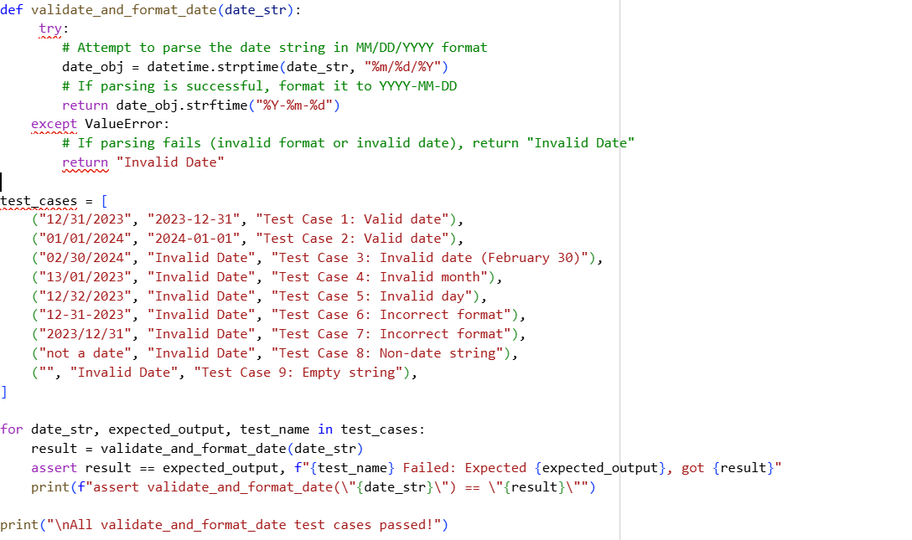
Output:
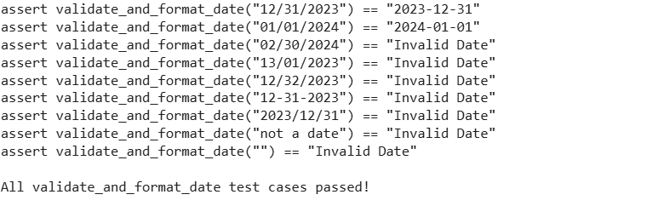
Explanation:
- from datetime import datetime: This line imports the datetime class from the datetime module. This class is used to work with dates and times.
- def validate_and_format_date(date_str):: This defines the function validate_and_format_date that takes one argument, date_str, which is the string that is expected to contain a date.
- try:: This block starts a try...except block, which is used to handle potential errors that might occur during the execution of the code within the try block. In this case, it's used to catch errors that might happen when trying to parse the date string.
- date_obj = datetime.strptime(date_str, "%m/%d/%Y"): This is the core of the validation and parsing.
- datetime.strptime(): This class method is used to parse a string (date_str) into a datetime object.
- "%m/%d/%Y": This is a format code string that tells strptime the expected format of the input date_str. %m represents the month as a zero-padded decimal number (e.g., 01, 12), %d represents the day of the month as a zero-padded decimal number (e.g., 01, 31), and %Y represents the year with century (e.g., 2023). The slashes / are expected separators in the input string.
- If date_str successfully matches this format and represents a valid date (e.g., no February 30th), a datetime object is created and stored in date_obj. If the format is incorrect or the date is invalid, a ValueError exception is raised.
- return date_obj.strftime("%Y-%m-%d"): If the strptime call in the try block is successful (meaning the date is valid and in the correct format), this line is executed.
- date_obj.strftime("%Y-%m-%d"): This method is called on the datetime object (date_obj) to format it into a string according to the specified format code. %Y is the year, %m is the month, and %d is the day, separated by hyphens -. The resulting formatted string is then returned by the function.
- except ValueError:: This block is executed if a ValueError is raised during the execution of the try block (i.e., if strptime fails because the input string doesn't match the format or represents an invalid date).
- return "Invalid Date": If a ValueError occurs, the function returns the string "Invalid Date" to indicate that the input was not a valid date in the expected format.
- test_cases = [...]: This section defines a list of test cases. Each test case is a tuple containing:
- The input date_str to be passed to the function.
- The expected_output string ("YYYY-MM-DD" format or "Invalid Date") that the function should return.
- A test_name string to describe the test case.
- for date_str, expected_output, test_name in test_cases:: This loop iterates through each test case.
- result = validate_and_format_date(date_str): The validate_and_format_date function is called with the current test date_str, and the returned value is stored in result.
- assert result == expected_output, f"{test_name} Failed: Expected {expected_output}, got {result}": This assertion checks if the result matches the expected_output. If not, it raises an AssertionError with a descriptive message.
- print(f"assert validate_and_format_date(\"{date_str}\") == \"{result}\""): If the assertion passes, this line prints a string formatted like an assert statement, showing the input date string and the function's output.
- print("\nAll validate_and_format_date test cases passed!"): This is printed if all test cases pass without any assertions failing.

