Assignment-9.3

NAME: Akhil

H.NO:2403A52344

TASK:
- Write python function to return sum of even and odd numbers in the given list.
- Incorporate manual docstring in code with Google Style

CODE GIVEN BY GEMINI:
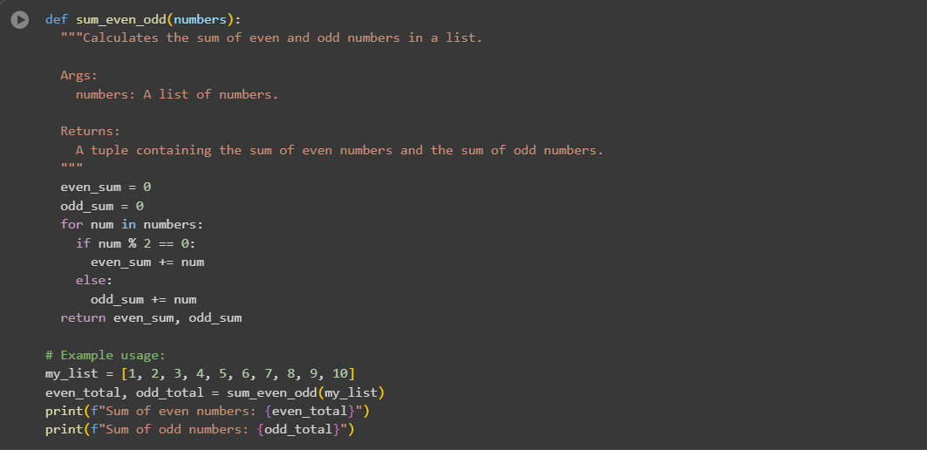

OUTPUT:


CODEGIVEN BY COPILOT:

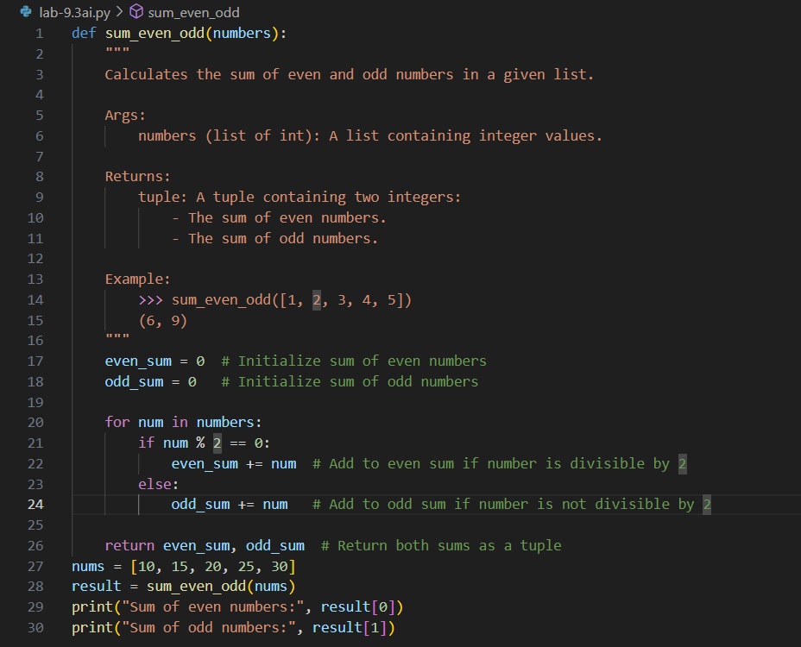

OUTPUT:
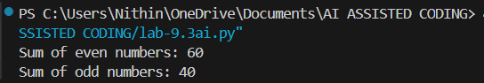

EXPLANATION:
Functionality
Both versions do the same thing: they take a list of numbers, separate them into even and odd, and return the sum of each. So in terms of logic and output, they’re equally correct.
Documentation
- Gemini’s version uses a basic docstring. It explains the purpose, the argument, and the return value in a short, readable format.
- Copilot’s version uses a more detailed and professional docstring. It follows the NumPy style, which includes:
  - Type hints (e.g., list of int)
  - A clearly formatted Returns section
  - An Example section showing how the function works
Comments
- Gemini’s version is clean and minimal—great for quick understanding.
- Copilot’s version adds inline comments inside the function, explaining each step (like initializing sums and checking even/odd). This helps beginners follow the logic more easily.
Summary
- Gemini’s version is simple and beginner-friendly.
- Copilot’s version is more detailed and professional, ideal for documentation, teaching, or reuse in larger projects.

CODE GIVEN BY GEMINI:
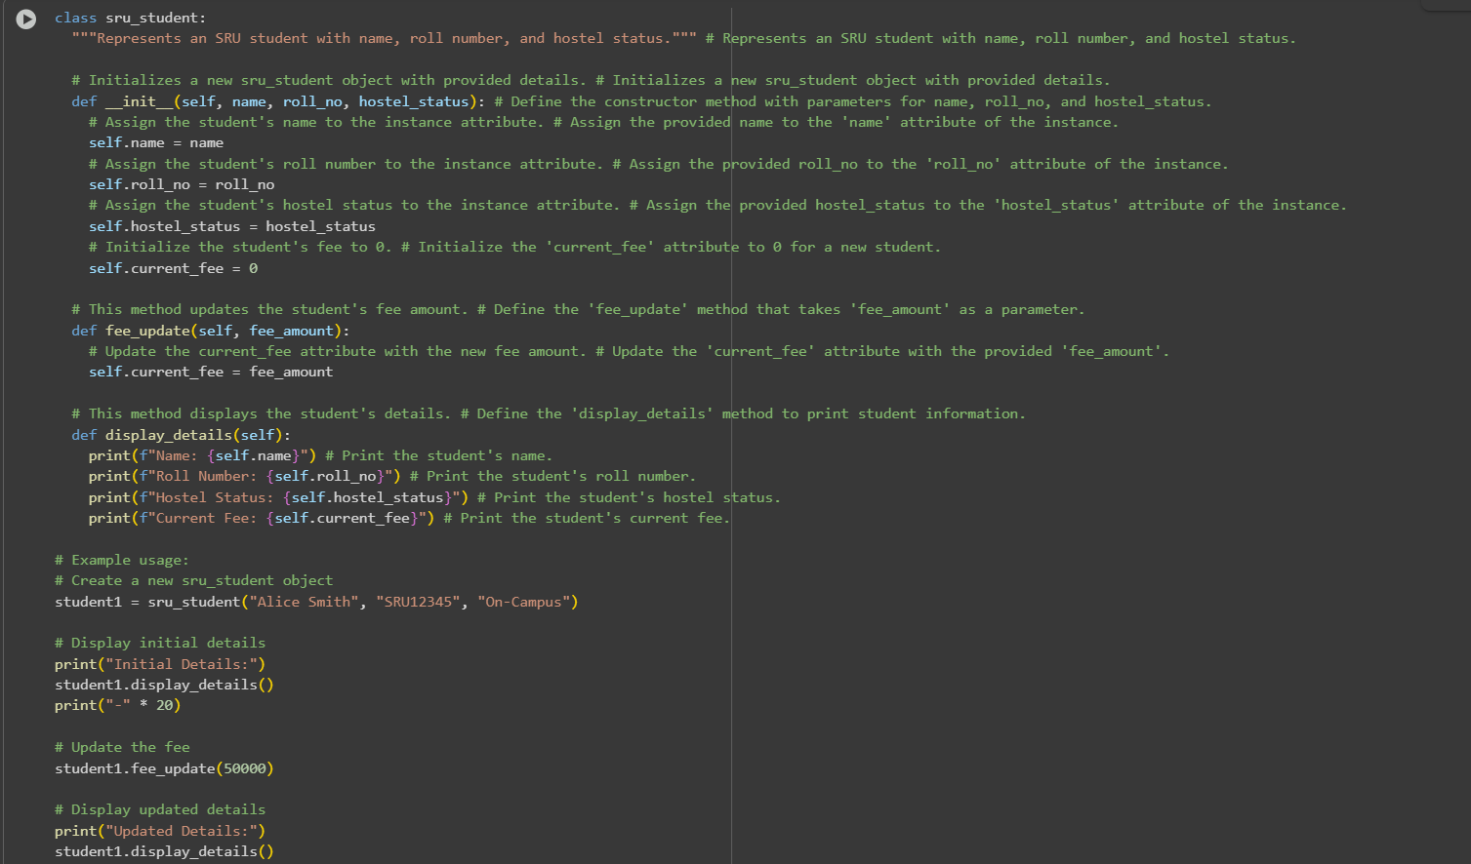

OUTPUT:
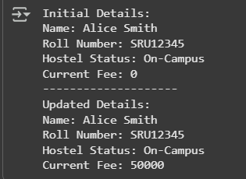

CODE GIVEN BY COPILOT:
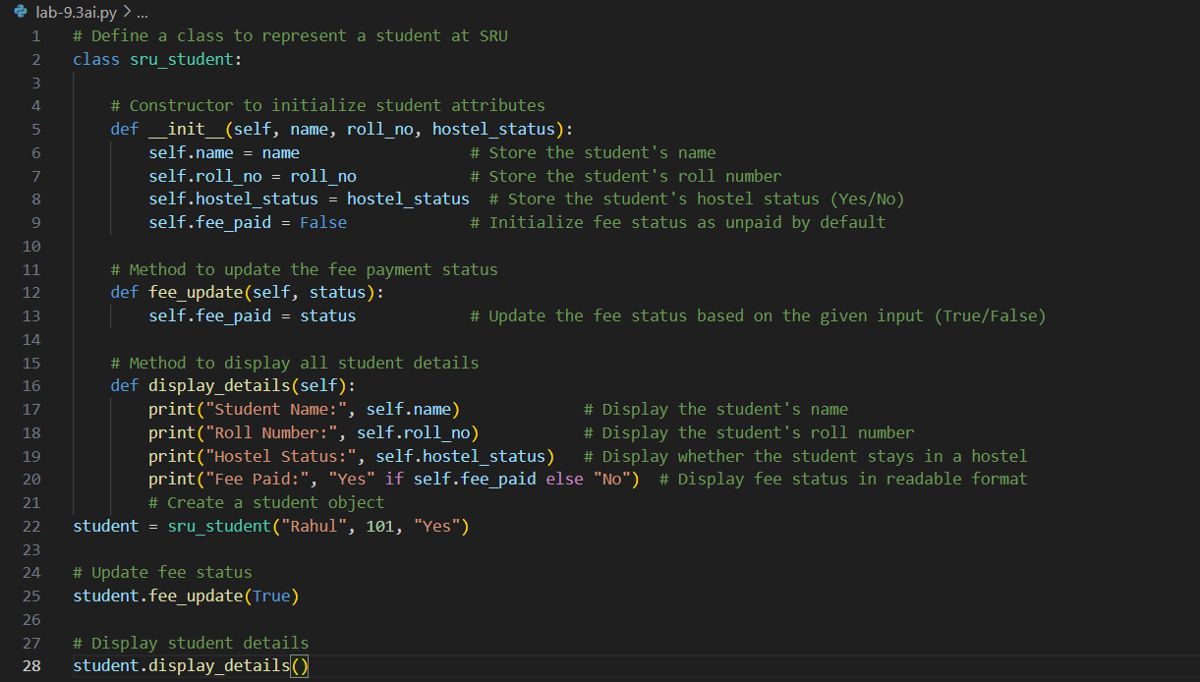

OUTPUT:
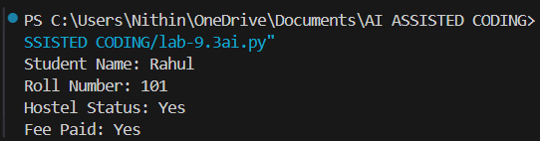

EXPLANATION:
Both classes are designed to represent student entities using object-oriented programming in Python. They include attributes like name, roll number, and hostel status, and offer methods to update fee information and display student details. However, they differ in how they handle fee tracking, naming conventions, and documentation style.
The sys_student class uses a numeric attribute called fee_amount to represent the actual fee paid by the student. This is useful when you want to track exact payment values, such as ₹50,000 or ₹75,000. The method fee_update() takes a number and updates the fee amount accordingly. This class also includes Google-style docstrings along with inline comments, making it well-documented and ideal for collaborative or production-level code.
On the other hand, the SRU_student class uses a boolean attribute called fee_paid to indicate whether the fee has been paid or not. This simplifies the logic—it's either True or False—but it doesn’t capture how much was paid. The method update_fee_status() reflects this binary approach. This class uses inline comments only, which are helpful but less formal than docstrings.
Another difference lies in naming conventions. sys_student uses roll as the attribute name, while SRU_student uses roll_no, which is slightly more descriptive. Similarly, the example roll number in sys_student is a string like "S1234", whereas in SRU_student it's an integer like 101. These choices might reflect different institutional formats or design preferences.
In terms of clarity and documentation, sys_student is more polished due to its use of structured docstrings and consistent commenting. But if simplicity and boolean logic are preferred, SRU_student is easier to implement and understand.
In short, both are solid examples of class design, but they serve slightly different purposes. One is geared toward tracking actual fee amounts, while the other focuses on fee status. Depending on your use case—financial tracking vs. status checking—you might choose one over the other or even combine their strengths into a more robust class. Let me know if you'd like help with that.

TASK:
- Write a Python script with 3–4 functions (e.g., calculator: add, subtract, multiply, divide).

CODE GIVEN BY GEMINI:
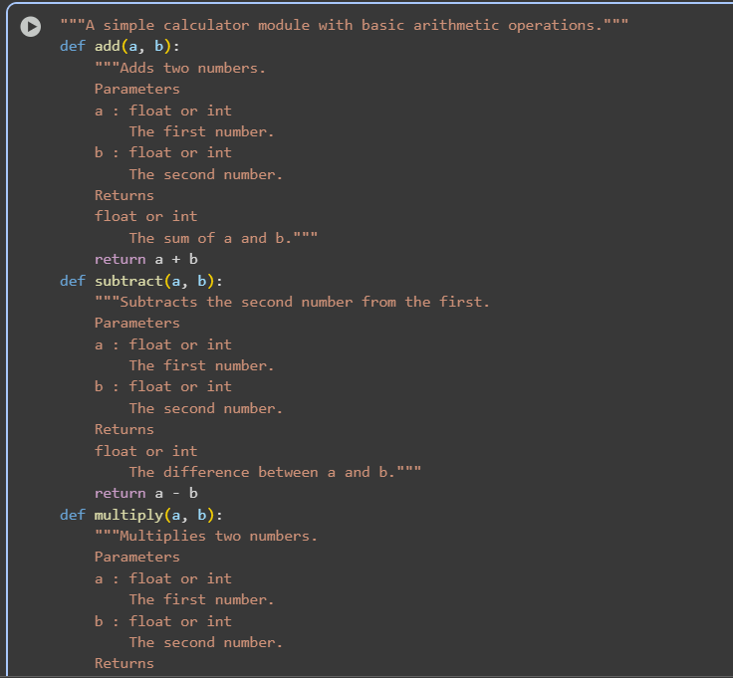
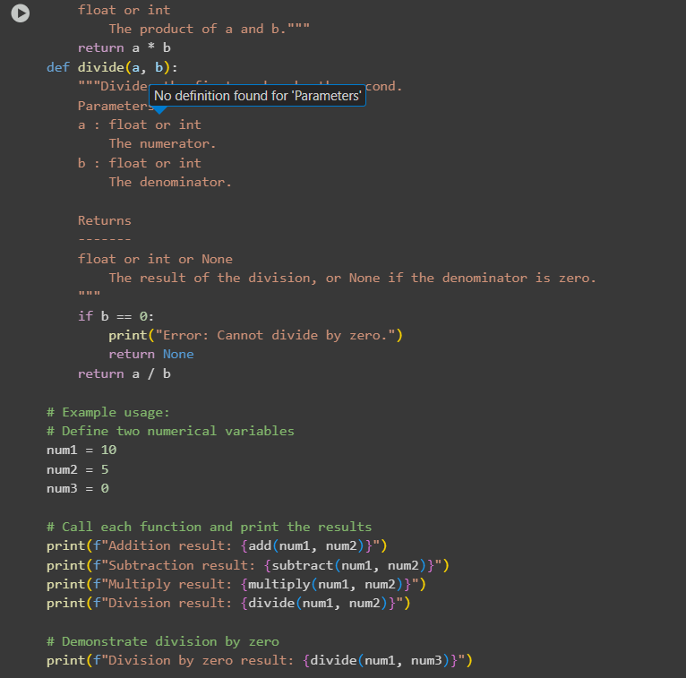

OUTPUT:
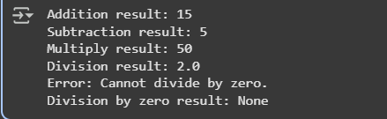

CODE GIVEN BY COPILOT:
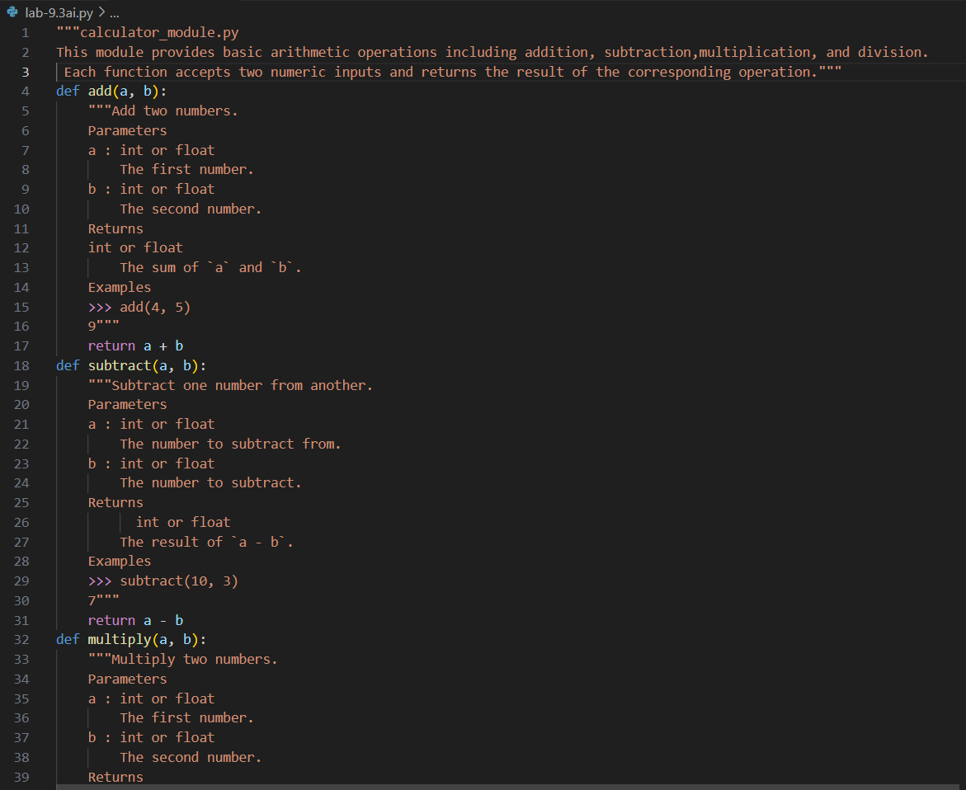
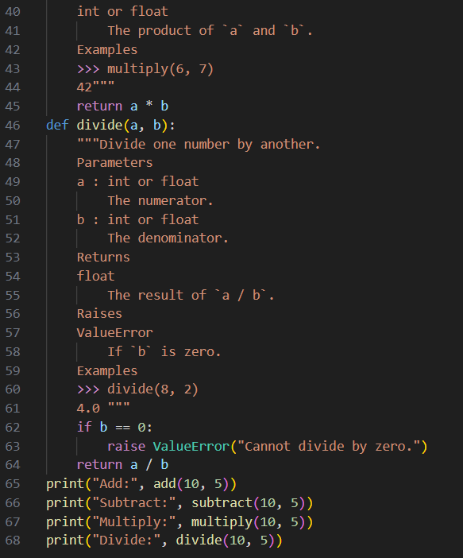

OUTPUT:
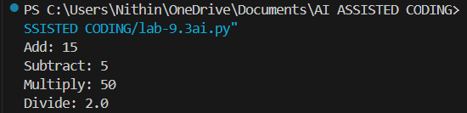

EXPLANATION:
Here's a simple explanation comparing the calculator scripts from Gemini and Copilot:
- Gemini’s version is short and easy to understand. It shows how to do basic math like addition and subtraction, and it uses simple comments. It’s great for beginners who are just learning Python.
- Copilot’s version is more complete and professional. It includes all four math functions (add, subtract, multiply, divide), uses detailed docstrings (like mini instructions inside the code), and handles errors properly—like checking for division by zero.
In short:
Gemini’s code is simple and good for quick learning.
Copilot’s code is well-documented and better for serious projects or sharing with others.

