ASSIGNMENT – 14.4
NAME : B.AKHIL
ROLL:NO : 2403A52344
BATCH : AI 13
TASK-1: Create a clean, responsive HTML and CSS web page layout that includes:
- A header with a website title and navigation menu
- A main content section with a welcome message and a placeholder image
- A footer with copyright info
Make sure the layout:
- Uses CSS media queries to adapt to desktop, tablet, and mobile screen sizes
- Is visually organized, using a container to center content
- Has a modern, minimal design
Code:

Index.html:
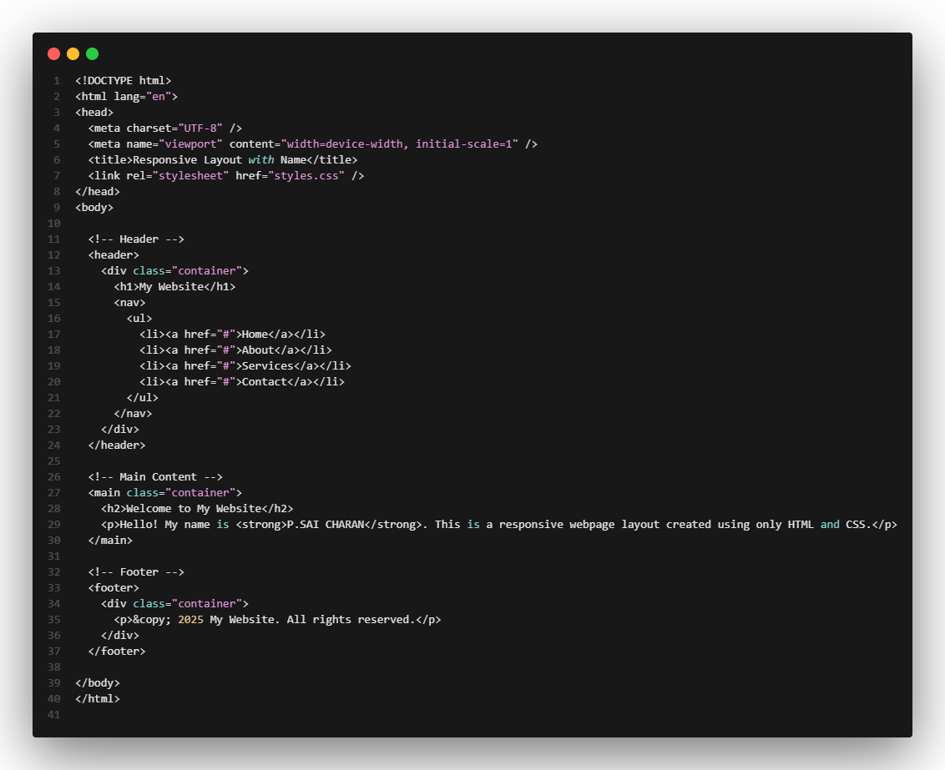

Style.css:
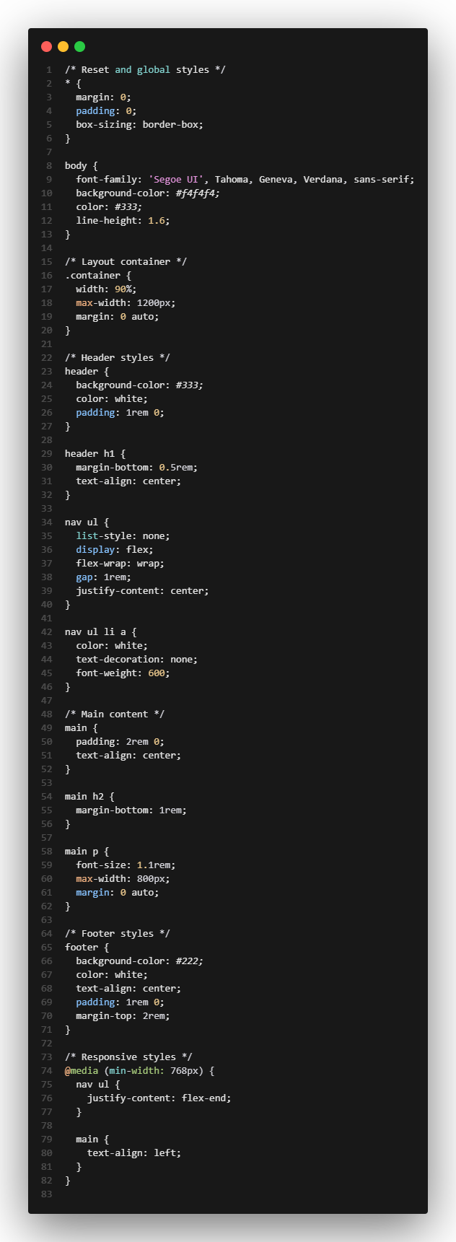
Output:
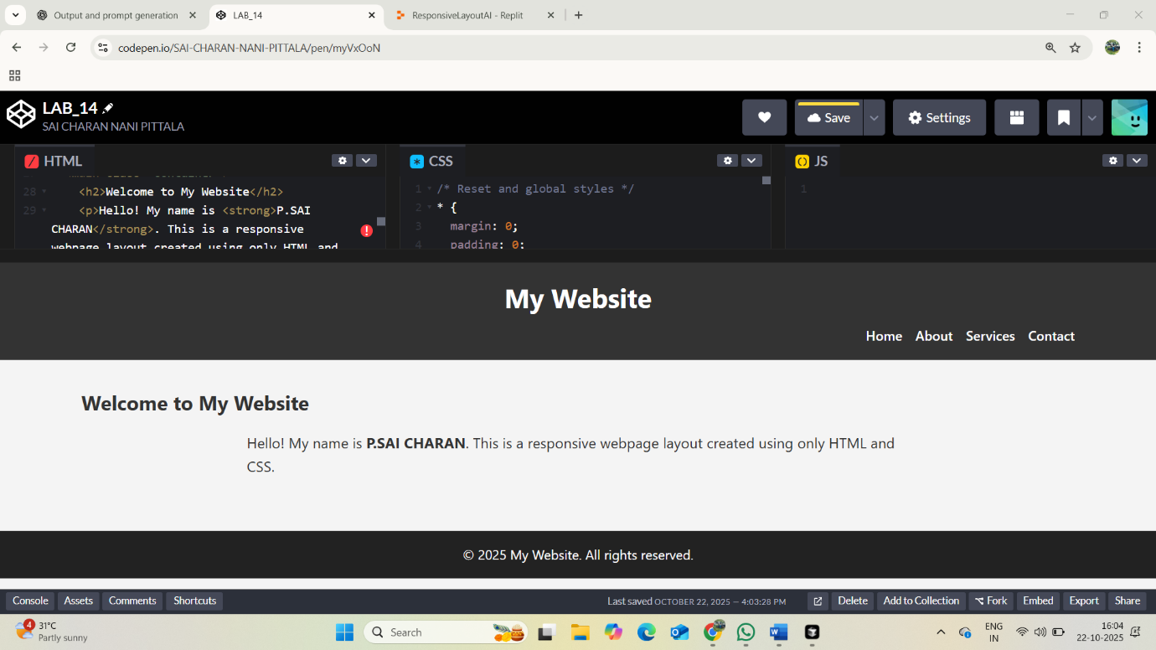

TASK-2: Create a simple HTML page with:
- A button labeled "Click Me"
- A JavaScript file that displays an alert saying "Button clicked!" when the button is pressed
The JavaScript should:
- Be in a separate file
- Use addEventListener to handle the click
- Include clear, helpful comments
Optionally, add minimal CSS styling to center the button and make it look nice.
Code:
Index.html:
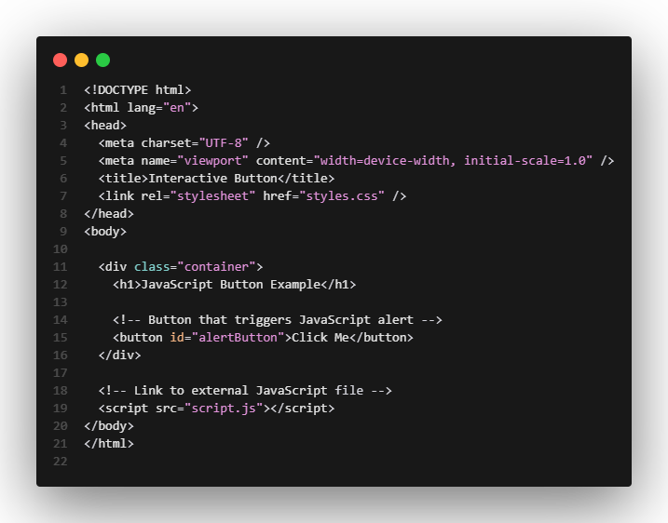

Style.css:
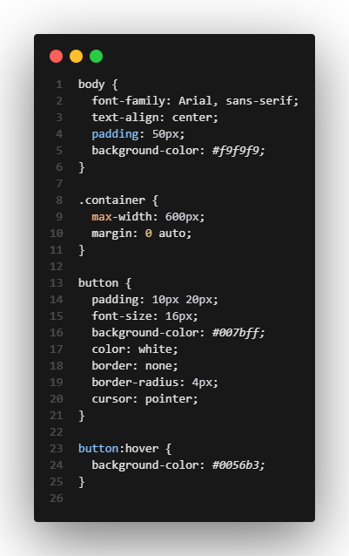

Script.js:
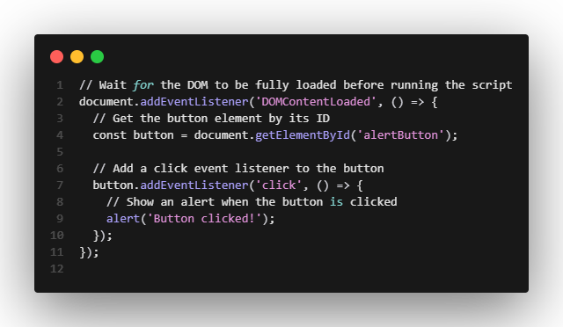
Output:
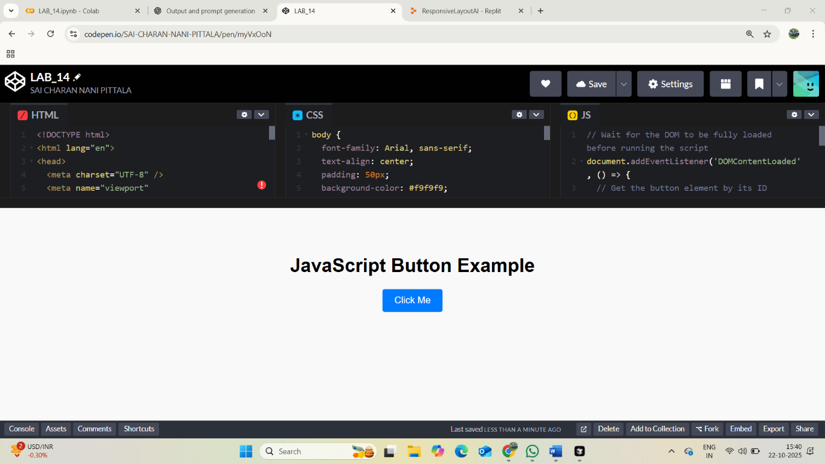
On clicking:
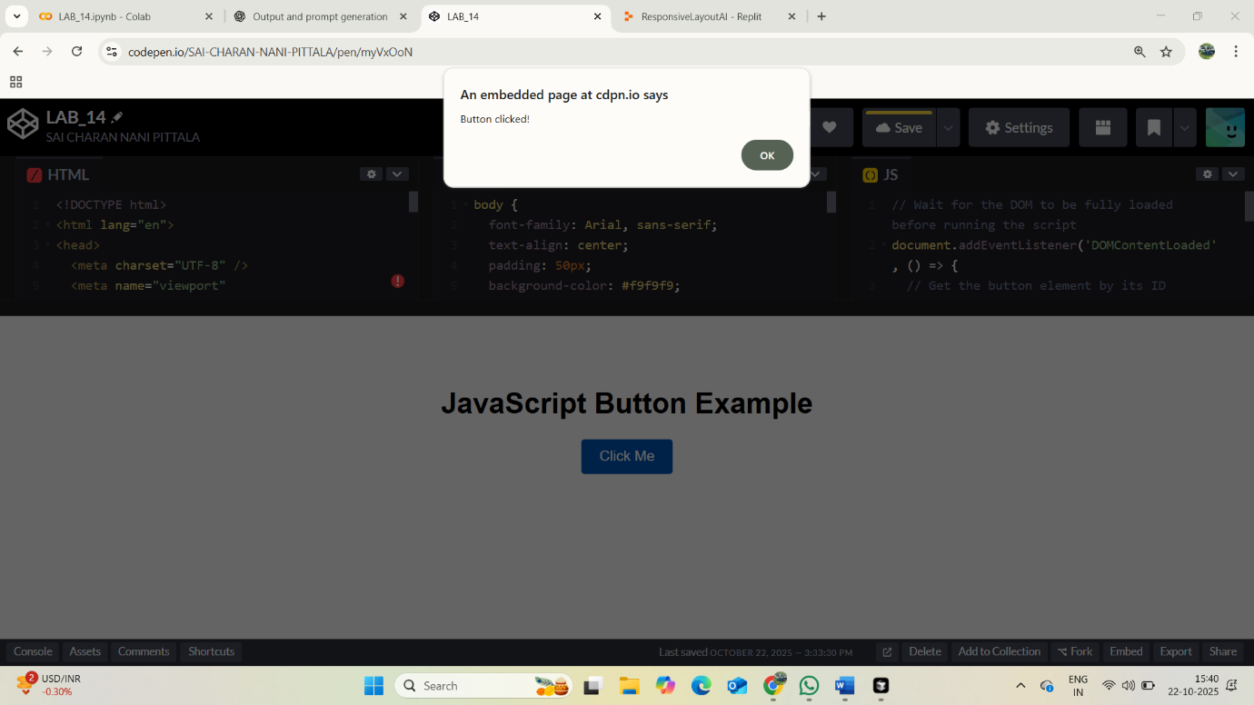
TASK-3: Create a contact form using HTML, CSS, and JavaScript. The form should include Name, Email, and Message fields. Add JavaScript form validation that checks:
- All fields are filled
- Email is in a valid format
Show inline error messages below each field if validation fails. If the form is valid, display a “Form submitted successfully” message. Make the code clean and well-commented.
Code:
Index.html:
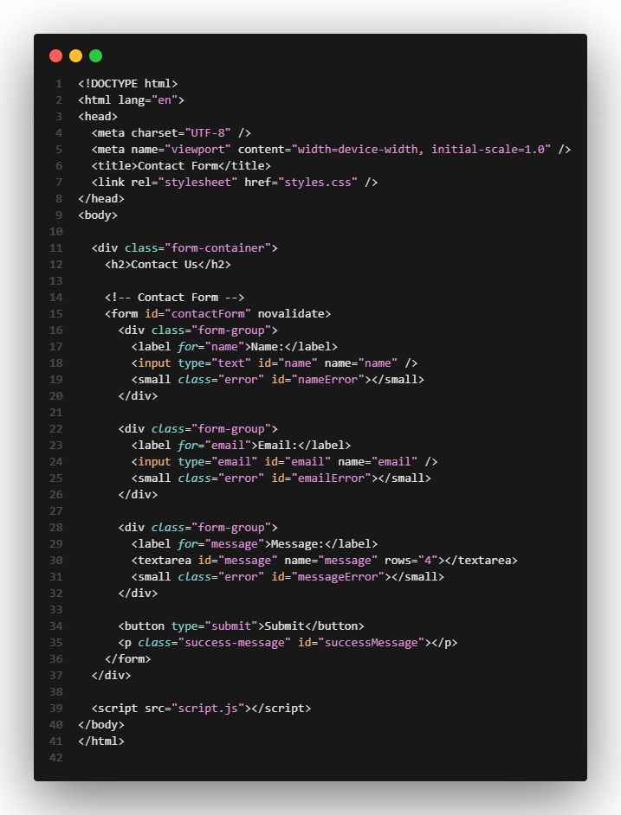Style.css:
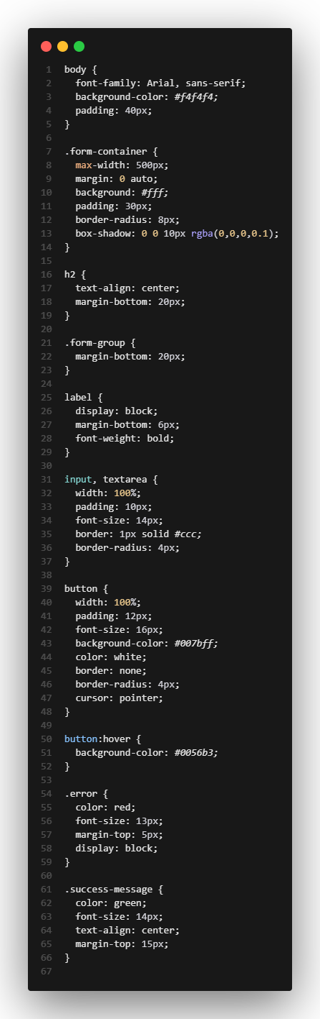
Script.js:
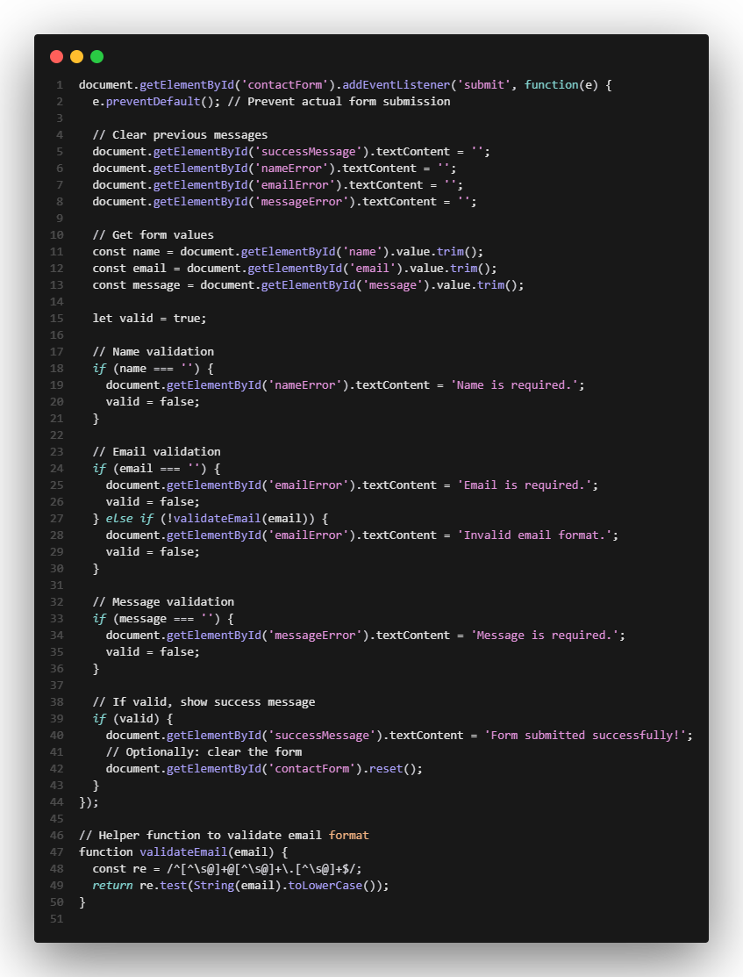

Output:
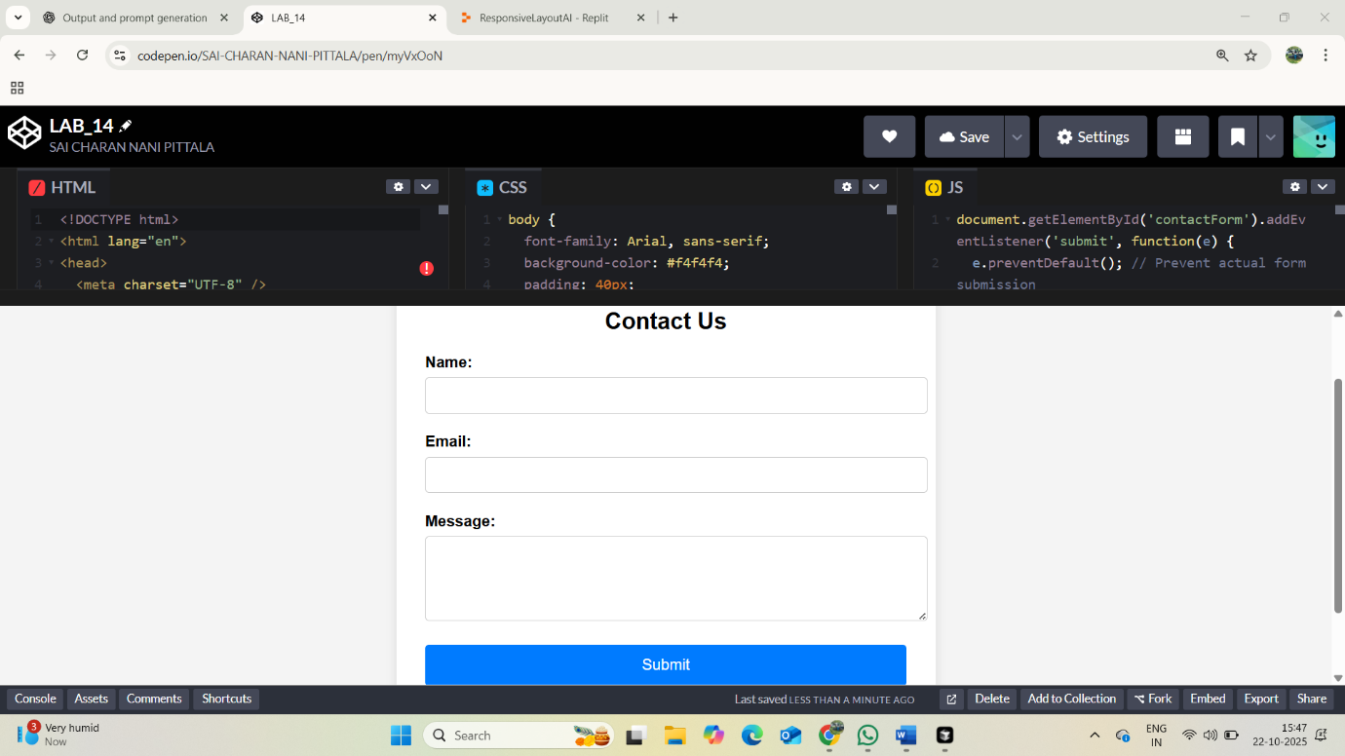
TASK-4: Create an HTML page with a list of items and two buttons: "Add Item" and "Remove Item". Use JavaScript to dynamically:
- Add a new item to the list each time "Add Item" is clicked (e.g., “Product 3”, “Product 4”)
- Remove the last item when "Remove Item" is clicked
Ensure the updates happen without reloading the page. Include basic CSS for styling.
Code:
Index.html:

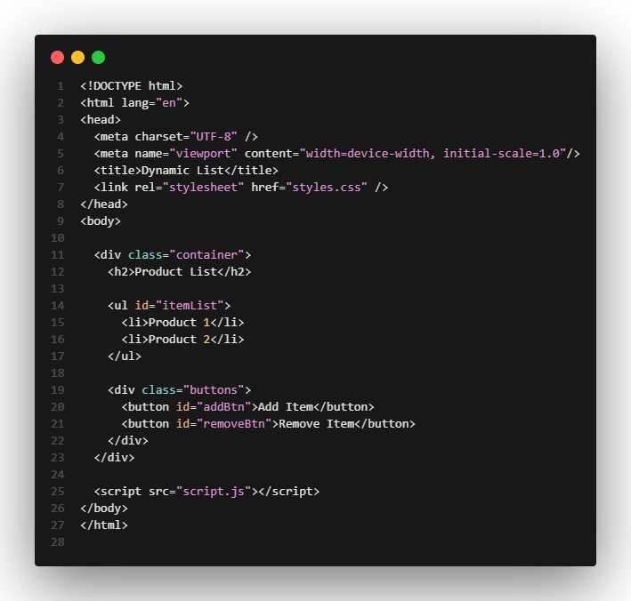
Style.css:
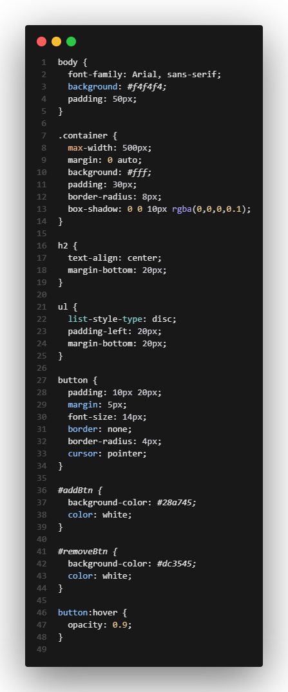
Script.js:
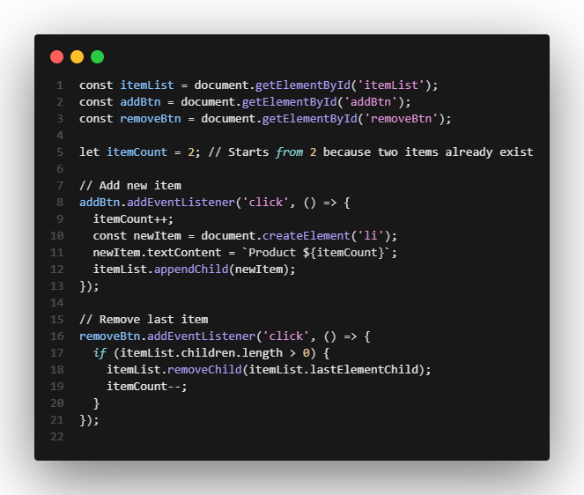

Output:
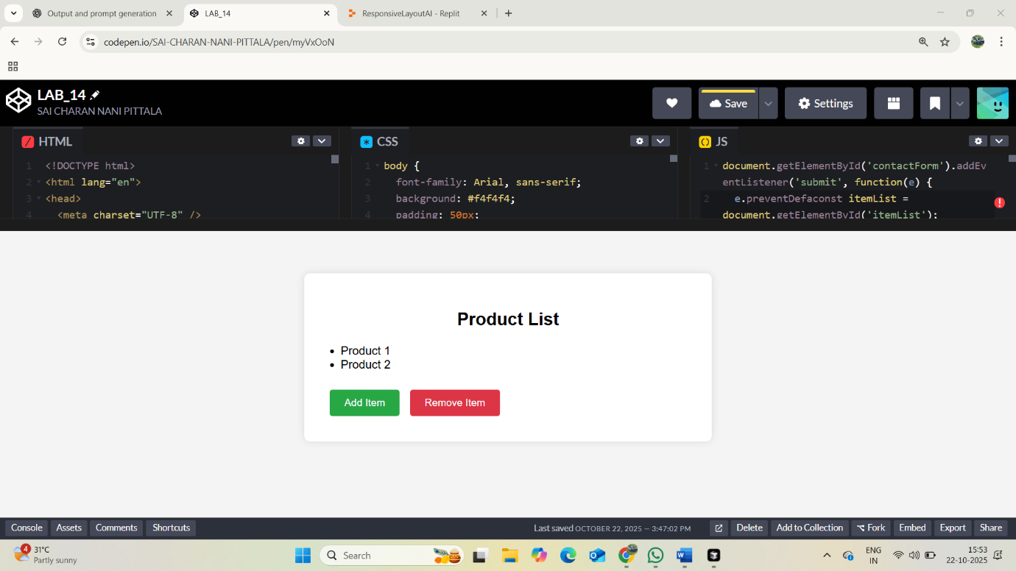

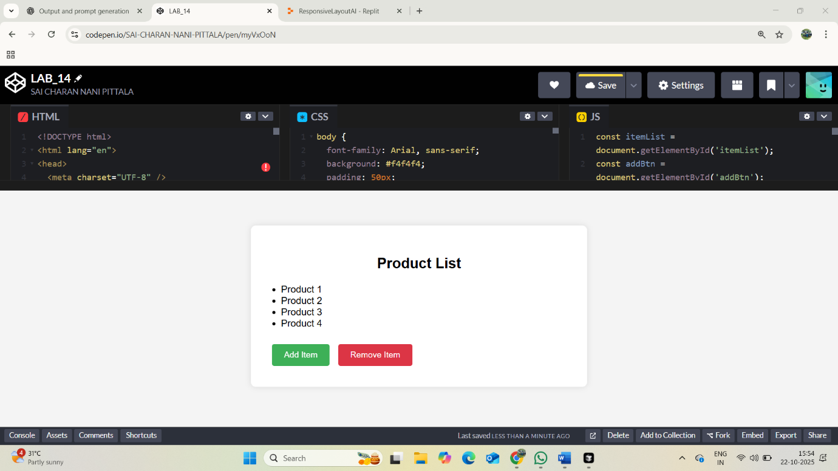
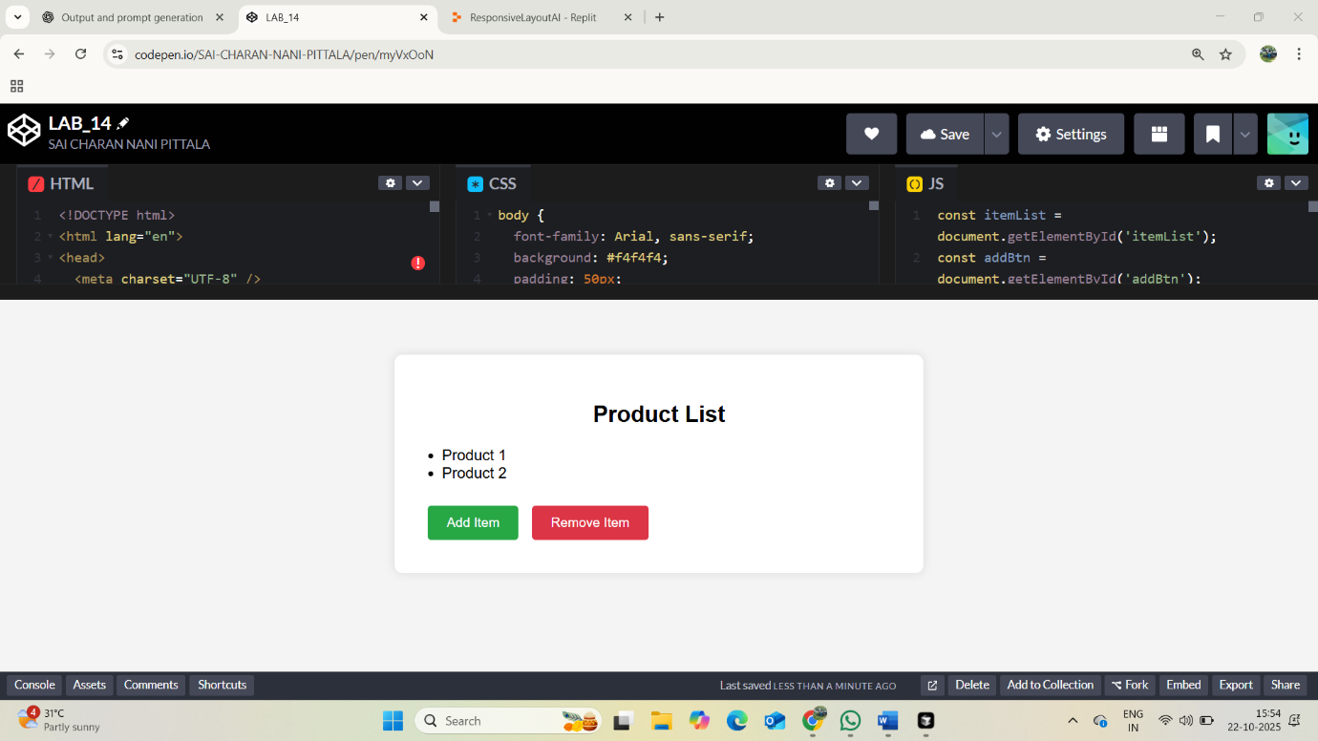

TASK-5: Create a modal popup in HTML, CSS, and JavaScript. The page should have a button labeled “Open Modal.” When clicked, a modal with a semi-transparent overlay appears. The modal has some content and a close “X” button. Clicking the close button or the overlay outside the modal content closes the modal. Style the modal and overlay nicely with CSS.
Code:

Index.html:
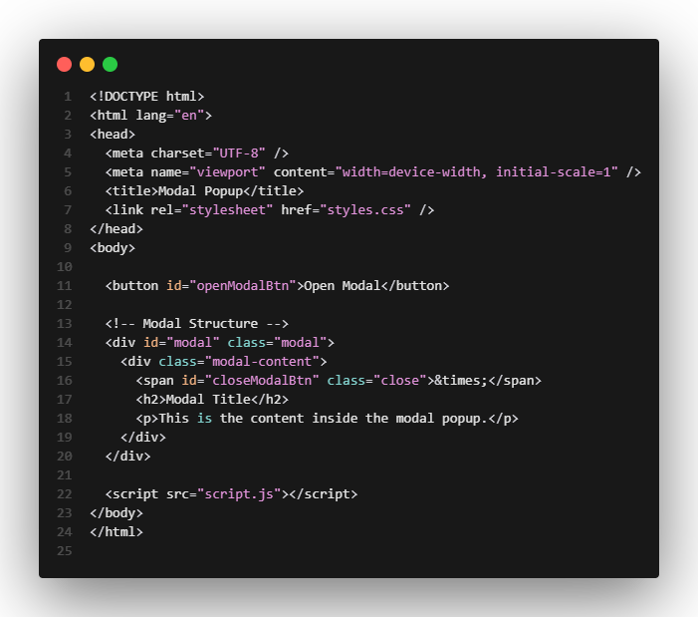

Style.css:
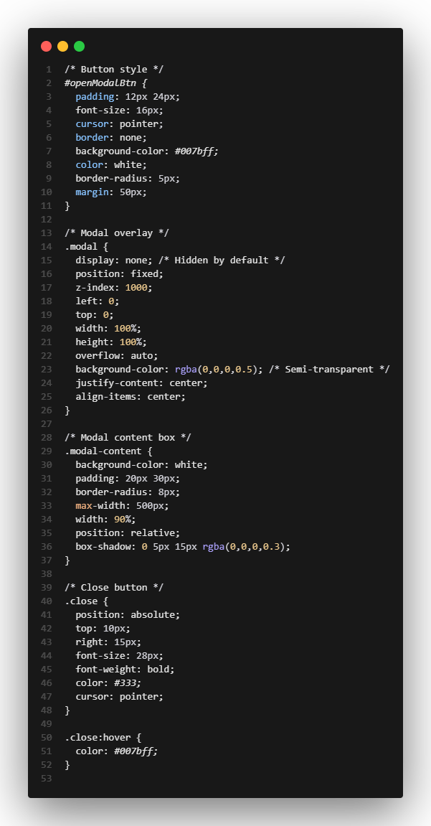
Script.js:
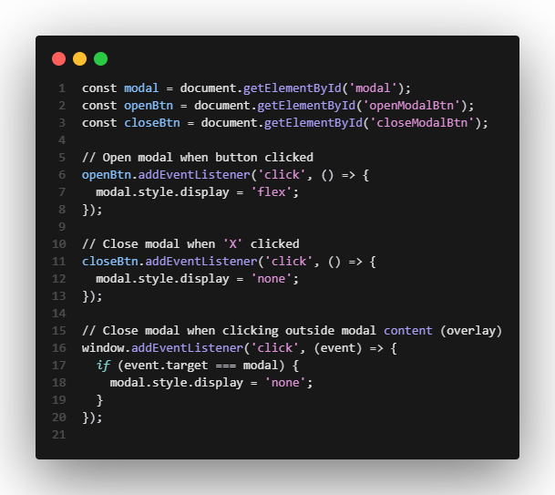

Output:
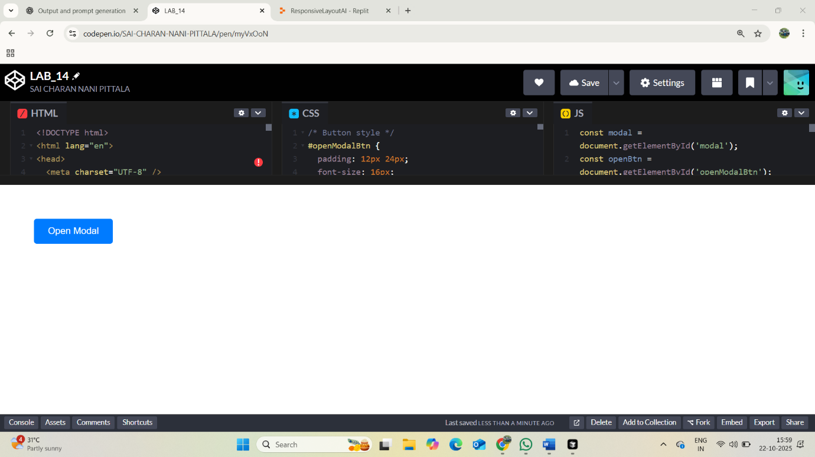
On clicking:
