WEEK-9 [V Akhil, 2520080029]
BOOKFLOW LIBRARY SYSTEM
Transactional Microservice using Spring Boot, Spring Data JPA and PostgreSQL
To develop a transactional BookFlow Library microservice using Spring Boot, Spring Data JPA and PostgreSQL for managing book inventory and borrowing orders, with FastAPI Gateway integration.

Database – bookflow creation in Postgresql
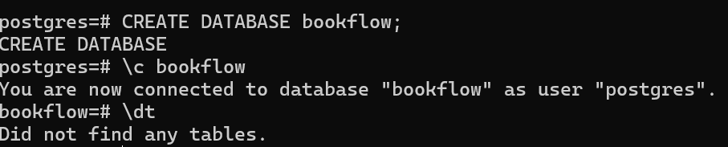

Tables Inserted
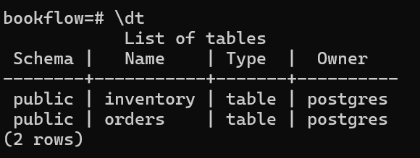

Initial Inventory Data in PostgreSQL
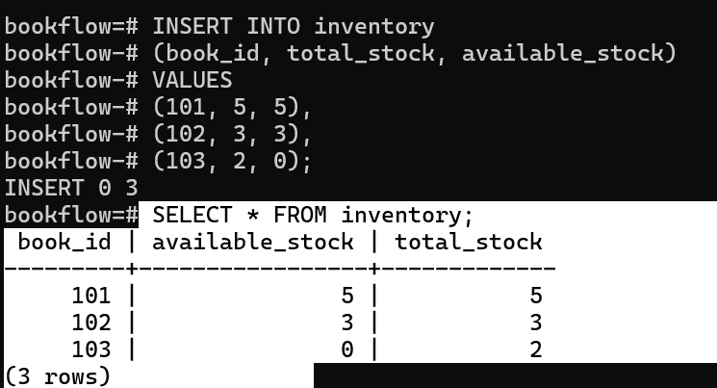

GET Inventory for Book 101

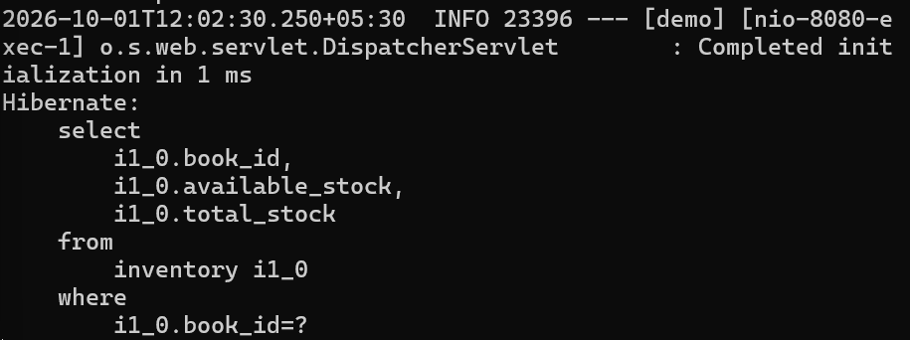
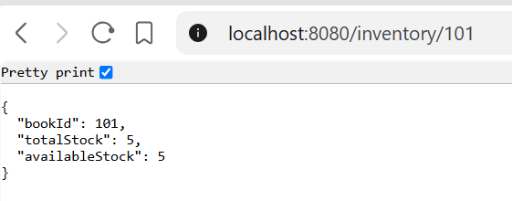

Successful Book Borrowing — POST /orders
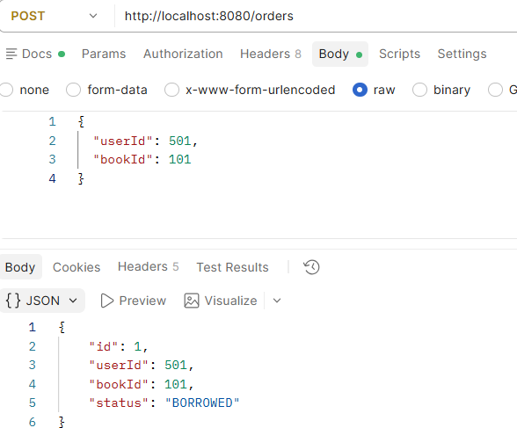

GET /inventory/101 — Inventory After Book Borrowing
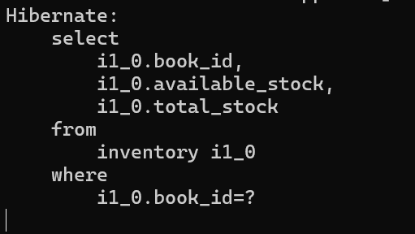
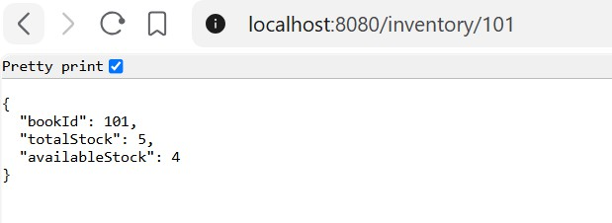

PostgreSQL Database — Inventory and Order Records After Borrowing
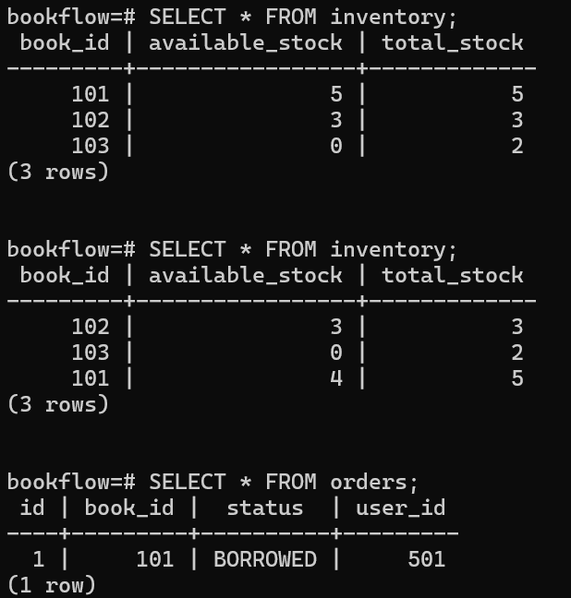

POST /orders — Out-of-Stock Book Returns 409 Conflict
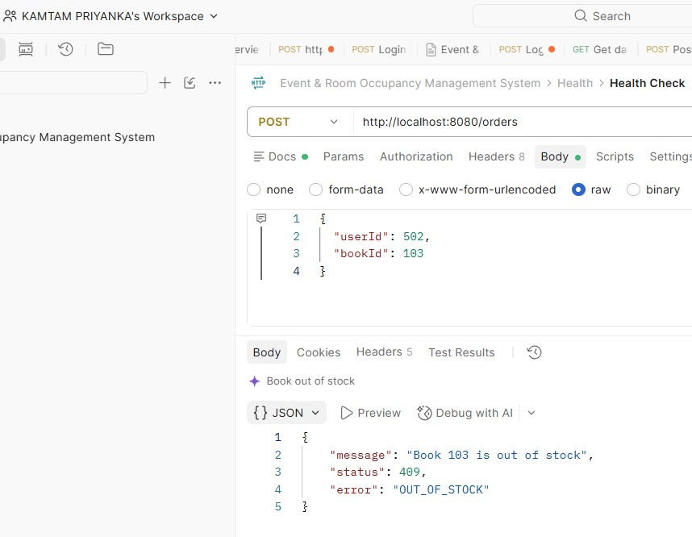
FastAPI Gateway — /gateway/orders Successfully Forwards Request to Spring Boot
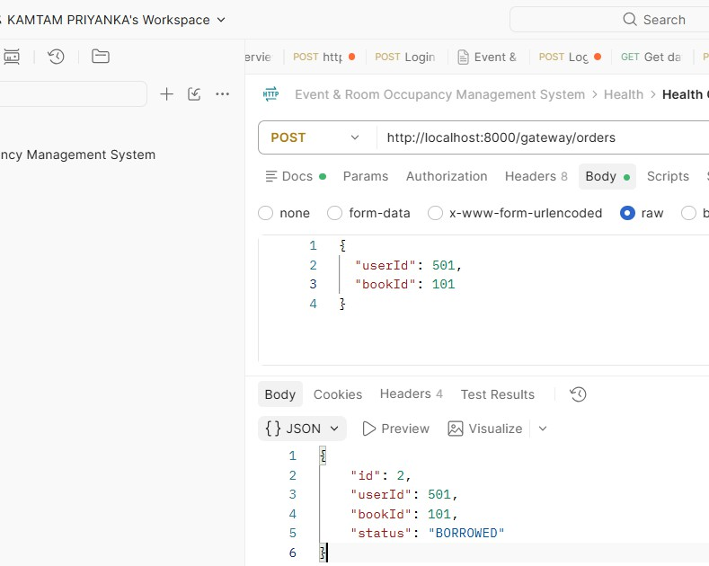

PostgreSQL — Final Inventory and Order Records
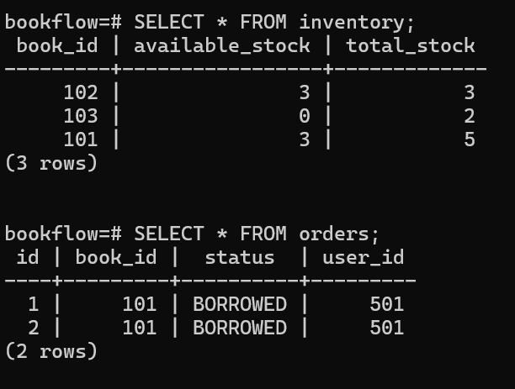

Folder Structure:
bookflow-transaction/
│
├── pom.xml
│
└── src/
└── main/
├── java/
│ └── com/
│ └── bookflow/
│ └── transaction/
│
│ ├── BookflowTransactionApplication.java
│ │
│ ├── controller/
│ │ ├── OrderController.java
│ │ └── InventoryController.java
│ │

│ ├── entity/
│ │ ├── Inventory.java
│ │ └── Order.java
│ │
│ ├── repository/
│ │ ├── InventoryRepository.java
│ │ └── OrderRepository.java
│ │
│ ├── service/
│ │ ├── InventoryService.java
│ │ └── OrderService.java
│ │
│ ├── dto/
│ │ └── OrderRequest.java
│ │
│ └── exception/
│ ├── BookOutOfStockException.java
│ └── GlobalExceptionHandler.java
│
└── resources/
└── application.yml

Codes:
- pom.xml

<?xml version="1.0" encoding="UTF-8"?>
<project xmlns="http://maven.apache.org/POM/4.0.0" xmlns:xsi="http://www.w3.org/2001/XMLSchema-instance" xsi:schemaLocation="http://maven.apache.org/POM/4.0.0 https://maven.apache.org/xsd/maven-4.0.0.xsd">

<modelVersion>4.0.0</modelVersion>

<parent>
<groupId>org.springframework.boot</groupId>
<artifactId>spring-boot-starter-parent</artifactId>
<version>3.5.5</version>

<relativePath/>
</parent>

<groupId>com.bookflow</groupId>
<artifactId>bookflow-transaction</artifactId>
<version>0.0.1-SNAPSHOT</version>

<name>bookflow-transaction</name>
<description>BookFlow Transactional Microservice</description>

<properties>
<java.version>17</java.version>
</properties>

<dependencies>

<dependency>
<groupId>org.springframework.boot</groupId>
<artifactId>spring-boot-starter-web</artifactId>
</dependency>

<dependency>
<groupId>org.springframework.boot</groupId>
<artifactId>spring-boot-starter-data-jpa</artifactId>
</dependency>

<dependency>
<groupId>org.postgresql</groupId>
<artifactId>postgresql</artifactId>
<scope>runtime</scope>
</dependency>

<dependency>
<groupId>org.springframework.boot</groupId>
<artifactId>spring-boot-starter-validation</artifactId>
</dependency>

<dependency>
<groupId>org.springframework.boot</groupId>
<artifactId>spring-boot-starter-test</artifactId>
<scope>test</scope>
</dependency>

</dependencies>

<build>
<plugins>
<plugin>

<groupId>org.springframework.boot</groupId>
<artifactId>spring-boot-maven-plugin</artifactId>
<configuration>
<mainClass>com.bookflow.transaction.BookflowTransactionApplication</ma
inClass>
</configuration>
</plugin>
</plugins>
</build>

</project>

- application.yml

spring: datasource:
url: jdbc:postgresql://localhost:5432/bookflow username: postgres
password: UR_PASSWORD

jpa:
hibernate:
ddl-auto: update show-sql: true properties:
hibernate: format_sql: true

server: port: 8080

- BookflowTransactionApplication.java

package com.bookflow.transaction;

import org.springframework.boot.SpringApplication;
import org.springframework.boot.autoconfigure.SpringBootApplication;

@SpringBootApplication
public class BookflowTransactionApplication {

public static void main(String[] args) { SpringApplication.run(BookflowTransactionApplication.class, args);
}
}

- Inventory.java

package com.bookflow.transaction.entity;

import jakarta.persistence.Entity; import jakarta.persistence.Id; import jakarta.persistence.Table;
import jakarta.validation.constraints.Min;

@Entity
@Table(name = "inventory") public class Inventory {

@Id
private Long bookId;

@Min(value = 0, message = "Total stock cannot be negative") private Integer totalStock;

@Min(value = 0, message = "Available stock cannot be negative") private Integer availableStock;

public Inventory() {
}

public Inventory(Long bookId, Integer totalStock, Integer availableStock)
{
this.bookId = bookId; this.totalStock = totalStock;
this.availableStock = availableStock;
}

public Long getBookId() { return bookId;
}

public void setBookId(Long bookId) { this.bookId = bookId;
}

public Integer getTotalStock() { return totalStock;
}

public void setTotalStock(Integer totalStock) { this.totalStock = totalStock;
}

public Integer getAvailableStock() { return availableStock;
}

public void setAvailableStock(Integer availableStock) { this.availableStock = availableStock;
}
}

- Order.java
package com.bookflow.transaction.entity; import jakarta.persistence.Entity;
import jakarta.persistence.GeneratedValue;
import jakarta.persistence.GenerationType; import jakarta.persistence.Id;
import jakarta.persistence.Table;

@Entity
@Table(name = "orders") public class Order {

@Id
@GeneratedValue(strategy = GenerationType.IDENTITY) private Long id;

private Long userId; private Long bookId; private String status;

public Order() {
}

public Order(Long userId, Long bookId, String status) { this.userId = userId;
this.bookId = bookId; this.status = status;
}

public Long getId() { return id;
}

public void setId(Long id) { this.id = id;
}

public Long getUserId() { return userId;
}

public void setUserId(Long userId) { this.userId = userId;
}

public Long getBookId() { return bookId;
}

public void setBookId(Long bookId) { this.bookId = bookId;
}

public String getStatus() { return status;
}

public void setStatus(String status) { this.status = status;
}
}

- InventoryRepository.java
package com.bookflow.transaction.repository; import com.bookflow.transaction.entity.Inventory;
import org.springframework.data.jpa.repository.JpaRepository;

public interface InventoryRepository extends JpaRepository<Inventory, Long> {
}

- OrderRepository.java
package com.bookflow.transaction.repository; import com.bookflow.transaction.entity.Order;
import org.springframework.data.jpa.repository.JpaRepository;

public interface OrderRepository extends JpaRepository<Order, Long> {
}

- OrderRequest.java

package com.bookflow.transaction.dto;

import jakarta.validation.constraints.NotNull; public class OrderRequest {
@NotNull
private Long userId;

@NotNull
private Long bookId;

public Long getUserId() { return userId;
}

public void setUserId(Long userId) { this.userId = userId;
}

public Long getBookId() { return bookId;
}

public void setBookId(Long bookId) { this.bookId = bookId;
}
}

- InventoryService.java

package com.bookflow.transaction.service;

import com.bookflow.transaction.entity.Inventory;
import com.bookflow.transaction.repository.InventoryRepository; import org.springframework.stereotype.Service;

@Service
public class InventoryService {

private final InventoryRepository inventoryRepository;

public InventoryService(InventoryRepository inventoryRepository) { this.inventoryRepository = inventoryRepository;
}

public Inventory getInventory(Long bookId) { return inventoryRepository.findById(bookId)
.orElseThrow(() -> new RuntimeException("Book not found"));
}
}

- OrderService.java

package com.bookflow.transaction.service;

import com.bookflow.transaction.dto.OrderRequest; import com.bookflow.transaction.entity.Inventory; import com.bookflow.transaction.entity.Order;
import com.bookflow.transaction.exception.BookOutOfStockException; import com.bookflow.transaction.repository.InventoryRepository; import com.bookflow.transaction.repository.OrderRepository;
import org.springframework.stereotype.Service;
import org.springframework.transaction.annotation.Transactional;

@Service
public class OrderService {

private final InventoryRepository inventoryRepository; private final OrderRepository orderRepository;

public OrderService(
InventoryRepository inventoryRepository, OrderRepository orderRepository) {
this.inventoryRepository = inventoryRepository; this.orderRepository = orderRepository;
}

@Transactional
public Order borrowBook(OrderRequest request) {

Inventory inventory = inventoryRepository.findById(request.getBookId())
.orElseThrow(() -> new RuntimeException("Book not found"));

if (inventory.getAvailableStock() <= 0) { throw new BookOutOfStockException(
"Book " + request.getBookId() + " is out of stock");
}

inventory.setAvailableStock( inventory.getAvailableStock() - 1);

inventoryRepository.save(inventory);

Order order = new Order(
request.getUserId(), request.getBookId(), "BORROWED");

return orderRepository.save(order);
}
}

- InventoryController.java
package com.bookflow.transaction.controller; import com.bookflow.transaction.entity.Inventory;
import com.bookflow.transaction.service.InventoryService;
import org.springframework.web.bind.annotation.*;

@RestController @RequestMapping("/inventory") public class InventoryController {

private final InventoryService inventoryService;

public InventoryController(InventoryService inventoryService) { this.inventoryService = inventoryService;
}

@GetMapping("/{bookId}")
public Inventory getInventory(@PathVariable Long bookId) { return inventoryService.getInventory(bookId);
}
}

- OrderController.java

package com.bookflow.transaction.controller;

import com.bookflow.transaction.dto.OrderRequest; import com.bookflow.transaction.entity.Order;
import com.bookflow.transaction.service.OrderService; import jakarta.validation.Valid;
import org.springframework.http.HttpStatus; import org.springframework.web.bind.annotation.*;

@RestController @RequestMapping("/orders") public class OrderController {

private final OrderService orderService;

public OrderController(OrderService orderService) { this.orderService = orderService;
}

@PostMapping @ResponseStatus(HttpStatus.CREATED)
public Order borrowBook(@Valid @RequestBody OrderRequest request) { return orderService.borrowBook(request);
}
}

- BookOutOfStockException.java

package com.bookflow.transaction.exception;
public class BookOutOfStockException extends RuntimeException { public BookOutOfStockException(String message) {
super(message);
}
}

- GlobalExceptionHandler.java

package com.bookflow.transaction.exception;

import org.springframework.http.HttpStatus; import org.springframework.web.bind.annotation.*;
import java.util.Map; @RestControllerAdvice
public class GlobalExceptionHandler {

@ExceptionHandler(BookOutOfStockException.class) @ResponseStatus(HttpStatus.CONFLICT)
public Map<String, Object> handleOutOfStock( BookOutOfStockException ex) {

return Map.of(
"status", 409,
"error", "OUT_OF_STOCK", "message", ex.getMessage()
);
}

}

- gateway.py — FastAPI gateway
from fastapi import FastAPI import httpx

app = FastAPI()
SPRING_SERVICE = "http://localhost:8080" @app.post("/gateway/orders")
async def create_order(order: dict):
async with httpx.AsyncClient() as client: response = await client.post(
f"{SPRING_SERVICE}/orders", json=order
)
return response.json()

