NAME: V Akhil ID NO: 2520080029
Couse: OSSP
WEEK 2
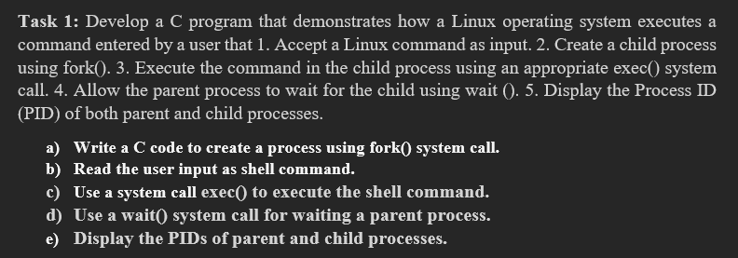
- Create a file
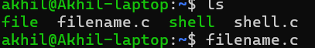
Then press enter to open command
2)write a code

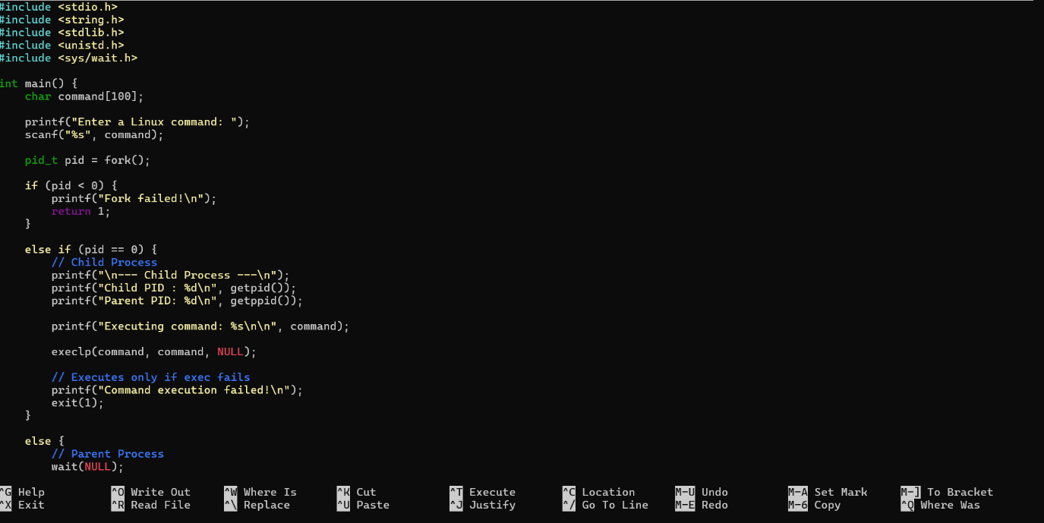
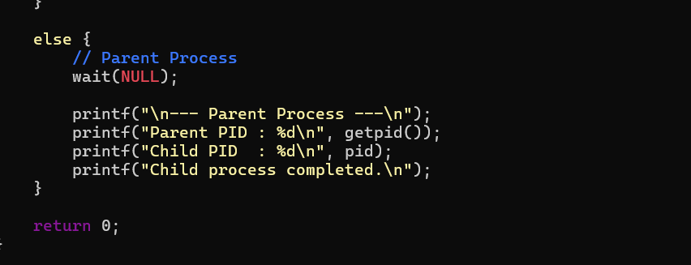
- To save press control O
- To come back to shell press control X
- Then for compilation write a command
gcc filename.c -o filename
Then press enter then to view a output write a command
./filename
Then you will be asking to enter linux command to view the output
In ENTER LINUX COMMAND: enter either "pwd” command (or) “ls” command to see the output of your code
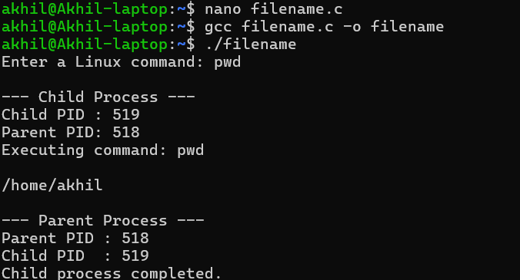
OUTPUT :
Enter Linux command : pwd

Parent Process
Parent PID: 518

Child Process
Child PID: 519
/home/Akhil
Child process completed.
Task-2: Using Linux terminal commands (uname, lscpu, ps, top), investigate the relationship between hardware resources and operating system services. Prepare a report explaining how the OS abstracts CPU, memory, storage, and I/O devices.
