SKILL WEEK 4
Process Management and Shell Programming

Name: Balaji Patil
Roll Number: 2520080065

Tasks 1, 2 and 3 — Code and Output

TASK 1

CODE
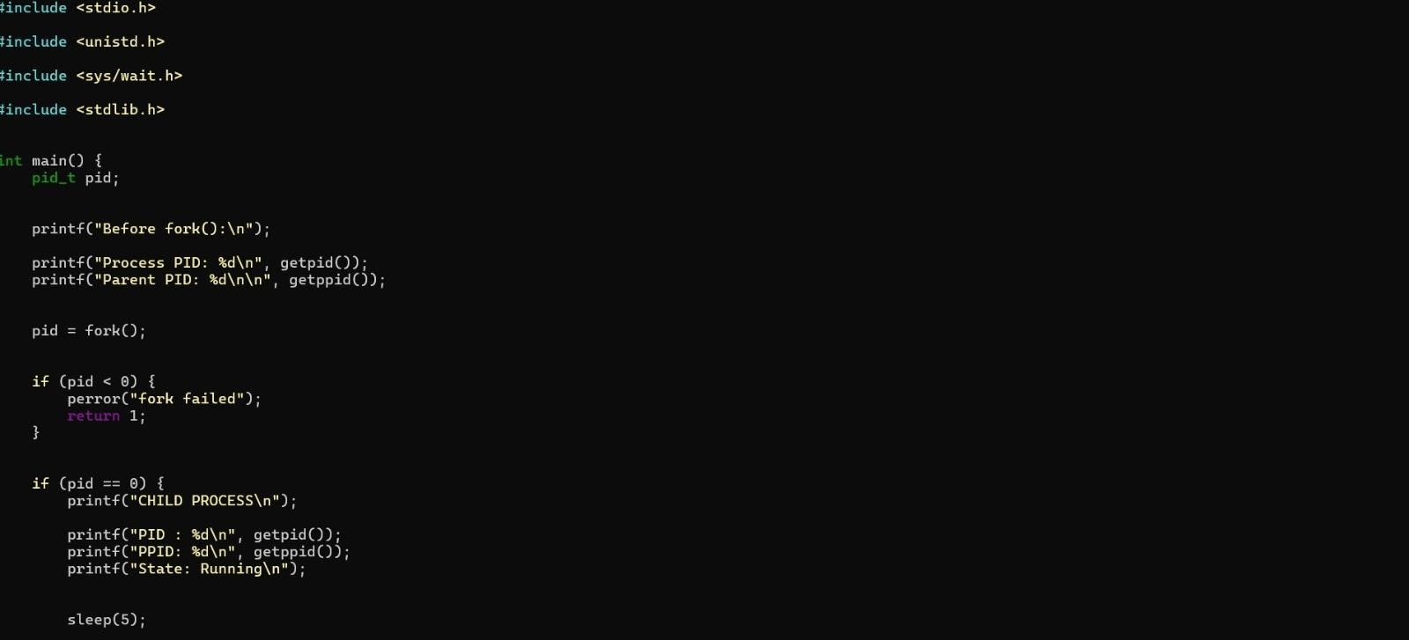
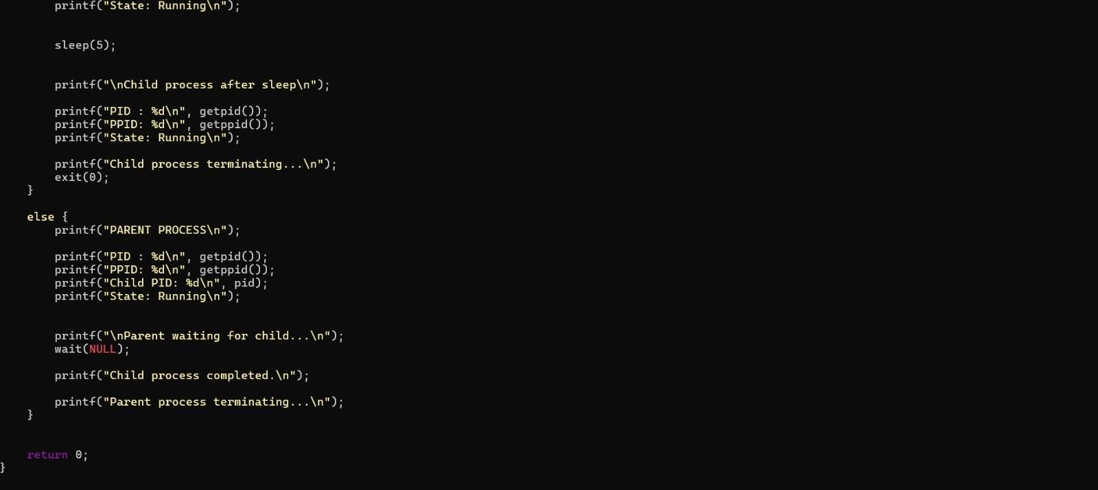

TASK 1 — OUTPUT
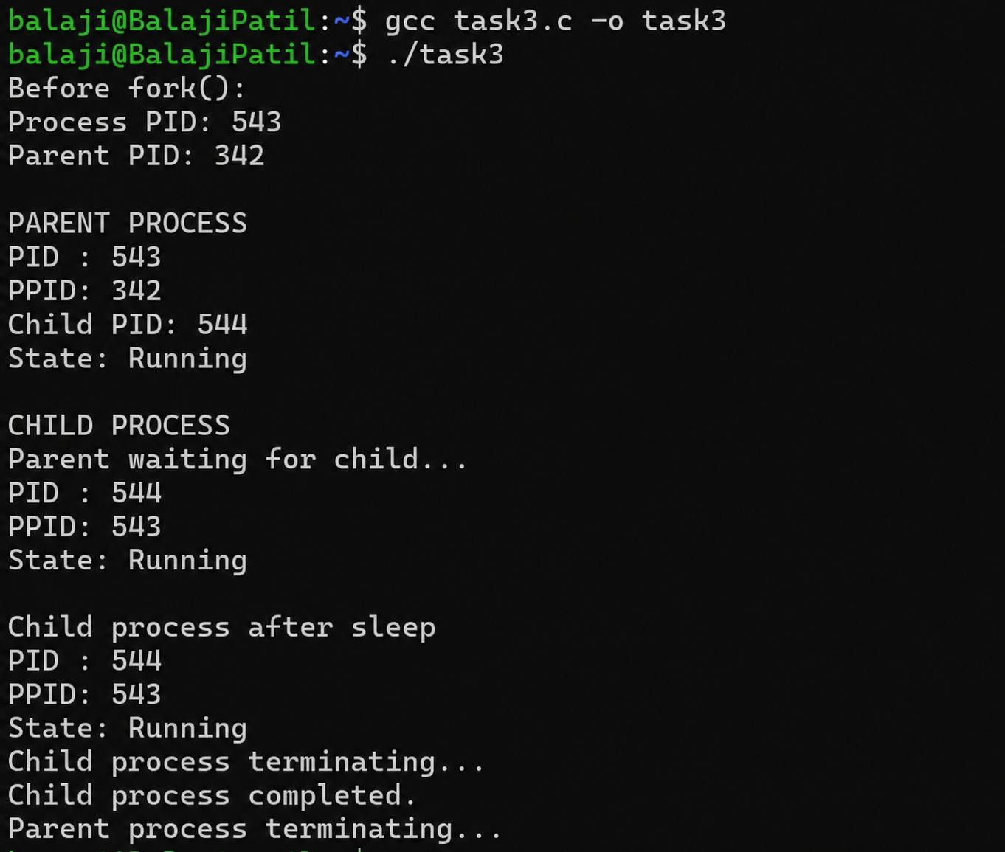
OUTPUT

TASK 2

CODE
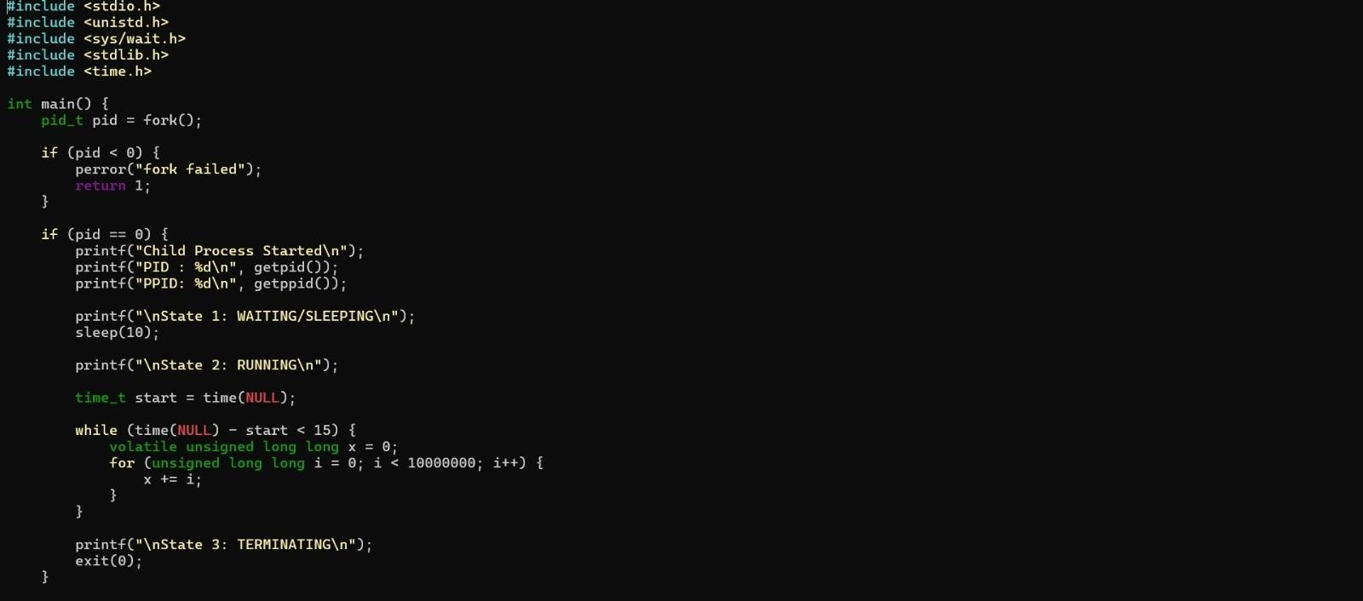
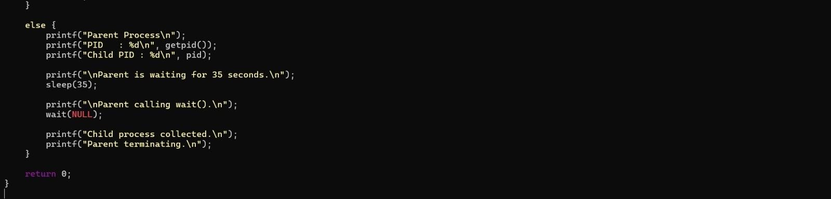

TASK 2 — OUTPUT
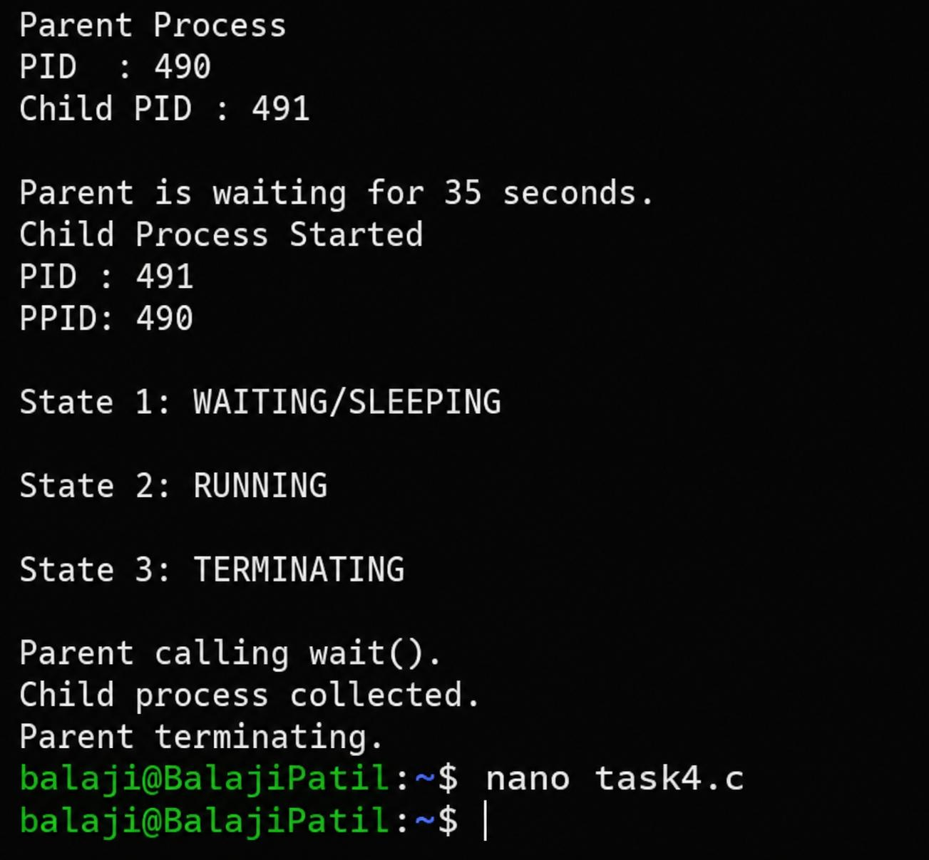
OUTPUT

TASK 3

CODE
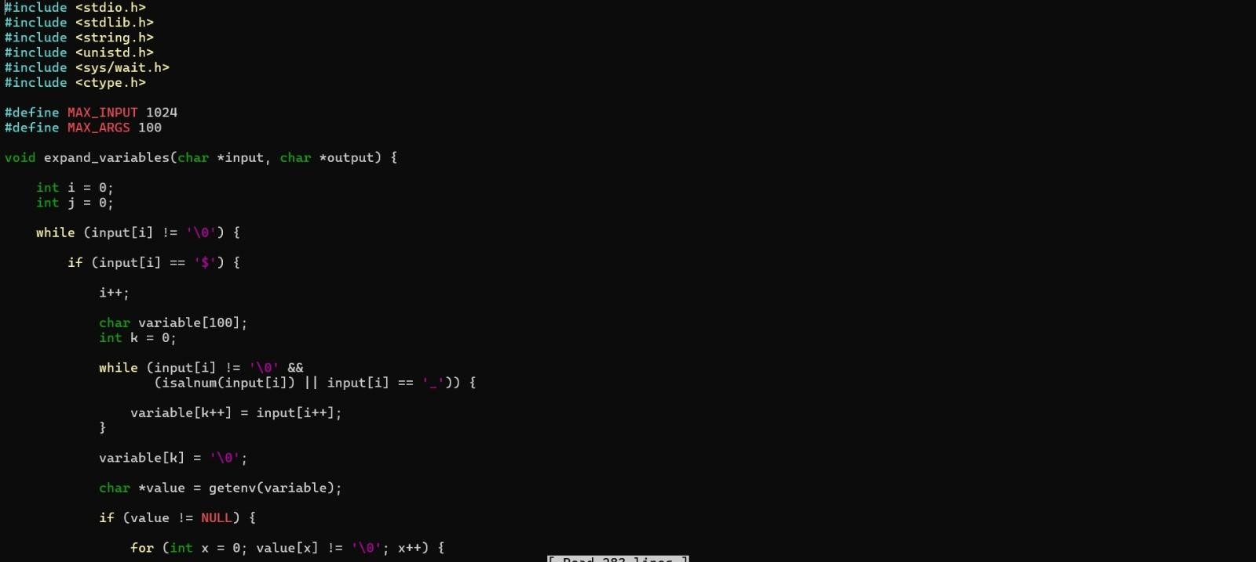
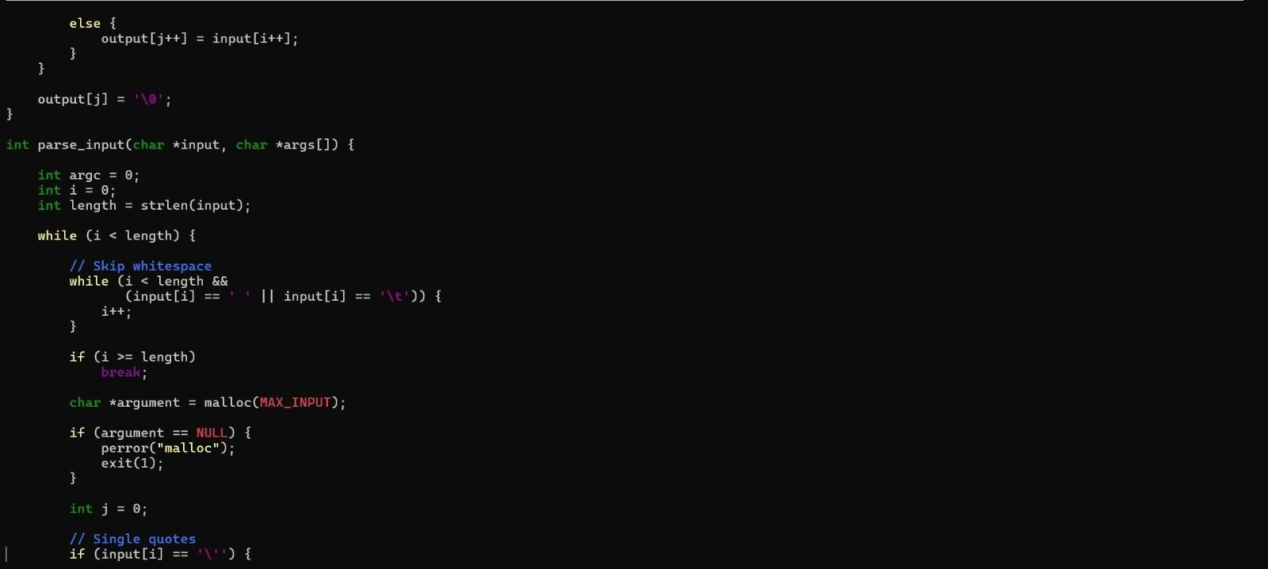
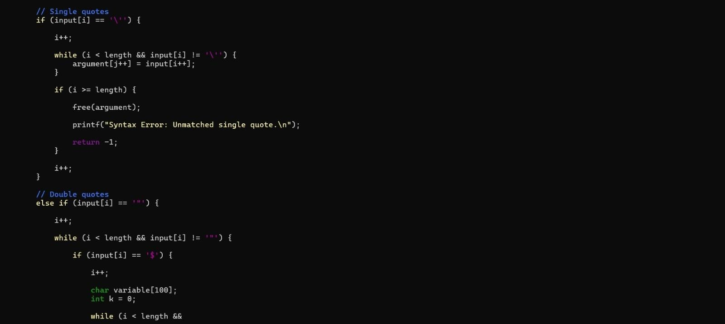

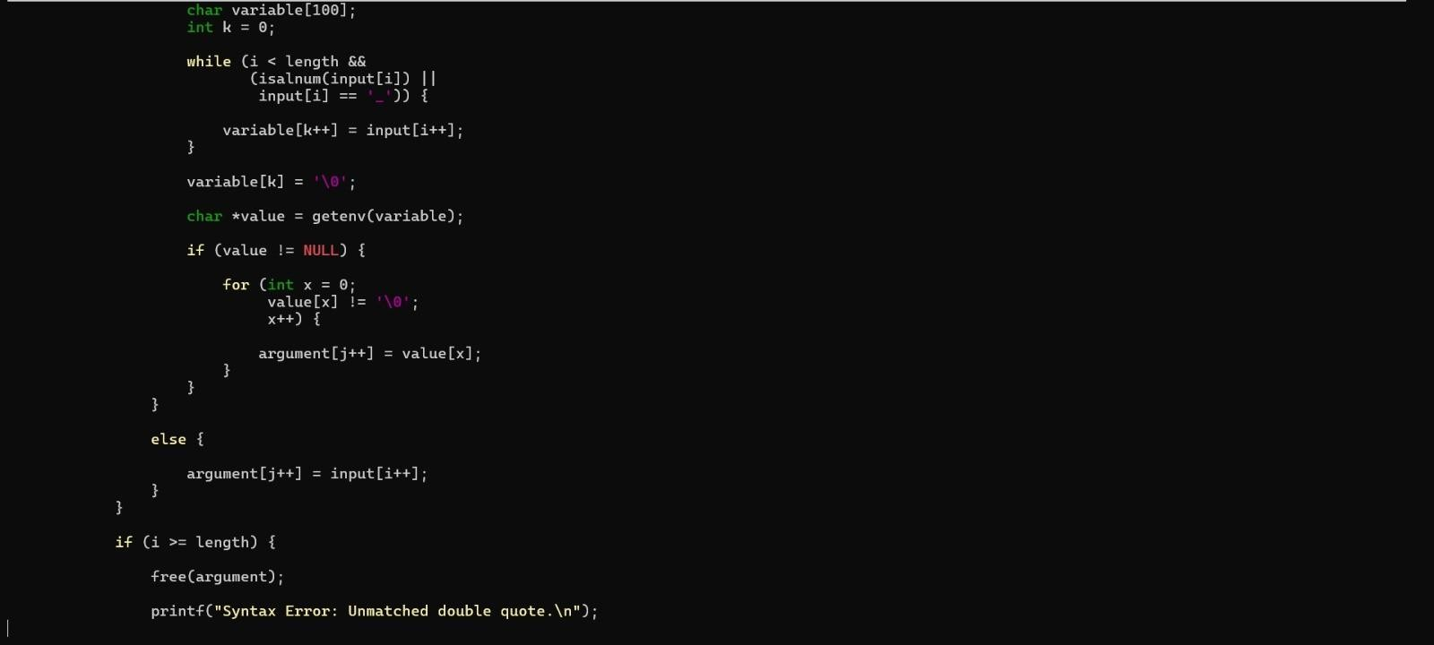
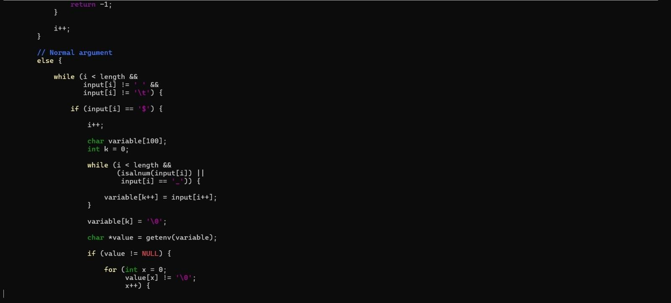
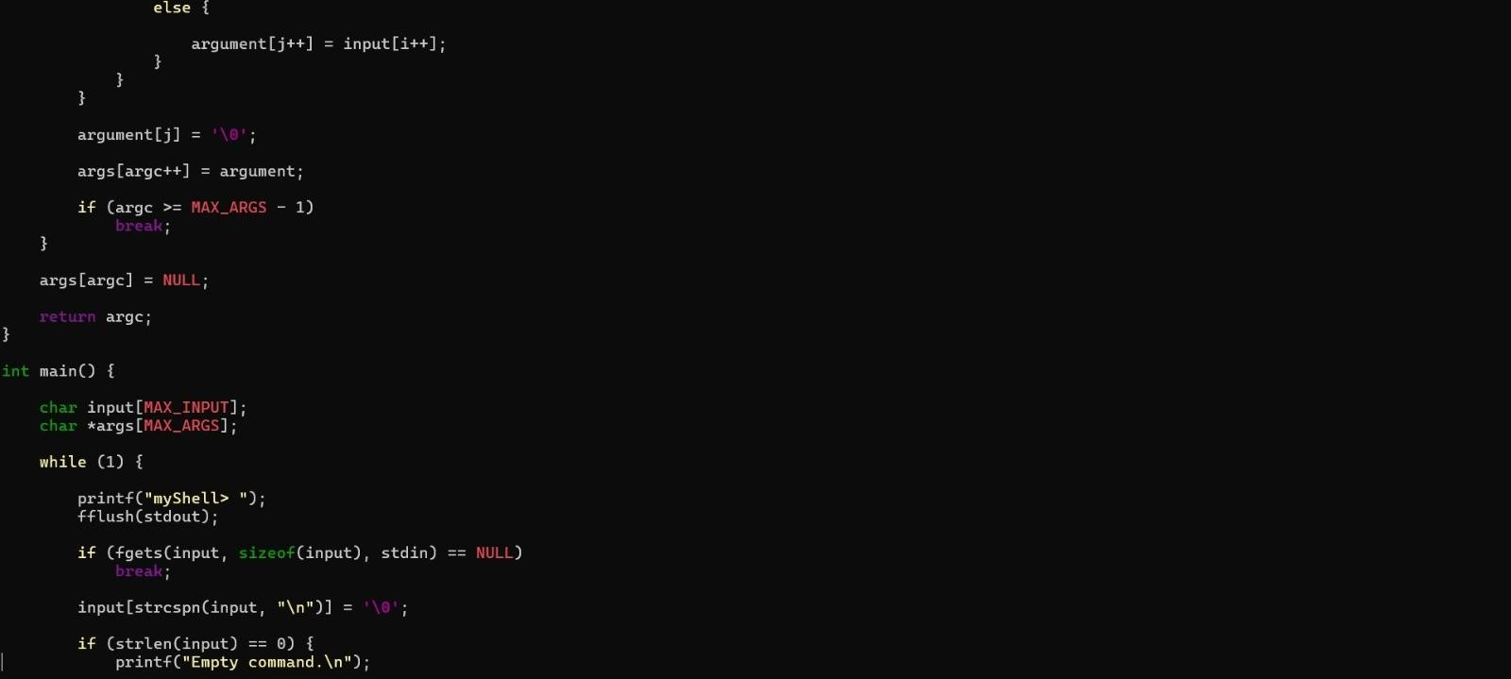

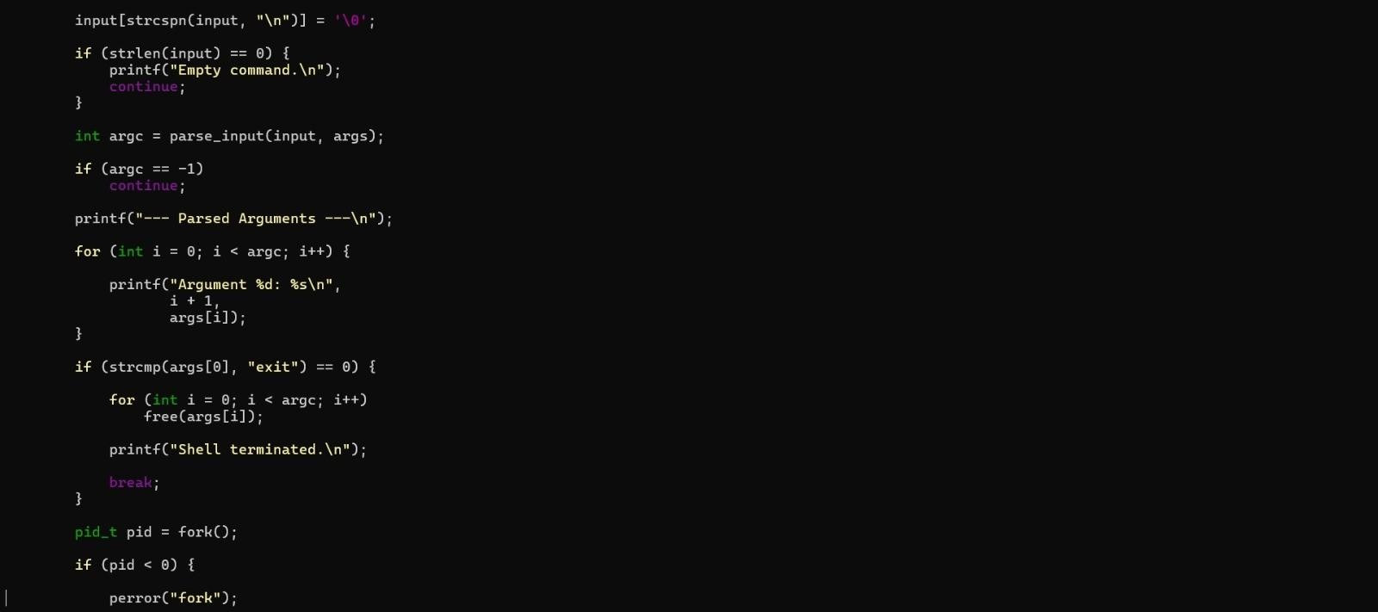

TASK 3 — OUTPUT

OUTPUT
myShell> echo "Hello $USER"
--- Parsed Arguments ---Argument 1: echo Argument 2: Hello balaji Child Process
PID = 1254
Hello balaji
Child process completed.

myShell> echo 'Hello World'
--- Parsed Arguments ---Argument 1: echo Argument 2: Hello World Child Process
PID = 1255
Hello World
Child process completed.

myShell> echo "Hello World
Syntax Error: Unmatched double quote.

myShell> exit Shell terminated.

Note: The Task 3 output above is a representative output generated from the submitted parsing logic; process IDs can differ each time the program is run.

