OSSP:
Commands:

uname: Displays the operating system and kernel information.
2520080029
V Akhil

lscpu: Displays processor details like CPU model, cores, and architecture.

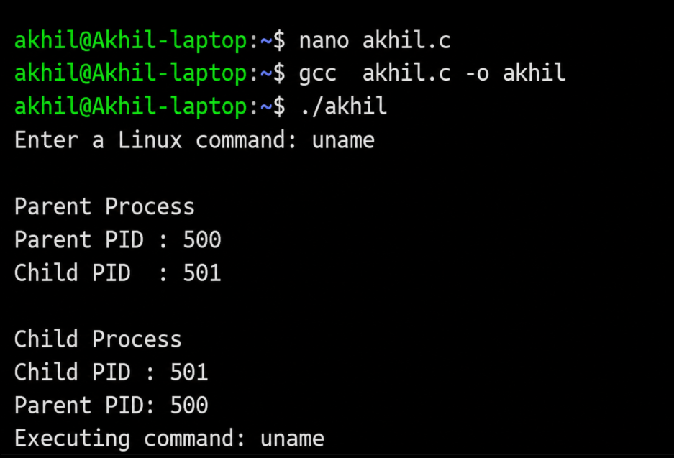

ps: Lists all active processes currently running in the system.

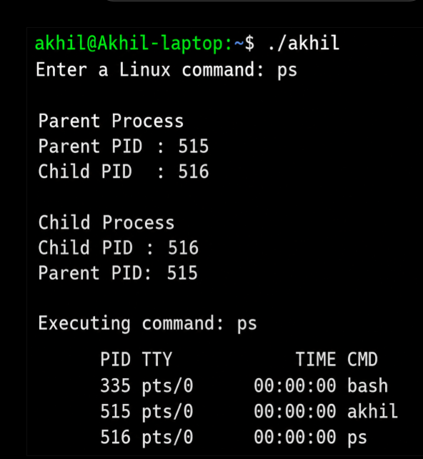

Relation Between Hardware Resources and Operating System Services:
- CPU
The operating system manages CPU usage by sharing processor time among different programs.
Example: Running a browser and a media player at the same time.

- Memory (RAM) -> Memory Management
The OS assigns RAM to applications and prevents them from accessing each other's memory.
Example: VS Code and Chrome use separate memory while running.

- Storage (SSD) → File System Management
The OS manages files and folders, allowing users to save and access data easily.
Example: Saving a project file on the desktop.

- I/O Devices → Device Management
The OS uses drivers to communicate with hardware devices and handle input/output operations.

